Diego Stembert Appointed General Manager of Four Seasons Resort Bora Bora

Former Resort Manager led property through extensive renovation and enhancement
July 8, 2019, Bora Bora, French Polynesia

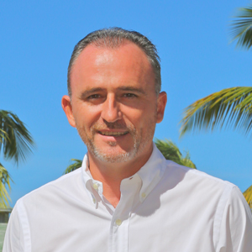
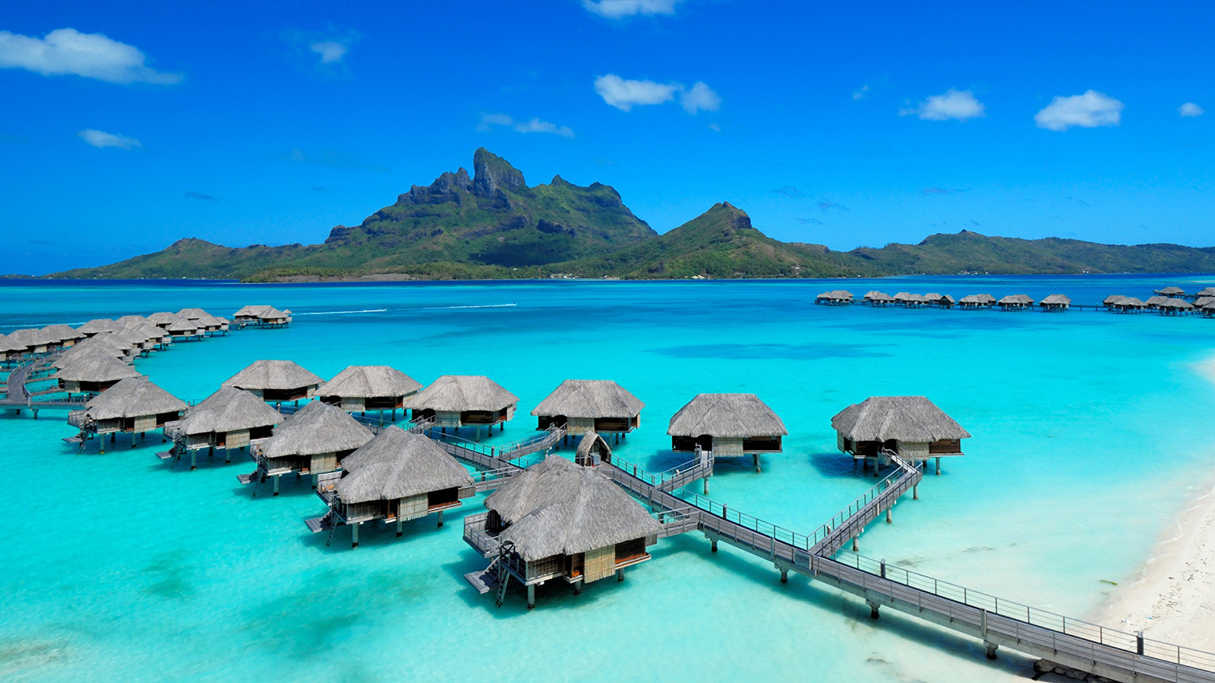 | 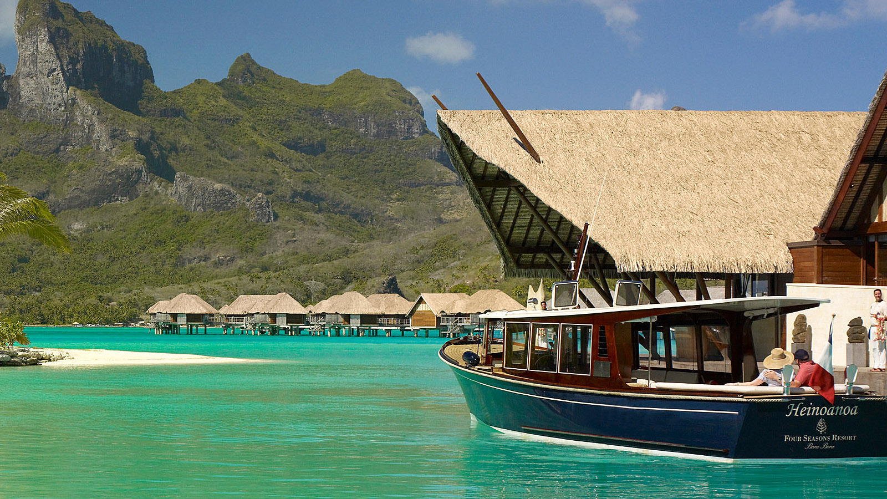 | 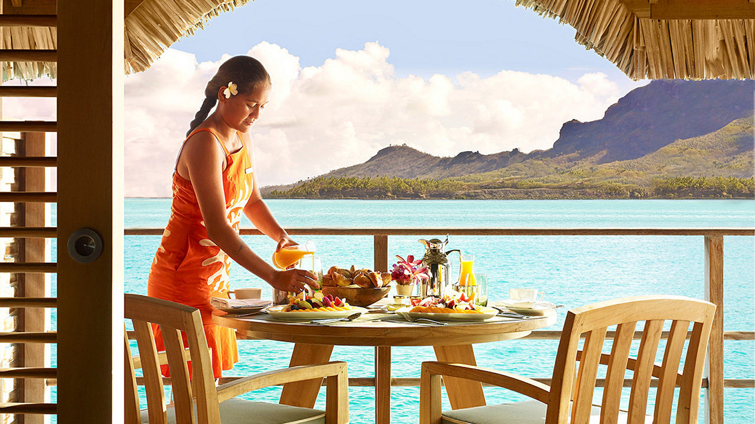
Diego Stembert has been named General Manager of Four Seasons Resort Bora Bora.
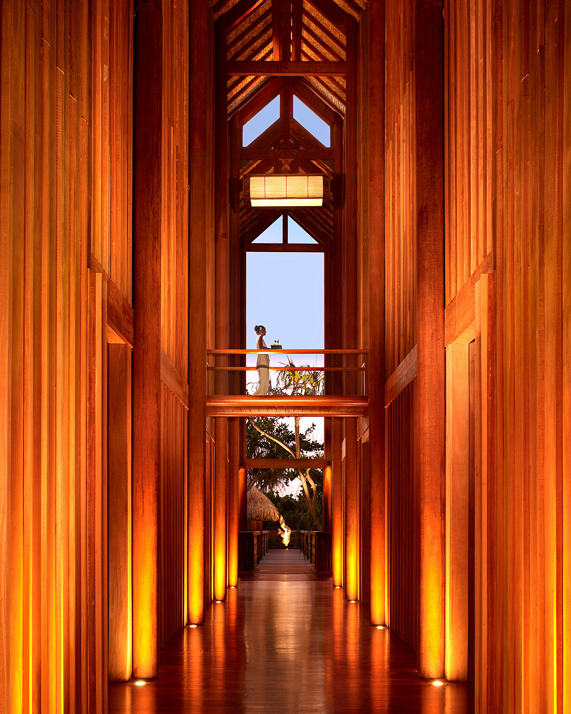 | 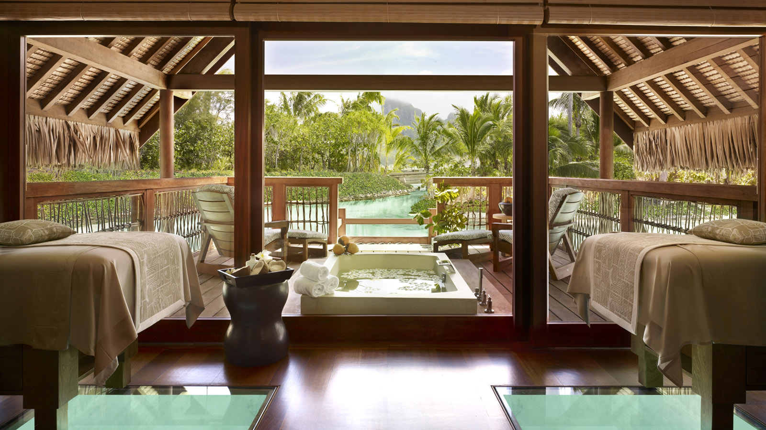 | 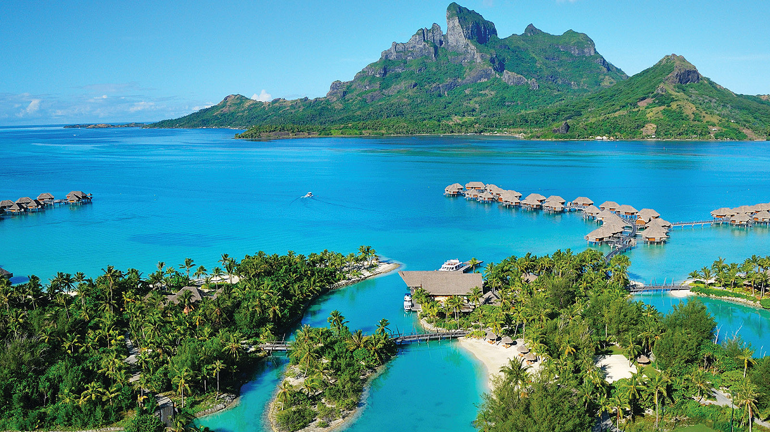
A native of San Sebastian, Spain, Stembert has always been inspired by excellence and innovation. After earning his Diploma in International Hotel Management from Le Roches Global Hospitality Education in Marbella, Spain, Stembert gained valuable experience throughout his home country, at The Westin La Quinta Golf Resort in Marbella; The Westin Palace in Madrid; and Hotel Alfonso XIII, A Luxury Collection Hotel in Seville. From there, island life called and he headed to Mauritius, where he held the positions of director of rooms and director of operations at The Grand Mauritian, A Luxury Collection Resort & Spa.
Stembert’s Four Seasons career began in 2010, when he joined the company as Director of Rooms at Four Seasons Resort Nevis, where he spend the next three and a half years, holding the positions of Director of Rooms, Executive Assistant Manager, and Resort Manager. Prior to joining as Resort Manager of Four Seasons Resort Bora Bora in 2015, Diego served as Hotel Manager of Four Seasons Hotel Mexico City.
“While I’ve worked in some great hotels around the world, being a part of this island paradise is very special experience,” says Diego Stembert, General Manager of Four Seasons Resort Bora Bora. “It is an honour to lead our passionate team in helping our guests create memories which will truly last a lifetime.”
Stembert, who speaks English, French and Spanish, and his wife Loubna (whom he met on his first day of hotel school) enjoy their free time playing tennis, having a beach day, watching movies, and travelling with their two children Sofia and Nicolas.
The Resort’s accommodations include 108 refreshed overwater bungalow suites and seven inclusive beachfront villa estates, all designed with traditional thatched roofs and decorated with indigenous artwork. Dining options at the Resort offer a vast selection of creative culinary experiences, from Polynesian to French to South Pacific fusion. A full-service spa, balanced by the powerful rhythms of the Pacific Ocean and the secluded tranquility of the island’s lagoon offers a combination of relaxation and exhilaration.
Four Seasons Resort Bora Bora is currently offering the 4th Night Free package, which includes accommodations in an overwater bungalow suite or beachfront villa estate and daily breakfast buffet for two. The Resort is also offering the Ashore Afloat package, combining the best of staying in a beachfront villa and overwater bungalow. For reservations, book online, call 888 521 6648 or contact your travel professional (chain code FS).

RELATED

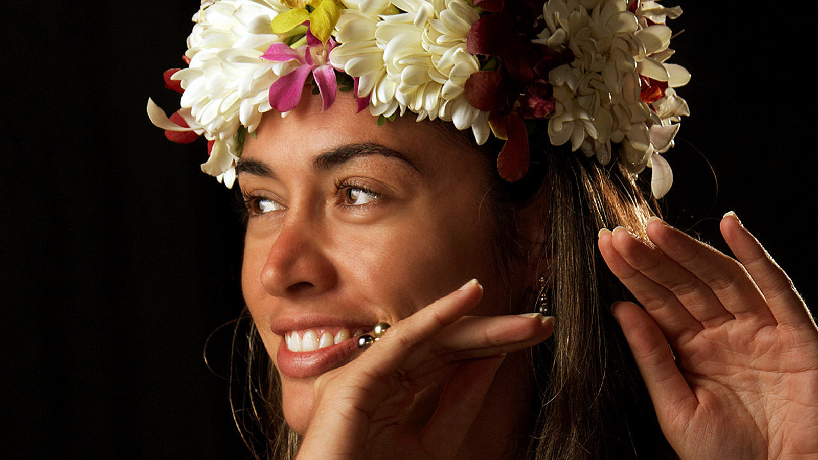 | June 17, 2019, Bora Bora, French Polynesia  Four Seasons Resort Bora Bora Celebrates Heiva I Bora Bora 2019  https://publish.url/borabora/hotel-news/2019/heiva-i-bora-bora-celebrations.html
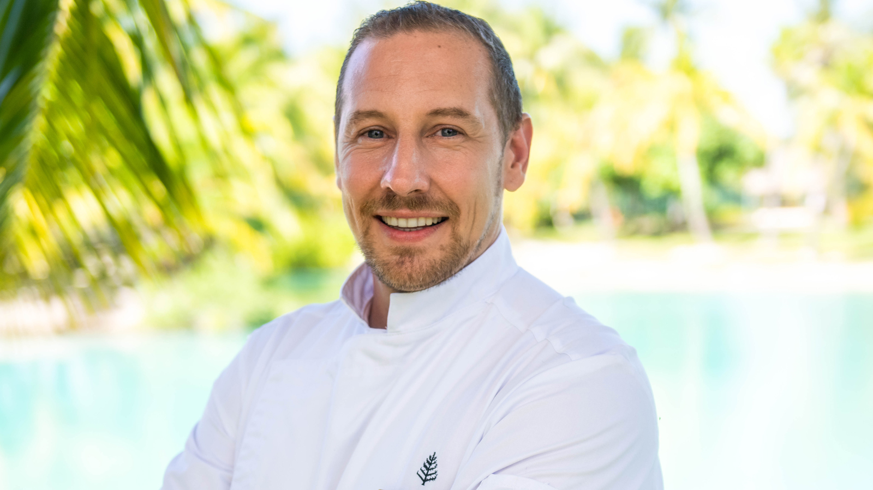 | April 23, 2019, Bora Bora, French Polynesia  Eric Desbordes Named Executive Chef of Four Seasons Resort Bora Bora  https://publish.url/borabora/hotel-news/2019/new-executive-chef-eric-desbordes.html

PRESS CONTACTS

Brad Packer
Director of Public Relations
350 South Beverly Drive, Suite 100
Beverly Hills
U.S.A.
brad.packer@fourseasons.com

+1 310 712 1493

