Four Seasons Resort Lanai Makes Golf More Fun, More Accessible To All Guests

February 28, 2018, Hawaii, Lanai, U.S.A.

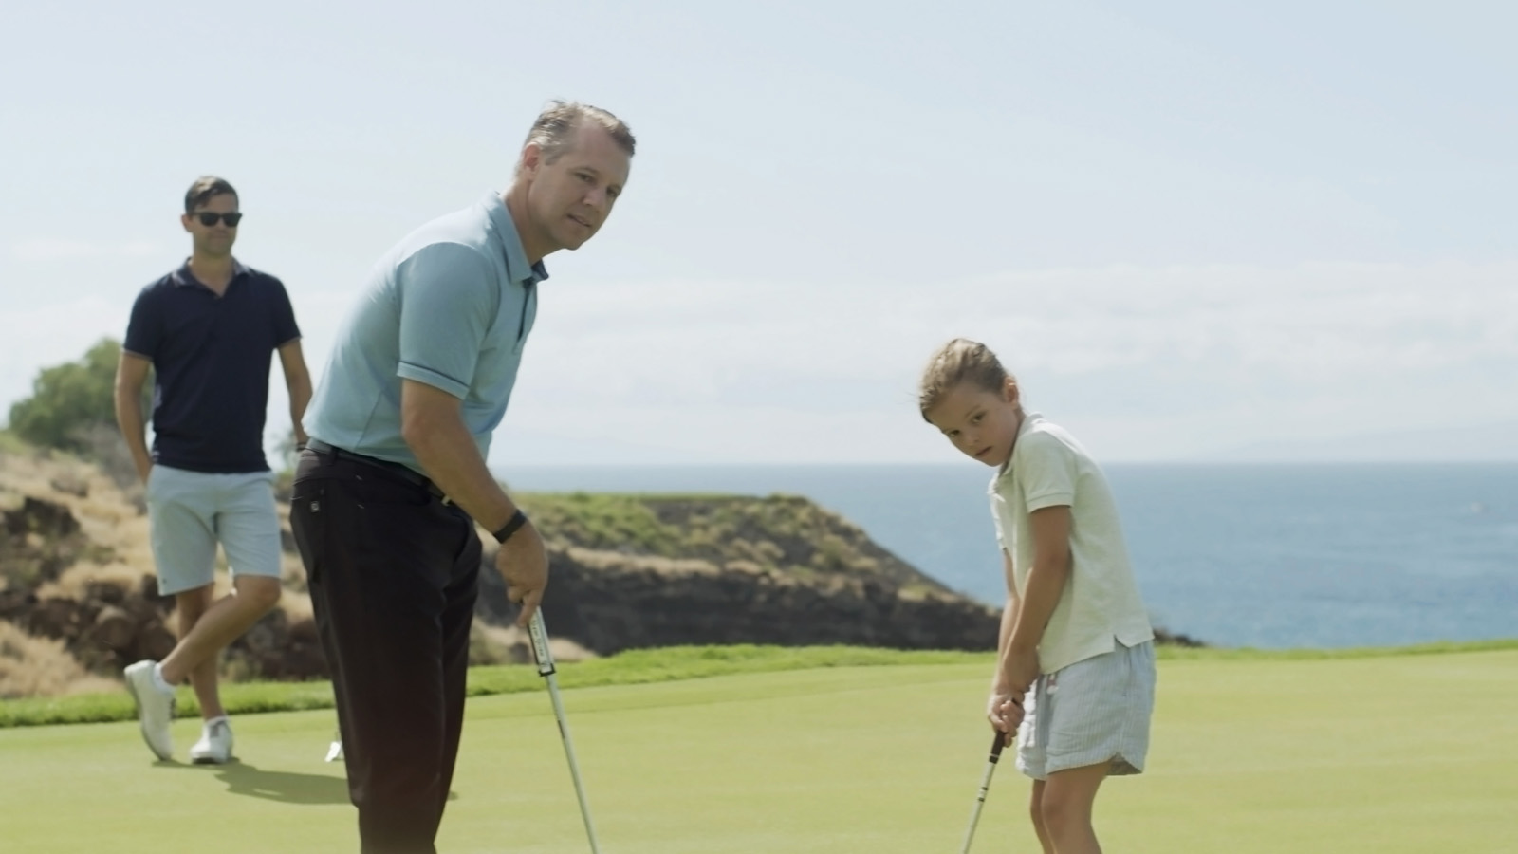
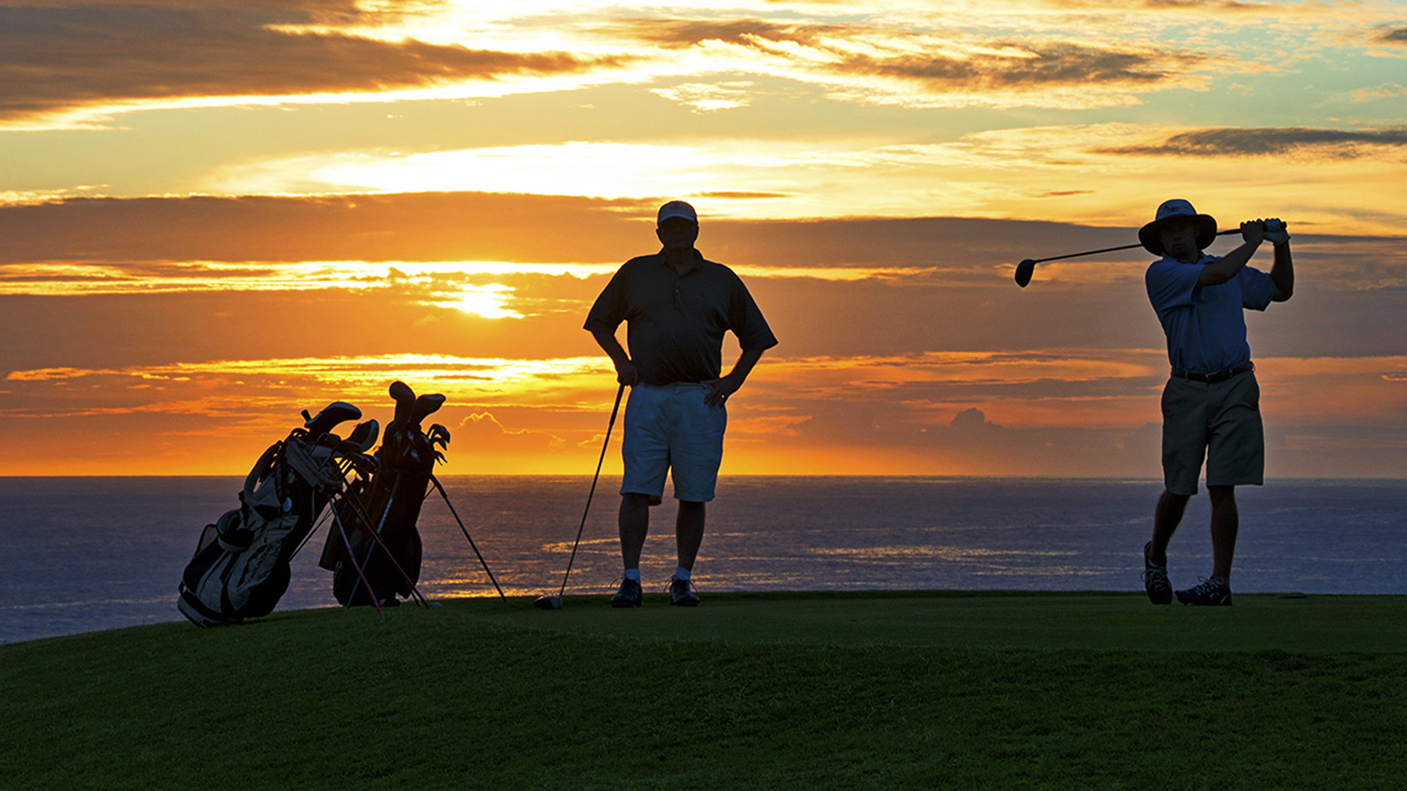 | 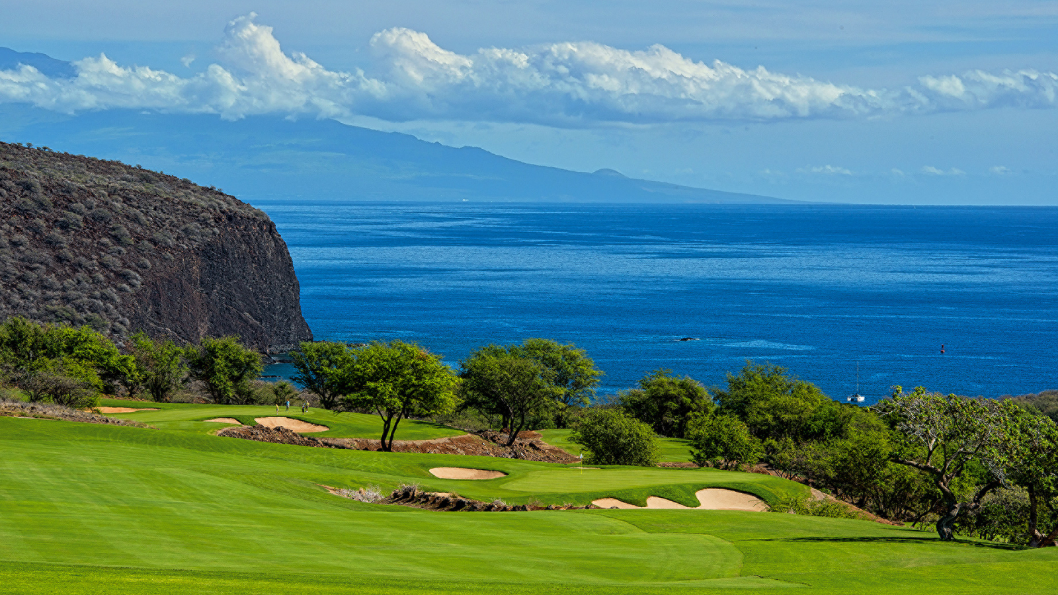
Golfers the world over know that the signature Jack Nicklaus-designed Manele Golf Course at
Four Seasons
Resort Lanai is one of the world’s most striking venues for the game, offering beauty, challenge and fun in a true island paradise.
But beyond the traditional 18 holes, resort guests are treated to golf options sure to enchant non-players, newbies and veterans alike.
Each Wednesday afternoon, the Manele practice range transforms into Mini Manele, a six-hole, par-3 course that’s a uniquely enjoyable way to take a walk, listen to music, and enjoy gorgeous views overlooking Hulopoe Bay. And of course, have fun hitting shots to holes as short as 30 yards and no more than 90 yards. Mini Manele is complimentary to Resort guests, with rental clubs and a logo golf ball included in the experience.
On Thursdays, the complimentary nine-hole Manager’s Scramble is hosted by a member of
Four Seasons
Resort management with teams formed upon arrival. The shotgun start goes off at 3:00 pm, with complimentary rental clubs available.
Friday’s popular Sunset Nine Tour is a scenic swing along the course’s signature Ocean 9 holes, made even more exciting thanks to cocktails and the chance to win prizes by hitting the green at Manele’s famous par-3 12th hole. The casual caper starts at 5:00 pm, for USD 50 per person, limited to 10 guests per tour.
Guests can play the Sunset Nine every day of the week after 3:00 pm in the company of a specialty cocktail - served at check in, delivered on course, or poured after the round - for USD 195 per person. Complimentary rental clubs are available.
And to kick one's game up a notch, club fittings using Trackman will ensure the club one swings sets them up for success on the greens. Manele Golf Course is one of two courses in Hawaii featuring Trackman; the fitting fee is applied to club purchase.
For newcomers to the game, Golf 101 is a casual but complete two-hour introduction to the game tailored to absolute beginners. Each session includes instruction on every aspect of the game and an introduction to golf etiquette, an overview of a scorecard and basic rules. Guests will also play one hole on Manele Golf Course.
Youngsters are encouraged to join the fun as Juniors Play Free. Guests 17 and younger play the Manele Course free when with a paid adult any day after 12:00 noon. Complimentary rental clubs are available.
The course also now features motorised golf boards that “surf the earth,” a unique way to get around the greens.

RELATED

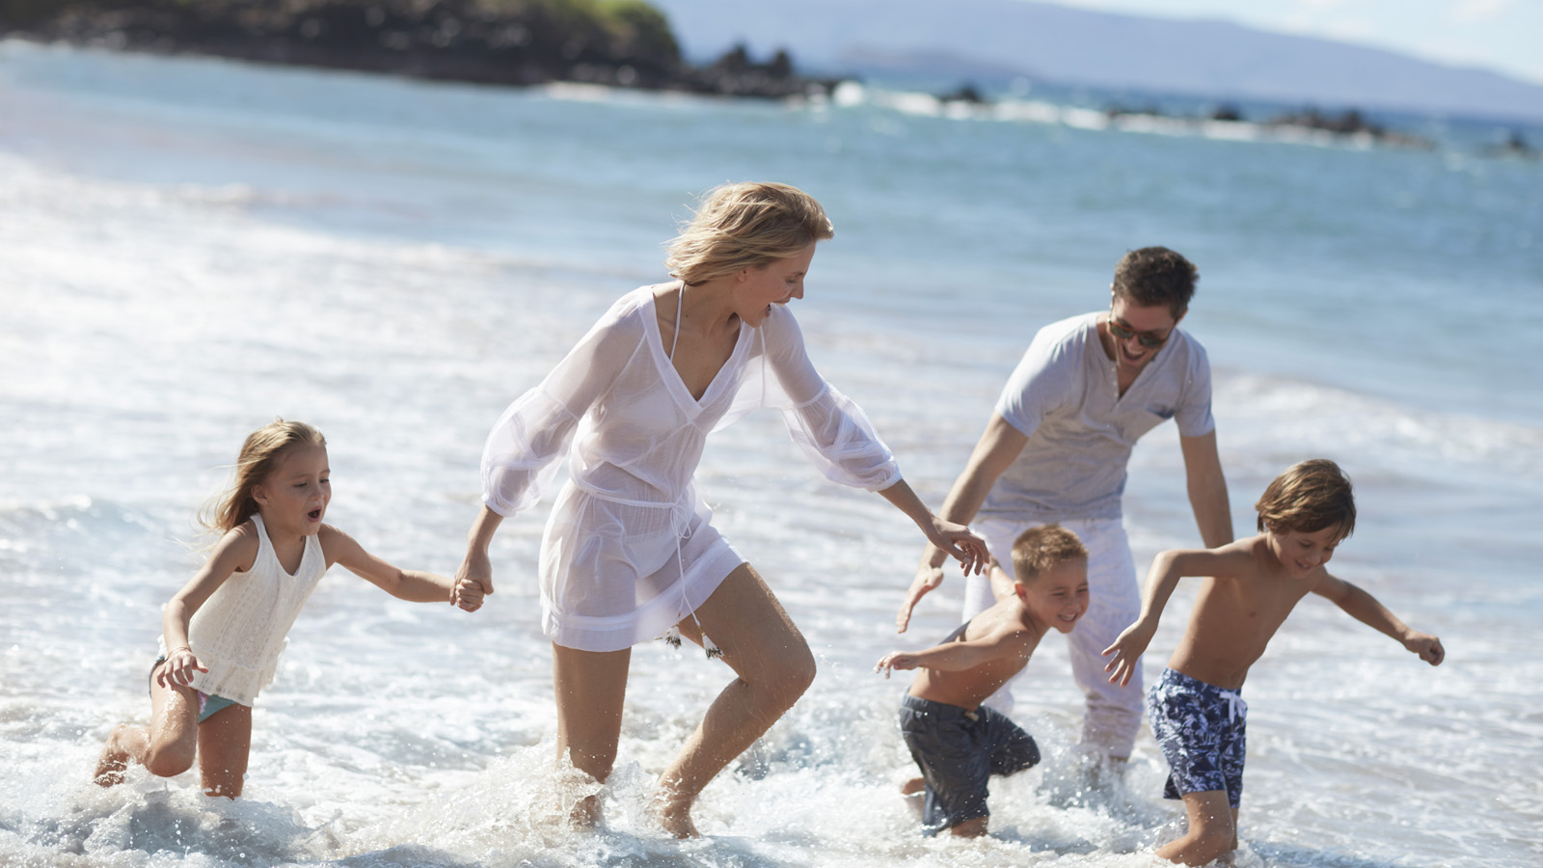 | February 21, 2018, Hawaii, Maui, U.S.A.  Four Seasons Resort Maui at Wailea Presents Special Family Programming for Spring Break  https://publish.url/maui/hotel-news/2018/family-spring-break.html
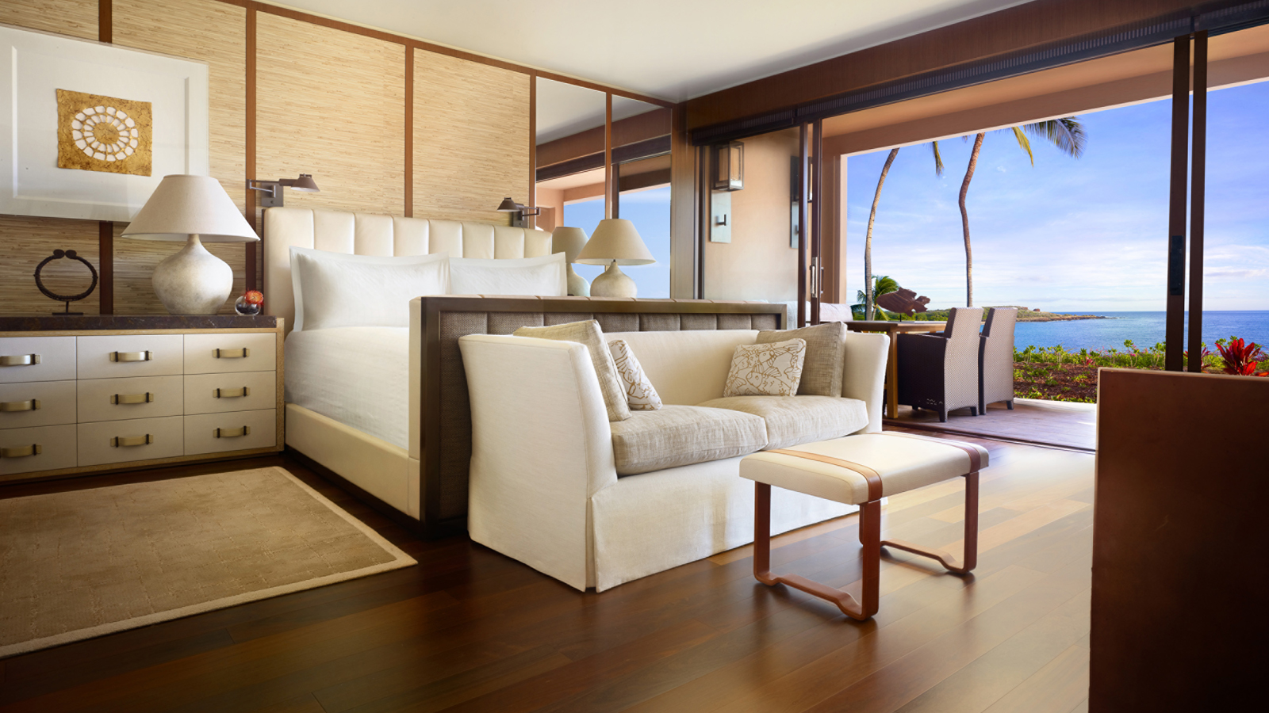 | February 6, 2018, Hawaii, Lanai, U.S.A.  Four Seasons Resort Lanai Named #1 Hotel in the United States  https://publish.url/lanai/hotel-news/2018/number-one-hotel-in-america.html

PRESS CONTACTS

Lori Holland
Director of Public Relations
6100 Center Drive, Suite 1250
Los Angeles
U.S.A.
lori.holland@fourseasons.com

+1 (201) 294-7810

Olivia Kragen
Digital Marketing Manager
6100 Center Drive, Suite 1250
Los Angeles
U.S.A.
olivia.kragen@fourseasons.com

+1 (310) 695-3385

Laura Fairweather
Director of Public Relations, Americas
1165 Leslie Street
Toronto
Canada
PRSM@fourseasons.com
@FourSeasonsPR
1 (416) 441-4233

