Four Seasons Hotel Istanbul at the Bosphorus Kicks Off January with Live Music Performances by Turkey’s Beloved Artists

AQUA Restaurant & Bar continues to adorn Istanbul nights with live music performances by beloved artists and delicious menus
December 20, 2021, Istanbul at the Bosphorus, Turkey

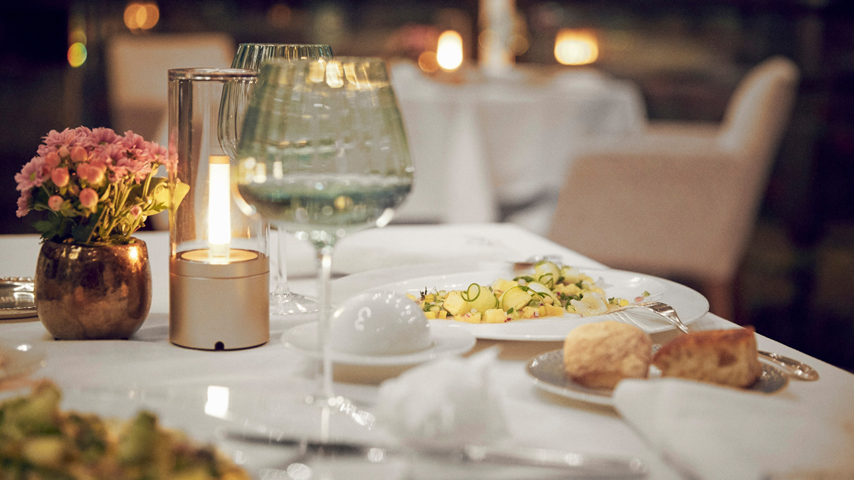
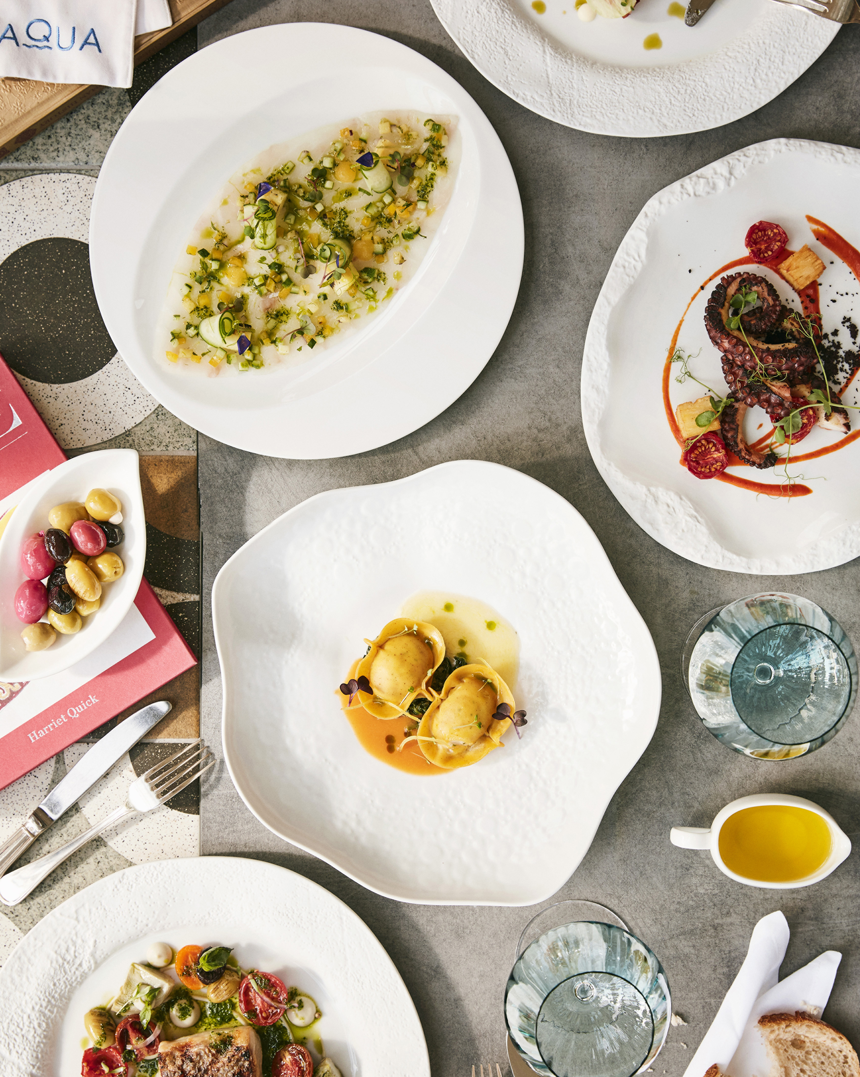 | 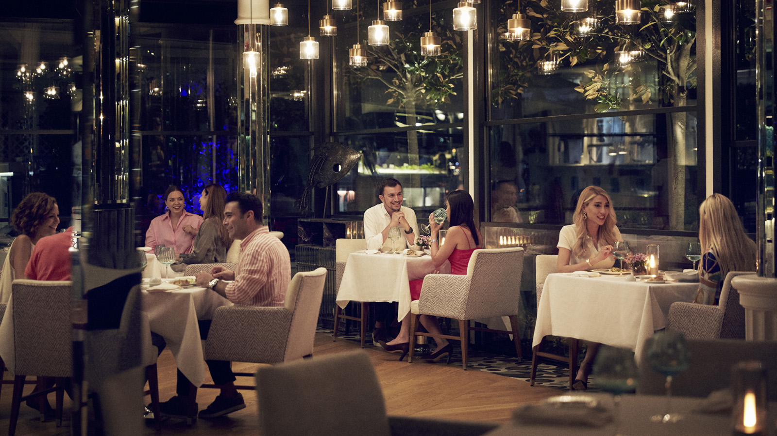 | 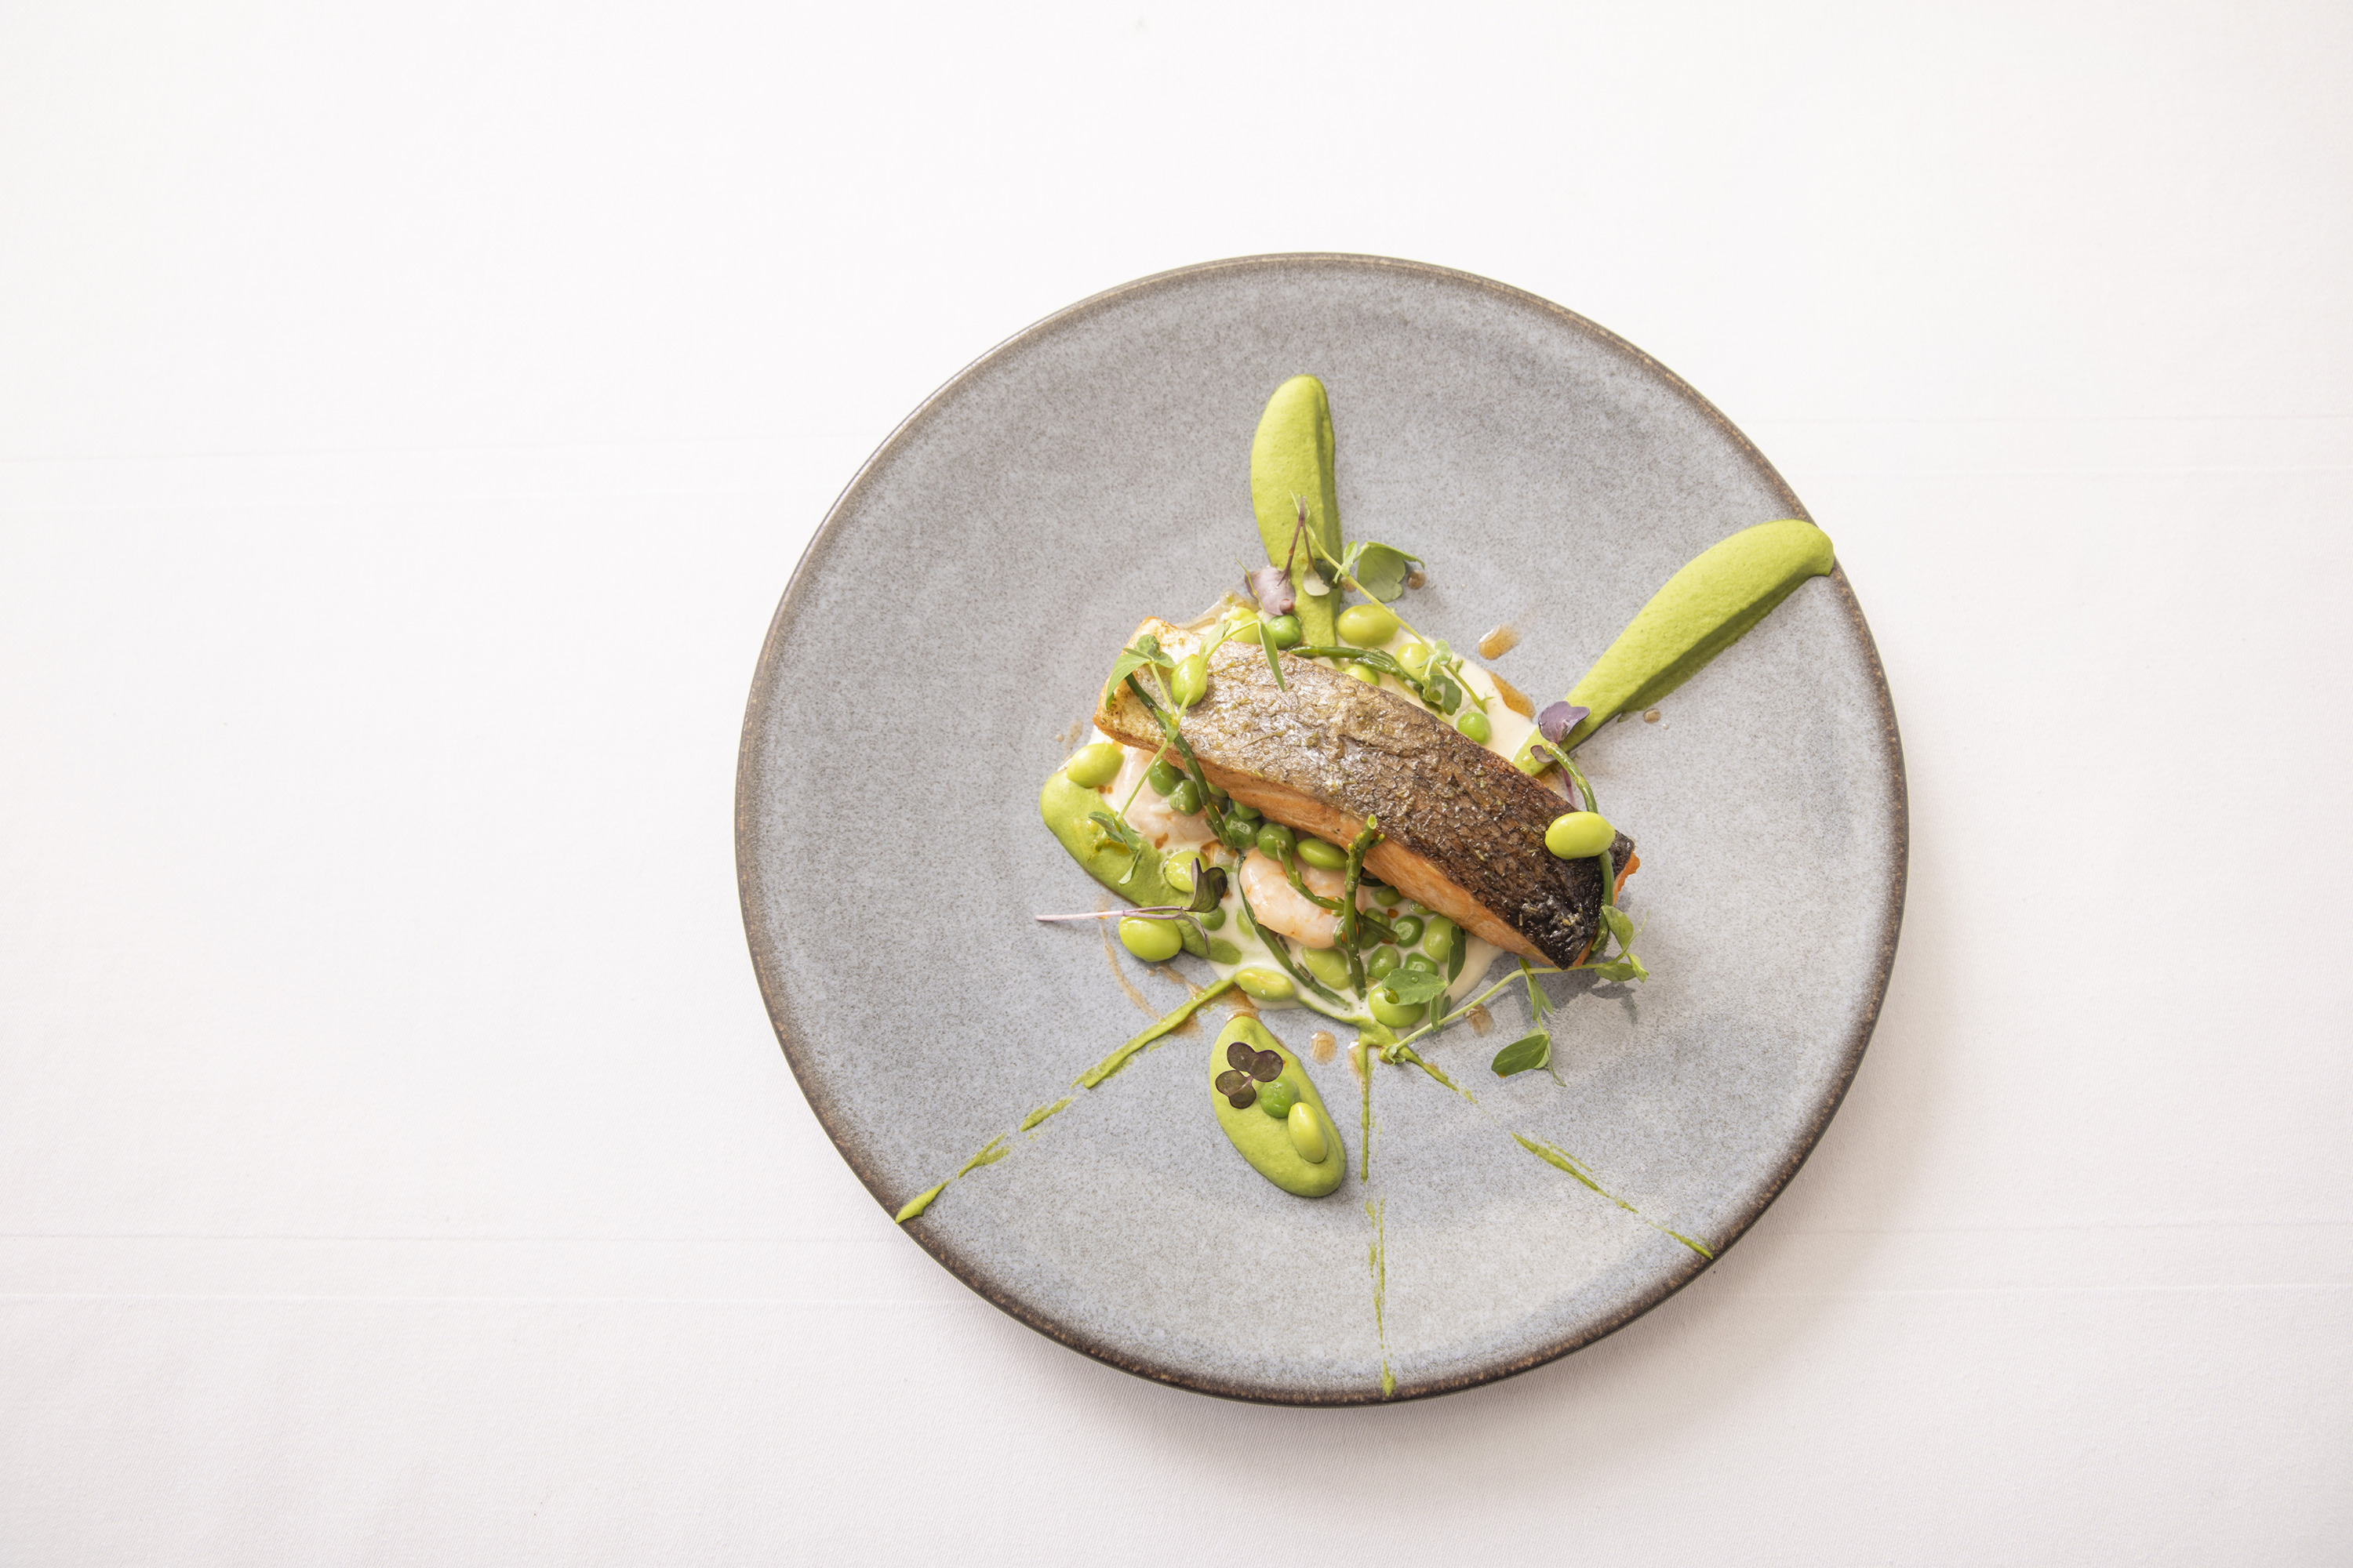
Four Seasons Hotel Istanbul at the Bosphorus, with stunning views of the Bosphorus, welcomes January 2022 with dynamic entertainment programs and savoury menus at AQUA. Live music performances every night throughout the week at AQUA Restaurant & Bar will enhance memorable dining experiences with creative and delicious dishes prepared by the Hotel’s Executive Sous Chef Görkem Özkan.
The menu, always prepared with fresh and seasonal ingredients, includes delicious seafood varieties such as oysters, caviar, shrimp, and lobster accompanied with a rich selection of wines. The chic restaurant and bar invite guests to enjoy a joyous ambiance in the company of live performances by Turkey’s popular artists for a positive start to 2022.
Every Friday night throughout January, guests will make a pleasant start to the weekend with Barbaros and his Barbaros & Friends themed performances. Every week, different artists, either in the audience or backstage, will make surprise apperances and join Barbaros on stage for delightful performances and unforgettable duets.
AQUA Restaurant & Bar will delight its guests with different programs throughout the month of January. Turkey’s renowned performers Demet Sağıroğlu (January 8), Zuhal Olcay (January 15), Ayşegül Aldinç (January 22), and Yeni Türkü (January 29) will take the stage at AQUA on Saturday nights.
At AQUA, the musical performances are not limited with Fridays and Saturdays. The other musical performances throughout January include the pianist Aslı Güral on Monday and Tuesday evenings, Ayşe Evrim on Wednesday evenings and Hande Ateş on Thursday and Sunday evenings.
For reservations, call 0090212 381 4000.

RELATED

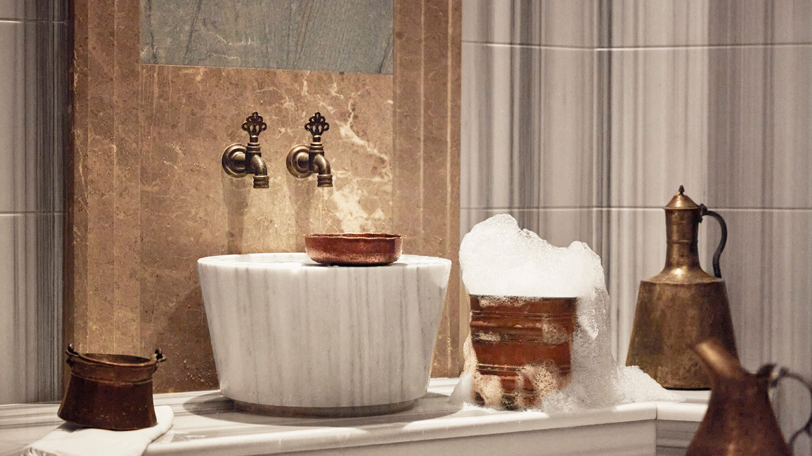 | December 15, 2021, Istanbul at the Bosphorus, Turkey  The Spa at Four Seasons Hotel Istanbul at the Bosphorus Offers the Perfect New Year Gift Options  https://publish.url/bosphorus/hotel-news/2021/spa-gifts.html
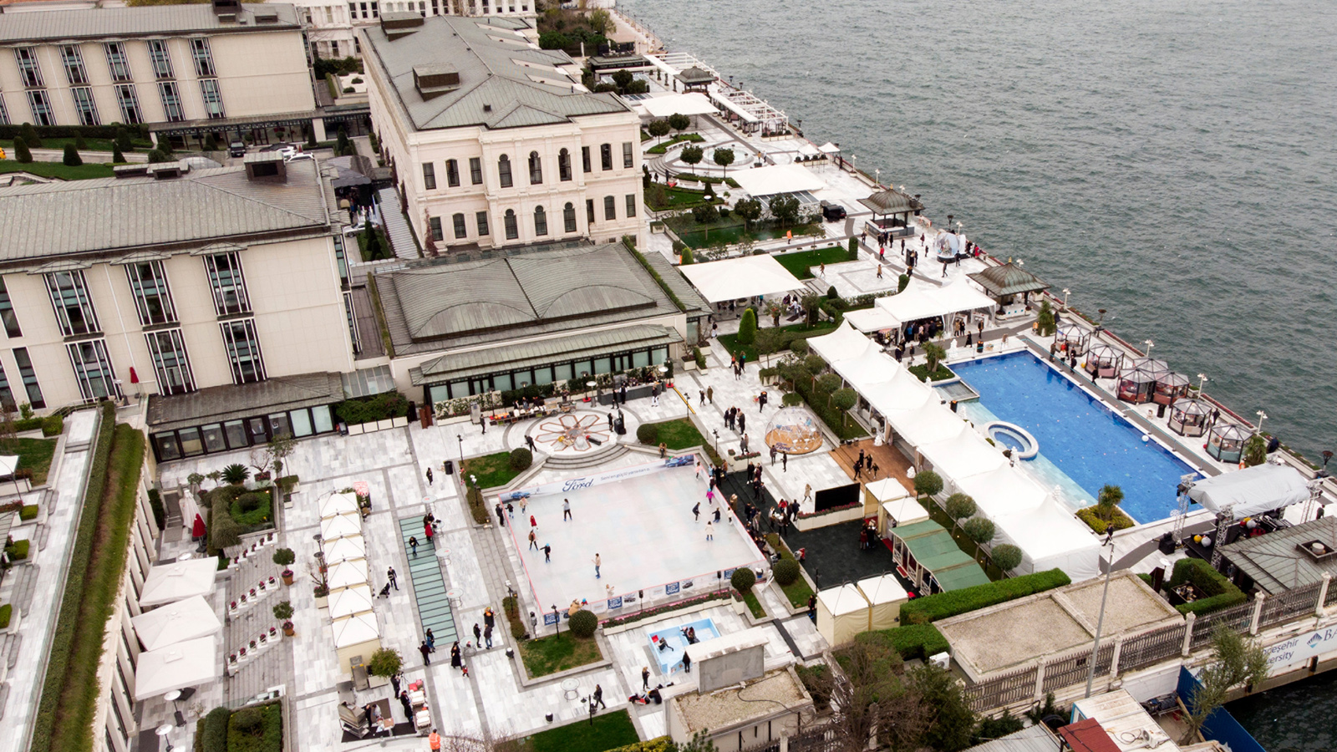 | November 26, 2021, Istanbul at the Bosphorus, Turkey  With its Ideal Setting for a Magical Outdoor Experience, Winter City is Back at Four Seasons Hotel Istanbul at the Bosphorus  https://publish.url/bosphorus/hotel-news/2021/winter-city.html

PRESS CONTACTS

Sibel Benli
Senior Director of Public Relations and Communications
Çırağan Cad. No. 28
Istanbul
Turkey
sibel.benli@fourseasons.com

90 (212) 381 41 35

