A Fairytale Romance: Six Reasons to Elope to Four Seasons Resort Langkawi

Escape with the love of your life to this special island sanctuary, ideal for intimate weddings and vow renewals
May 3, 2022, Langkawi, Malaysia

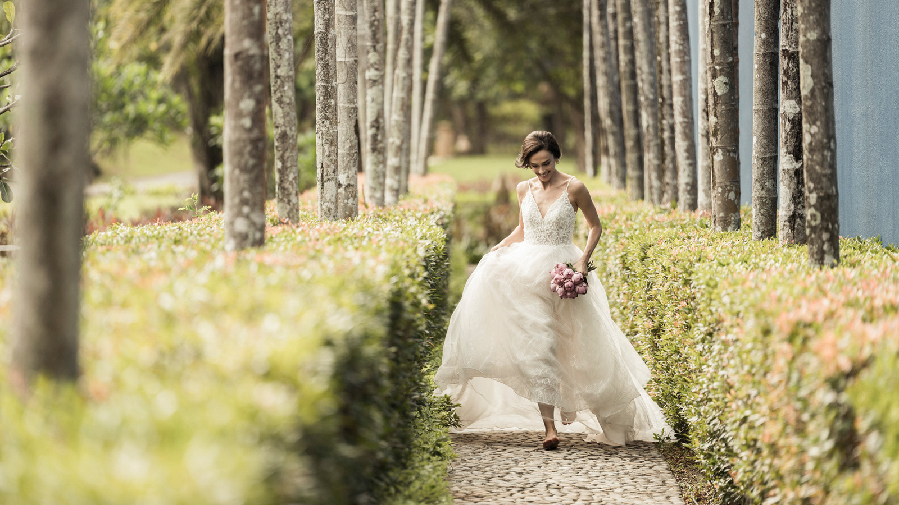
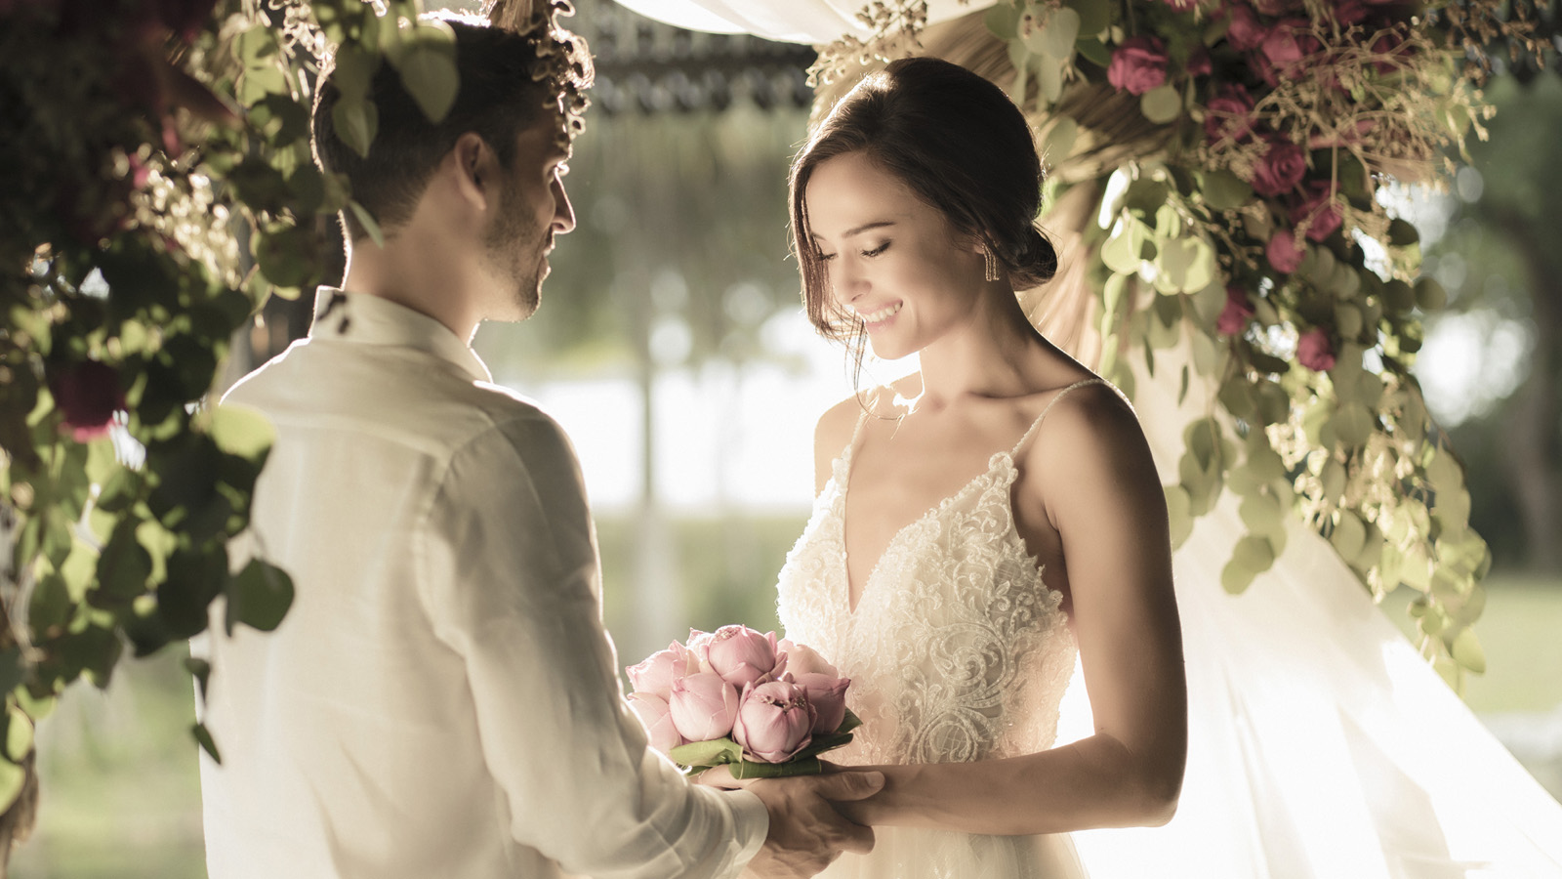
As the sun dips toward the horizon, the Andaman Sea shimmers under skies of pink and lavender, blue and gold. The ethereal glow illuminates the joyful smiles of the newlyweds and their loved ones. With nature herself blessing the nuptials, here is the perfect beginning to a lifetime of happiness together.
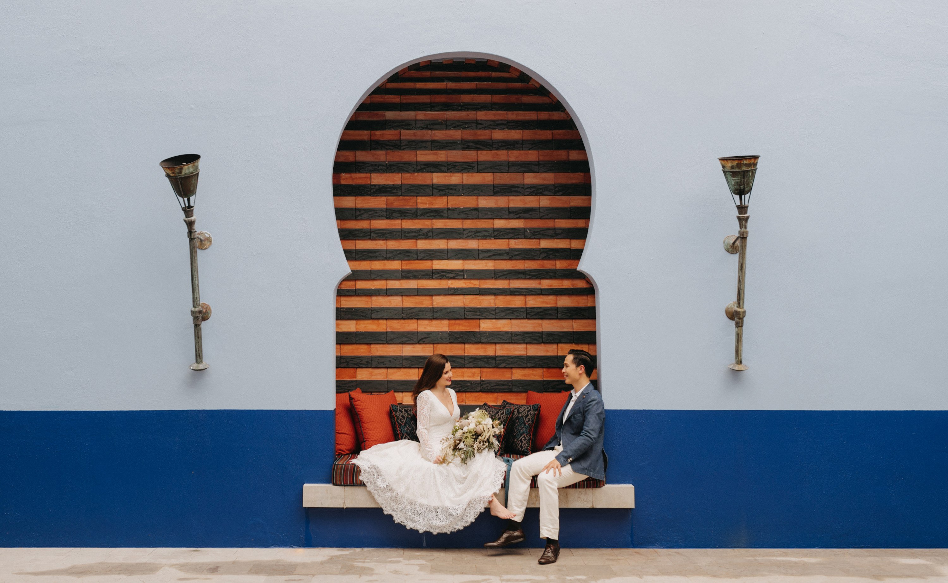
The fairytale setting of Four Seasons Resort Langkawi is tailormade for small destination weddings, be it a romantic ceremony just for two or an intimate celebration with family and close friends. Wrapped in tropical landscapes and spectacular sea views, the stunning island Resort breathes enchantment into every moment. The pure gifts of nature are elevated by striking design, luxurious amenities and warm hospitality.
With a number of expertly curated packages to choose from, each couple can make their special day effortlessly unforgettable. The experienced Four Seasons team takes all the stress out of wedding planning, thus creating a sense of ease and joy for the bride and groom.
Here are six excellent reasons for lovebirds to celebrate their union at Four Seasons Resort Langkawi.
- Sublime backdrops. Flanked by tropical rainforests and dramatic limestone cliffs, the seafront sanctuary offers a collection of surreal settings. With a pristine mile-long beach, the ocean is a cherished guest at every wedding. White sands sweep down to kiss the azure waves, providing a picturesque backdrop for romance, while pink lotus blooms lend a spiritual resonance. Bathed in a palette of vivid Moroccan blues, this Bill Bensley-designed Resort brings vibrancy and flair to the festivities.
- Unrivalled exclusivity. Tucked along the northern coast of Langkawi island, Four Seasons is a secluded oasis. Leave the rest of the world behind as you step into a realm of palm trees and lush vegetation, whispering waves and hushed sands. With expansive open spaces through the Resort, guests enjoy a luxurious sense of space at all times. This exclusive atmosphere is ideal for those who deeply value privacy and safety.
- Hallmark hospitality. A dedicated wedding specialist helps the couple to personalize their celebration at every step. Combining genuine warmth with impeccable service, the Four Seasons team crafts memorable moments that reflect the personal style of the bride and groom.
- Timeless rituals. Nuptials can be woven with time-honoured traditions, from the Malay ritual of henna art for the bride to the Indian rite of exchanging floral garlands as a symbol of commitment. Chinese couples may opt for the wedlock wine ritual, signifying their devotion to each other. For those who would like to script a new tale of togetherness, the Resort provides the option of a personalized, non-religious ceremony.
- One-stop destination. Let the Four Seasons team take care of all the details, from flowers, cake, hair and make-up, to the photographer and wedding celebrant. Along with hosting magical celebrations at the Resort, the couple can also get pampered at the Spa, enjoy exquisite dining with family and friends, and begin their married life together with a memorable mini-honeymoon. Glide through mysterious mangrove forests, share a royalty-inspired wellbeing ritual, and make delectable new memories with romantic meals under the stars.
- Great value. Four Seasons Resort Langkawi offers world-class venues, cuisine and hospitality at an excellent price point. Choose from a range of attractive packages, designed especially for weddings and vow renewals. Offers include a number of special benefits and complimentary add-ons for the bride and groom, as well as their guests.
To plan a fairy-tale wedding or vow renewal at Four Seasons Resort Langkawi, contact the team via the Four Seasons App.

RELATED

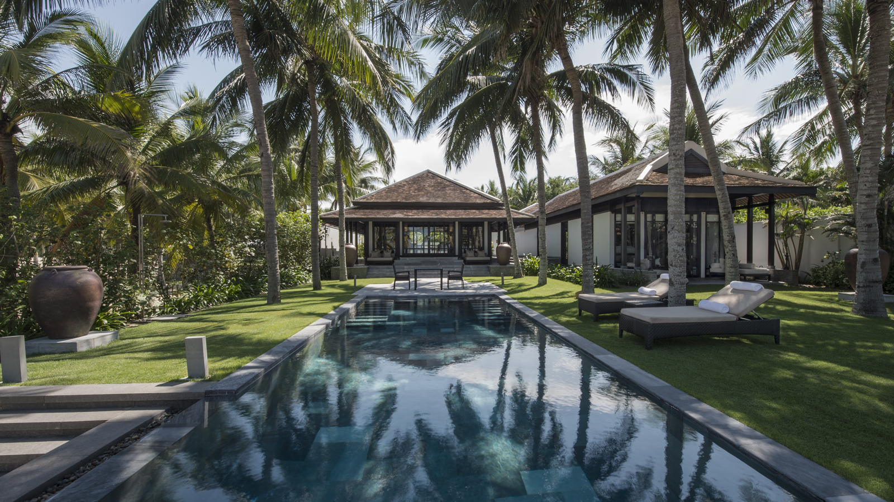 | April 29, 2022, Hoi An, Vietnam  Four Seasons Resort The Nam Hai Redefines Luxury Travel Beyond Prestigious Recognition from Forbes Travel Guide 2022  https://publish.url/hoian/hotel-news/2022/forbes-five-star-hotel.html
April 25, 2022, Bali at Jimbaran Bay, Indonesia
Bali’s Best-Kept Secret Unveiled: The Healing Village Spa at Four Seasons Resort Bali at Jimbaran Bay Opens to the World
https://publish.url/jimbaranbay/hotel-news/2022/welcome-back-to-the-healing-village-spa.html

PRESS CONTACTS

Kanchana Ganglani
Director of Public Relations
145 Jalan Ampang
Kuala Lumpur
Malaysia
kanchana.ganglani@fourseasons.com

+6(03) 2382 8740

