Four Seasons Resort Palm Beach Welcomes Back Mazen Saleh as General Manager

Respected leader and Four Seasons success story returns to Palm Beach Island resort
March 13, 2023, Palm Beach, U.S.A.

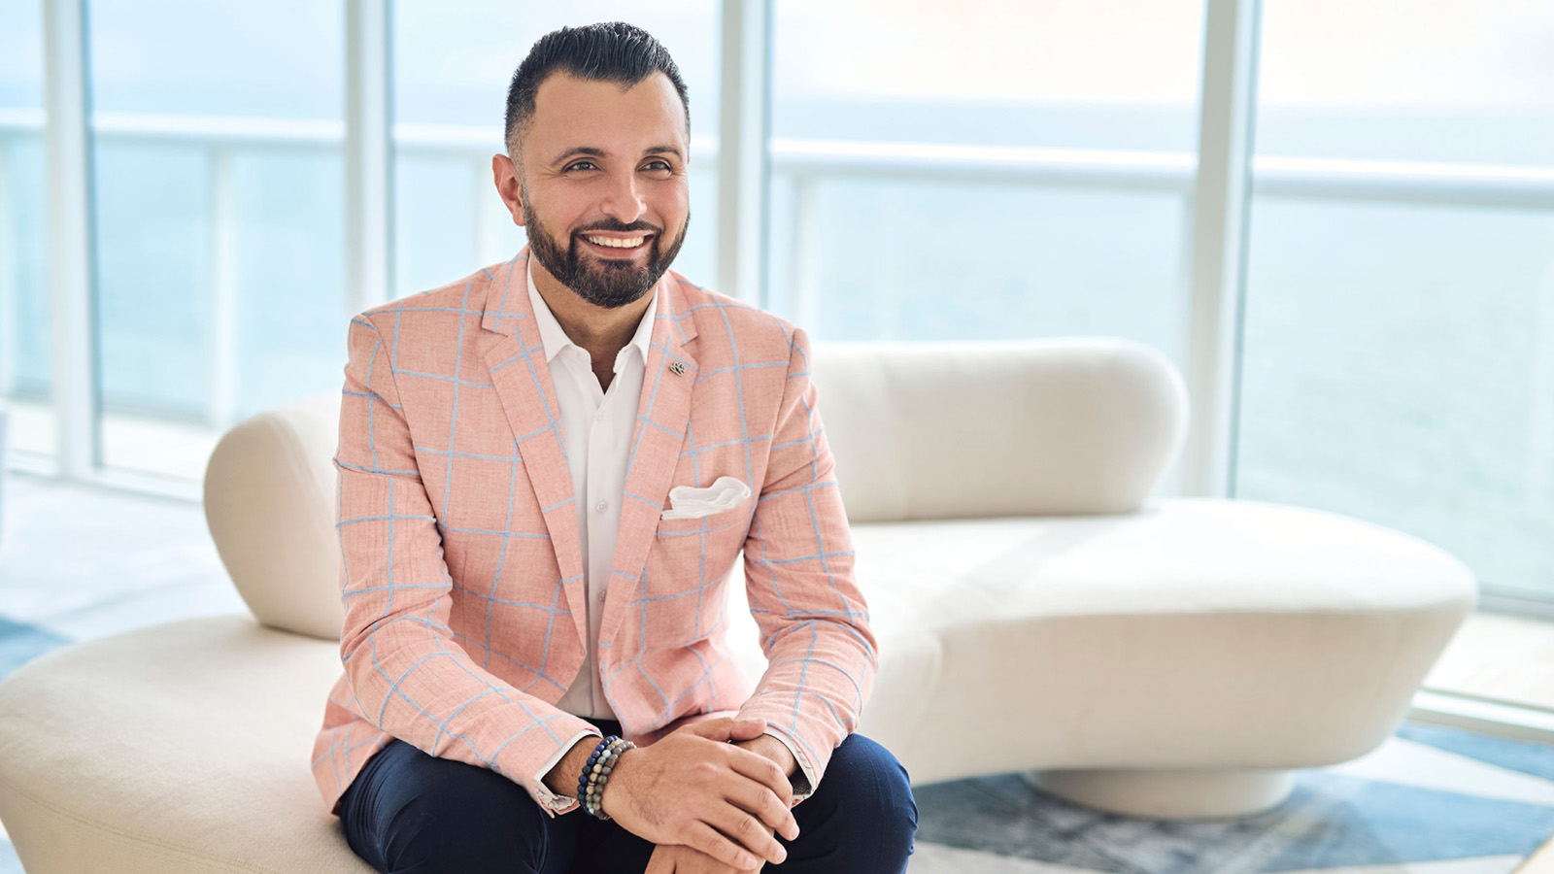
Mazen Saleh, a 20-year Four Seasons veteran and an adored-by-all leader, has been named General Manager of Four Seasons Resort Palm Beach, the iconic island’s award-winning Five Star, Five Diamond Resort.
Mazen’s creative side and collaborative spirit are among his exceptional hotelier qualities, driving the success of his most recent role as General Manager of Four Seasons Hotel and Residences Fort Lauderdale, which just celebrated its milestone one-year anniversary. Here, Mazen partnered with the property’s global visionaries, built the Hotel’s team, and created experiences property-wide, from Fort Lauderdale’s best ocean-view dining at Evelyn’s Fort Lauderdale to the city’s most service-centric pool experience elevated on the Ocean Sun Deck. Now, his new appointment as General Manager in Palm Beach is a bit of a homecoming for Mazen, as it was the property that brought his Four Seasons career to South Florida, first as Director of Food and Beverage in 2015 before being promoted to Resort Manager in 2017.
“I’ve always kept Four Seasons Resort Palm Beach close to my heart and I am so excited to be back home with this exceptional team within this picture-perfect vacation setting,” says Mazen.
First joining Four Seasons in 2003, it’s the only company Saleh has ever worked for, a testament to both his loyalty and respected reputation. Beginning as a management trainee in Sharm El Sheikh, Saleh quickly rose through food and beverage positions while jumping on task force opportunities at openings in Mauritius, Beirut, Alexandria and Istanbul. He joined the reopening of Four Seasons Resort Nevis as Assistant Director of Food and Beverage in 2010, and three years later took the same position in Austin for a city hotel experience before his journey along South Florida’s Atlantic Ocean coast began.
At home, Mazen never tires of checking out new restaurants, wineries and distilleries with his partner Rene and playing with their new pup Milo during his downtime away from work.

RELATED

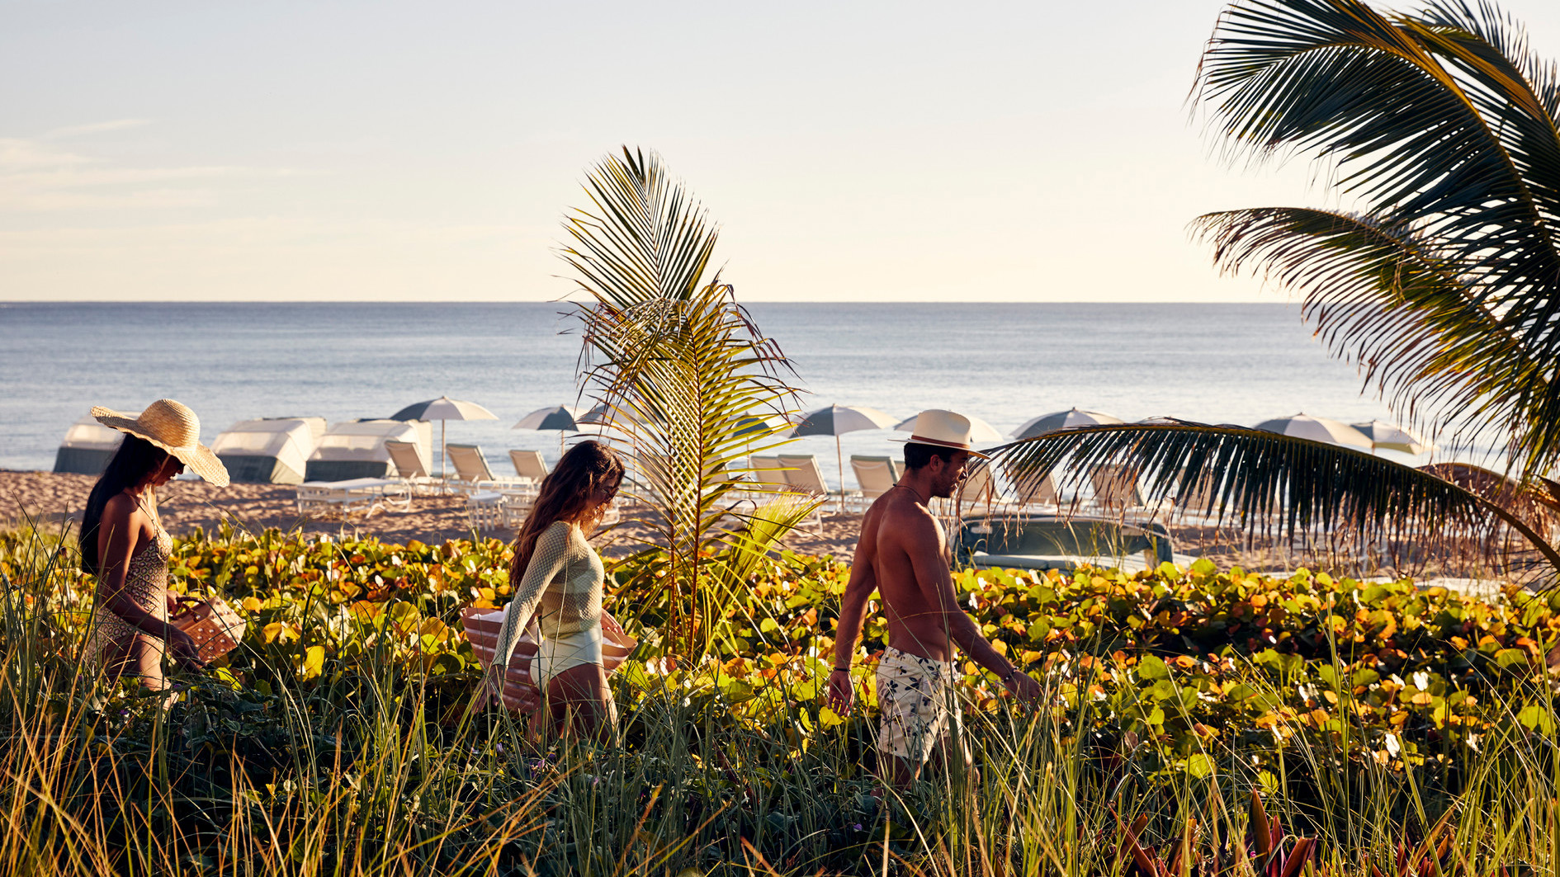 | March 10, 2023, Palm Beach, U.S.A.  Spirited Pool Scenes, Seasonal Spa Treatments and Blooming Menus Mark Spring at Four Seasons Resort Palm Beach  https://publish.url/palmbeach/hotel-news/2023/spring-programming.html
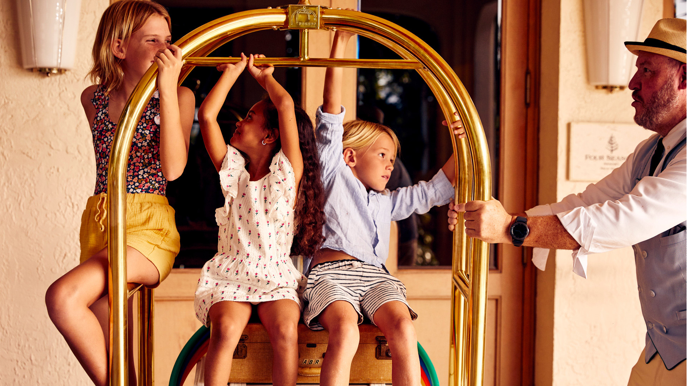 | February 19, 2023, Palm Beach, U.S.A.  Four Seasons Resort Palm Beach Celebrates Quarter Century Long Recognition of Highest Honours by Forbes Travel Guide  https://publish.url/palmbeach/hotel-news/2023/forbes-five-star-hotel-and-spa.html

PRESS CONTACTS

Eileen Sturgis
Public Relations and Communications Manager
2800 South Ocean Boulevard
Palm Beach
USA
eileen.sturgis@fourseasons.com

+1 561 493 5549

Laurie Herrick
Regional Director of Public Relations and Communications
2800 South Ocean Boulevard
Palm Beach
USA
laurie.herrick@fourseasons.com

