Discover Serengeti Together with Four Seasons: From Wildlife Sightings to Local Spa Treatments, New Package at Four Seasons Safari Lodge Offers a Perfect Escape for Couples this September Through November

August 29, 2019, Serengeti, Tanzania

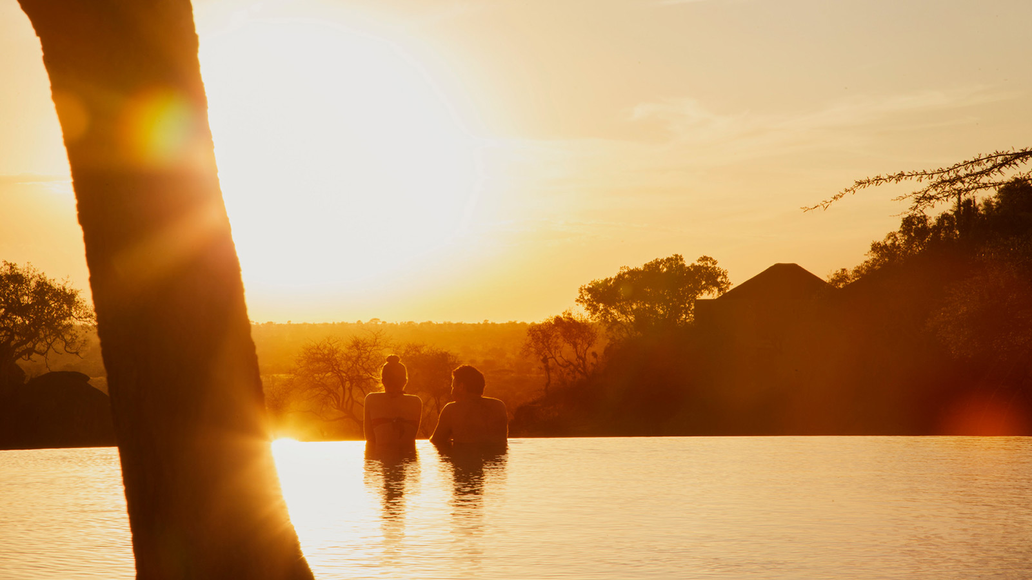
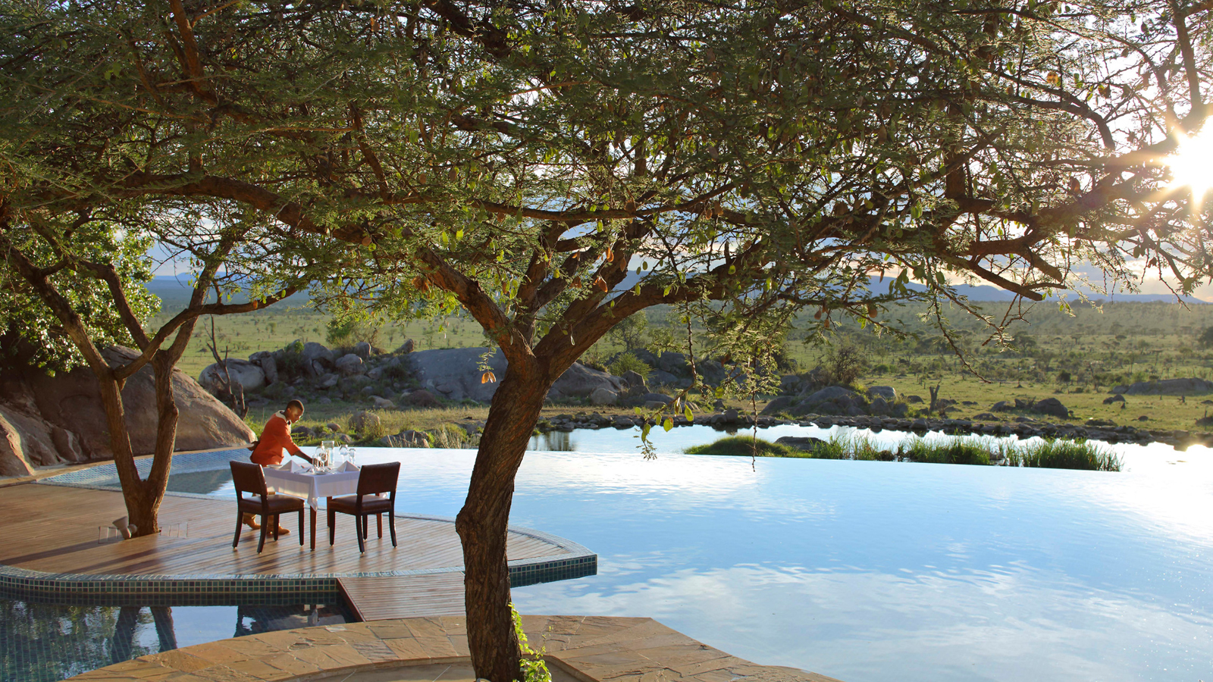 | 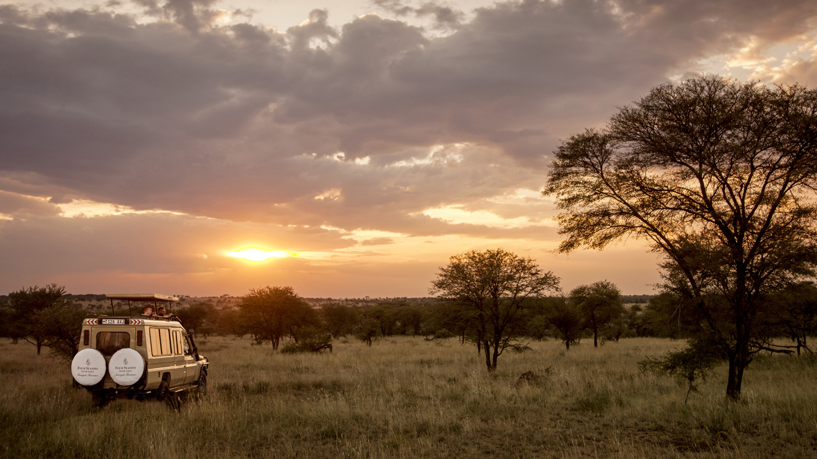 | 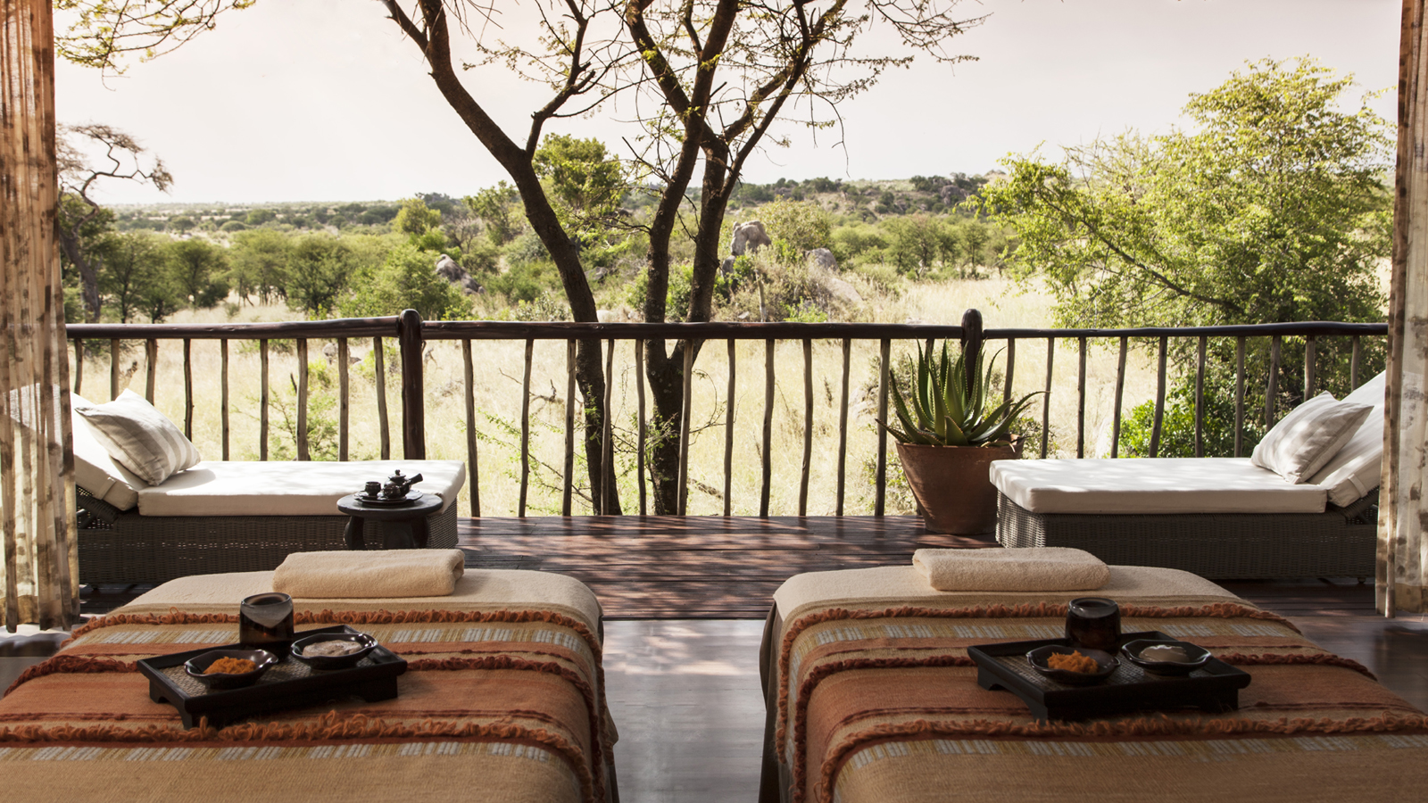
With the migration returning from Kenya in the coming weeks, Four Seasons Safari Lodge Serengeti is offering couples the chance to make the most of this period with its new Serengeti Together package.
Featuring 20 percent savings on room rates, the new package also includes a 60 minute Burudika (relaxing) massage, two half day game drives with an expert driver guide, a candlelight poolside dinner, and return ground transfers from Seronera Airstrip.
“This time of year is a wonderful time to visit,” says Ahmed Attas, Discovery Centre Manger. “Not only will the migration pass close to the Lodge as it travels towards the lusher plains of southern Serengeti, but all other wildlife remains in abundance around the Central Serengeti.”
Available on a minimum stay of three nights, Serengeti Together is applicable across all room, suite and villa categories. The package inclusions of spa and game drives also leave time for couples to enjoy the amenities around the Lodge during their stay, including the interactive Discovery Centre, infinity pool overlooking the animal watering hole and guided yoga classes.

RELATED

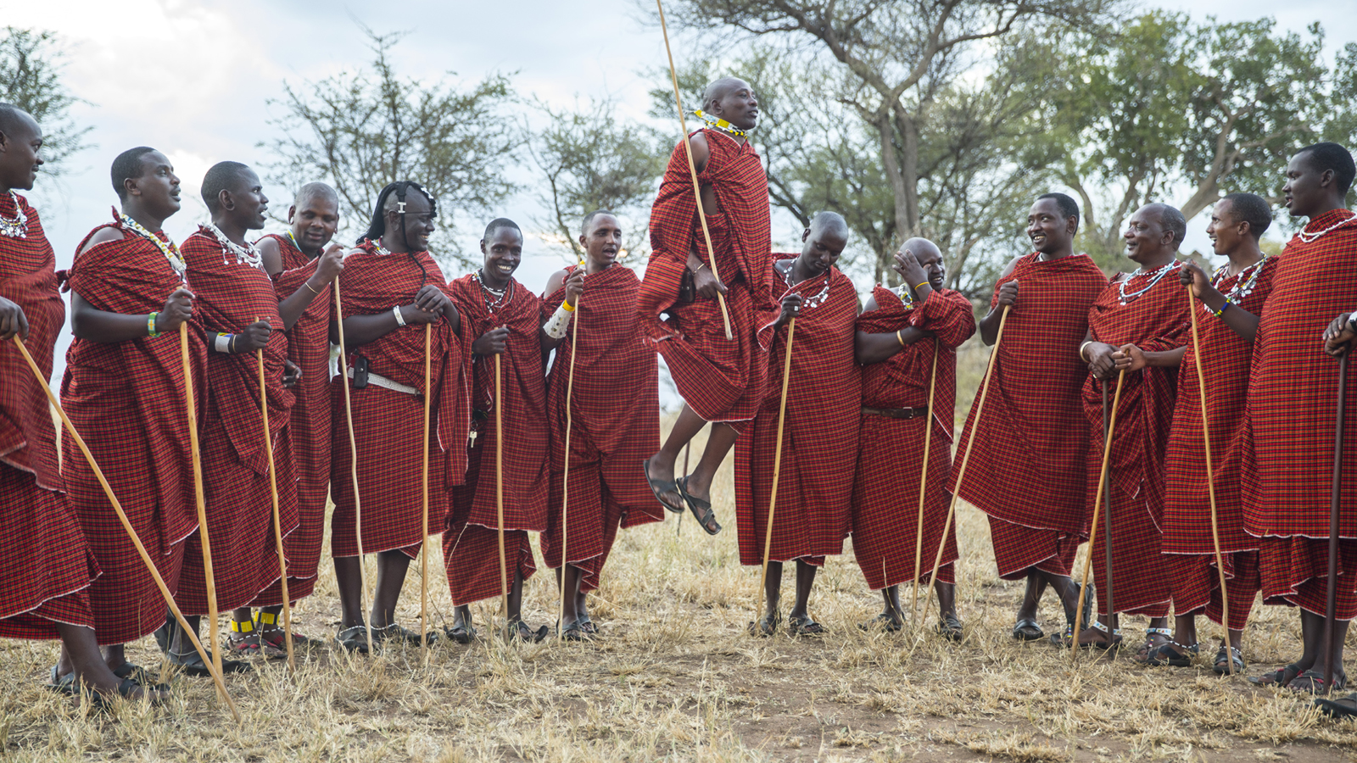 | June 13, 2019, Serengeti, Tanzania  Connect to Conservation and the Community with New Heart of Serengeti Package with Four Seasons Safari Lodge  https://publish.url/serengeti/hotel-news/2019/heart-of-serengeti-package.html
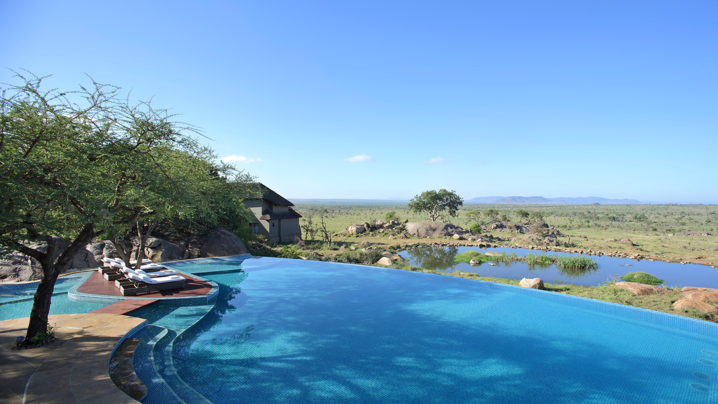 | May 18, 2019, Serengeti, Tanzania  This Global Wellness Day, Focus on Living Well, Both Physically and Spiritually  https://publish.url/serengeti/hotel-news/2019/global-wellness-day.html

PRESS CONTACTS

Debbie Duval
Senior Director of Public Relations and Communications

Beau Champ
Mauritius
debbie.duval@fourseasons.com

(230) 402 3100

