Colourful Summer: Start a Fine Arts Treasure Hunt at Four Seasons Hotel Beijing

Four Seasons Hotel Beijing and UCCA Kids jointly launch special art events for kids, presenting a unique way to spend the summer
August 11, 2022, Beijing, China

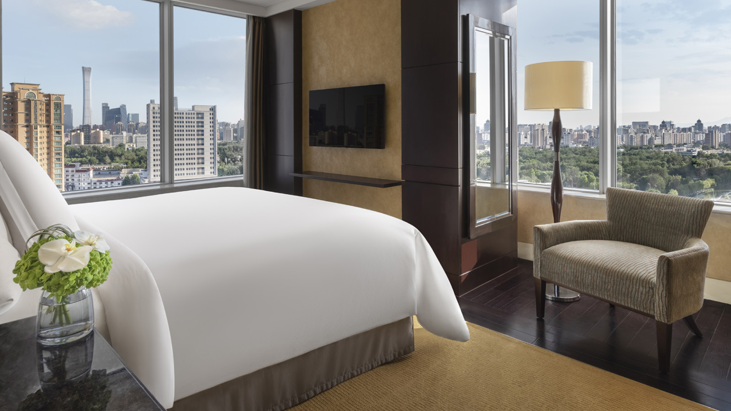
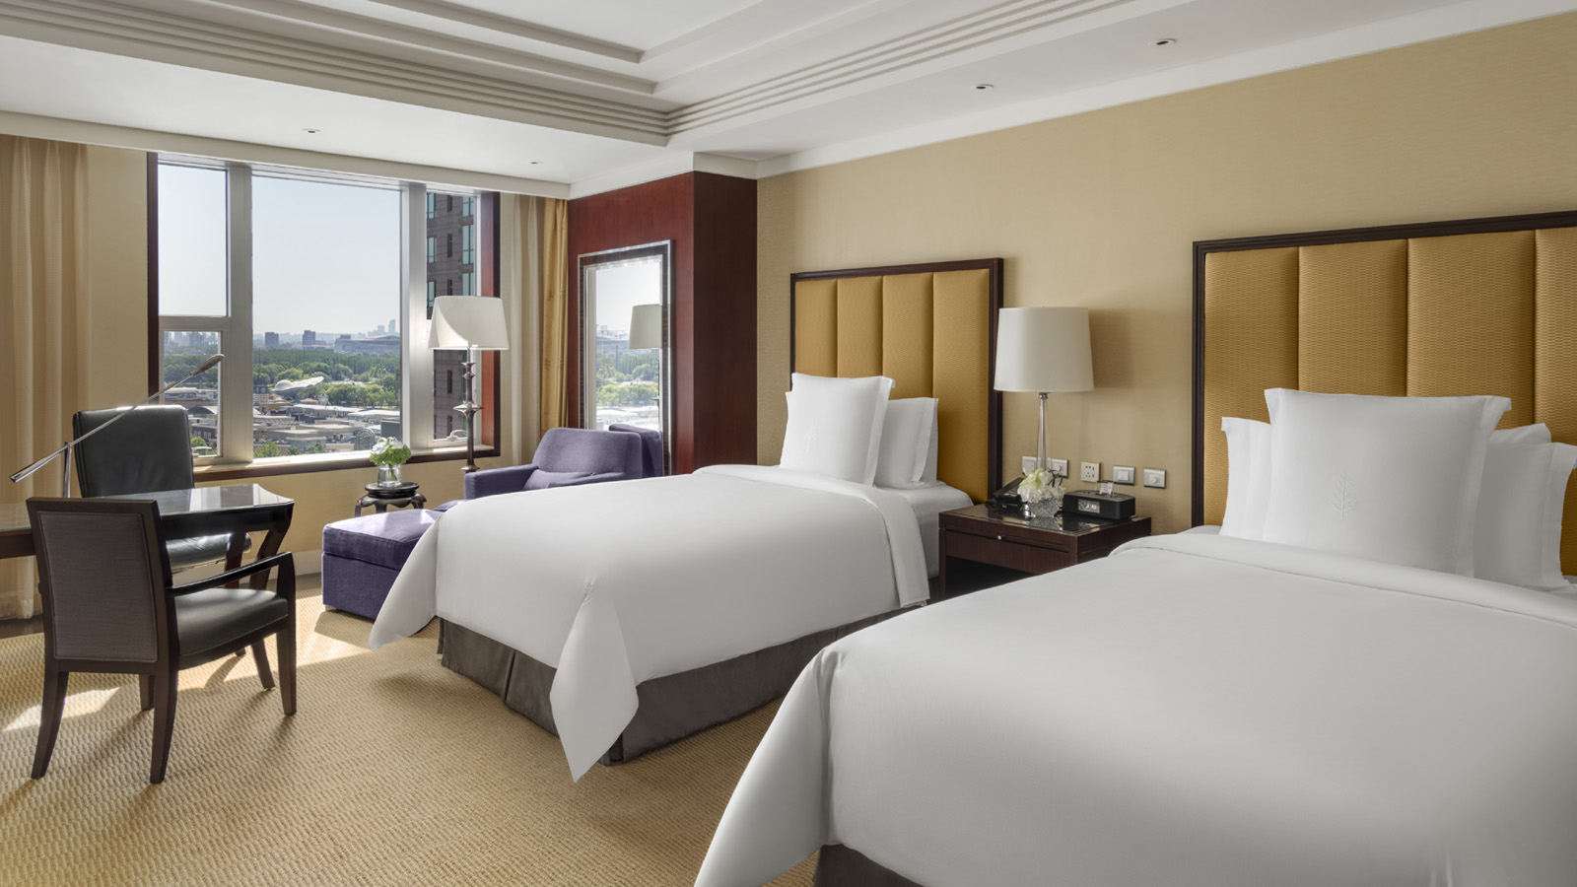 | 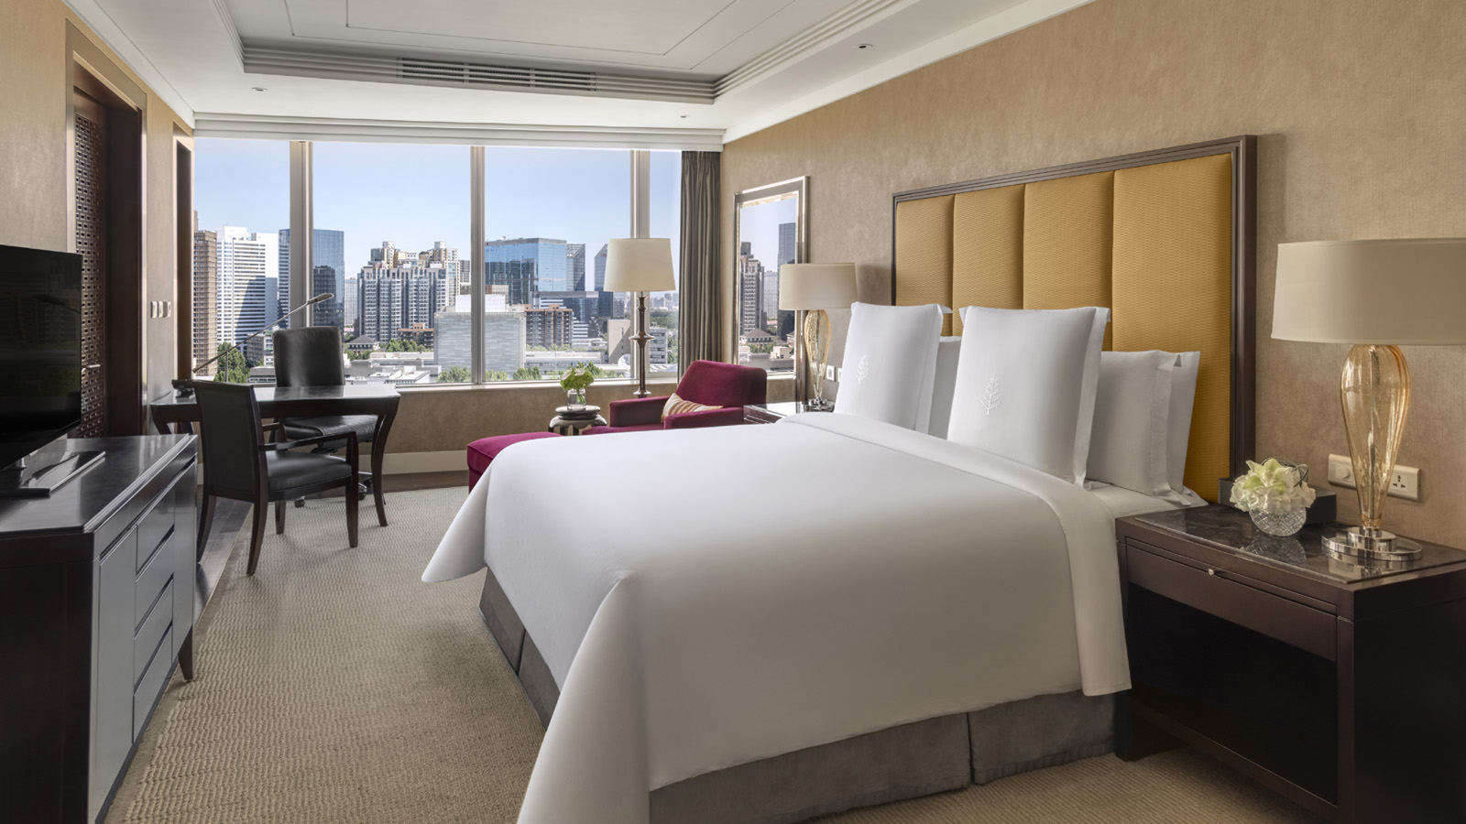 | 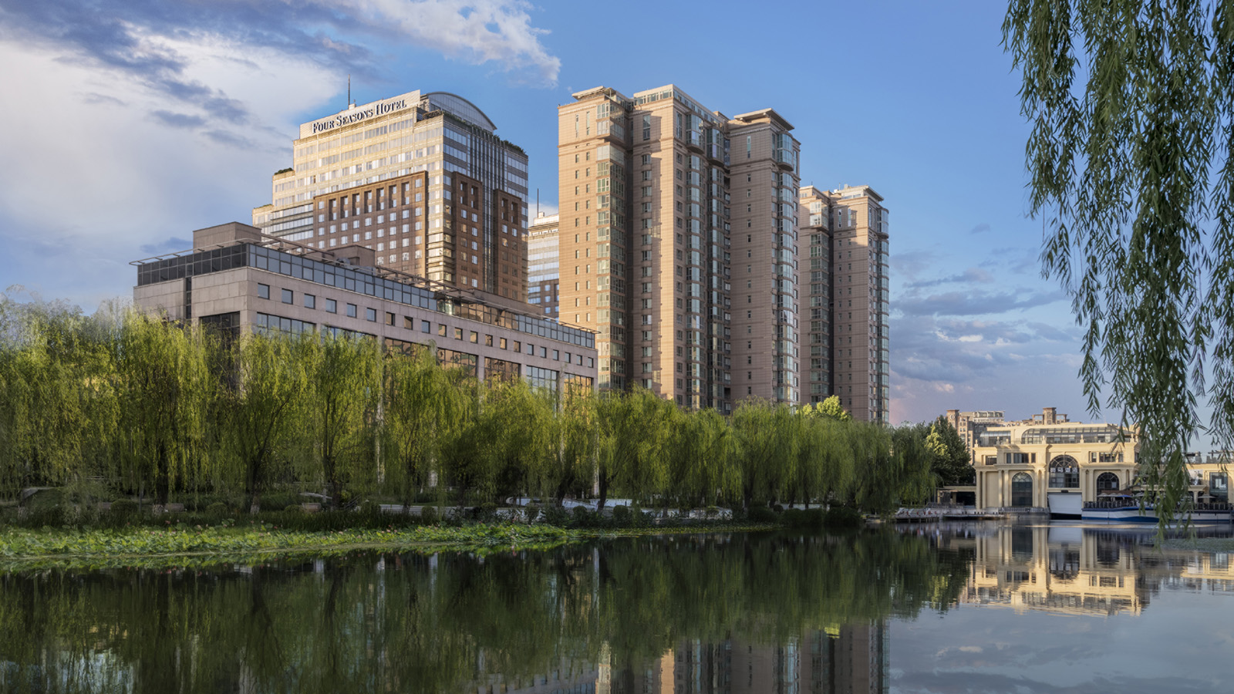
Summer for kids is meant to be the season of laughter. Nothing serves a better gift than having some quality parenting time with kids. Four Seasons Hotel Beijing has planned it all out by launching a series of colourful summer events, allowing kids to experience different kinds of arts in various events and leave unforgettable holiday memories.
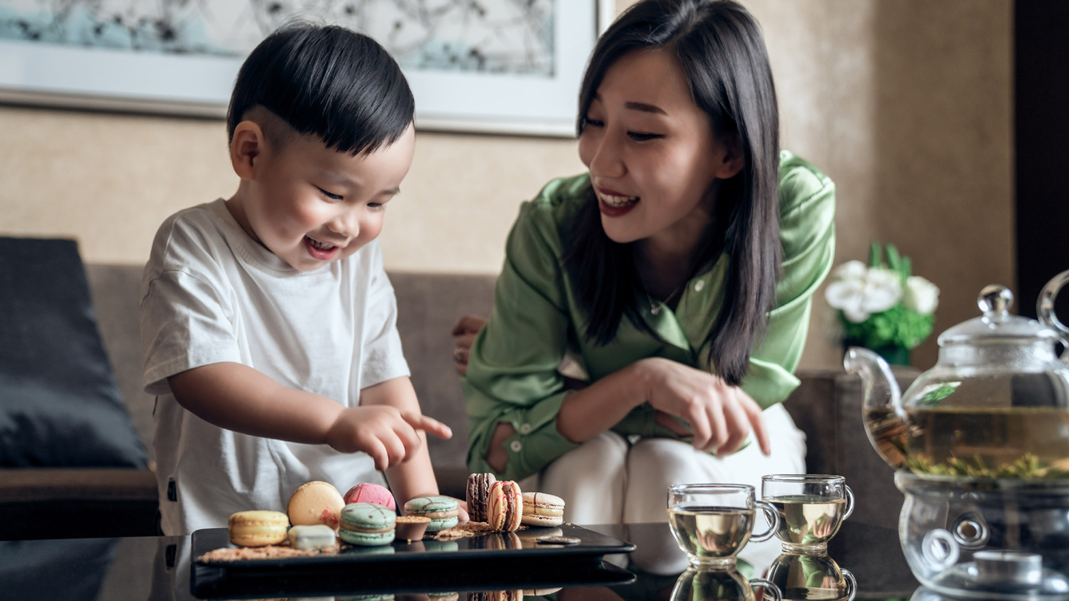
UCCA Kids Special Event
Four Seasons Hotel Beijing joins hands with UCCA Kids to launch a special event, making a stay at the Hotel an exciting art discovery trip. Guests may take kids to the art gallery where interesting lectures are given to little visitors, letting curiosity lead the way of exploring the new and the unknown.
With an adventurous and innovative spirit, Four Seasons Hotel Beijing opens the door for guests to an immersive arts wonderland that spurs endless imagination while integrating the distinctive touch of Four Seasons. An special space is crafted for kids in the art gallery that allows them to freely explore culture and arts, to develop new understandings of the classic cartoon figure Mickey and the caterpillar by the picture book master Eric Carle, and to discover a unique way to spend the summer.
Mickey: The True Original & Ever Curious Beijing exhibition is jointly presented by Disney and UCCA Lab. Following its successful tour in Shanghai, Chengdu, and Shenzhen, Beijing will be the last stop of the tour across the Chinese mainland. The Beijing stop will bring the audience a Mickey-themed art exhibition of the largest scale so far with the most artists exhibiting their works. Sixty artists/artist groups from China and the rest of the world will present Mickey-inspired creations at the 798 Art Zone, shaping new perspectives of the old friend Mickey in the form of painting, sculpture, calligraphy, installation, sound, intangible cultural heritage, new media, literature, and more.
In addition, UCCA Lab will collaborate with KIDDY Art Museum to present Playful World of Eric Carle Beijing exhibition. Eric Carle is a world-renowned children’s picture book author and artist with an iconic artistic style. His works apply a unique collage technique with bright and cheerful colours, which are fun, informative, and educational. The beautiful butterfly on the poster of this exhibition is from Eric Carle’s representative picture book The Very Hungry Caterpillar, which tells the story of how the caterpillar discovers its true self and finally transforms into a butterfly. Carle unfolds a lifetime’s journey of growth and pays tribute to the great qualities of natural life in his vivid storytelling language, which dominates the theme of his creations. Apart from presenting the classic works of Eric Carle, the Beijing exhibition introduces for the first time the interactive exhibition for children co-developed by the Eric Carle Museum of Picture Book and the Children’s Museum of Pittsburgh, bringing to life and gamifying the scenarios in the picture book via a variety of mediums and restoring Eric Carle’s artistic kingdom of innocence and imagination. The interactive exhibition encourages parent-child communication through an immersive and educational experience, hoping to let kids learn about the wonderful world through games and explorations by centring on the theme: to “inspire.”
From July 23 to November 6, 2022, guests can sign up for Four Seasons Hotel Beijing × UCCA Kids special event. A stay in a deluxe room or above from CNY 2,588 at Four Seasons Hotel Beijing will go with a UCCA Kids class, an adult and children’s tickets for the exhibition, and a nutritious breakfast for two adults and one child.
For more information about the special event, contact the Hotel at +86 (10) 5695 8780. Reservations shall be made at least two days in advance and are subject to availability.
Joyful Summer Camp
A happy, carefree, and energetic summer is what the Hotel hopes to deliver to kids through a series of interesting activities. The Hotel is adjacent to the banks of the Liangma River, a perfect spot for families to enjoy some quality time by having outdoor activities in the bright summer days. A stay in executive rooms or above goes with complimentary kids’ courses. There are various summer camp programs for kids at the Hotel every morning and afternoon. Kids can explore the secrets behind Chinese dim sums and Italian pizzas in the cooking class by Hotel’s Michelin-starred chefs, or learn to make cupcakes or mocktails, both of which are bound to inspire their creativity and curiosity.
Kids Golf Summer Camp
Explore the charm of golf with a six-night stay at Four Seasons Hotel Beijing plus PGA Kids Golf Summer Camp that start from CNY 19,666. Kids will be taught golf etiquette, skills, self-discipline, independence, communication, teamwork, and leadership in a set of courses under the guidance of professional coaches.
For more information, contact the Hotel’s reservation department at +86 (10) 5695 8780.
About UCCA Kids
UCCA Kids organizes art workshops, classes, camps, tours, and more for children aged 2-12, drawing upon the museum’s exhibition programs as a resource for engaging, whole-child learning. Through programs of weekly classes, special workshops, and camps staged over summer vacations and other holidays, UCCA Kids teaches creative and critical thinking through art, and allows children to create their own artworks, learn basic techniques, and discover great artists and styles, providing a new way to inspire a budding artist under the influence of great artworks.

RELATED

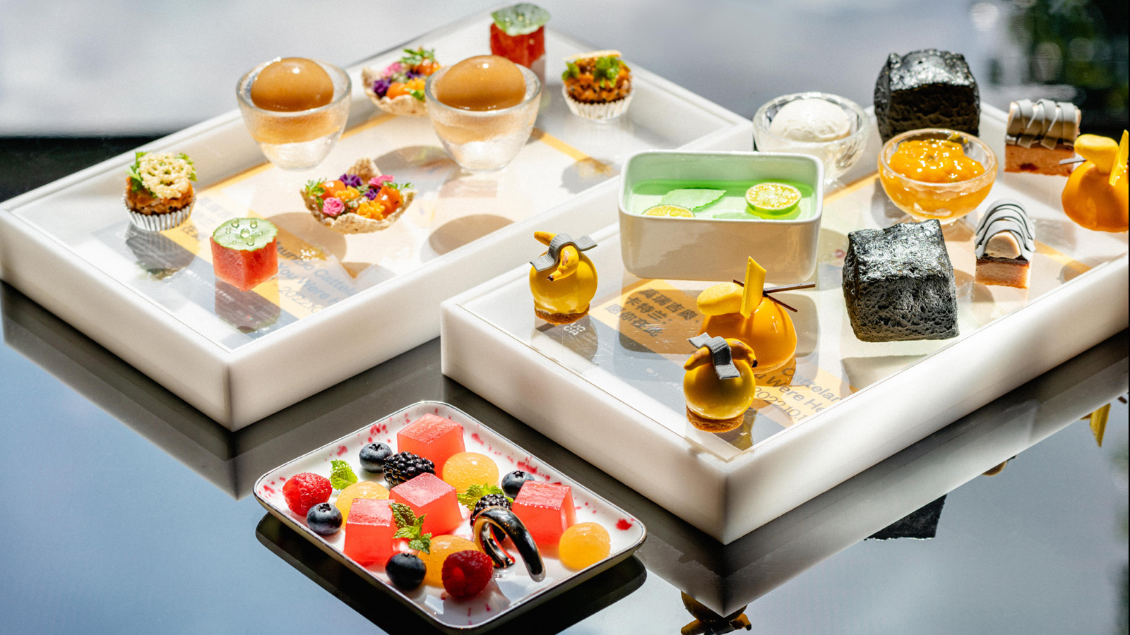 | August 10, 2022, Shenzhen, China  当奢华旅居体验融合当代艺术  https://publish.url/zh/shenzhen/hotel-news/2022/art-exhibition-and-tea-2.html
August 10, 2022, Shenzhen, China
Where Art Meets Luxury: Four Seasons Hotel Shenzhen Launches Collaboration with UCCA, China’s Leading Institution of Contemporary Art and Sea World Culture and Arts Center
https://publish.url/shenzhen/hotel-news/2022/art-exhibition-and-tea.html

PRESS CONTACTS

Iris Li
Director of Public Relations and Communications
48 Liang Ma Qiao Road Chaoyang District
Beijing
China
iris.yue.li@fourseasons.com

+86 10 5695 8706

