Four Seasons Resort Oahu at Ko Olina Debuts Manalo Lounge

Relax at the water’s edge at the Resort’s all-new casual and relaxed lounge
January 18, 2023, Hawaii, Oahu, U.S.A.

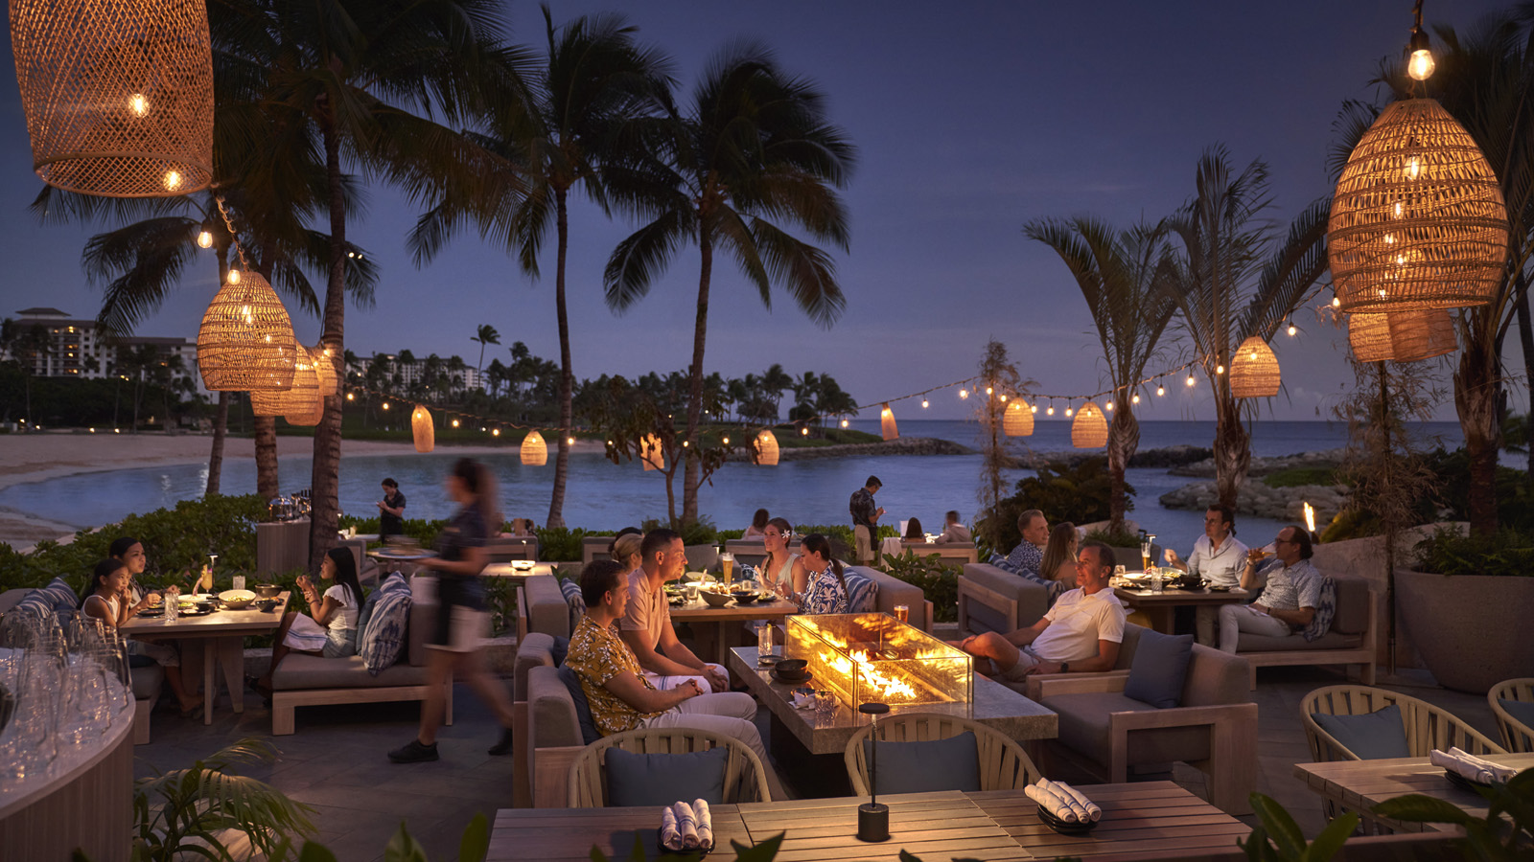
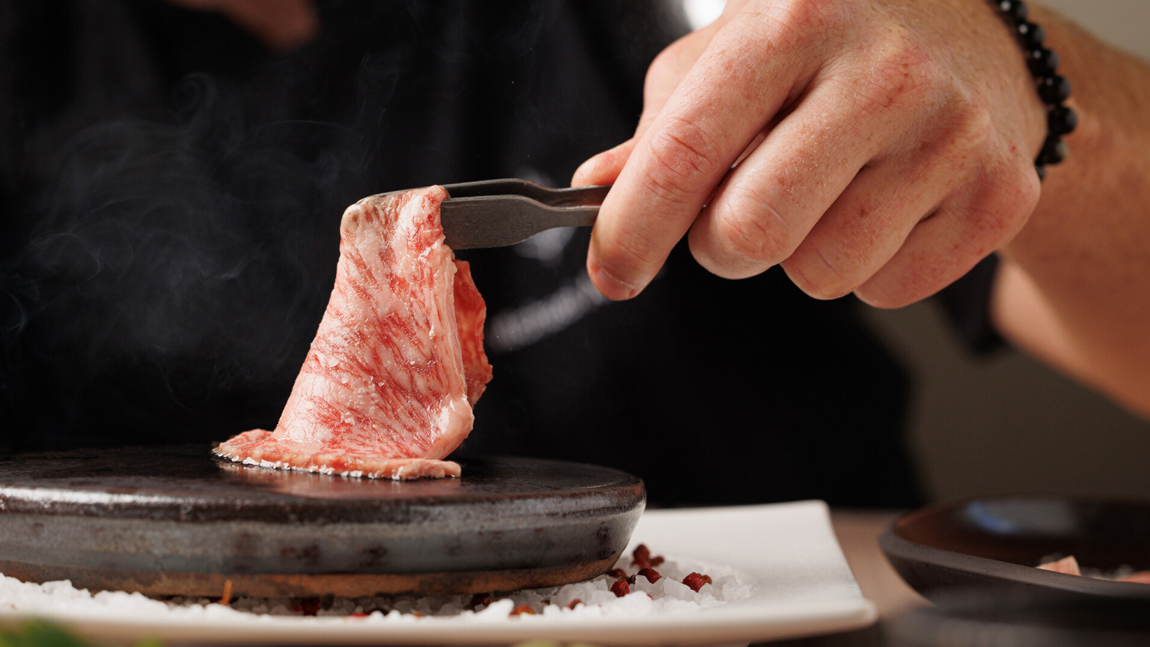 | 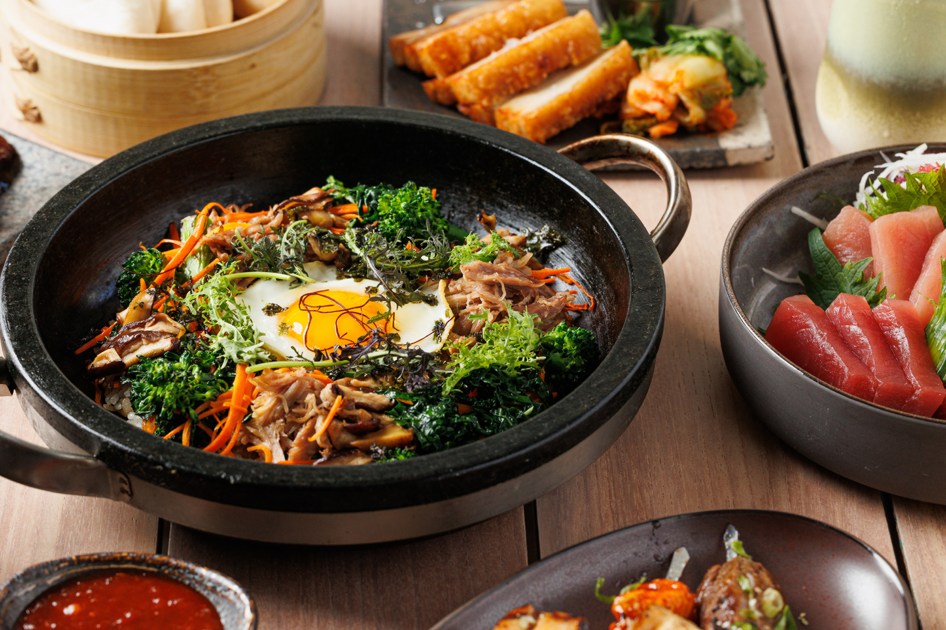 | 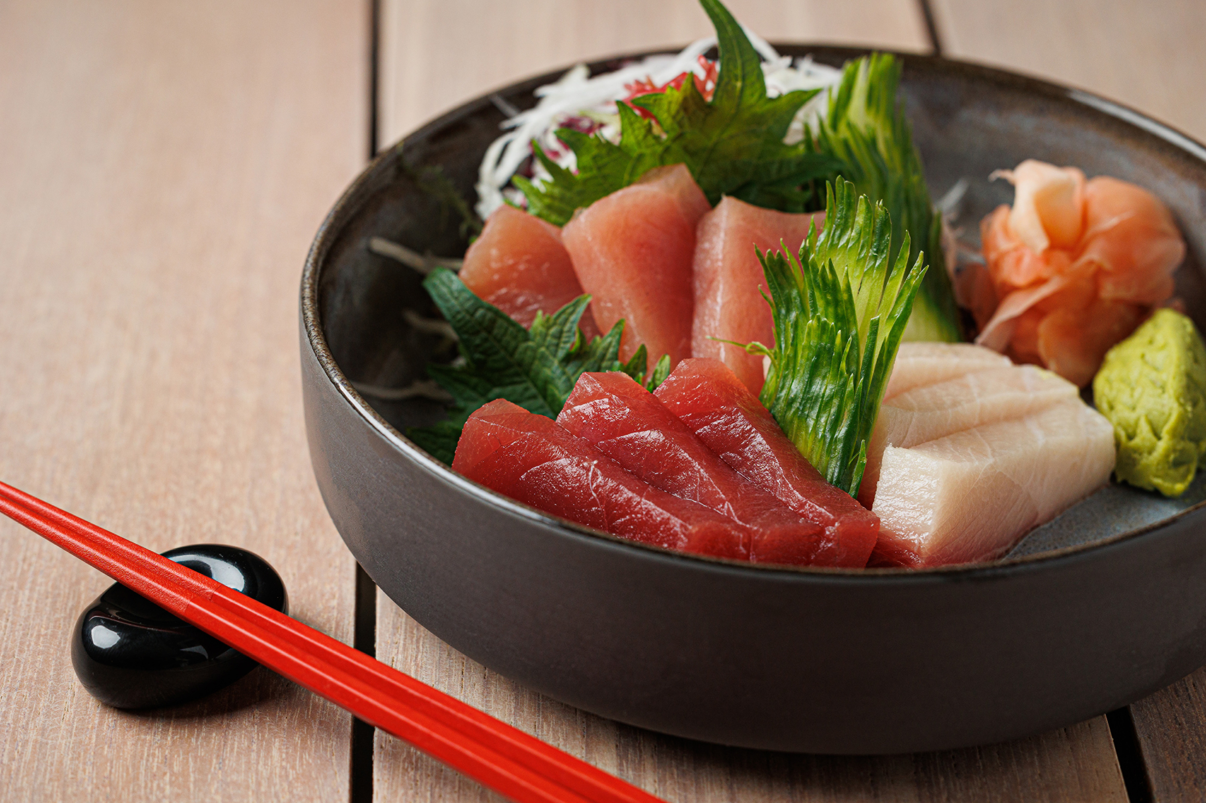
Four Seasons Resort Oahu at Ko Olina debuts Manalo Lounge, the Resort’s all-new lounge located alongside the water’s edge. Meaning “sweet water” in Hawaiian, Manalo Lounge celebrates Hawaii’s diverse mix of cultures that have influenced the area’s cuisine. Inspired by Oahu’s natural resources - where the fresh water of the mountains harmoniously merges with the salt water of the ocean, thus creating a sweet water, the cuisine pays homage to the mix of cultures found in Hawaii, as well as throughout Asia and across the greater Pacific. From Japanese, Korean, and Chinese to Hawaiian and Filipino cuisine, the vibrant menu is composed of dishes featuring locally sourced and seasonal ingredients.
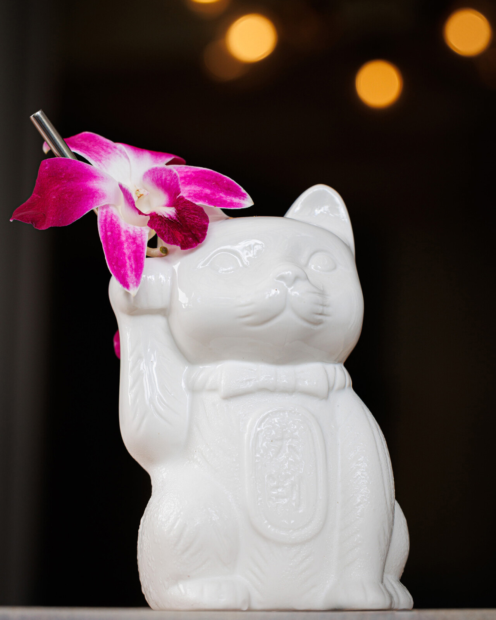 | 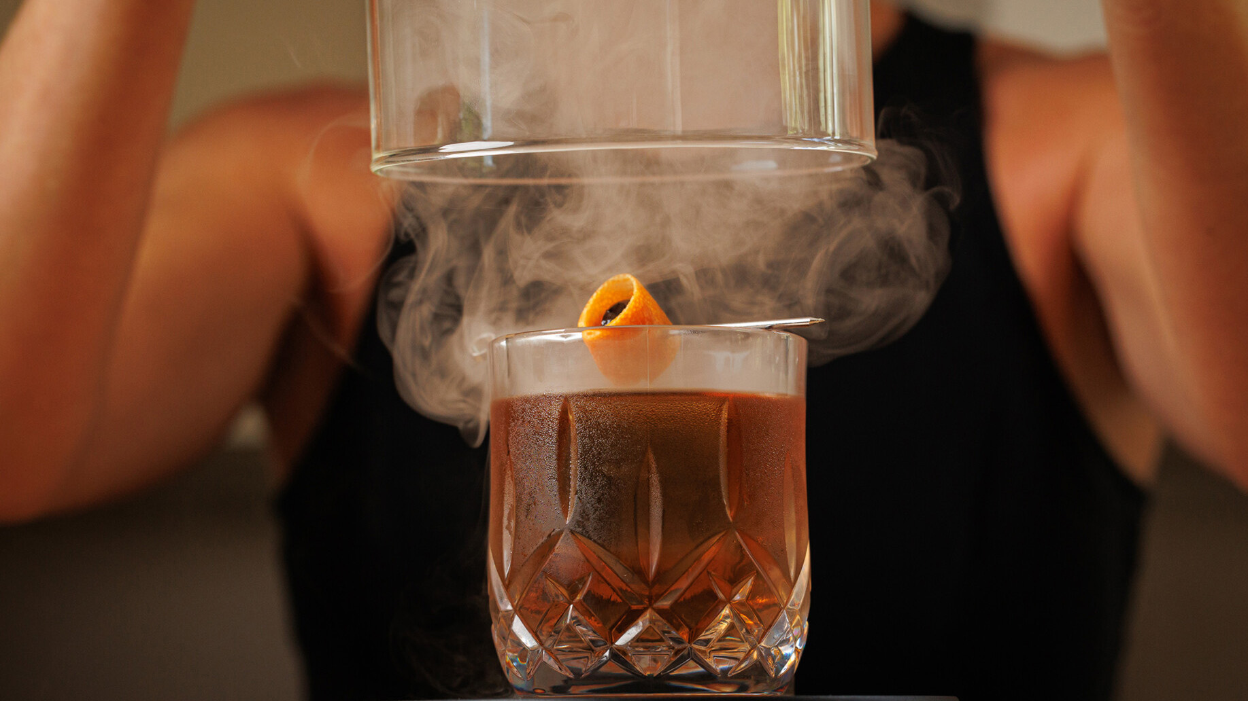
“Manalo Lounge celebrates the diverse mix of cultures that have influenced our cuisine here in Hawaii,” notes Four Seasons Resort Oahu Executive Chef Michael Arnot. “Along with the flavourful food and unique cocktail menu, the ambiance - a feeling of community, where you are invited to gather around the table with family and friends to enjoy a delicious meal and ‘talk story’ about the day - is a prominent theme woven throughout and creates such an inviting atmosphere, just like being welcomed into a friend’s home.”
Led by Chef Arnot, Manalo Lounge features sharable plates, with signature dishes that include Stone Pot Bibimbap with duck confit, hapa rice, and topped with a fried egg; Steamed Bao with spicy balsamic hoisin; and the Yakitori Trio with sticky sesame filet, crispy gochujang chicken, and yuzu grilled ali’i mushroom. The menu also features a selection of sushi and sashimi, along with the signature A5 Wagyu Hot Stone.
Equally as delicious as the cuisine, is the libation menu led by a collection of coveted Japanese whiskey and sake. Signature drinks include The Wagyu Old Fashioned with A5 wagyu, washed Tottori bourbon whiskey, house-made syrup, and bitters; the Matcha Aloha with Suntory Toki whiskey, matcha, Cointreau, and lemon; or the Neko Neko with Roku gin, yuzu sake, strawberry calpico, and lemon, and served in none other than a ceramic Lucky Cat glass – a traditional Japanese good luck symbol.
The lounge is open nightly, from 5:00 to 9:00 pm and in keeping with the welcoming and casual ambiance, reservations are not required.

RELATED

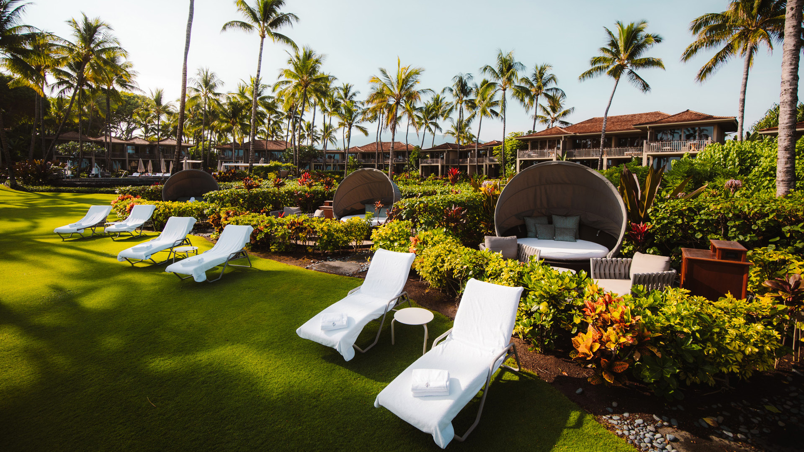 | January 18, 2023, Hawaii, Hualalai, U.S.A.  Four Seasons Resort Hualalai Offers Distinct Couples Programming Designed to Connect Guests to Hawaii Island and Each Other  https://publish.url/hualalai/hotel-news/2023/programming-for-couples.html
January 18, 2023, Hawaii, Lanai (Sensei), U.S.A.
At Sensei Lanai, A Four Seasons Resort, Couples Can Grow Well Together
https://publish.url/sensei/hotel-news/2023/couples-retreat.html

PRESS CONTACTS

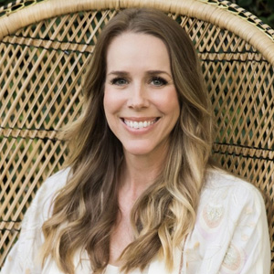 | Michelle Edwards  Director of Public Relations and Marketing Communications  92-1001 Olani Street  Kapolei  USA  michelle.edwards@fourseasons.com  +1 808 679 3364

