Fall in Love with Autumn at Four Seasons Resort and Residences Jackson Hole

Discover a new side to Jackson Hole this October and November
September 21, 2022, Jackson Hole, U.S.A.

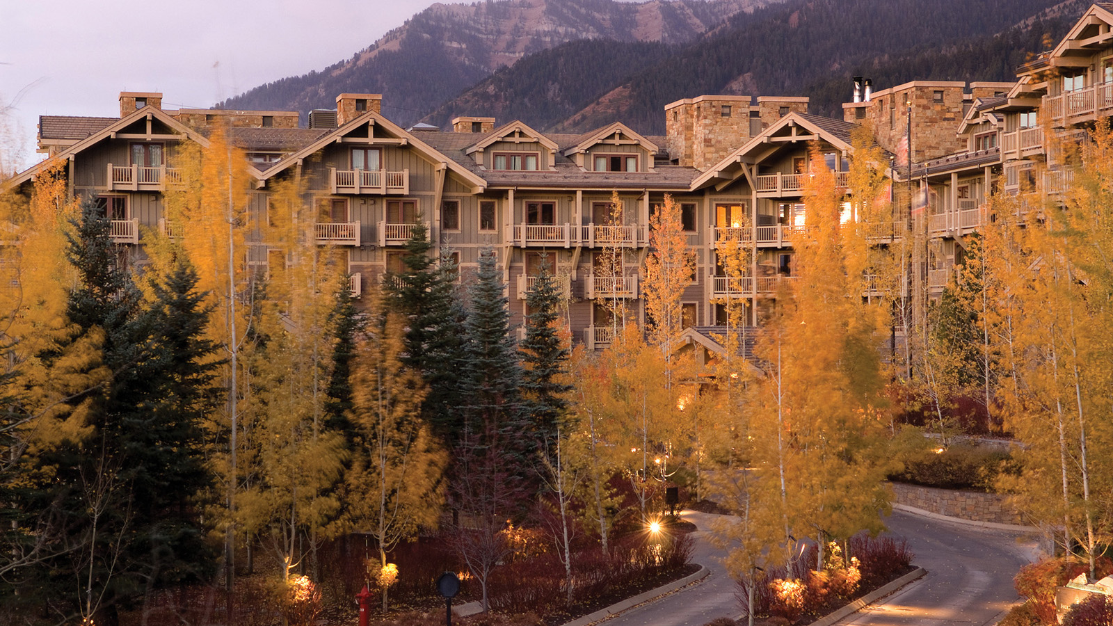
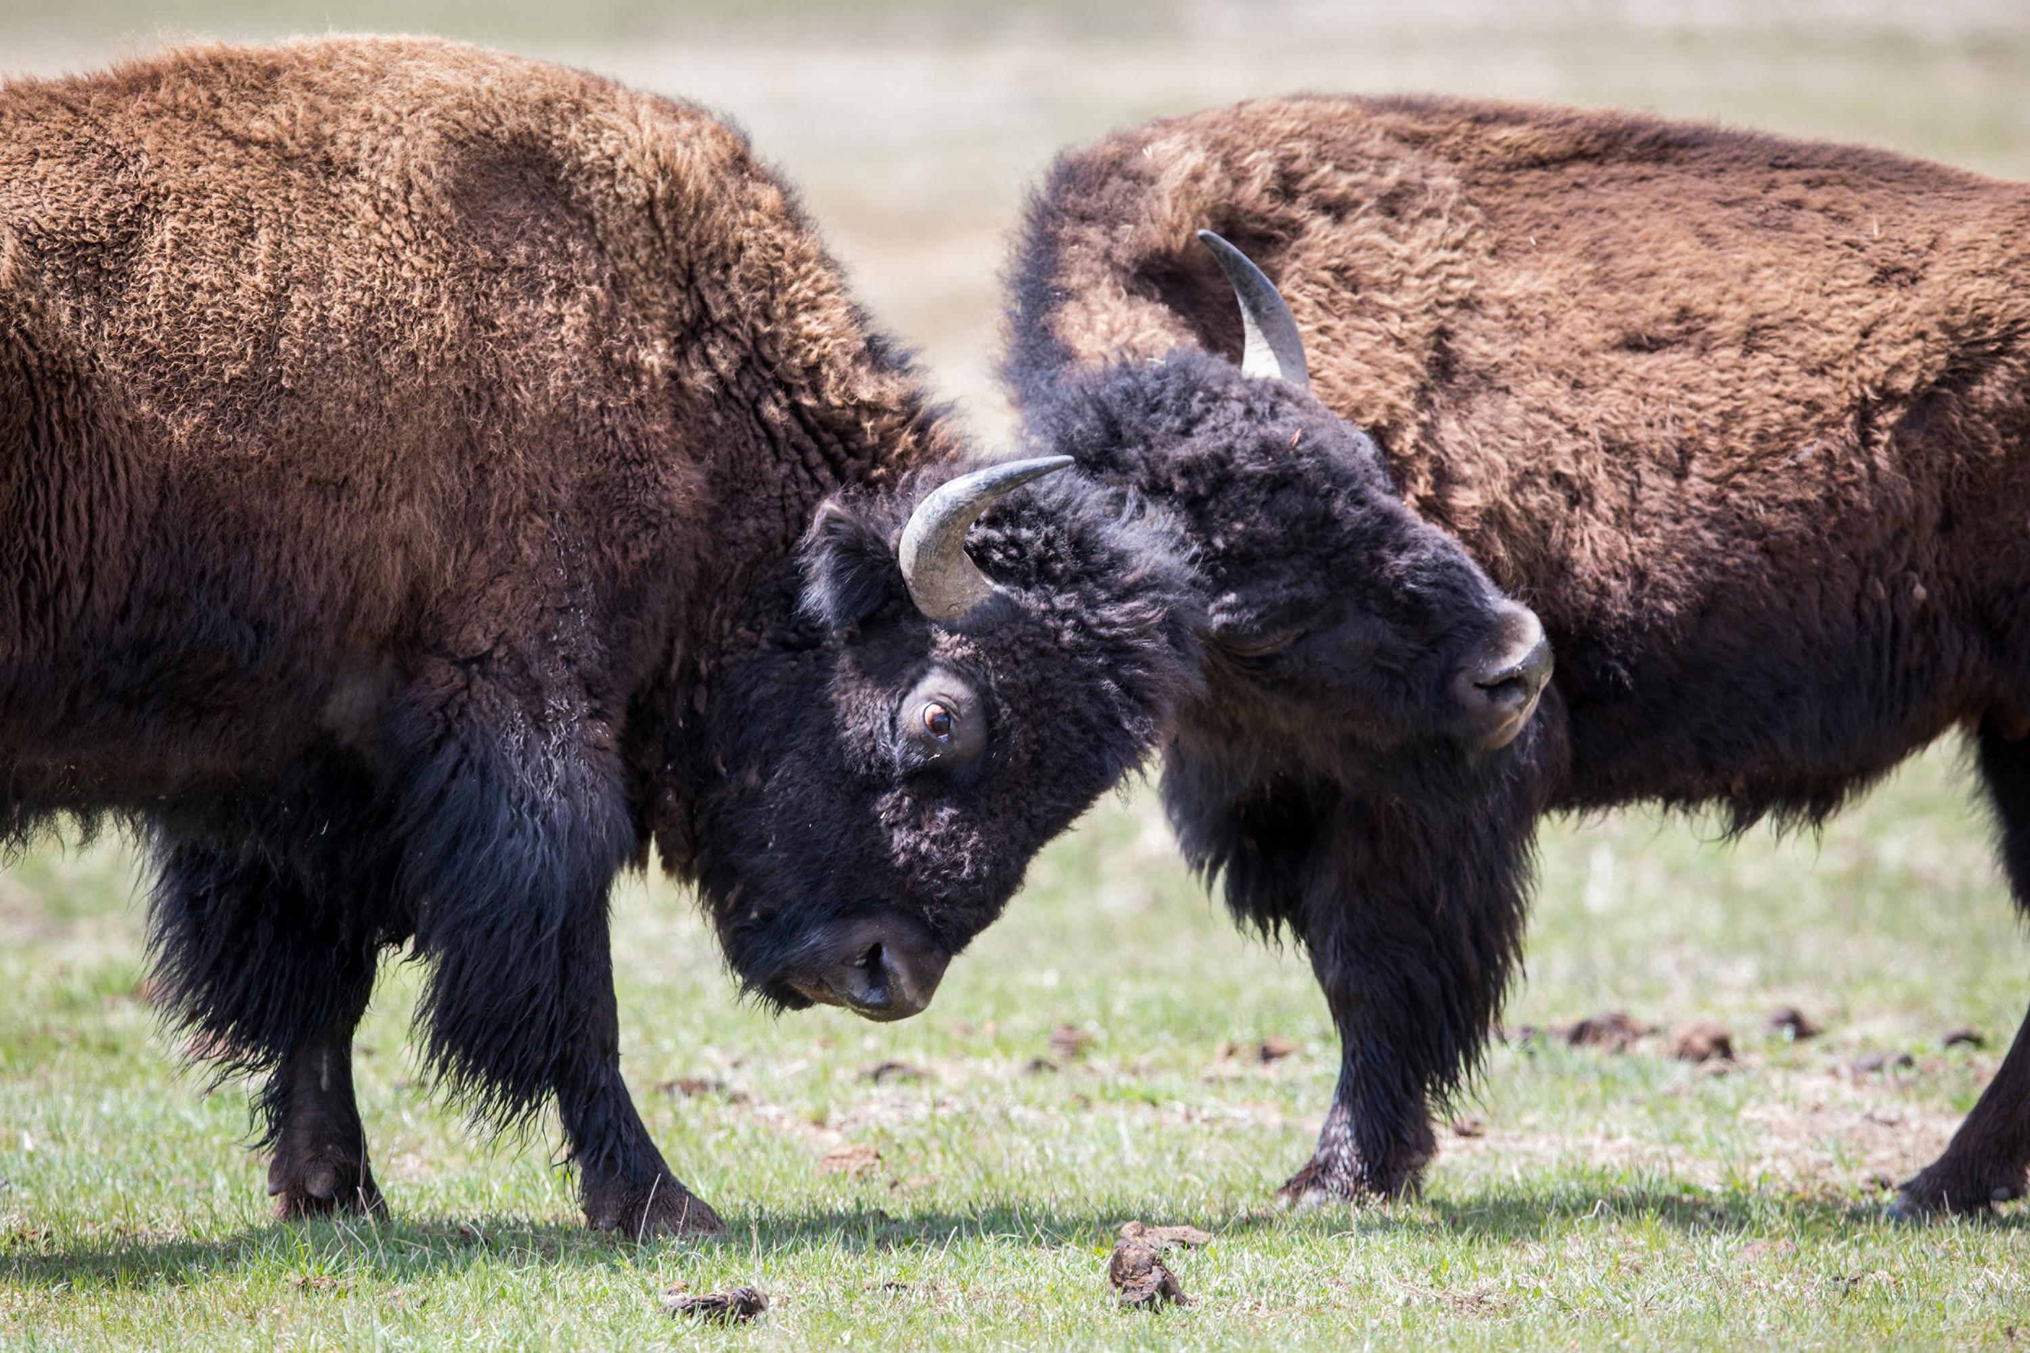 | 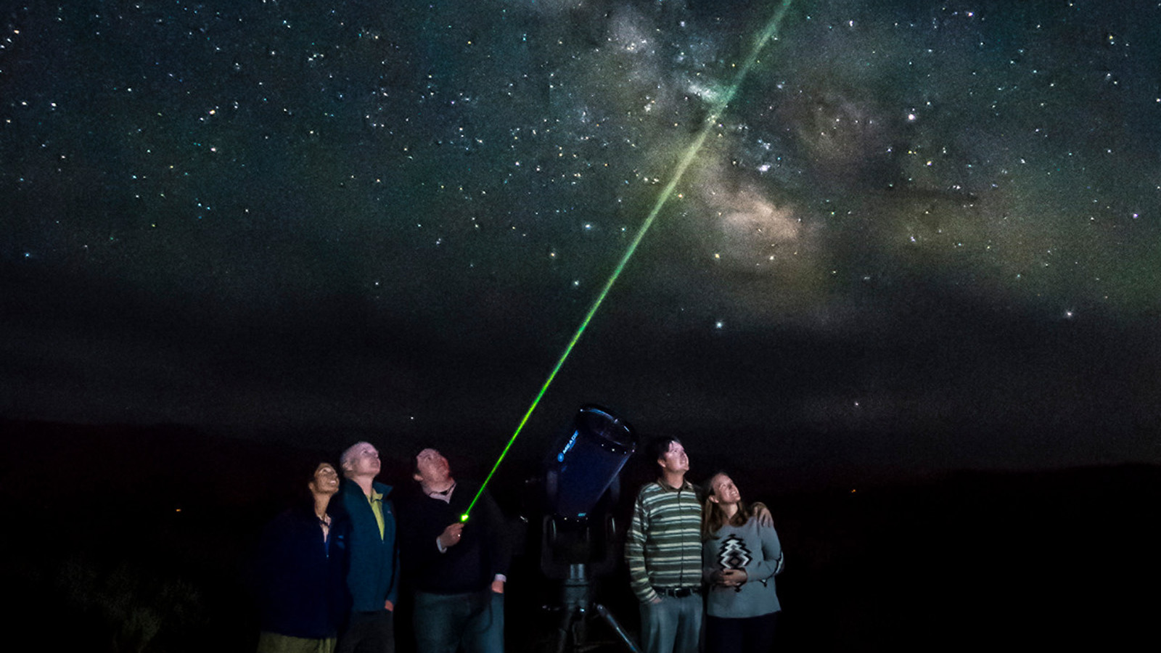
Experience Wyoming’s magical fall season at Four Seasons Resort and Residences Jackson Hole, with special seasonal rates and a variety of complimentary weekly programming including wine tasting, yoga and cocktail pairing classes.
“Many visitors know Jackson Hole for winter skiing and summer adventure, but have never had the opportunity to visit in the fall,” says General Manager Ryan Grande. “Autumn is a time of unique beauty in the destination, crisp weather perfect for shopping and sightseeing, and plentiful wildlife viewing opportunities.”
Complimentary Weekly Programming
Guests this fall will enjoy a calendar of complimentary weekly offerings, ranging from yoga and nature walks to wine tasting and painting classes. Family movie nights are offered throughout the week, along with local Wyoming Whiskey cocktail pairing classes and wine tasting with Jackson Hole winery.
An intro e-bike class will be offered weekly, weather dependent, featuring a light ride to nearby Grand Teton National Park. Guests will be inspired by Jackson Hole’s natural beauty with a weekly “paint and sip” class offered by a local artist, and can learn about the resident birds of prey in the greater Yellowstone ecosystem with a weekly Teton raptor encounter. Cap the weekend with a complimentary Bloody Mary and Mimosa bar in the lobby.
Relaxation and Wellness
Inspired by rudeneja, the Lithuanian sentiment for the transition into fall, the seasonal Autumn Spice Scrub features a rich, exfoliating polish to leave the body invigorated and glowing. A sugar scrub combining cardamom, ginger, clementine, bergamot, vanilla, black pepper, cinnamon bark, clove bud and ylang-ylang warms the body refreshes the skin. After a Swiss rainfall shower rinses away dull cells, a silky blend of vanilla and sweet almond oil is applied to the body. The treatment concludes with a spice-blended conditioning foot wrap to quench dry skin. This 60-minute treatment is offered for the months of October and November, at a cost of USD 260.
Guests can relax or recover after a day of outdoor adventure with a treatment or hydrotherapy in the Spa. The full-service Spa offers an array of locally inspired treatments, including body therapies, facials and massage. Immerse tired muscles into the warm waters of tranquil whirlpools or take the exhilarating plunge into a cold tub to awaken the body and reduce inflammation.
The year-round, heated pool offers a tranquil setting. Take a dip as the alpine glow sets in just before dusk. Relax tired muscles in one of three outdoor heated spa tubs, while towels and robes are kept warm in heater boxes.
Seasonal Sips
Ascent Lounge will feature a menu of seasonal fall cocktails, perfect for toasting on brisk autumn nights. Choose from an apple cider hot toddy, featuring bourbon, honey, spiced house cider and lemon. The Backcountry Old Fashioned combines Wyoming Whiskey Single Barrel, brown sugar, cinnamon, clove and orange. Or try the Fall Sangria, with red wine, cognac, vanilla, clove and citrus.
Exploring Jackson Hole and Beyond
This fall, explore the region’s deep connection with the grey wolf population of Yellowstone National Park with the new Day with the Wolves experience, offered exclusively to Four Seasons guests in partnership with Jackson Hole Wildlife Safaris. Embark on a private flight on a journey across the country’s most pristine wilderness and be guided by an expert naturalist, who provides the opportunity to view wolves in their natural habitat. This experience must be booked in advance.
Also offered by Jackson Hole Wildlife Safaris, embark upon a half or full day wildlife safari, exploring the National Elk Refuge and Teton National Park in search of the area’s abundant wintering wildlife. Thousands of mule deer, elk, moose, bighorn sheep and bison migrate into the valley in search of food each year along with coyotes, foxes, bald and golden eagles, swans, and even packs of wolves. Enjoy gourmet food and beverage and luxury transportation directly from the Resort.
Guests can experience some of the darkest skies in North America in Jackson Hole, providing the perfect backdrop for stargazing. Offered directly on property, each session lasts one and a half hours and includes the use of a state-of-the-art telescope for an intimate view of nebulas, the cosmos, and more. Refreshments include wine, cheese, charcuterie and desserts.
For reservations, click here.

RELATED

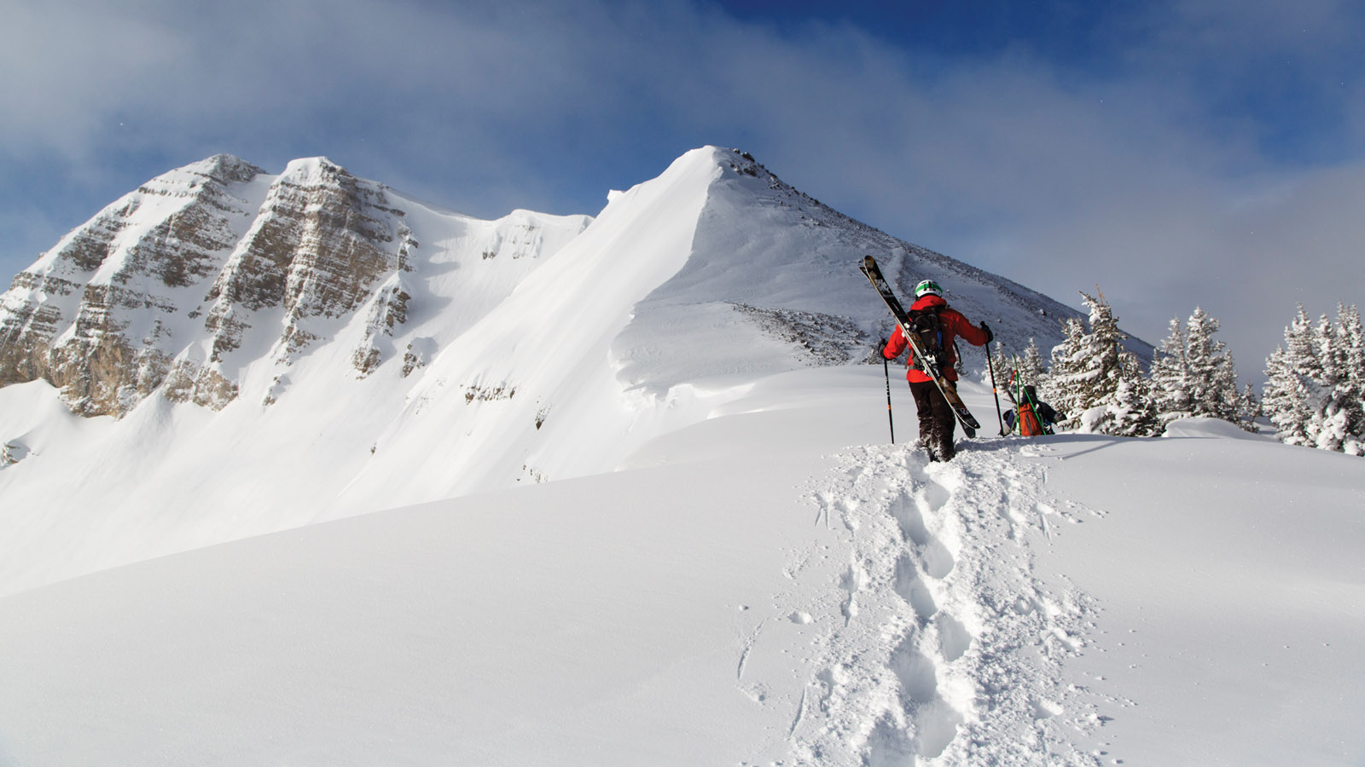 | January 23, 2023, Jackson Hole, U.S.A.  Acclimate This Winter with New Slope-Side Oxygen Bar, IV Therapy at Four Seasons Resort and Residences Jackson Hole  https://publish.url/jacksonhole/hotel-news/2023/new-elevate-oxygen-bar.html
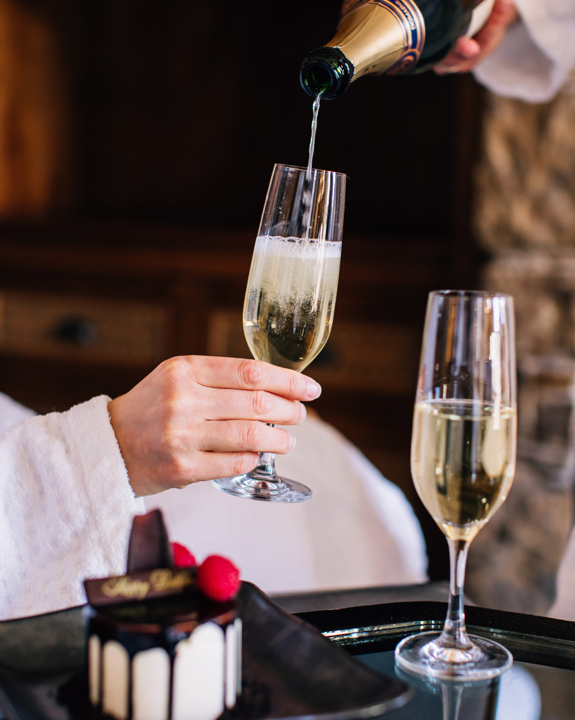 | January 19, 2023, Jackson Hole, U.S.A.  Moments Made for Sharing This February at Four Seasons Resort and Residences Jackson Hole  https://publish.url/jacksonhole/hotel-news/2023/valentines-day.html

PRESS CONTACTS

Kim Cole APR
Director of Public Relations
7680 Granite Loop Road, PO Box 544
Teton Village
USA
kim.cole@fourseasons.com

+1 480 980 8773

Jordan Ben-Hanania
Digital Marketing Manager, Sales & Marketing
7680 Granite Loop Road, PO Box 544
Teton Village
USA
jordan.ben-hanania@fourseasons.com

+1 307 732 5617

