Historic Hidden Gems on the Doorstep of Ten Trinity Square

May 1, 2018, London at Ten Trinity Square

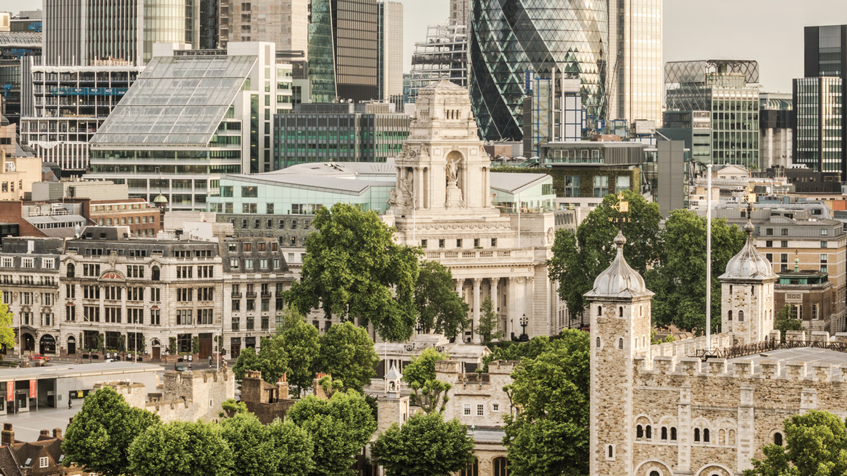
With two of London’s most renowned visitor attractions, the Tower of London and Tower Bridge, right on our doorstep there is no need to go much further. Nevertheless, for those wanting to delve deeper into the heart of historic London, there are myriad other hidden gems within an easy walk of
Four Seasons
Hotel London at Ten Trinity Square.
St. Olave's Church
Located just behind the Hotel on the corner of Hart Street and Seething Lane, St. Olave’s is one the smallest churches in the City and one of only a handful of medieval city churches that escaped the Great Fire of London on 1666. Along with his men from the nearby naval yards, William Penn Senior blew up the houses surrounding the church to create a fire break. The flames came within 100 yards (90 metres) of the church but a sudden wind direction saved the building and several others on the eastern side of the City.
The diarist Samuel Pepys – whose house and Royal Navy office were located on Seething Lane - regularly worshipped here. In 1660 he had a gallery built on the south side of the church along with an outside stairwell so that he could go to church without a soaking from the rain. The gallery is now long gone but a memorial marks the location of the stairway’s door. Both Pepys and his beloved wife Elisabeth are buried in the nave of the church. Open weekdays from 9:00 am to 5:00 pm, St. Olave’s makes for the perfect spot for quiet reflection away from the hustle and bustle of the City. The Concierge Team at
Four Seasons
Hotel London at Ten Trinity Square will be able to advise also on regular lunchtime concerts and recitals.
Trinity House
Trinity House, built in 1796, is our nearest neighbour on Trinity Square. The Corporation – to this day dedicated to safeguarding shipping and seafaring – first came into being in 1514 by Royal Charter granted by Henry VIII as a result of a petition put forward by mariners based just down the river in Deptford. The mariners were troubled by the poor conduct of unregulated pilots on the Thames and asked the Hing for a license to regulate pilotage. The first Master of Trinity House was Thomas Spert, sailing master of Henry’s flagship Mary Rose. The name of the guild derives from the Holy Trinity and St. Clement, the patron saint of mariners. Masters since Thomas Spert have included the diarist Samuel Pepys and the Duke of Wellington while Winston Churchill had a Trinity House vessel named after him, the THV Winston Churchill. Regular tours take place of Trinity House – our Concierge Team will be able to assist with dates and tickets.
Trinity Square Gardens
Located just in front of our Hotel, Trinity Square Gardens was once the site of the Tower Hill scaffold site, where a confirmed 125 people met their fate, the last in 1747 – look out for the stone set in the paving indicating the site of the former scaffold. Now a much more peaceful spot, parts of the wall enclosing the Roman settlement of Londinium can be found nearby as well as Edwin Lutyens’ Tower Hill Memorial built in 1928 and dedicated to the almost 24,000 merchant sailors who died in both world wars and have no known grave. Wander around the memorials, discover the Roman wall or simply join hordes of nearby workers who flock to the Gardens on sunny days during their lunchbreaks.
All Hallows by the Tower
Founded by the Abbey of Barking in 675 AD – 300 years before the Tower of London – All Hallows by the Tower is the oldest church in the Square Mile. An arch from the original Saxon church can still be seen today. In the crypt beneath is a second century Roman pavement, discovered in 1926, evidence of city life on this site for nearly two thousand years. William Penn Junior was baptised in the church and educated in the old schoolroom while John Quincy Adams, sixth president of the USA, was married in All Hallows in 1797. The Church suffered extensive bomb damage during World War II and only the tower and walls remained. After the war the church was rebuilt and rededicated in 1957. Visit the Crypt Museum or take one of the guided tours - available weekdays from 2:00 to 4:00 pm between April and October each year.
St. Dunstan's in the East
Located just a short walk from Four Seasons Hotel London at Ten Trinity Square on S.t Dunstan’s Hill is St. Dunstan’s in the East. Originally built around 1100 in gothic style, the church was severely damaged in the Great Fire of London. Rather than being completely rebuilt, the damaged church was patched up and a steeple designed by Sir Christopher Wren – of St. Paul’s Cathedral fame – was added. Suffering substantial damage during World War II, it was decided to not rebuild the church; however Wren’s tower and steeple survived intact along with its north and south walls. Now a beautiful public garden with trees within the ruins and a fountain sitting in the middle of former nave, St. Dunstan’s in the East is perhaps one of the Square Mile’s most peaceful spots.

RELATED

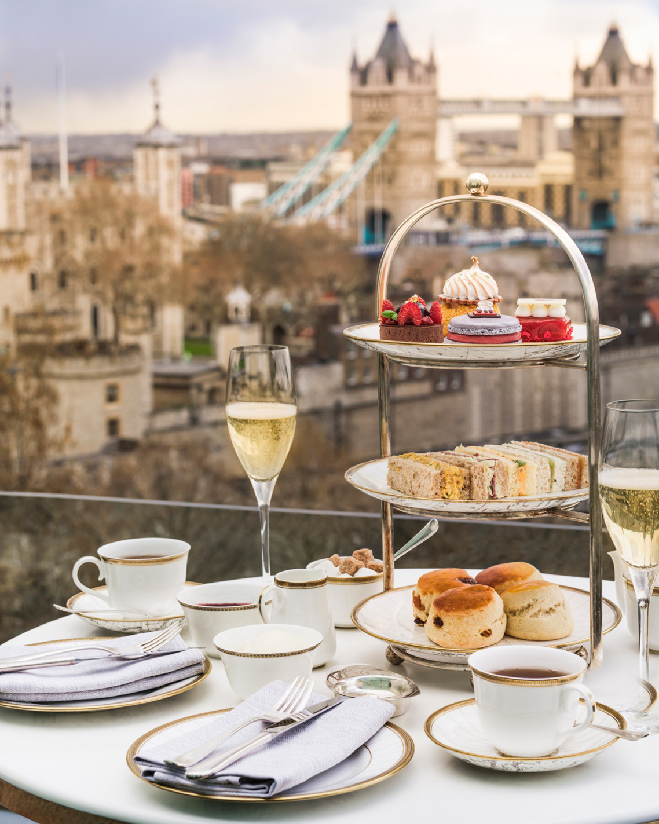 | April 17, 2019, London at Ten Trinity Square  A Taste of Royalty with the Crown Jewels Afternoon Tea at Four Seasons Hotel London at Ten Trinity Square  https://publish.url/tentrinity/hotel-news/2019/crown-jewels-afternoon-tea.html
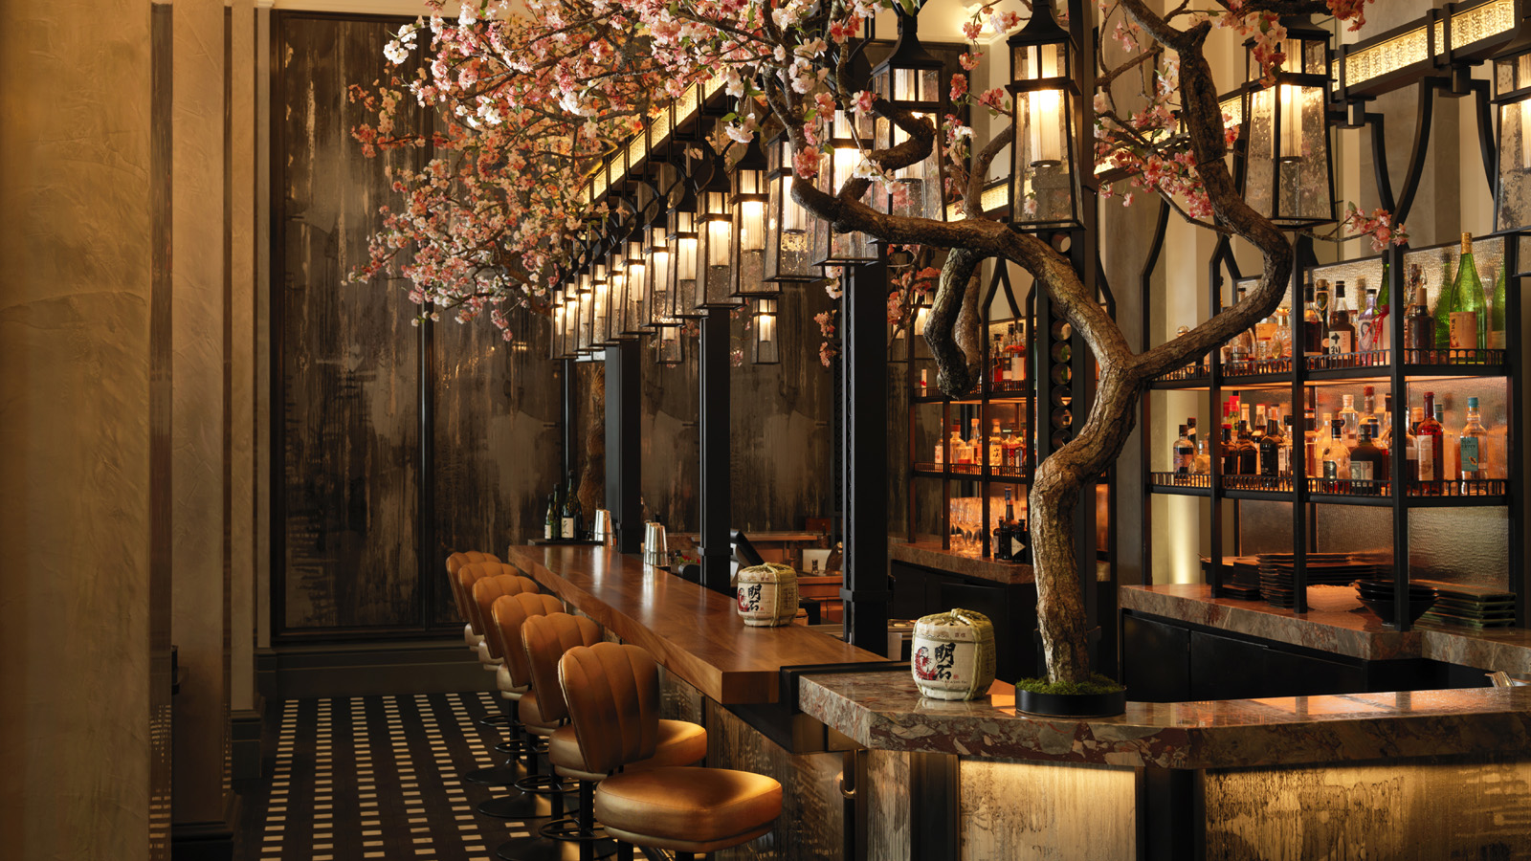 | March 1, 2019, London at Ten Trinity Square  In Bloom: Mei Ume at Four Seasons Hotel London at Ten Trinity Square Celebrates the Spring Festival Hanami  https://publish.url/tentrinity/hotel-news/2019/spring-festival-at-mei-ume.html

PRESS CONTACTS

Caroline Drayton
Director of Communications UK Collection
Hamilton Place, Park Lane
London
United Kingdom
caroline.drayton@fourseasons.com

+44 (20) 7319 5344

Gemma Minto
Director of Public Relations
10 Trinity Square
London
UK
gemma.minto@fourseasons.com

+44 (0) 203 297 9232

