The Most Intriguing Historic Figures of the Czech Republic

As the birthplace of many internationally famous writers, composers and scientists, Prague and the Czech Republic is a history buff's dream destination.
March 21, 2019, Prague, Czech Republic

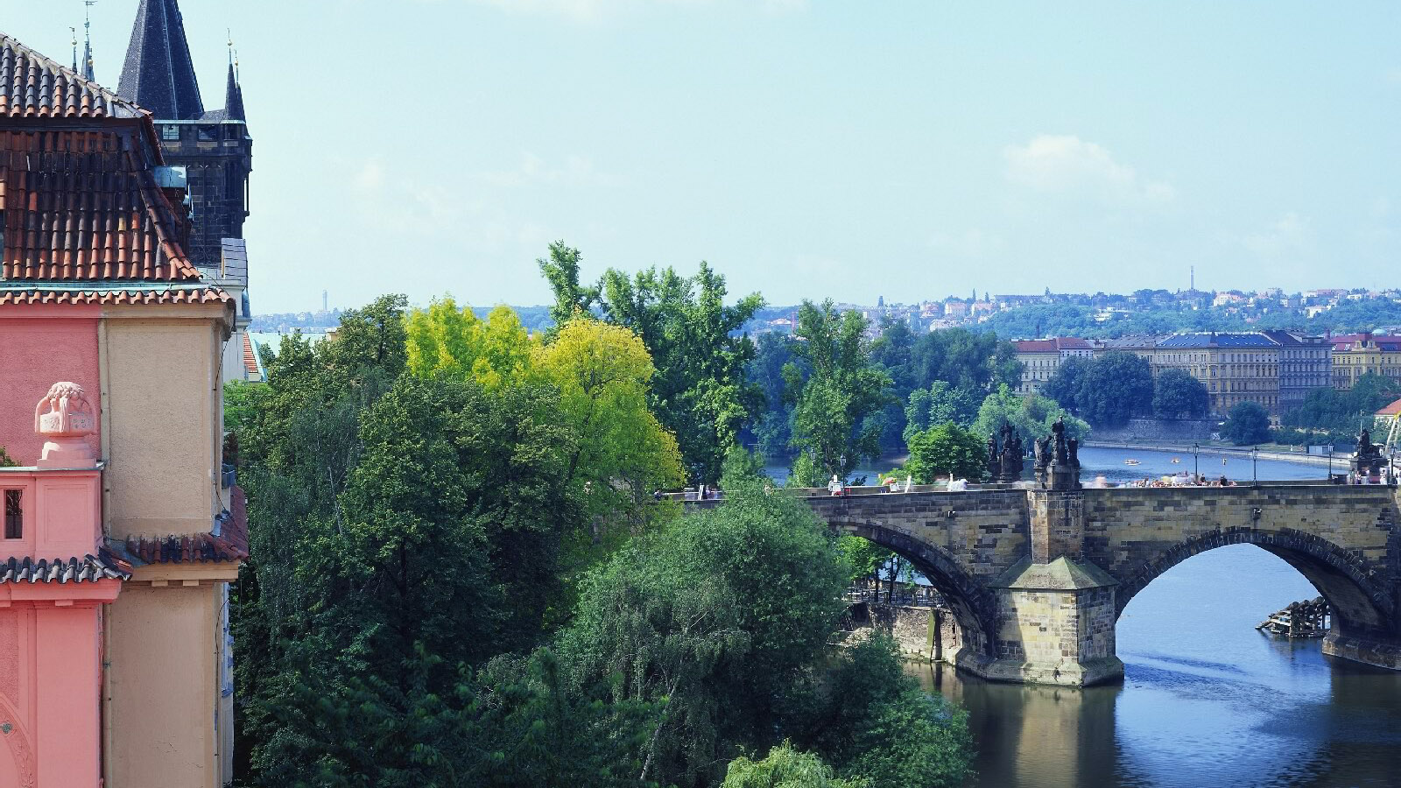
Discover the unique personalities and inventions that originated in Prague and the Czech Republic. How many of the following do you know?
Artists and the Czech Republic
- Franz Kafka, one of the major figures of 20th-century literature, is buried around the corner from the Four Seasons Hotel Prague in the New Jewish Cemetery.
- The famous 18th-century seducer Giacomo Casanova spent the last 13 years of his life at Duchcov Castle in Bohemia, where he wrote his memoirs.
- Many of history’s most renowned artists, composers, scientists and thinkers frequented the renowned spas of Karlovy Vary, and Marianske Lazne, including Mozart, Beethoven, Tchaikovsky, Gogol, Goethe, Freud, Edison, Schopenhauer and Marx, to name but a few.
- One of Mozart’s best-known operas, Don Giovanni, premiered at Prague’s Estates Theatre in 1787 and is to this day still performed there.
- American astronaut Neil Armstrong listened to Antonin Dvorak’s New World Symphony as he walked on the Moon’s surface in 1969. The Largo movement of the symphony is in a box, still spinning through outer space.
Scientists and the Czech Republic
- Albert Einstein spent over a year in Prague as a professor at the Institute of Theoretical Physics.
- The first person to categorise blood into four types (A, B, AB, O) was the Czech neurologist Jan Jansky. In his honour, the Jansky Plaque is awarded to volunteer blood donors in the Czech Republic and Slovakia.
- It was a Czech scientist, Otto Wichterle, who invented modern contact lenses and founded macromolecular chemistry.
- The founder of genetics, Johan Gregor Mendel, was born in Hynčice and spent most of his life in Brno.
- The Czech pedagogue and philosopher Jan Ámos Komenský (Comenius) who wrote an encyclopaedia for children, Orbis Pictus (World in Pictures) is considered the father of modern education.
Czech Natives and Inventions with a Global Footprint
- Figures such as Oskar Schindler (whose life is portrayed in the book and film “Schindler’s List”), the philosopher Edmund Husserl, psychiatrist Sigmung Freud, the composer Gustav Mahler and the writer Rainer Maria Rilke were all born in what is now the Czech Republic.
- Madeleine Albright, the first female US Secretary of State, was born in Prague.
- Today’s Czech Republic was also the home of businessman of Tomáš Baťa, the global footwear manufacturer and retailer from Zlín. He was also the first to introduce the clever pricing format “.99” (as in €99.99).
- The bottom-fermentation method used in beer production was invented by the brewers of Plzeň (Pilsen) in 1842, and is now applied and enjoyed across the world.

RELATED

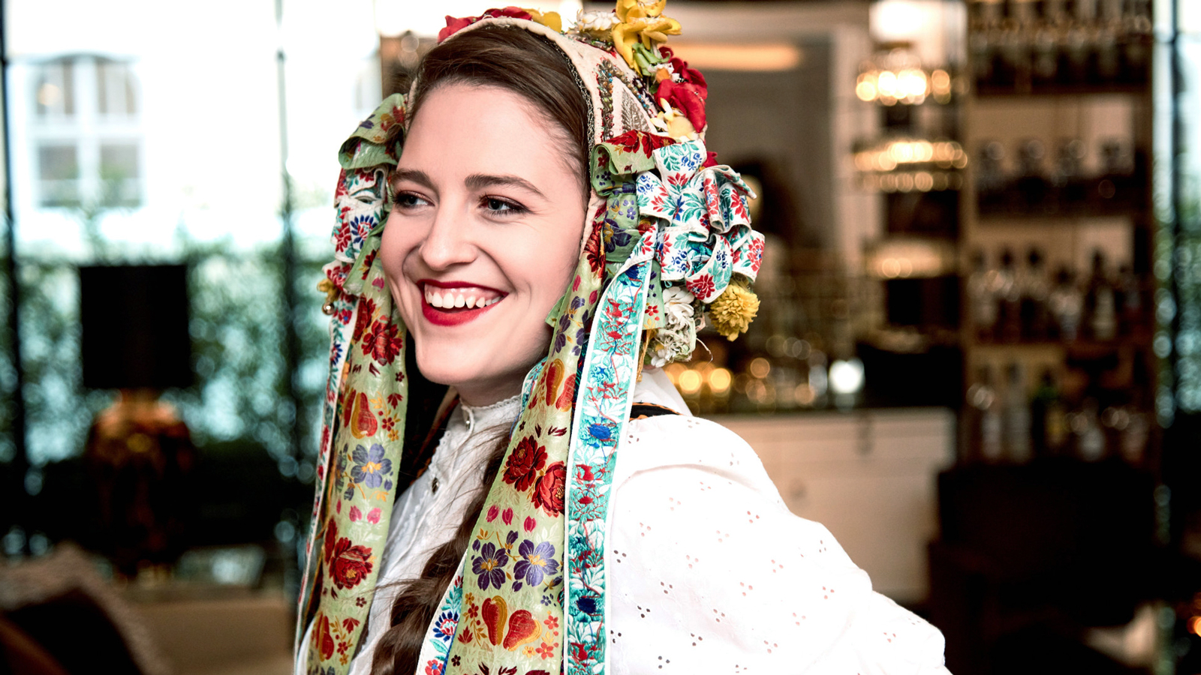 | March 14, 2019, Prague, Czech Republic  Tradiční velikonoční brunch v restauraci CottoCrudo hotelu Four Seasons Prague  https://publish.url/cs/prague/hotel-news/2019/easter-2.html
March 14, 2019, Prague, Czech Republic
Traditional Bohemian Easter Brunch at CottoCrudo at Four Seasons Hotel Prague
https://publish.url/prague/hotel-news/2019/easter.html

PRESS CONTACTS

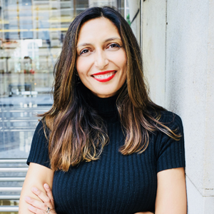 | Martina Vavrova  Director of Public Relations  Veleslavínova 2A/1098  Prague  Czech Republic  martina.vavrova@fourseasons.com  420 221 426 615

