Festive Feasting, Four Seasons Style at Four Seasons Hotel Shenzhen

November 29, 2022, Shenzhen, China

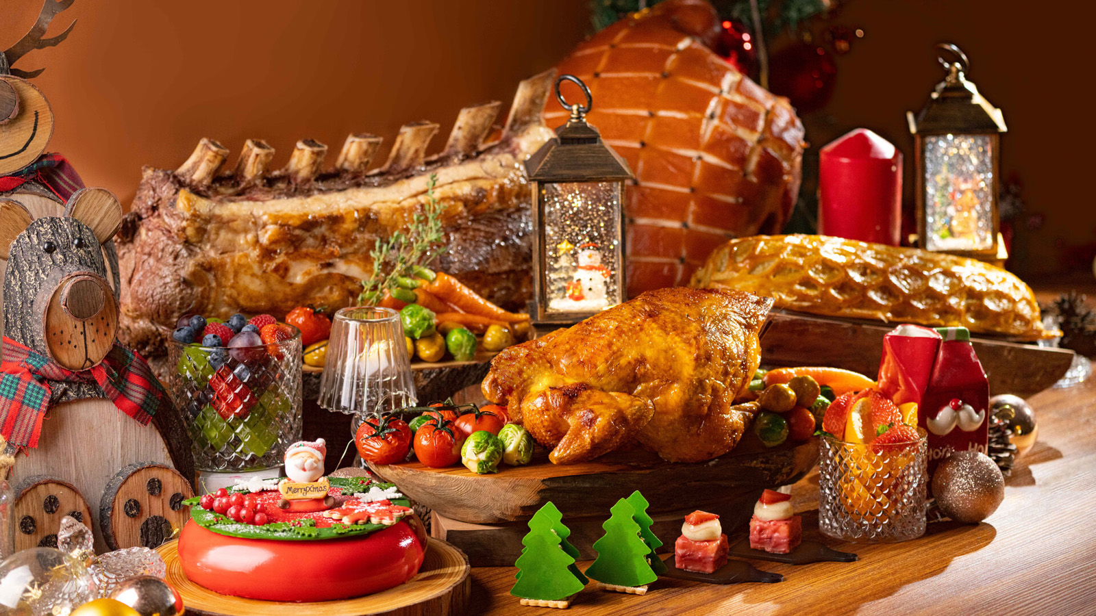
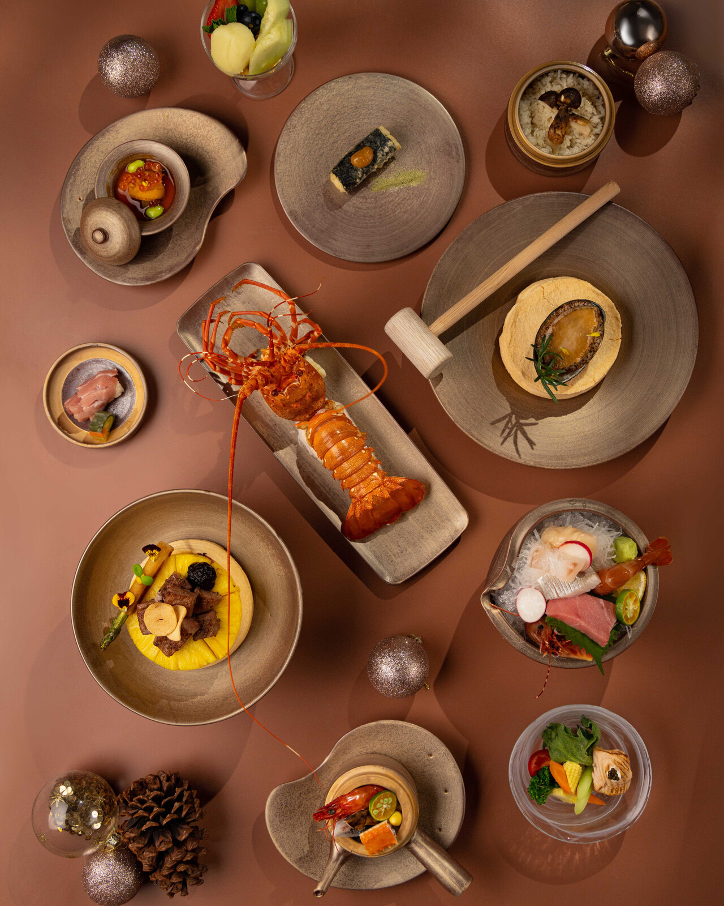 | 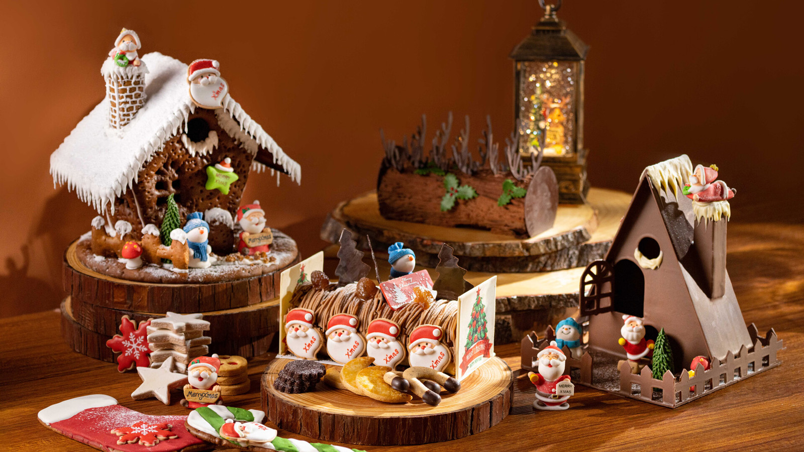 | 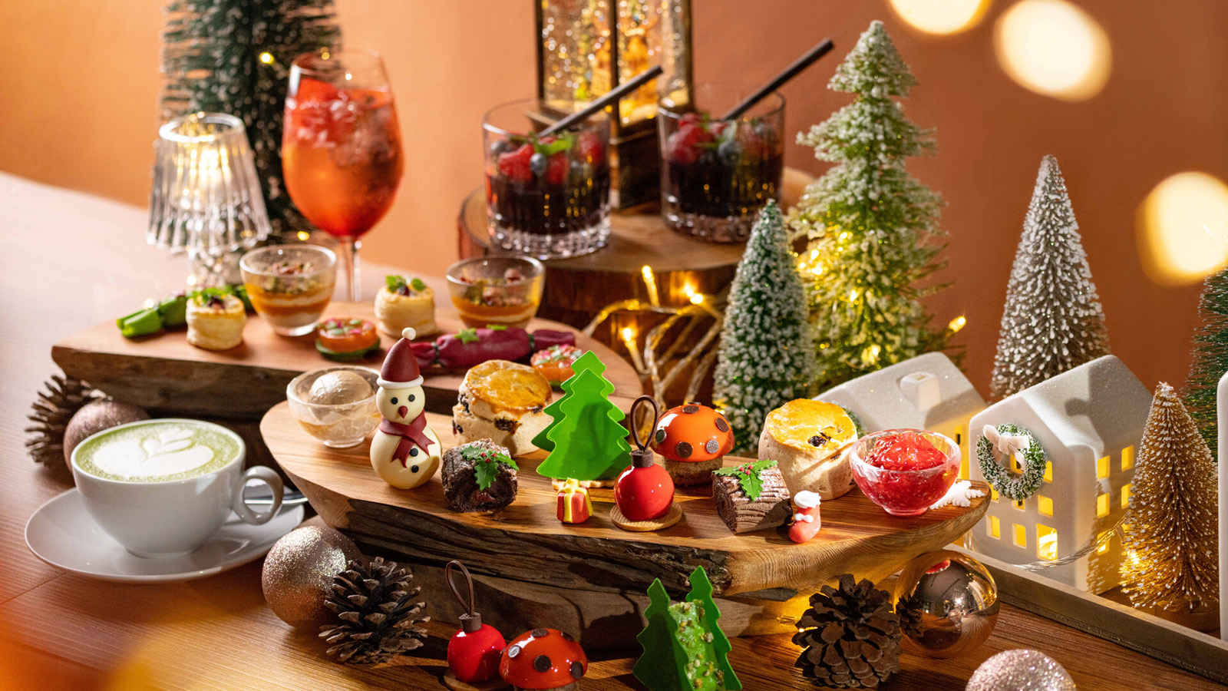
Four Seasons Hotel Shenzhen invites all guests to indulge in the festive atmosphere and share the joy together. From artful Afternoon Tea at Yi Lounge to decadent Cantonese delicacies at Zhuo Yue Xuan, Four Seasons Hotel Shenzhen brings a special sparkle to celebrations this festive season.
Three Ways to Share the Love at FOO
Indulge in the spirit of Christmas in the opulent surroundings of FOO with three seasonal buffet extravaganzas. Bring all the family together for FOO’s lavish international Christmas Eve Dinner Buffet or celebrate the big day with a Christmas Day Lunch or Dinner Buffet. The feasting continues with a New Year’s Eve Dinner Buffet. All three buffets include welcome Champagne and a cocktail, a Christmas gift, and entry into a festive lucky draw for the chance to win some great prizes.
Christmas Eve Dinner Buffet
- December 24, 2022, 6:00-10:00 pm
- CNY 1,188* per person
Christmas Day Buffet
- December 25, 2022, 12:00 noon – 2:30 pm and 6:00-10:00 pm
- CNY 988* per person
New Year’s Eve Dinner Buffet
- December 31, 2022, 6:00-10:00 pm
- CNY 988* per person
Afternoon Tea with a Christmas Twist at Yi Lounge
Flavoured with festive cheer and a sprinkling of seasonal magic, the pretty red and green Christmas Afternoon Tea is designed to condense the Christmas spirit into a bite of exquisite dessert. Feast on bite-size savoury favourites such as Turkey Veloute Vol Au Vent and Pumpkin Verrine with Truffle Foie Gras and Chestnuts, before satisfying that sweet tooth with Dark Chocolate and Raspberry Yule Log and Morello Cherry Cheesecake Christmas Ball – or a seasonal scone with gingerbread mascarpone. Every tea includes delightful drinks such as Matcha Latte and Berry Christmas.
Festive Afternoon Tea
- December 1-26, 2022, 2:00-5:30 pm
- CNY 428*/set, CNY 228* per person
New Year Countdown Party at Yi Bar Terrace
Count down to a new year full of potential in the lively outdoor ambience of Yi Bar Terrace with its glittering city views. As well as a glass of Champagne on arrival plus celebratory drink and snack packages on offer, guests can enjoy music from a live band beneath the night sky. Each ticket includes entry into a lucky draw.
Count Down Party
- December 31, 2022, 6:00 pm – 12:00 midnight
- Tickets CNY 198* per person
Seasonal Set Menu Magic at Matsuyi
Fabulous seasonal dining at Matsuyi brings two festive menus. Featuring the finest ingredients – including in-season snow crab and matsutake delivered by air to ensure freshness – the Christmas set menu wows with dishes such as Snow Foie Gras Omakase Sushi and Teppanyaki Rock Lobster. The New Year set menu is a rich fiesta of authentic Japanese flavours, from Sake Steamed Chicken and Shimeji Mushroom Salad with Onsen Egg Dressing to New Year Hot Soba Noodles with Bamboo Shoots and Rice Cake. A special take-home gift is included with all bookings for December 23-26, 2022.
Christmas Set Menu
- December 23-26, 2022, 11:30 am - 2:00 pm and 5:30-9:30 pm
- CNY 2,688 per set
New Year Set Menu
- December 31, 2022, 11:30 am - 2:00 pm and 5:30-9:30 pm
- CNY 988* per set
A Chinese-Style Christmas at Zhuo Yue Xuan
Golden decadence sets the scene for sumptuous Christmas and New Year dining at modern Cantonese restaurant Zhuo Yue Xuan. Savour lavish luxury in dishes such as Crispy Free Range Chicken with Truffle and Baked Crab Meat with Onion and Butter Cream, while an elegant Strawberry Red Wine Pudding offers plenty of festive colour and flavour.
Christmas Set Menu
- December 23-26, 2022, 11:30 am - 2:00 pm and 5:30-10:00 pm
- CNY 1888* per set
New Year Set Menu
- December 31, 2022, 11:30 am - 2:00 pm and 5:30-10:00 pm
- CNY 2023* per set
Festive Room Rates
Check in to luxury this Christmas with the Deluxe Room Package – from CNY 1,299 per stay – or dial-up the festive indulgence with the Club Room Package – from CNY 1,699 per stay – including:
- Breakfast for two persons and one child (under 12 years) at FOO
- CNY 200 SPA Voucher
- Buy-one-get-one-free lunch buffet or dinner buffet at FOO
- Complimentary use of the Hotel's indoor heated swimming pool, gym and parking
Divine Dining Direct to One’s Room
The full restaurant experience in the comfort of room, seasonal favourites such as Beef Wellington with Port Wine Sauce and Caramel Chestnuts and Christmas Yule Log are served course by course (unless preferred otherwise), with servers explaining each dish.
Festive In-Room Menu
- December 23-26, 2022, 11:00 am – 11:00 pm
- CNY 888* per person
Festive Turkey Takeaway: At Home with Four Seasons
Bring a tantalizing touch of Four Seasons luxury to the Thanksgiving or Christmas celebrations this year with Festive Turkey Takeaway. Crafted to perfection by the team of expert chefs, and the package includes a whole turkey as well as appetizers, side dishes and a pumpkin pie. Reserve at least two days in advance. Free delivery is available within 3 kilometres of the Hotel or pick up from FOO restaurant.
Turkey Takeaway
- November 20 – December 25, 2022
- CNY 1688 per set for 8-10 persons
- CNY 2188 per set including private carve turkey service
Festive Counter: A Feast for All the Senses
Step into a whimsical wonderland in the Festive Counter located in the Hotel Lobby. Purchase fragrant festive desserts including gingerbread houses, chocolate or chestnut Yule logs, themed pastries, traditional stollen, and fresh cookies baked in-house. For spreading the joy of the holiday, the Hotel is offering three delightful festive hampers bursting with seasonal treats such as Iberian ham, truffle honey, panettone, homemade Christmas stollen and gingerbread. Designed by Executive Pastry Chef Mary, these special hampers and the lavish store feature up to 42 kinds of hand-made goodies, crafted to spread happiness this season. Meanwhile, for spreading the love with the charity partner Handpicked Love Foundation, the Hotel will donate 8 percent of Festive Counter sales to support children who needs heart surgery.
Prices above are subject to 16.6 percent service charge and taxes. For enquiry or reservation, contact: 0755-88268888.

RELATED

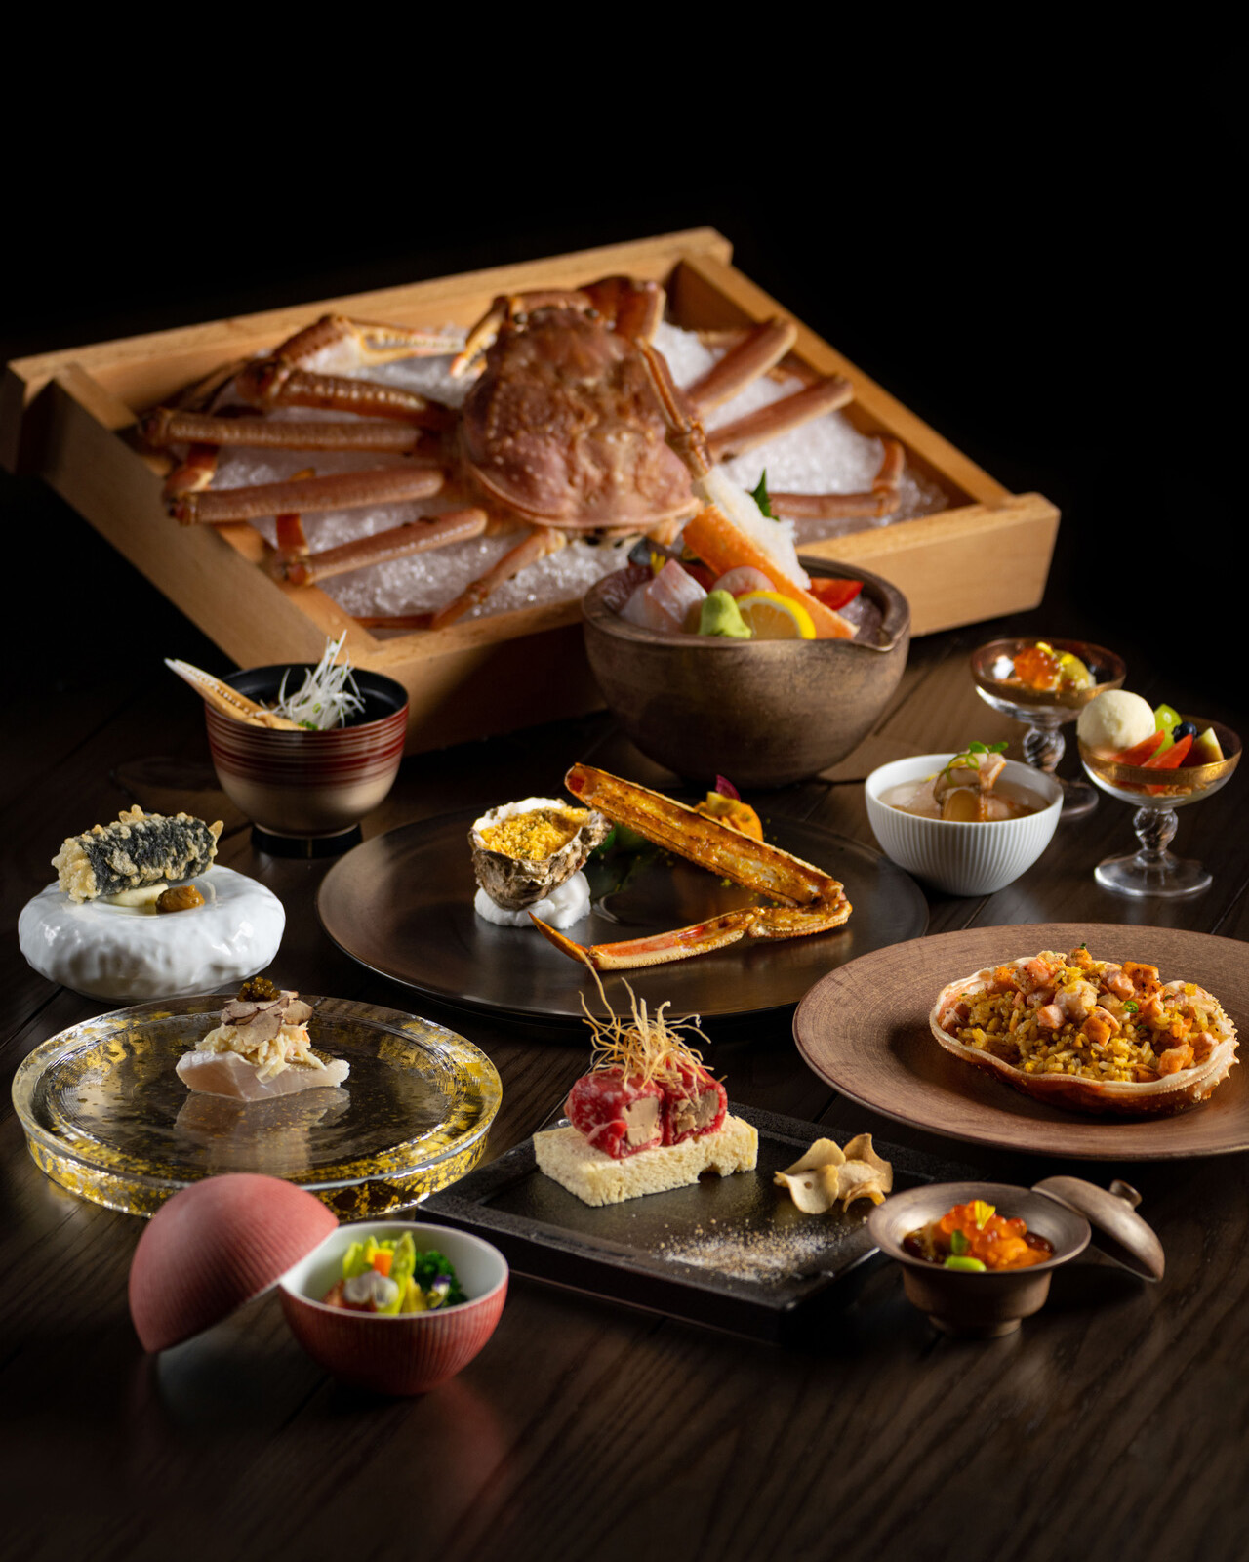 | November 16, 2022, Shenzhen, China  以美味，品秋色雅韵  https://publish.url/zh/shenzhen/hotel-news/2022/autumn-menus.html
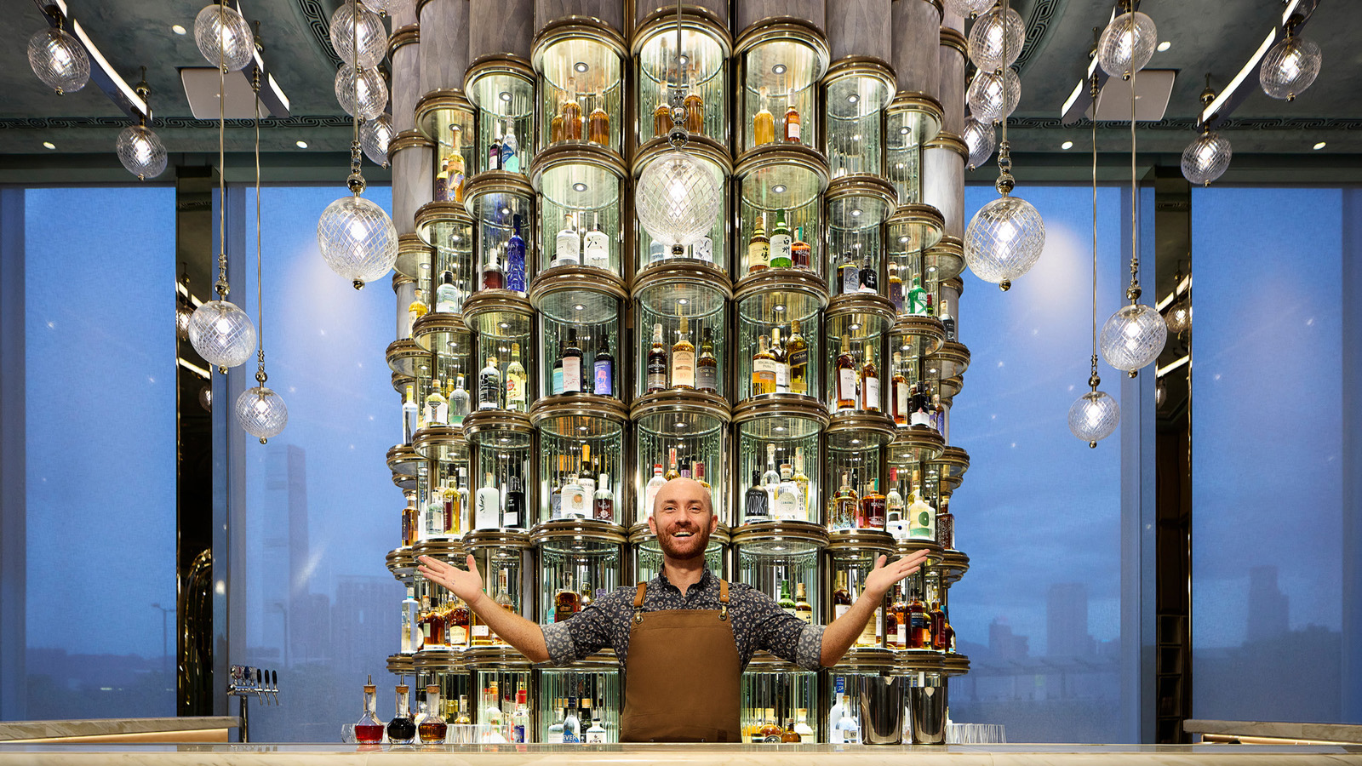 | November 14, 2022, Hong Kong, China  ARGO at Four Seasons Hotel Hong Kong Launches New Menu Celebrating Flavours and Stories of Hong Kong  https://publish.url/hongkong/hotel-news/2022/new-cocktail-menu-at-argo.html

PRESS CONTACTS

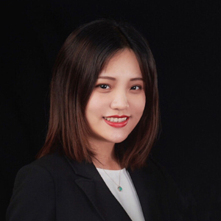 | Jackie Xu  Director of Public Relations  138 Fuhua Third Road, Futian District  Shenzhen  China  jackie.j.xu@fourseasons.com  +86 755 8826 8831

