Indulge in the Art of Pasta at Café Prat0, This November at Four Seasons Hotel Mumbai
November 7, 2019, Mumbai, India

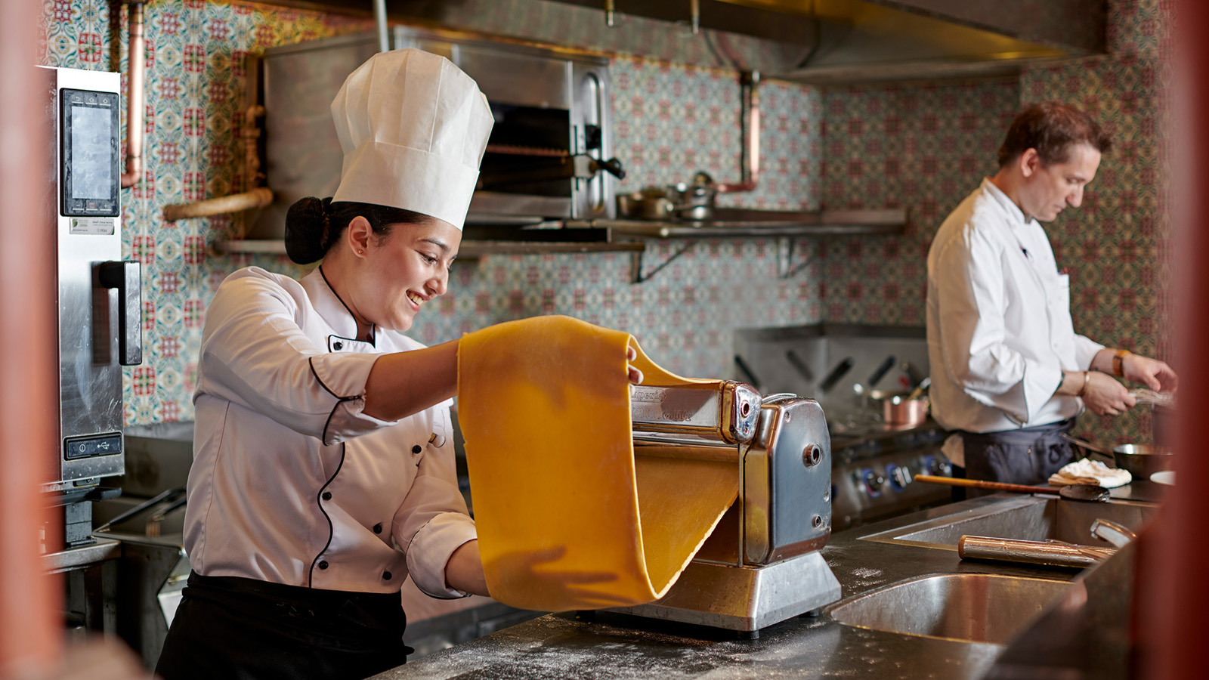
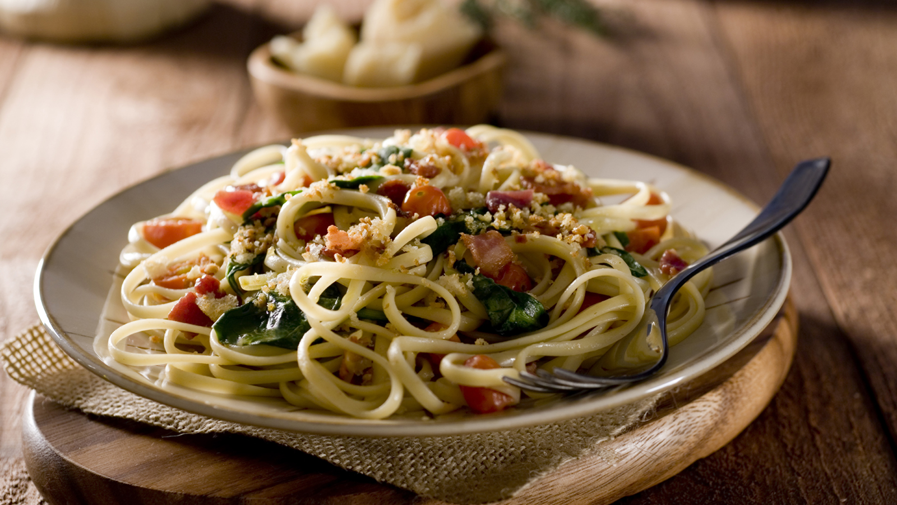 | 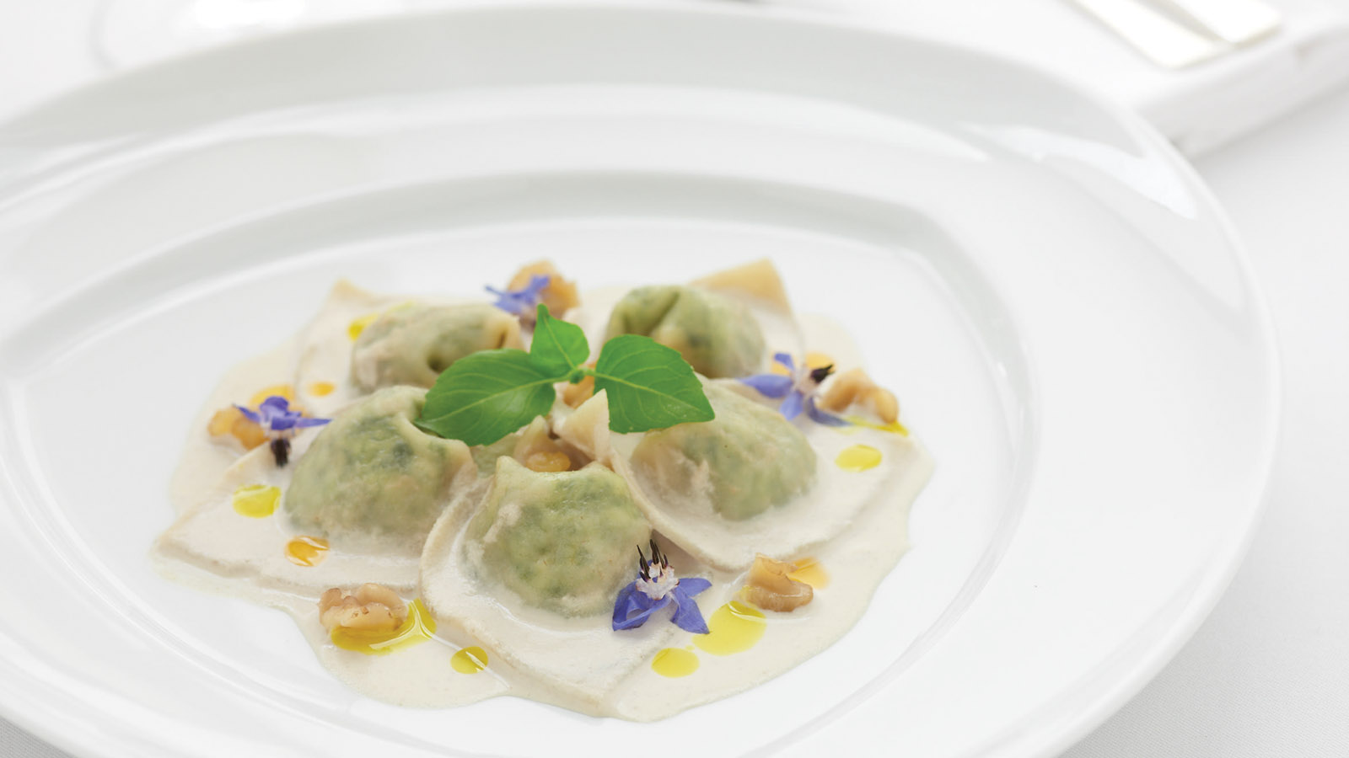
"Life is a combination of magic and pasta," once quipped the renowned Italian film director Federico Fellini, and the team at Four Seasons Hotel Mumbai couldn't agree more. A preparation known and loved by most people world over, Italian pasta is a universal language of its own and is arguably one of the most famous foods globally.
Delve into the silky tenderness of fresh handmade pasta crafted the authentic Italian way at Café Prato from November 18 to 30, 2019 Experience delicious dishes such as the stuffed conchiglioni with spinach, ricotta, tomato consommé and toasted pine nuts; schiaffoni lamb with bloom tomatoes and pecorino shavings; pappardelle marinara loaded with squid ink, river prawns, scallops and mussels; or mud crab ravioli in lemon butter fondue with basil pearls – all created by Executive Chef Anupam Gulati and his team of craftsmen.
The Art of Pasta is available throughout the day at Café Prato, and is priced between INR 900 and 1000, plus taxes. For more information, call 022 2481 8000.

RELATED

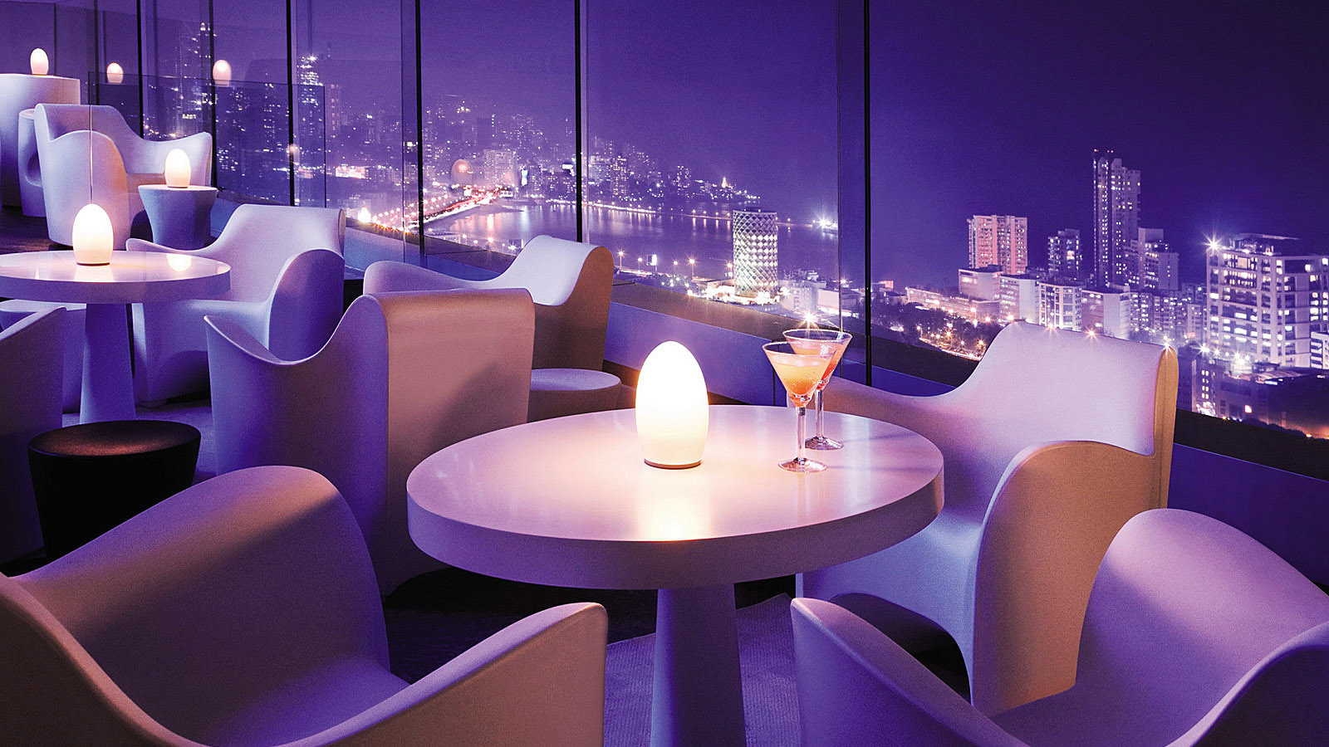 | October 28, 2019, Mumbai, India  AER – Bar and Lounge at Four Seasons Hotel Mumbai Awarded Best Hotel Bar in India at the 30 Best Bars India Awards  https://publish.url/mumbai/hotel-news/2019/best-hotel-bar-in-india.html
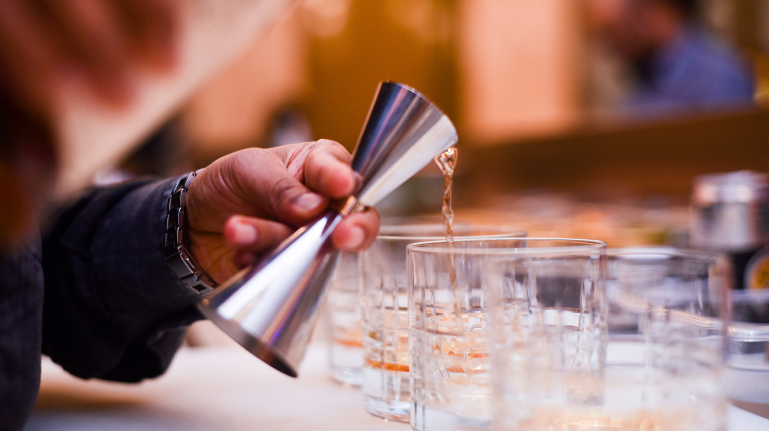 | October 23, 2019, Mumbai, India  Copitas Takes Over AER: Four Seasons Hotel Bengaluru Bar Team Previews New Cocktails at Four Seasons Hotel Mumbai  https://publish.url/bengaluru/hotel-news/2019/copitas-at-aer.html

PRESS CONTACTS

Stephanie D'Silva
Director of Marketing
1/136 Dr. E. Moses Road, Worli
Mumbai
India
stephanie.dsilva@fourseasons.com

986 706 1900

Neha Nair
Marketing Communications Manager
1/136 Dr. E. Moses Road, Worli
Mumbai
India
neha.nair@fourseasons.com

+91 (22) 2481 8062

