Did You Know? Top Ten Factoids About Four Seasons Hotel New York

November 12, 2013, New York, U.S.A.

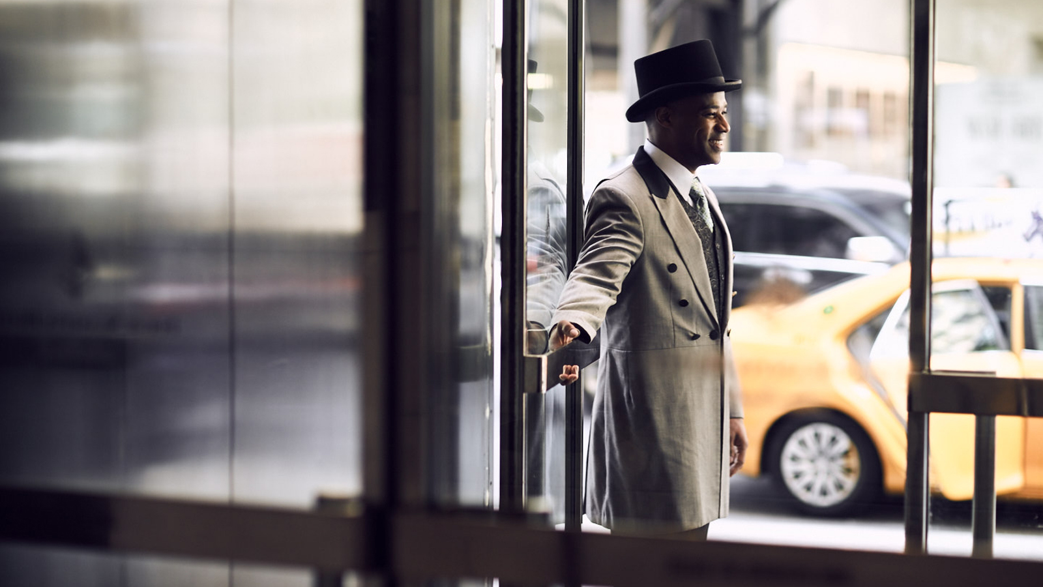
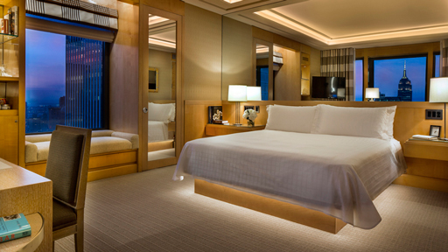 | 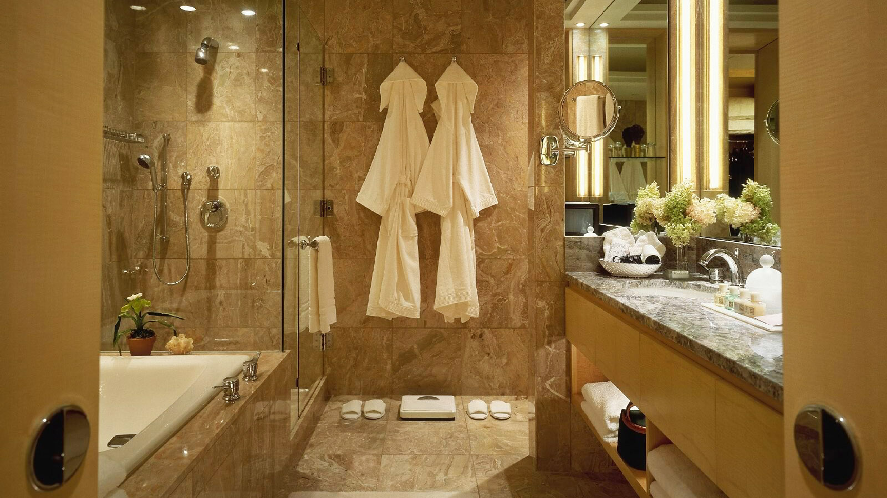 | 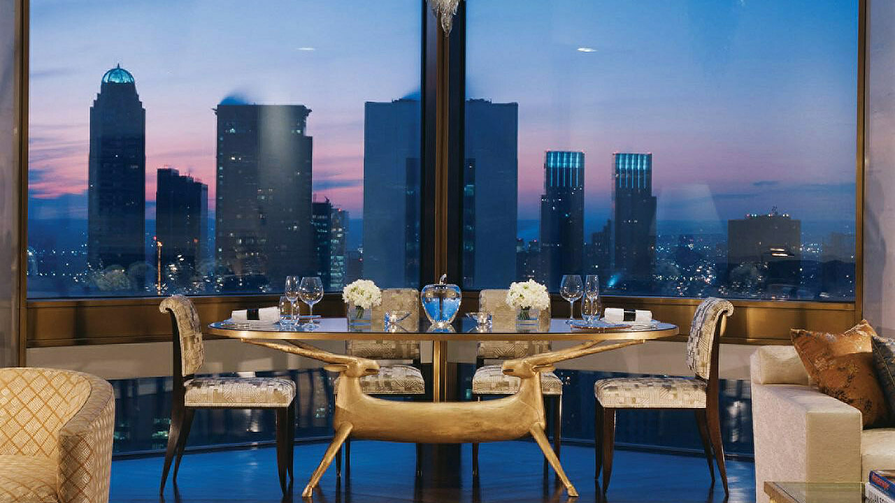
Take a peek behind the scenes at Four Seasons Hotel New York with these facts:
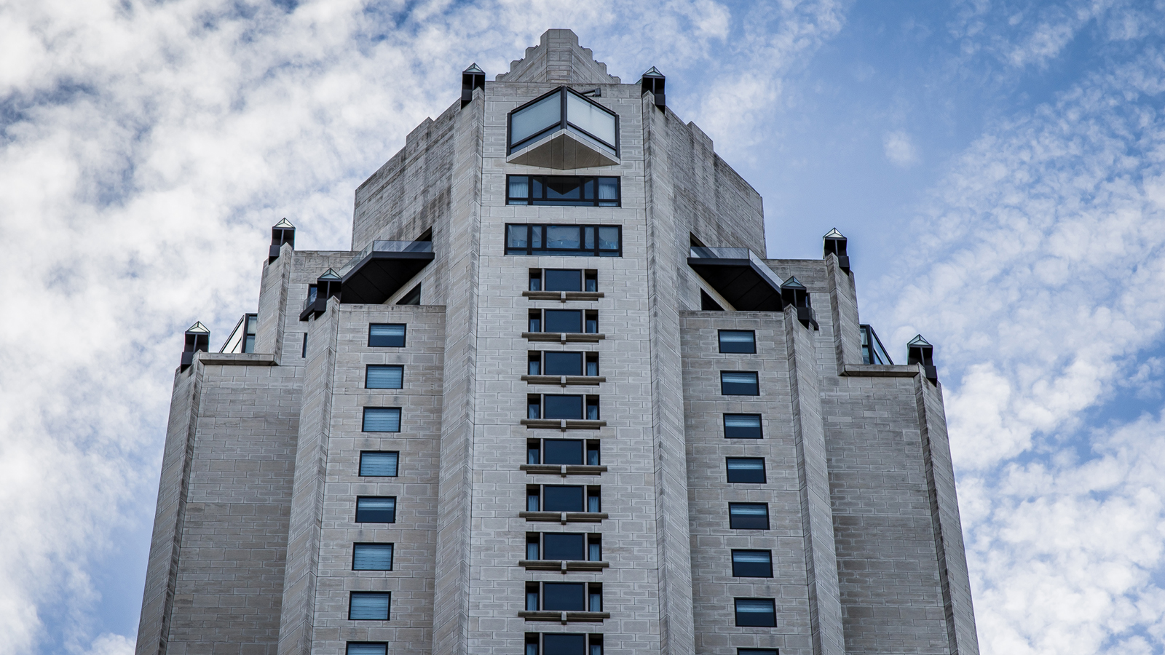
- The Hotel team includes of 535 staff members. The language pool consists of 43 different languages ranging from Afrikaans to Vietnamese.
- In a typical month the concierge desk receives and sends more than 5,400 emails, conducts more than 20,000 phone calls, books more than 1,450 dining reservations, and reserves more than 800 limousines.
- The Hotel's food and beverage storeroom contains of 13,080 glasses, 11,700 pieces of flatware, and 16,215 pieces of china.
- Tenured service enthusiasts hold the key to this master city. The concierge team at Four Seasons Hotel New York has more Les Clefs d'Or (golden keys) members than any other hotel in New York City.
- The Hotel's bell staff of 11 members boasts a total of almost two centuries of service.
- The 52-storey Four Seasons Hotel New York is the second tallest hotel in New York City, standing at nearly 700 feet (213 metres).
- Four Seasons Hotel New York offers the largest standard guest rooms in New York City, with an average 600 square feet (56 square metres).
- The Hotel is the only IM Pei-designed hotel in the western hemisphere. The honey-coloured French Magny “Le Louvre” limestone, which covers the Hotel’s exterior and interior, is the same limestone used by Pei in his expansion of The Louvre in Paris.
- At the Hotel there is a uniform room. Each of employee is allocated three sets of uniforms, for a grand total of more than 2,000 uniforms.
- The 4,300 square foot (400 square metre) Ty Warner Penthouse is priced at USD 50,000 per night, and is the most expensive one bedroom suite in the world.

RELATED

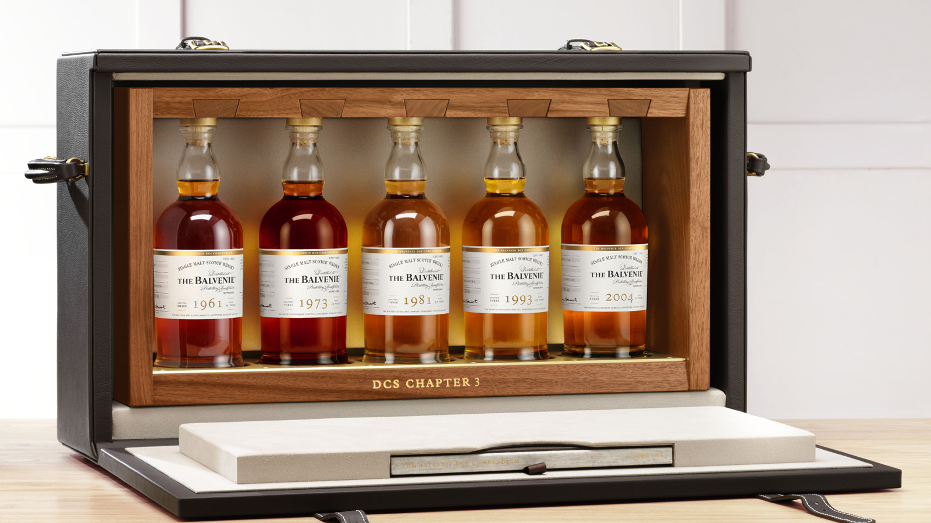 | October 25, 2017, New York, U.S.A.  The Balvenie Unveils DCS Compendium Chapter Three at Four Seasons Hotel New York, an Unprecedented Collection of Rare Whiskies Including the Oldest Balvenie Ever Released  https://publish.url/newyork/hotel-news/2017/balvenie-dcs-compendium-at-ty-bar.html
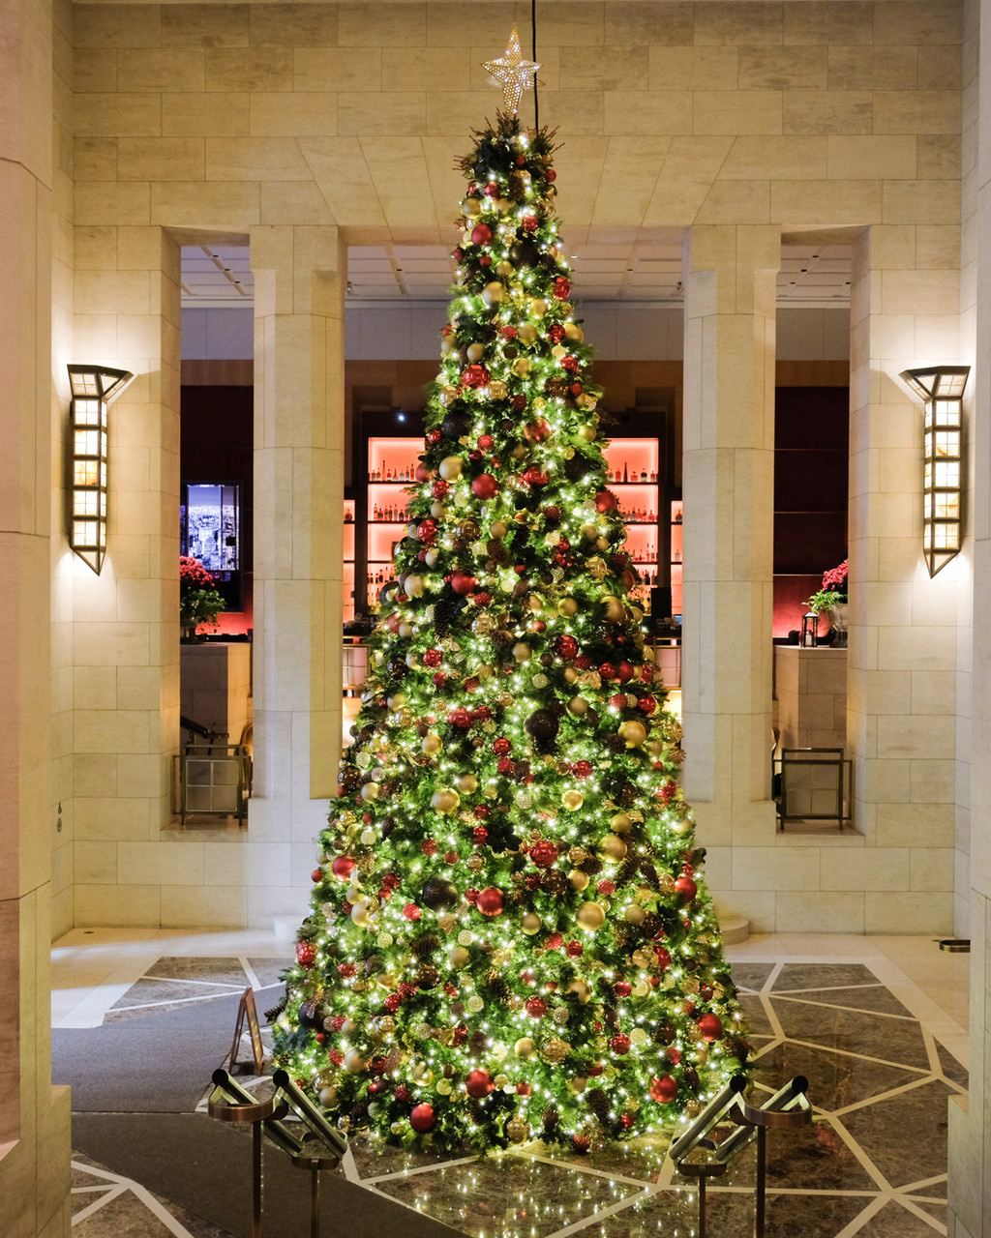 | October 16, 2017, New York, U.S.A.  Celebrate the Holidays in the Heart of Manhattan at Four Seasons Hotel New York  https://publish.url/newyork/hotel-news/2017/festive-season.html

PRESS CONTACTS

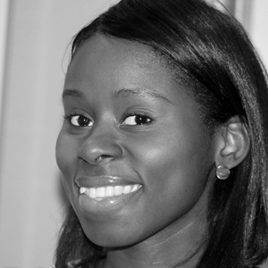 | Nieves Alvarez  Digital Marketing Manager  57 East 57th Street  New York  U.S.A.  nieves.alvarez@fourseasons.com  +1 (212) 350-6207

