Four Seasons Resort Nevis Named Among Forbes Travel Guide's 2019 Star Award Winners

Four Seasons is the only resort on the island of Nevis to receive a Forbes Star rating
February 21, 2019, Nevis, West Indies

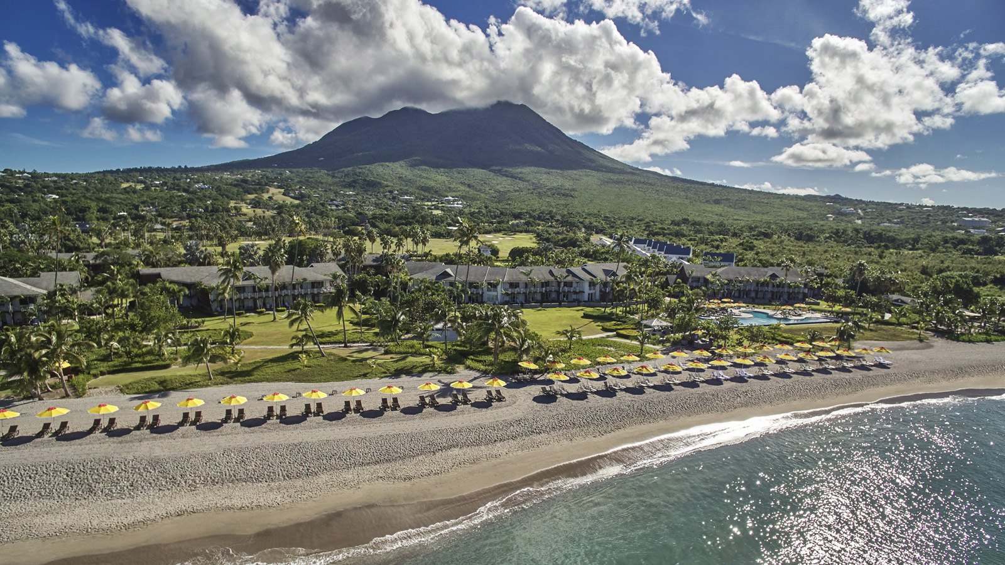
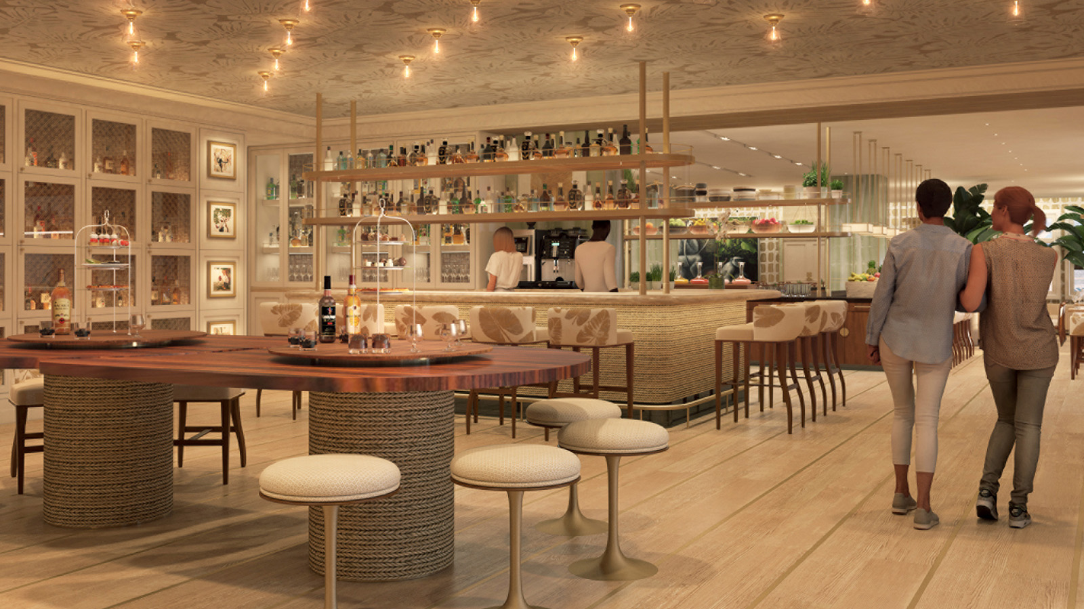 | 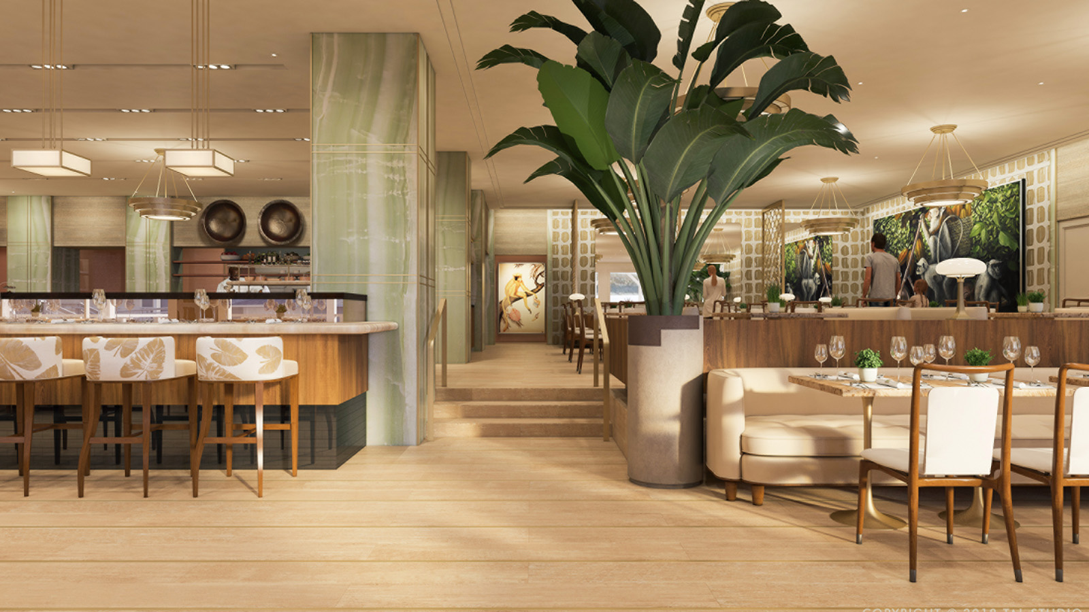 | 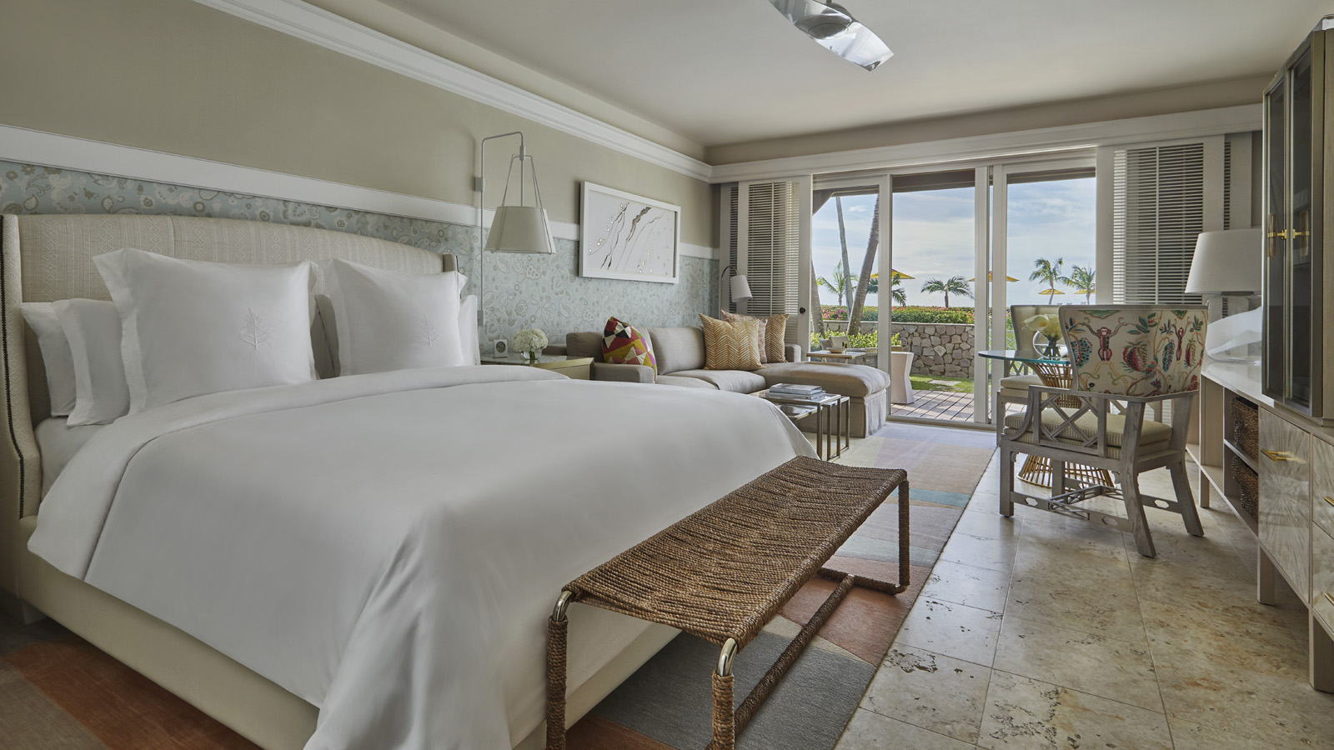
Celebrating more than 28 years of excellence and prestige within the Caribbean, Four Seasons Resort Nevis continues to shine bright among the world’s leading luxury resorts as the only property on the island to be named a Forbes Travel Guide Star Award Winner, for the third consecutive year. Making the honour even sweeter this year is the recognition of the property’s recent multi-million dollar renovation, of which the first phase was completed last December. Unveiling a fresh take on a timeless Caribbean experience, the 350-acre (140 hectare) property now features completely redesigned guest rooms and suites, an updated Great House lobby and two brand new food and beverage concepts – EsQuilina and crowned monkey RUM BAR.
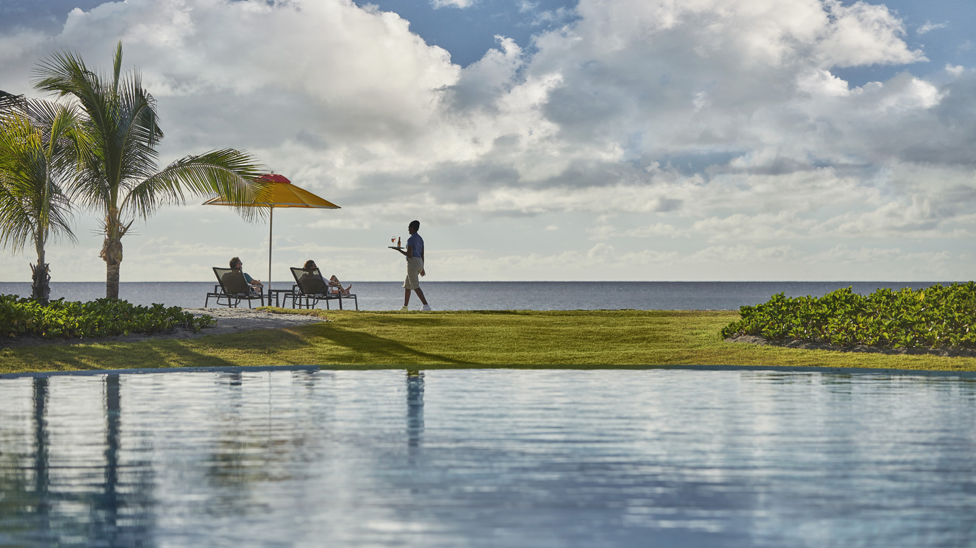 | 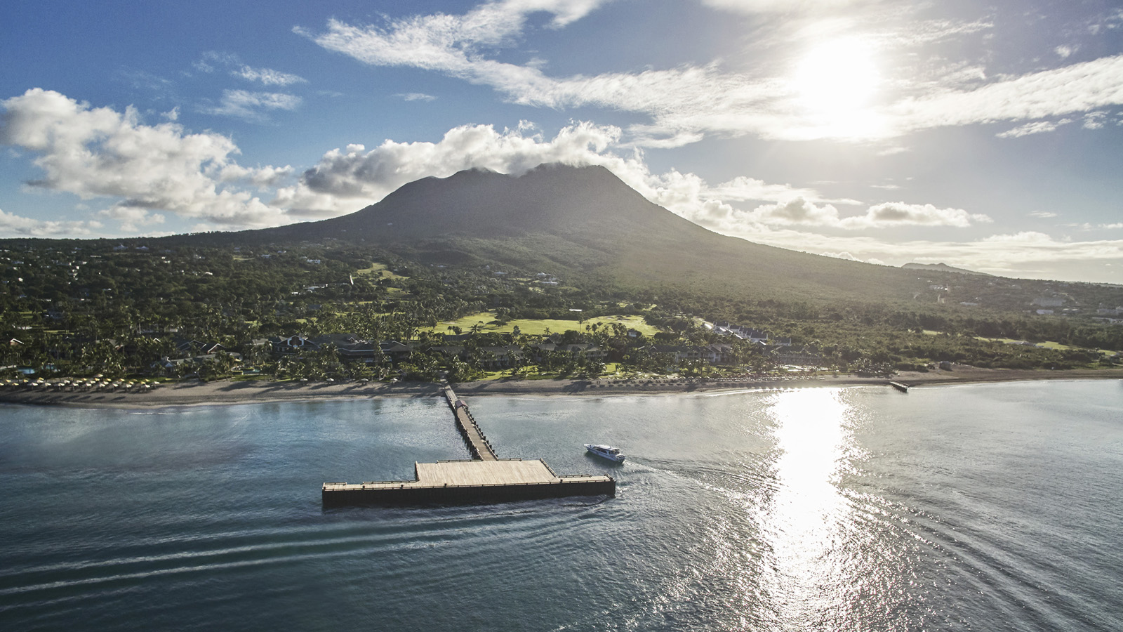 | 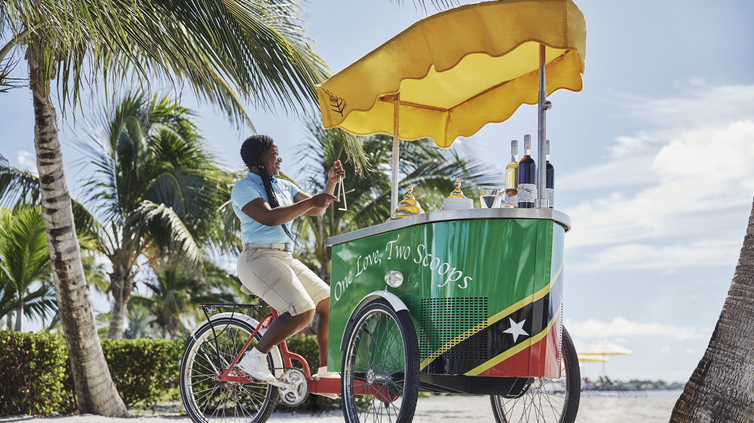
Forbes Travel Guide scours the globe to discover the world’s best hotels, restaurants and spas for its annual Star Awards. The rating emphasises the graciousness, thoughtfulness and personalised service of each property. Four Seasons Hotels and Resorts has received the most Five-Star ratings awarded to a hotel brand in a single year in the list’s 61-year history in 2019, solidifying the company as an innovative leader in craftsmanship, dedication and excellence within the luxury travel and hospitality industry.
“We are humbled and proud to receive this accolade once again from Forbes Travel Guide,” says Gonzalo Güelman Ros, General Manager of Four Seasons Resort Nevis. “Being recognised alongside the top hotels from around the world proves that even after 28 years, our Resort is still recognised as a leader within the industry and will continue to be that for many years to come. As we move into the future, we will stay committed to providing excellent service to our guest and offer them new and exciting experiences with the completion of our enhancement project.”
Offering infinite perfect places in one perfect paradise, Four Seasons Resort Nevis is not simply a resort on an island. A staple of Nevisian culture, the Resort blends seamlessly into its surroundings, embraces local traditions and style and strives to deliver personal and unique experiences for the modern traveller in search of authenticity and adventure. This honour is a true testament to those efforts.
For reservations, book online,call (869) 469 6238 or contact your travel professional (chain code FS).

RELATED

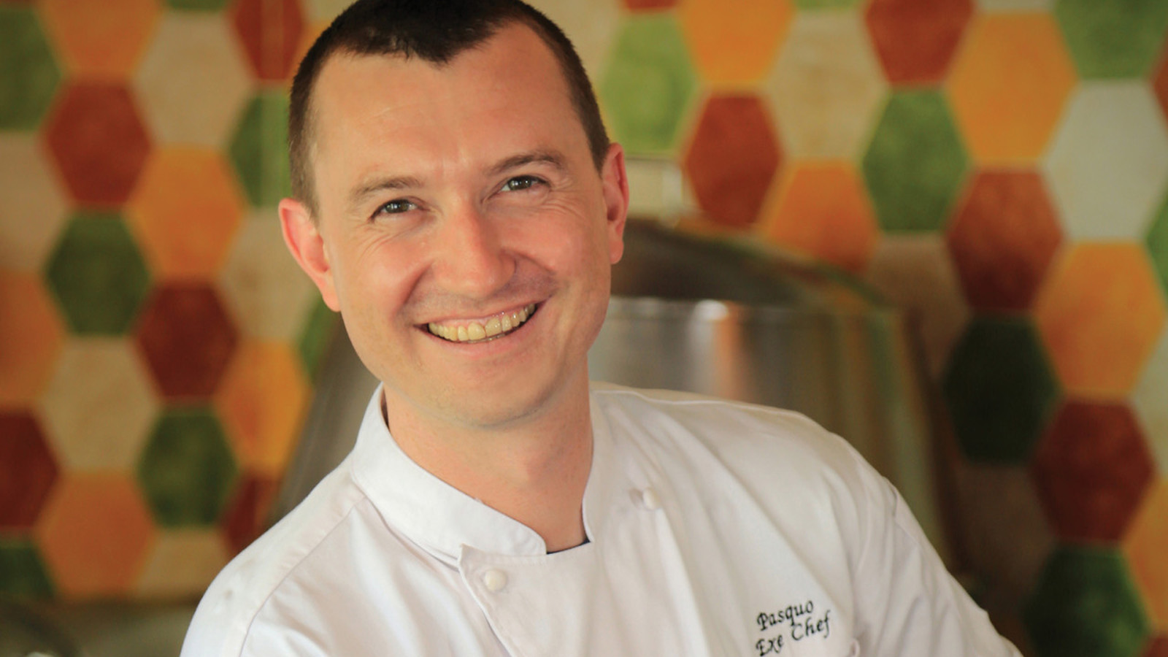 | December 4, 2018, Nevis, West Indies  Pasquo King Named New Director of Food and Beverage at Four Seasons Resort Nevis  https://publish.url/nevis/hotel-news/2018/new-food-and-beverage-director-pasquo-king.html
October 16, 2018, Nevis, West Indies
Four Seasons Resort Nevis Will Unwrap New Rooms, Restaurants and Guest Experiences Just in Time for the Holidays
https://publish.url/nevis/hotel-news/2018/resort-renovations-complete-for-festive-season.html

PRESS CONTACTS

Gillian Stoney
Digital Marketing Communications Manager

Four Seasons Resort Nevis
Nevis, West Indies, Caribbean
gillian.stoney@fourseasons.com

+1 (786) 655-8507

Mitchell Nover
Director of Public Relations and Communication
3350 SW 148th Avenue, Suite 204
Miramar
U.S.A.
mitchell.nover@fourseasons.com

+1 (786) 655-8509

