Tweets and Feathers

Four Seasons Hotel Hangzhou at West Lake presents new birdwatching ecotour
February 7, 2019, Hangzhou at West Lake, China

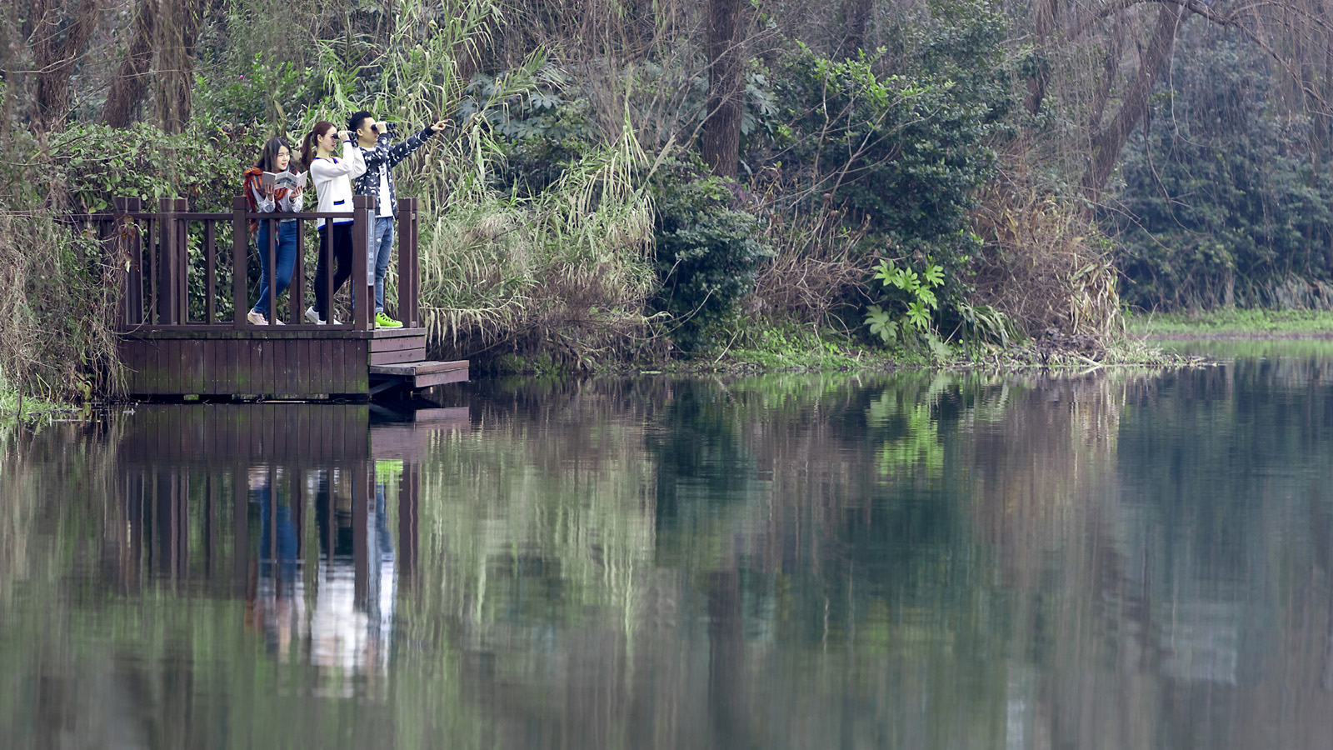
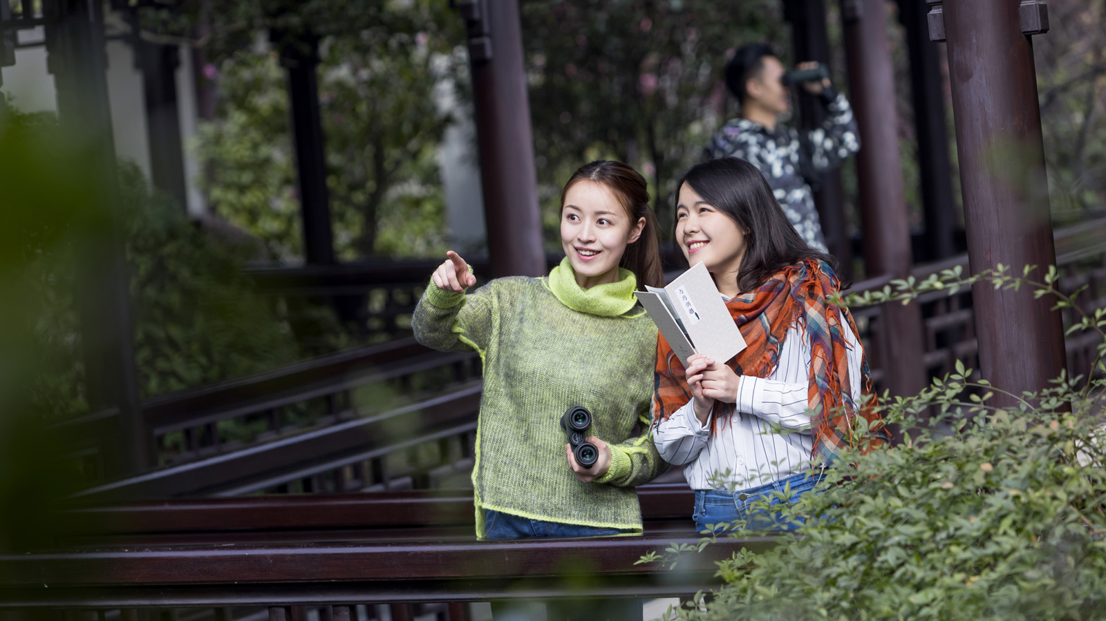 | 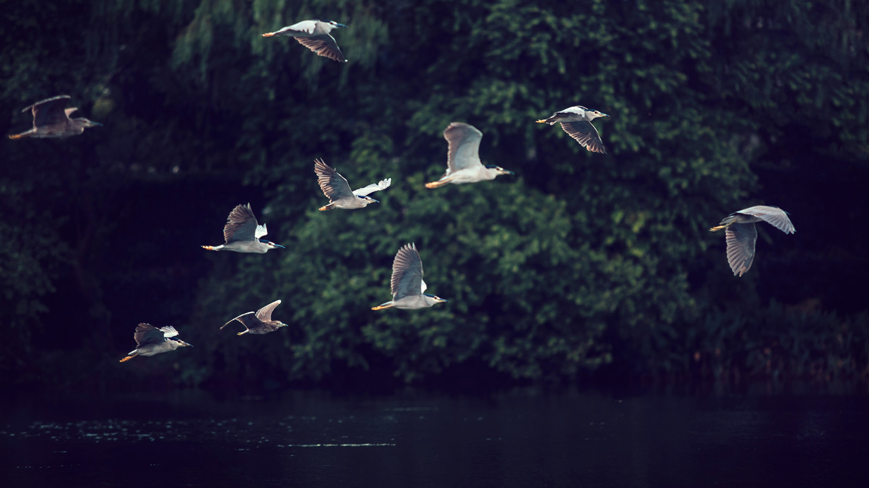
Originating from 18th century England, birdwatching has a history spanning over 200 years. Initially a recreational activity for European aristocrats, today, it has become a popular form of ecotourism and a hobby enjoyed by millions of people around the world. While birdwatching was first introduced in the west, China is becoming an increasingly coveted birding destination for its great biodiversity and large number of rare species of birds.
Prominently featured in ancient Chinese mythologies and folklores, birds have always held a special place in Chinese culture and are deemed a symbol of resilience and freedom. Birdwatching had its start in China in the 1980s. Hangzhou in particular, with its beautiful landscape and wonderful wildlife conservation efforts, has attracted the growing attention of professional and amateur birdwatchers alike.
To offer our guests a fun and sustainable way to discover Hangzhou’s wild birds and their natural habitats, Four Seasons Hotel Hangzhou at West Lake has designed an ecotourism program named the West Lake Wildbird Exploration. Guided by professional tour guides from the Hangzhou Wildbird Society, the tour starts from the hotel’s scenic garden before venturing around West Lake, and takes a total of 1-1.5 hours, depending on the guests’ preferences. Bring your binoculars and a birdwatching map specifically designed for the tour, and get ready to be greeted by an array of colourful wild birds such as the white wagtail, the Mandarin Duck, the little egret and the spangled drongo. No matter if you are an ornithologist extraordinaire or simply a fan of the winged creatures, the tour will be a unique and exciting opportunity for you to get close to nature and experience a different side of West Lake’s alluring charm.

RELATED

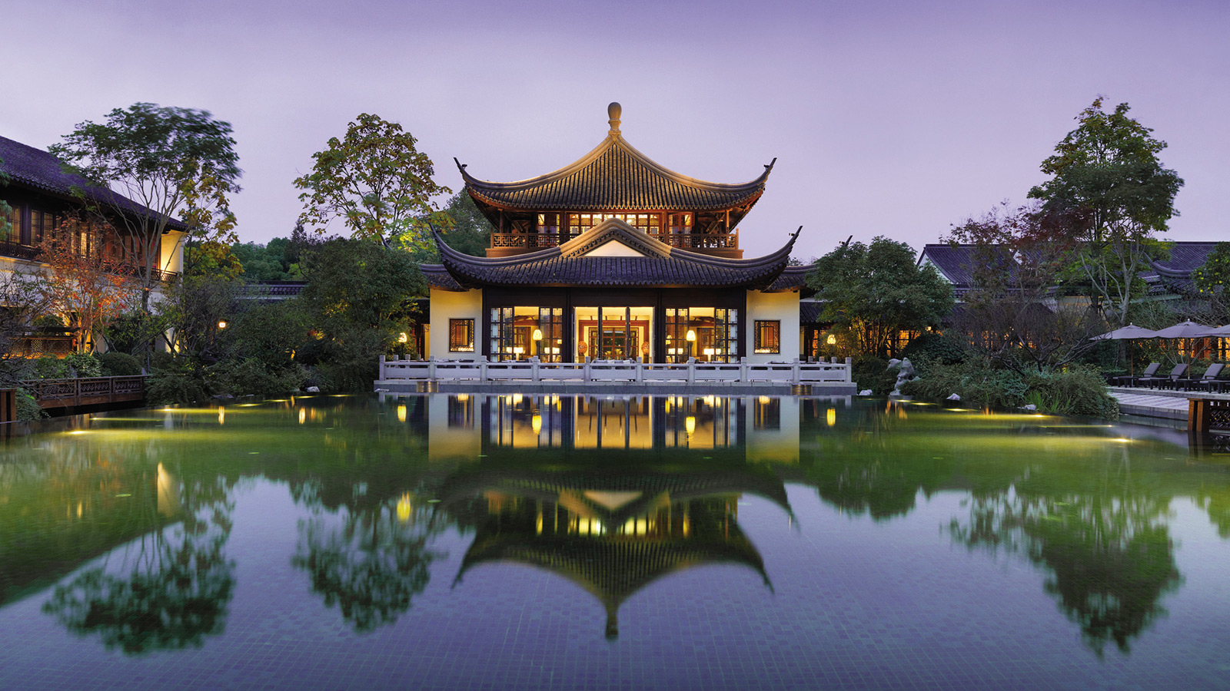 | January 24, 2019, Hangzhou at West Lake, China  Four Seasons Hotel Hangzhou at West Lake Receives Recognition in Elite Traveler Top 100 Hotels, Ctrip 7 Diamond Hotels and Black Pearl Ratings  https://publish.url/hangzhou/hotel-news/2019/recent-awards-and-accolades.html
January 24, 2019, Hangzhou at West Lake, China
杭州西子湖四季酒店荣获 Elite Traveler全球最佳100家酒店、 携程TOP全球酒店七钻酒店、大众点评黑珍珠餐厅指南三钻三项殊荣
https://publish.url/zh/hangzhou/hotel-news/2019/recent-awards-and-accolades-2.html

PRESS CONTACTS

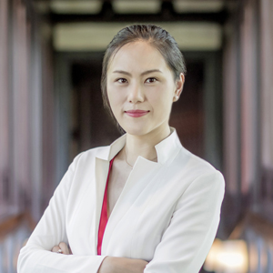 | Cecilia Xu  Assistant Director of Public Relations  5 Lingyin Road  Hangzhou  China  cecilia.xu@fourseasons.com  +86 571 8829 8888
Vivian Koh
Director, Public Relations and Content, Asia-Pacific
Tourism Court, 1 Orchard Spring Lane #04-01
Singapore
Singapore
vivian.koh@fourseasons.com

+65 6739 5806

