Four Seasons Hotel Sydney Celebrates Love at Mode Kitchen & Bar This Valentine’s Day

January 28, 2020, Sydney, Australia

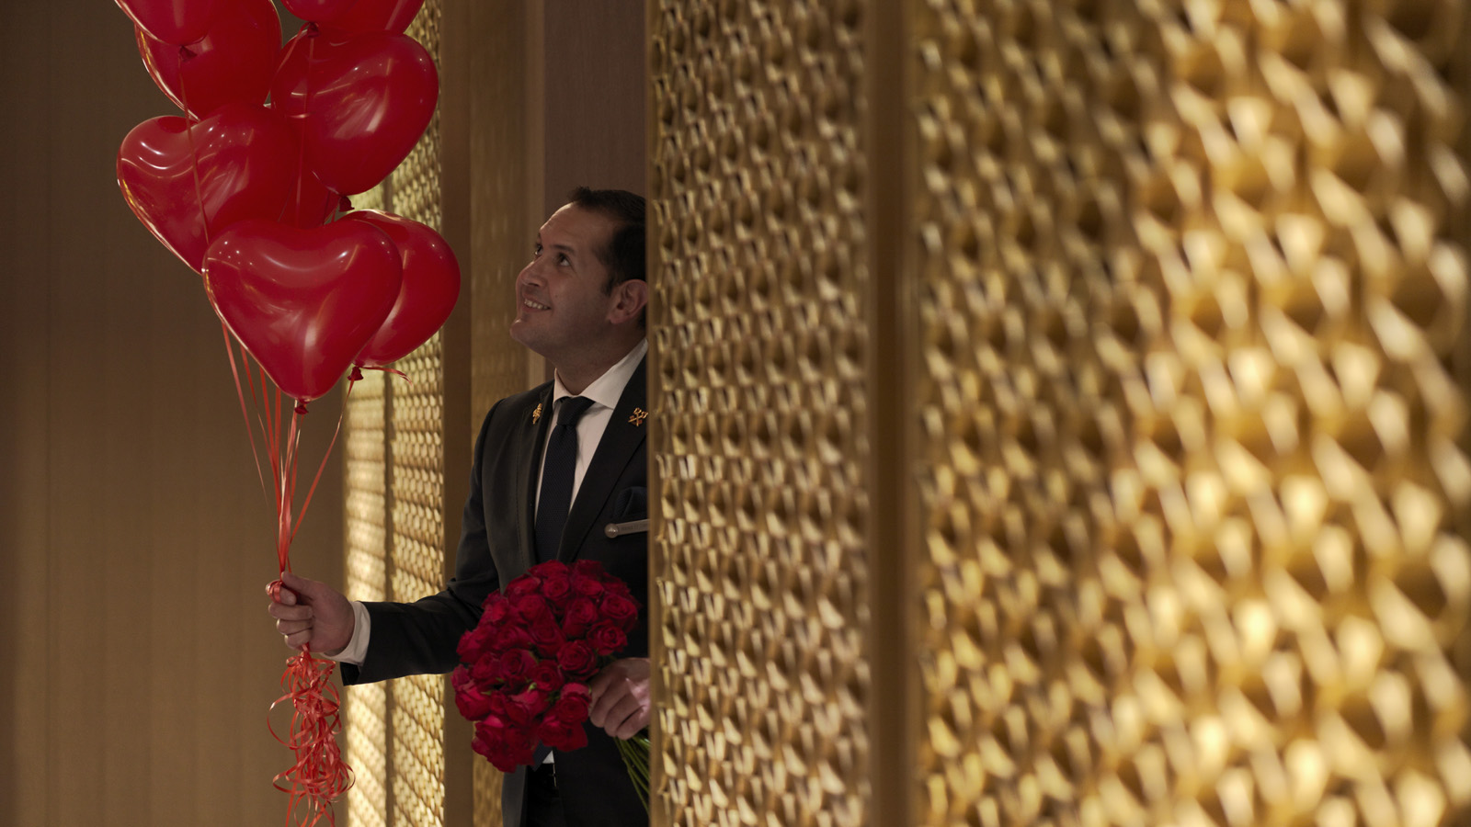
Celebrate Valentine’s Day with an indulgent five-course dinner hosted in Mode Kitchen & Bar’s warm, intimate setting.
Savour a variety of carefully-crafted dishes that showcase bold flavour profiles and fresh produce, designed by award-winning Head Chef Francesco Mannelli. From refined scallop tartare, finger lime and smoked Yarra Valley caviar to a rich and creamy saffron risotto with scarlet prawns and stracciatella, treat the palate to a truly memorable experience.
End the night on a sweet note by sharing a decadent raspberry and dark chocolate framboisier with a loved one, created by French pastry duo ElliottRoussel and Quentin Zerr.
Seats are strictly limited, available February 14, 2020 for AUD 130 per person. Reservations and pre-payment is required to secure the booking. Book today at hello@modekitchenandbar.com.au or (02) 9250 3160.
Menu
- Scallops tartare, finger lime and smoked Yarra Valley caviar
- “Gnudi” zucchini flowers, buffalo ricotta, butter and sage
- Saffron risotto, scarlet prawn and stracciatella
- Mayura Station striploin MB 7+, caramelised fig and orange; or, wood-roasted Glacier 51 toothfish and spicy tomato consommé and baby summer vegetables
- Raspberry and dark chocolate framboisier
- Petit fours
Mode Kitchen & Bar is located within Four Seasons Hotel Sydney.

RELATED

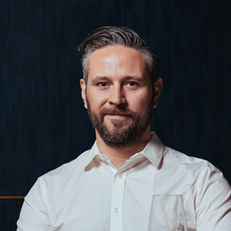 | January 28, 2020, Sydney, Australia  Mode Kitchen & Bar at Four Seasons Hotel Sydney Awarded Chef’s Hat by Australian Food Guide  https://publish.url/sydney/hotel-news/2020/chefs-hat-award-for-mode-kitchen-and-bar.html
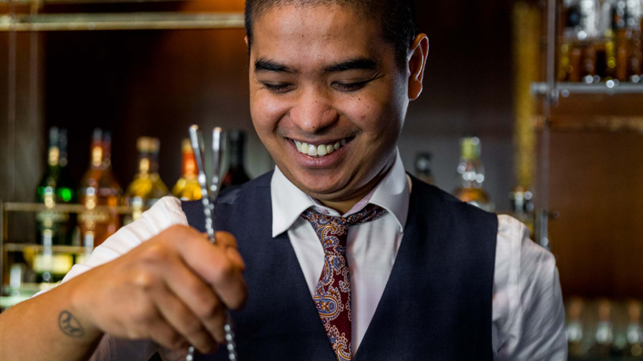 | August 1, 2019, Sydney, Australia  World-Acclaimed Cedric Mendoza Appointed as Head Bartender of Grain Bar at Four Seasons Hotel Sydney  https://publish.url/sydney/hotel-news/2019/new-head-bartender-cedric-mendoza.html

PRESS CONTACTS

Gabriella Lizzo
Director of Public Relations and Communications
199 George Street
Sydney
Australia
gabriella.lizzo@fourseasons.com

+61 2 9250 3315

