Four Seasons Hotel London at Ten Trinity Square Launches Exceptional New Events Spaces with Views of the Tower of London and Tower Bridge
- Four Seasons launches two exceptional new residential-style events spaces in the City of London
- The Thames Penthouse offers an extensive terrace with stunning views over the Tower of London, Tower Bridge and the River Thames
- Unique events spaces perfect for corporate events or social gatherings, just steps from major landmarks, business hubs and cultural destinations

July 4, 2019, London at Ten Trinity Square

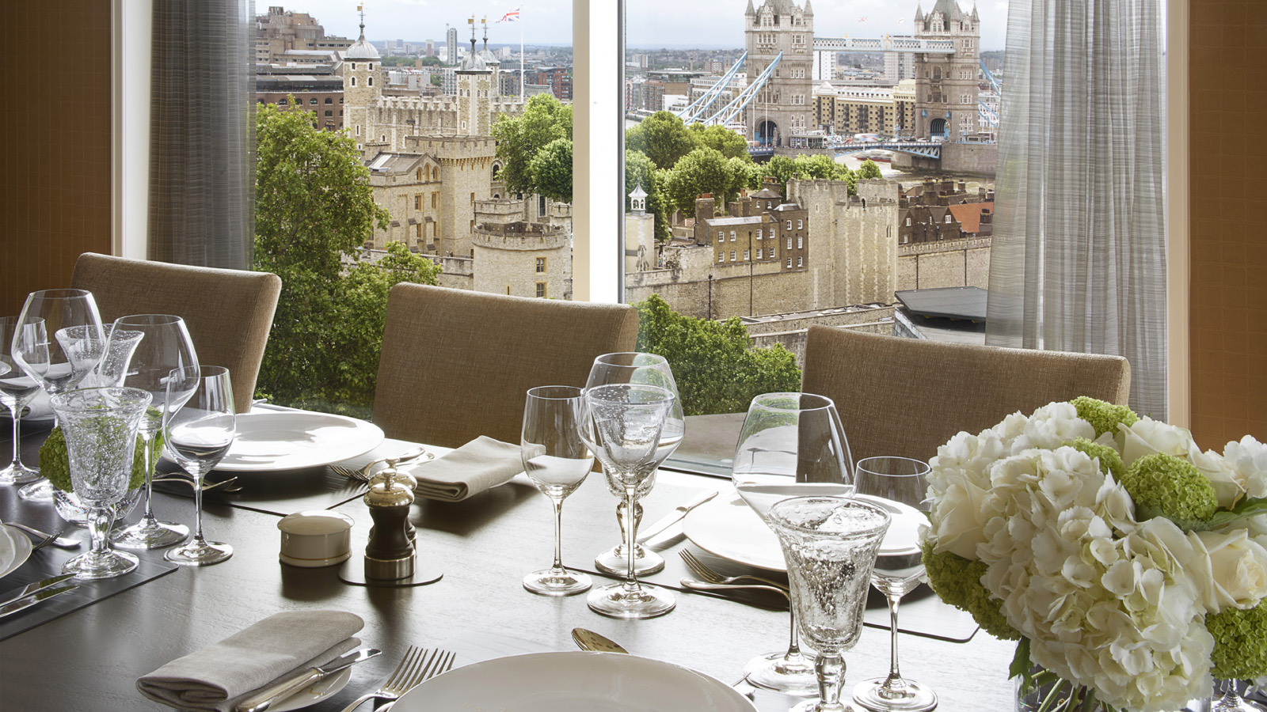
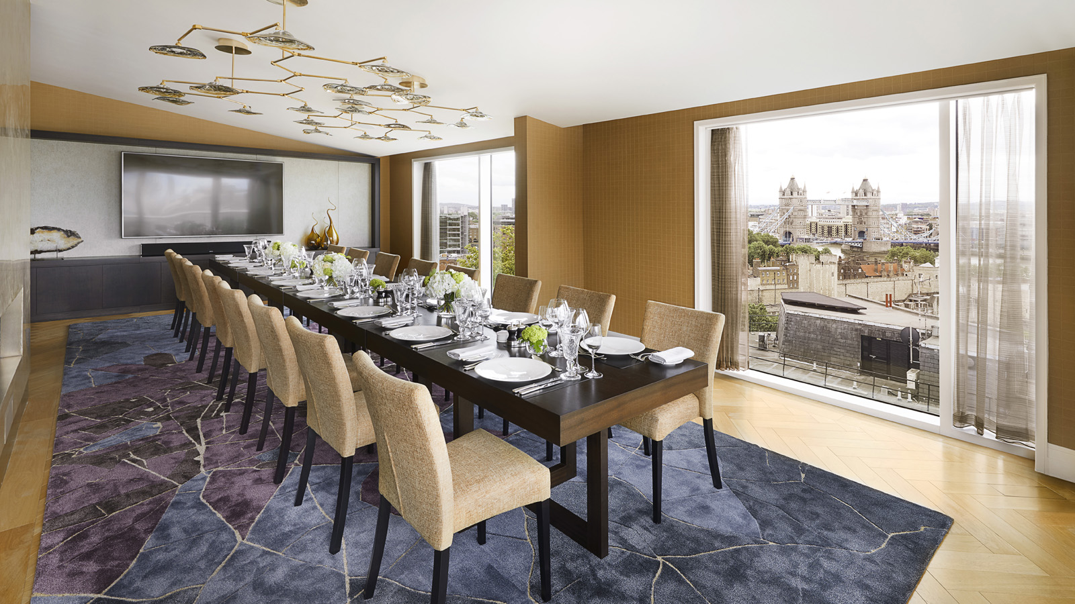 | 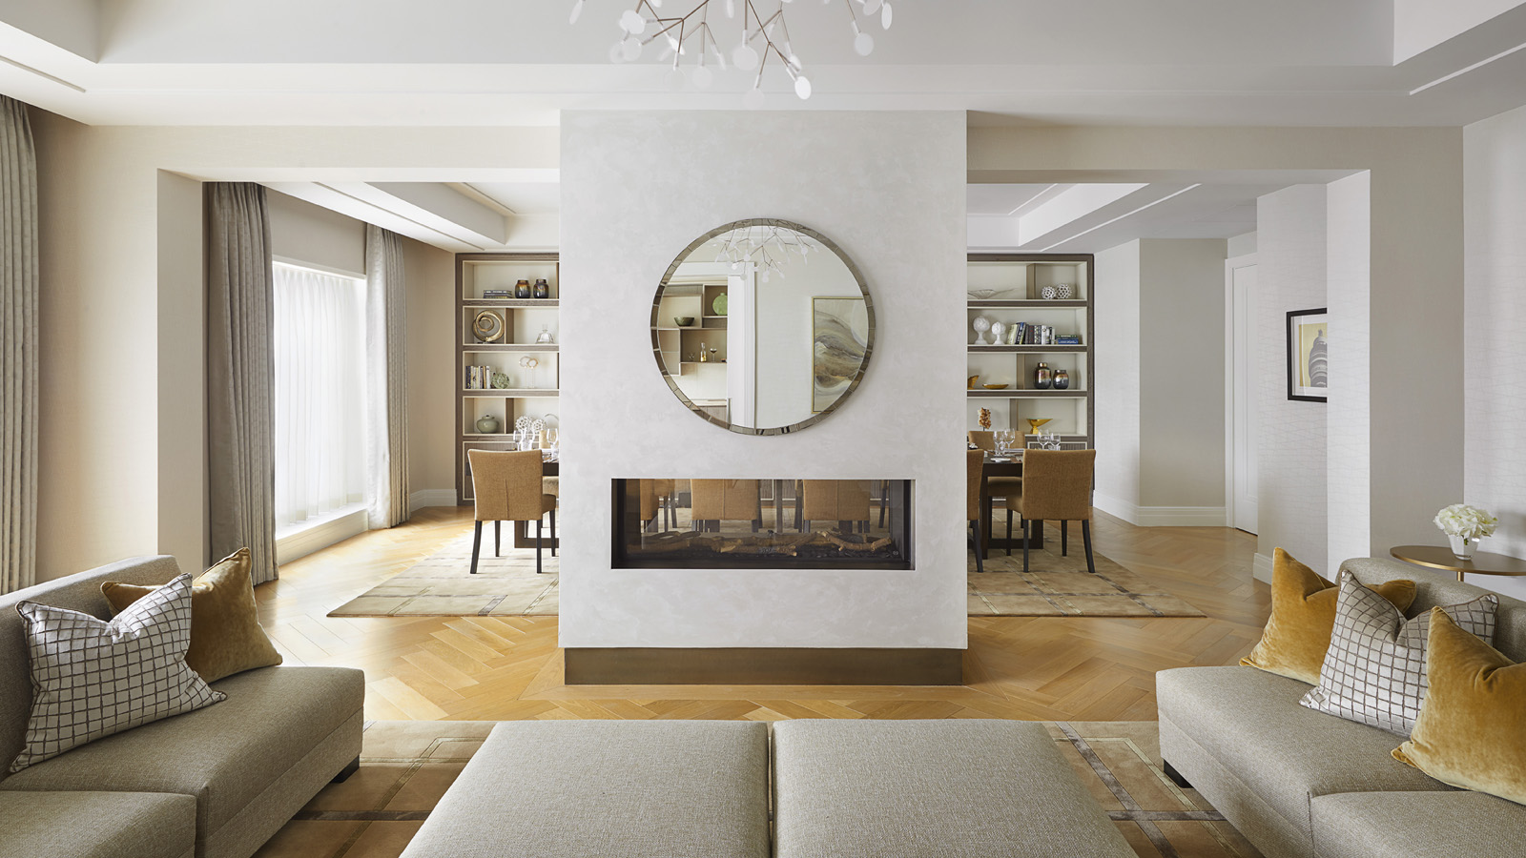 | 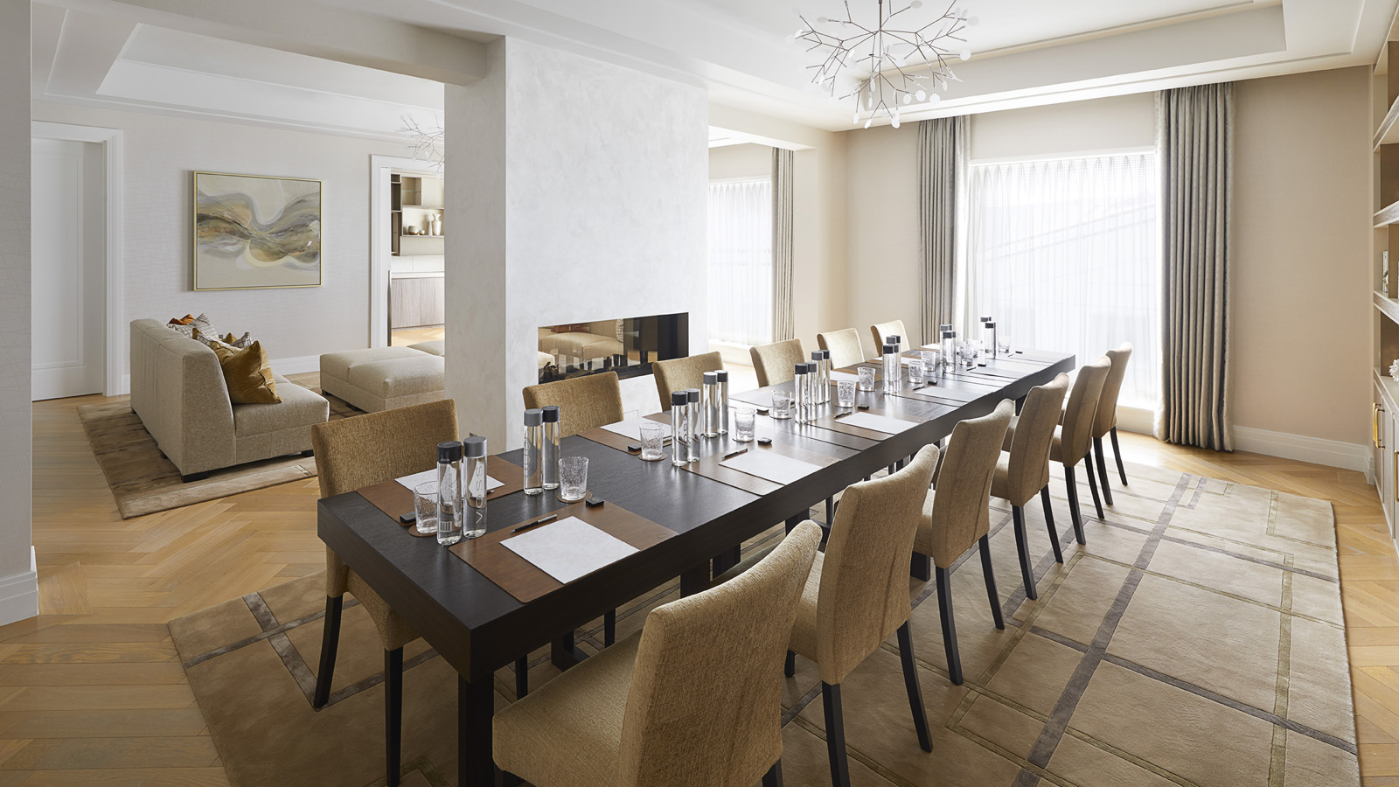
This month, Four Seasons Hotel London at Ten Trinity Square launched of two exceptional new events spaces - The Thames Penthouse and The City Penthouse - on the 7th floor of the historic Grade-II* listed building. London’s leading interior designer David Linley has transformed the venues with elegant and refined interiors with an individual style and character for each space. Offering a unique style of setting for social or corporate events, the two exclusive spaces are now available.
Offering panoramic views of the most iconic and historical architecture the city has to offer, the 6,000 square foot Thames Penthouse is incomparable in the City of London. The residential-style penthouse comprises a large entertaining space at the front of the building with stunning floor to ceiling windows and uninterrupted views over the Tower of London and Tower Bridge. Following the length of the penthouse, a 1,500 square foot terrace offers views over the City and the perfect setting for a summer party or cocktail reception. The penthouse also includes a bespoke bar, open plan seating/living area and kitchen as well as powder rooms. Suitable for receptions up to 80 people, private dinners and meetings or events the penthouse provides a wealth of opportunities for those seeking a unique setting.
The City Penthouse, located on the same floor, is a 3,000 square foot events space offering a light and contemporary venue perfect for smaller meetings or events. The main entertaining space benefits from large windows overlooking the Hotel atrium providing plenty of natural daylight. A connecting room offers the perfect breakout area for breakfast or lunch. The penthouse also comprises a large kitchen area and powder rooms.
Lisa O’Rahilly, Director of Events, comments, “We’re excited to be launching these new spaces and expanding on our existing offering at Four Seasons Hotel London at Ten Trinity Square. The Penthouses will be a great addition to the Hotel and a truly unique events space in the City of London.”
Be Among the First: The Thames and City Penthouses are now available for booking. Contact +44(0)20 3297 9200 or events.tentrinity@fourseasons.com.

RELATED

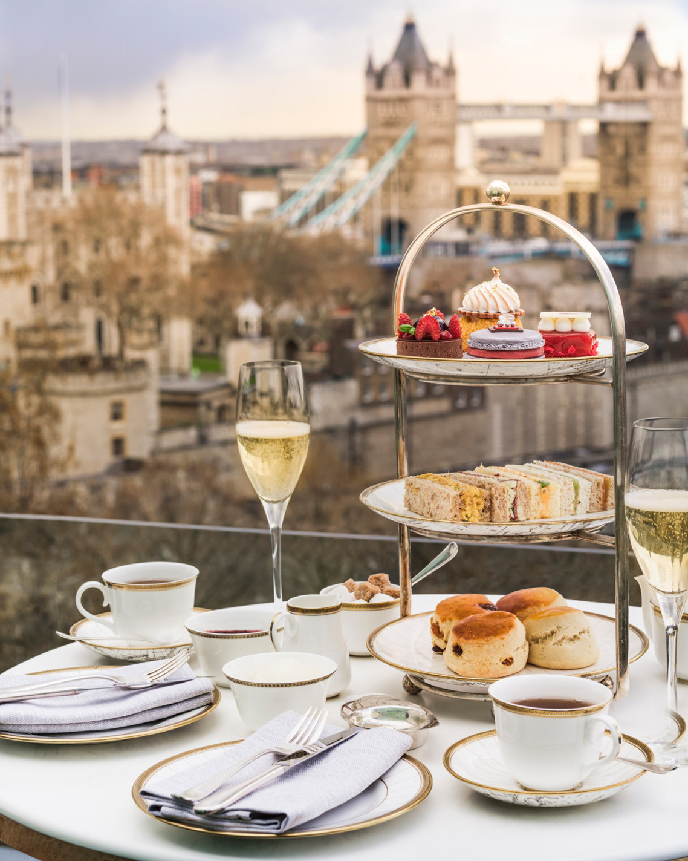 | April 17, 2019, London at Ten Trinity Square  A Taste of Royalty with the Crown Jewels Afternoon Tea at Four Seasons Hotel London at Ten Trinity Square  https://publish.url/tentrinity/hotel-news/2019/crown-jewels-afternoon-tea.html
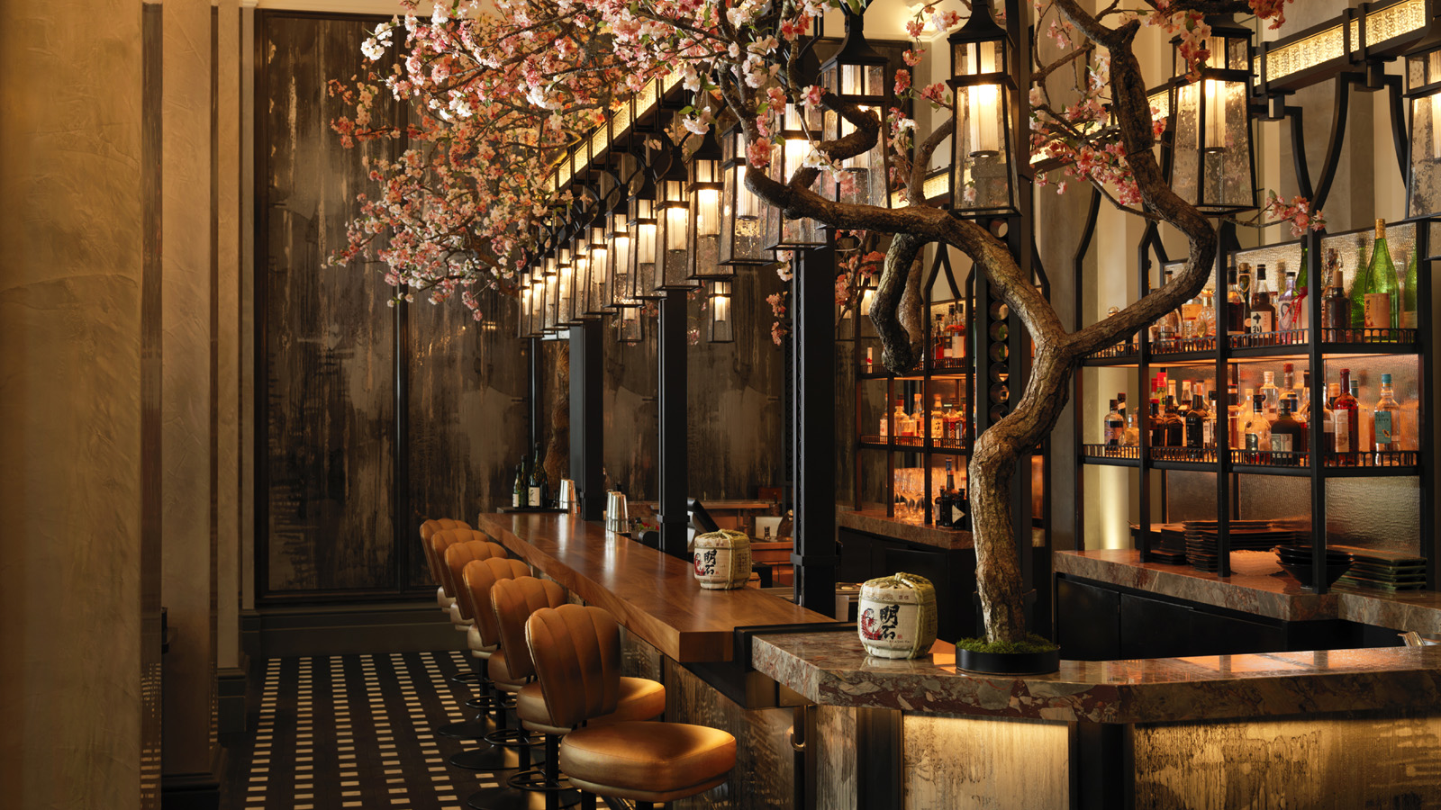 | March 1, 2019, London at Ten Trinity Square  In Bloom: Mei Ume at Four Seasons Hotel London at Ten Trinity Square Celebrates the Spring Festival Hanami  https://publish.url/tentrinity/hotel-news/2019/spring-festival-at-mei-ume.html

PRESS CONTACTS

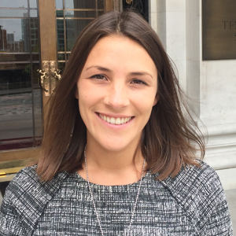 | Gemma Minto  Director of Public Relations  10 Trinity Square  London  UK  gemma.minto@fourseasons.com  +44 (0) 203 297 9232

