Celebrate the Fall Season with Four Seasons Hotel Casablanca

October 11, 2019, Casablanca, Morocco

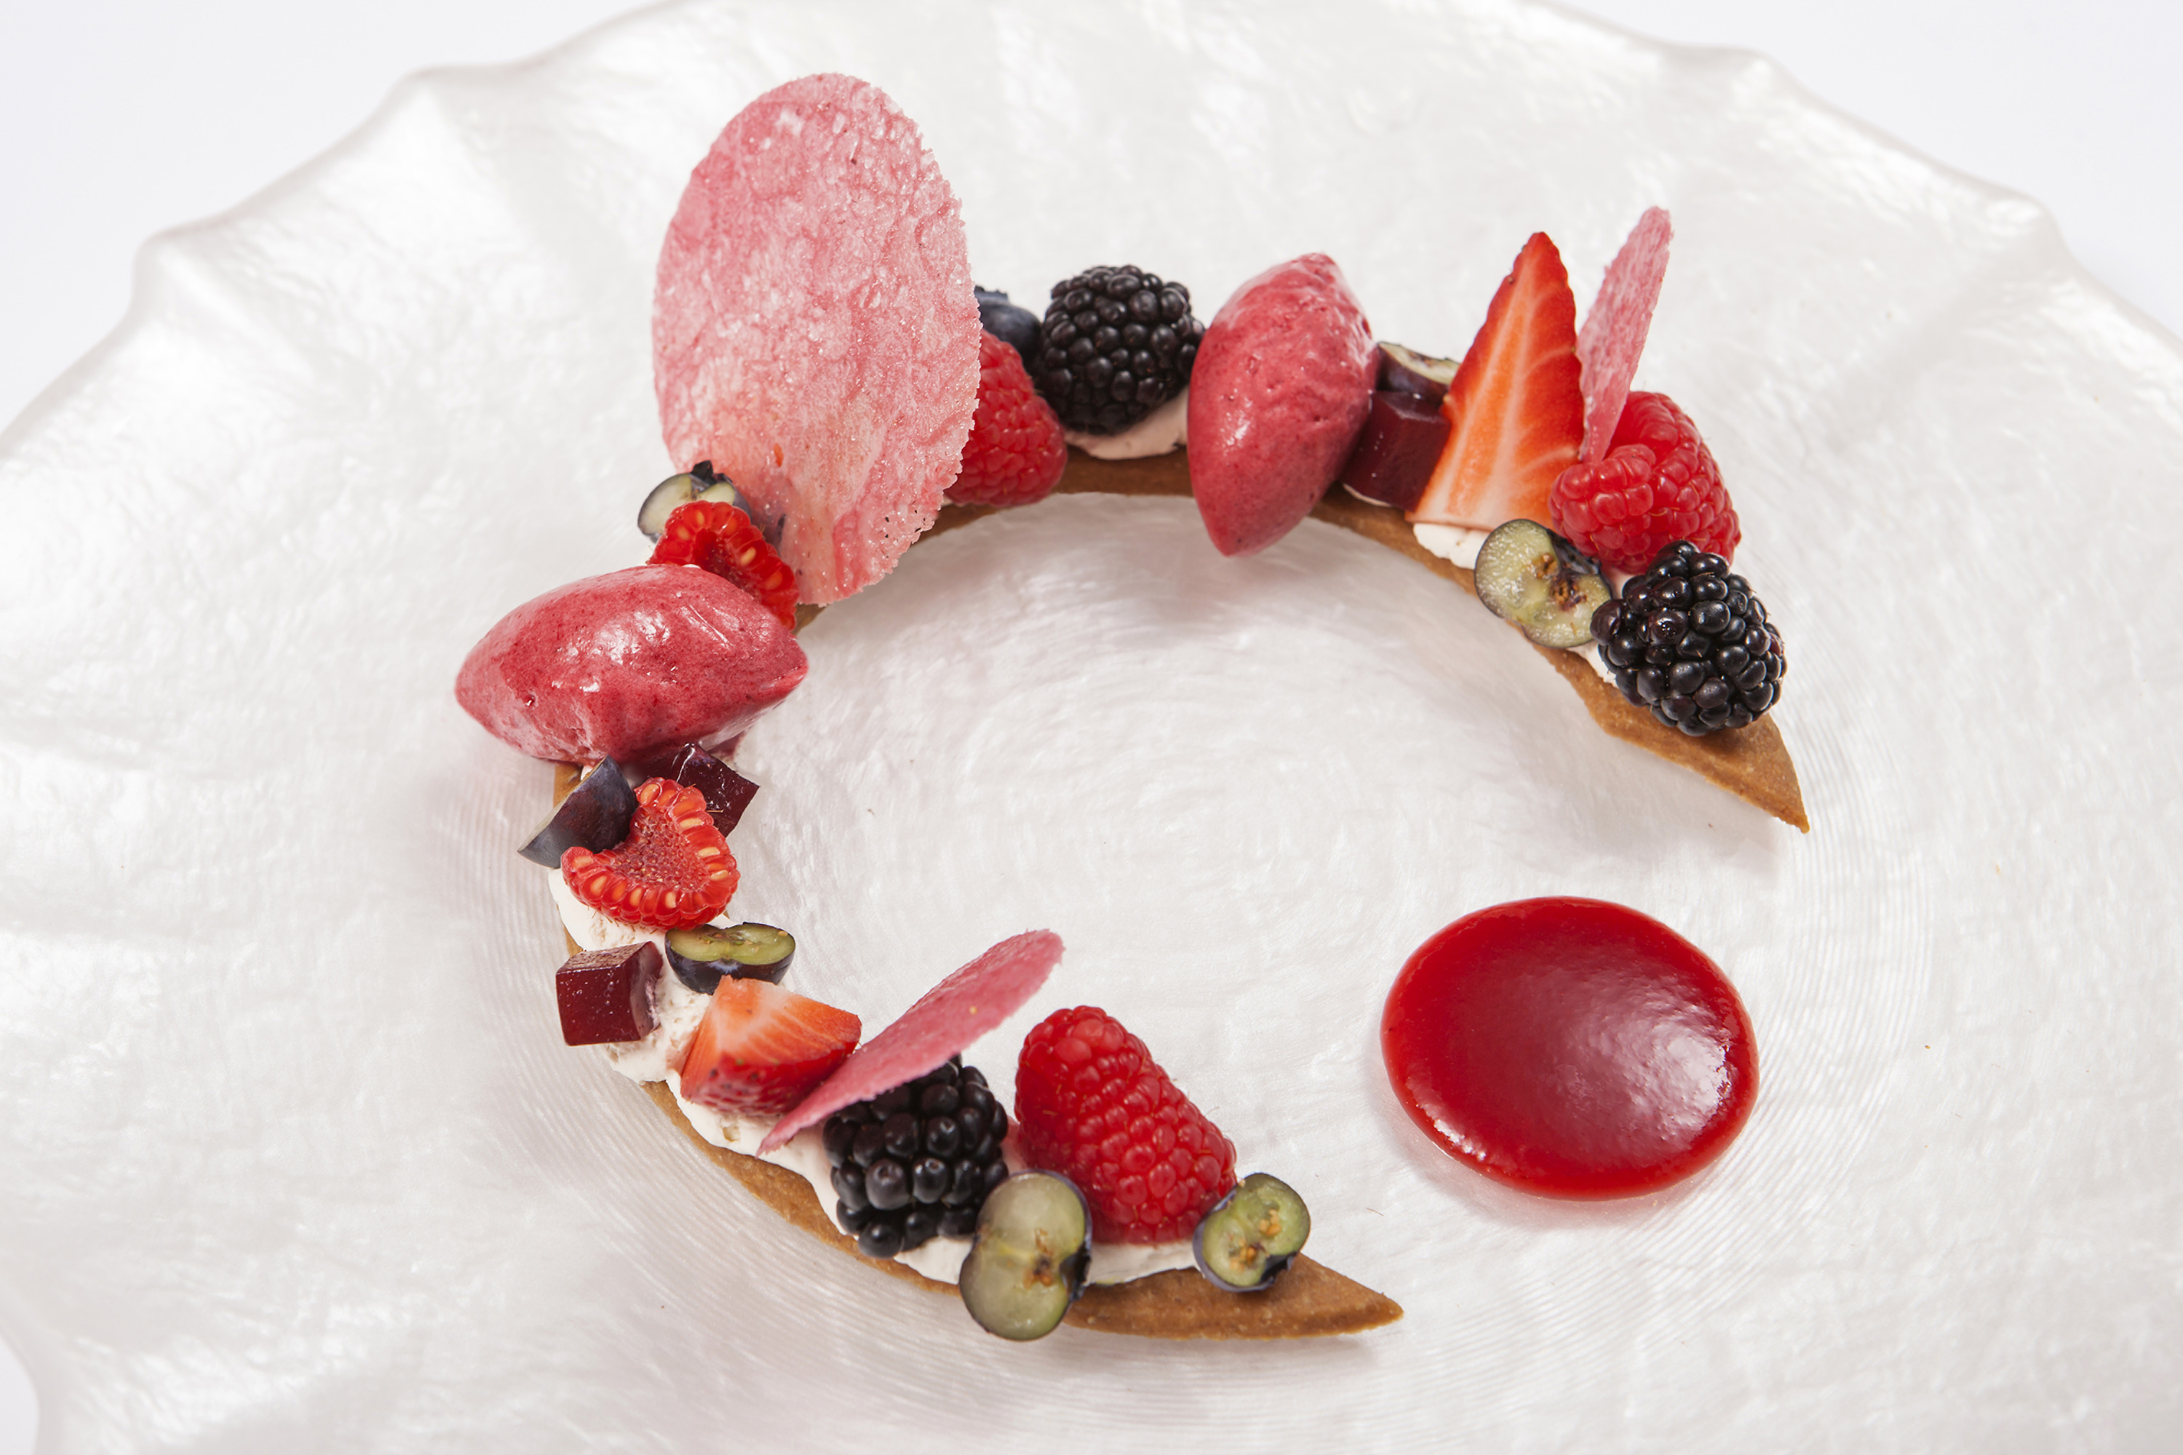
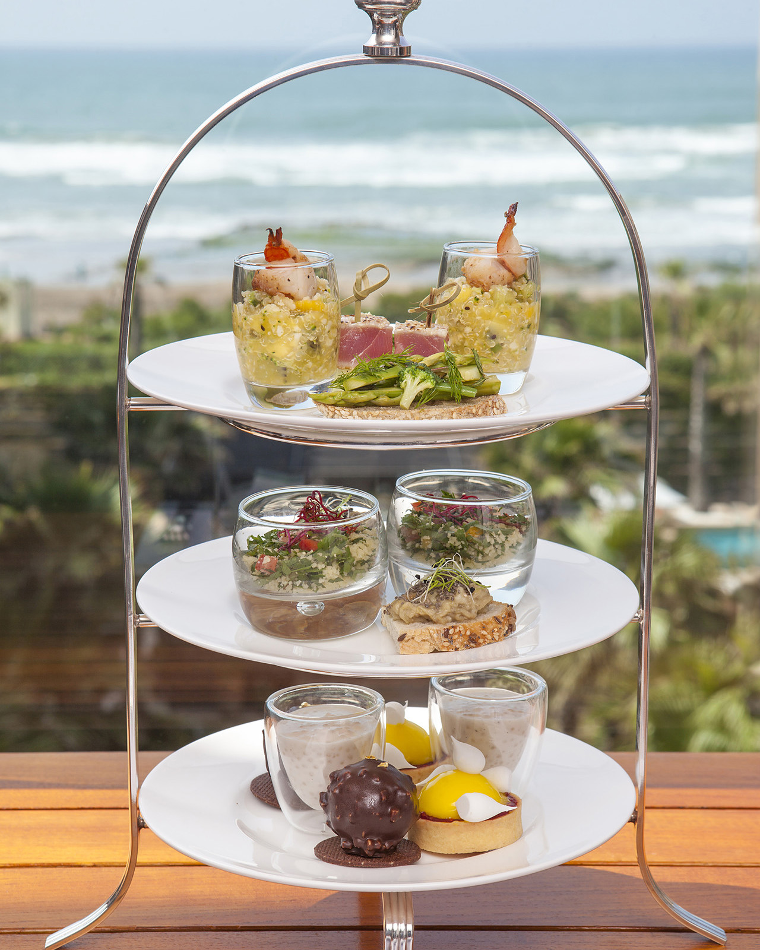 | 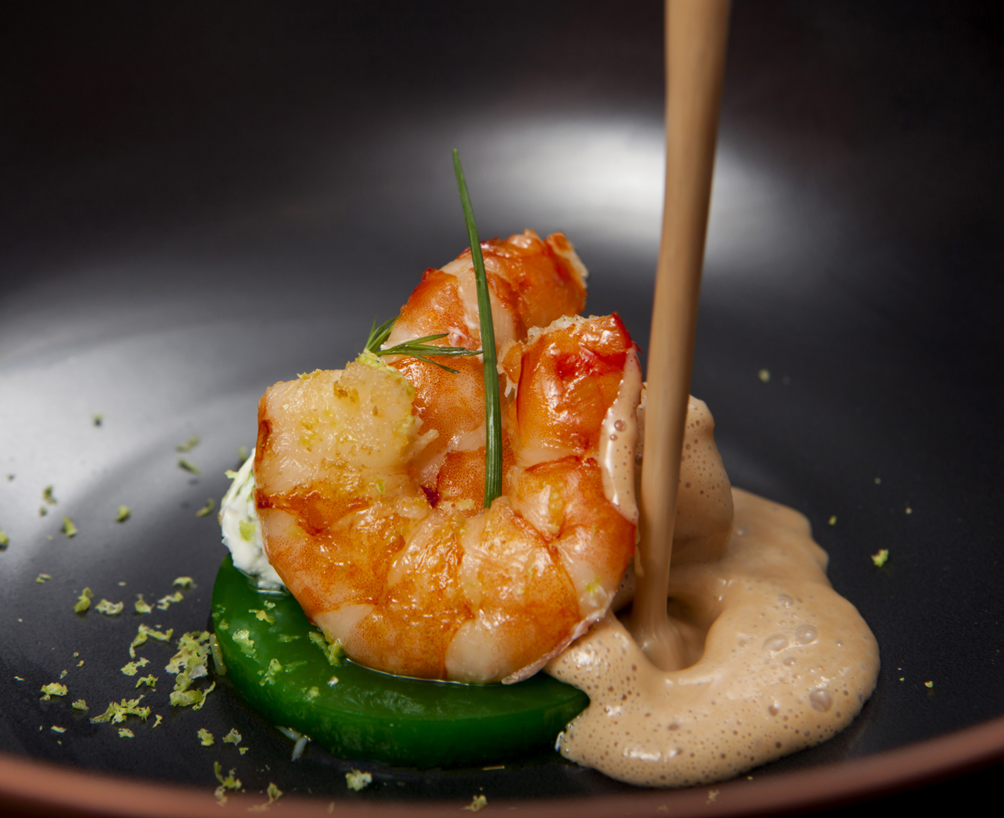 | 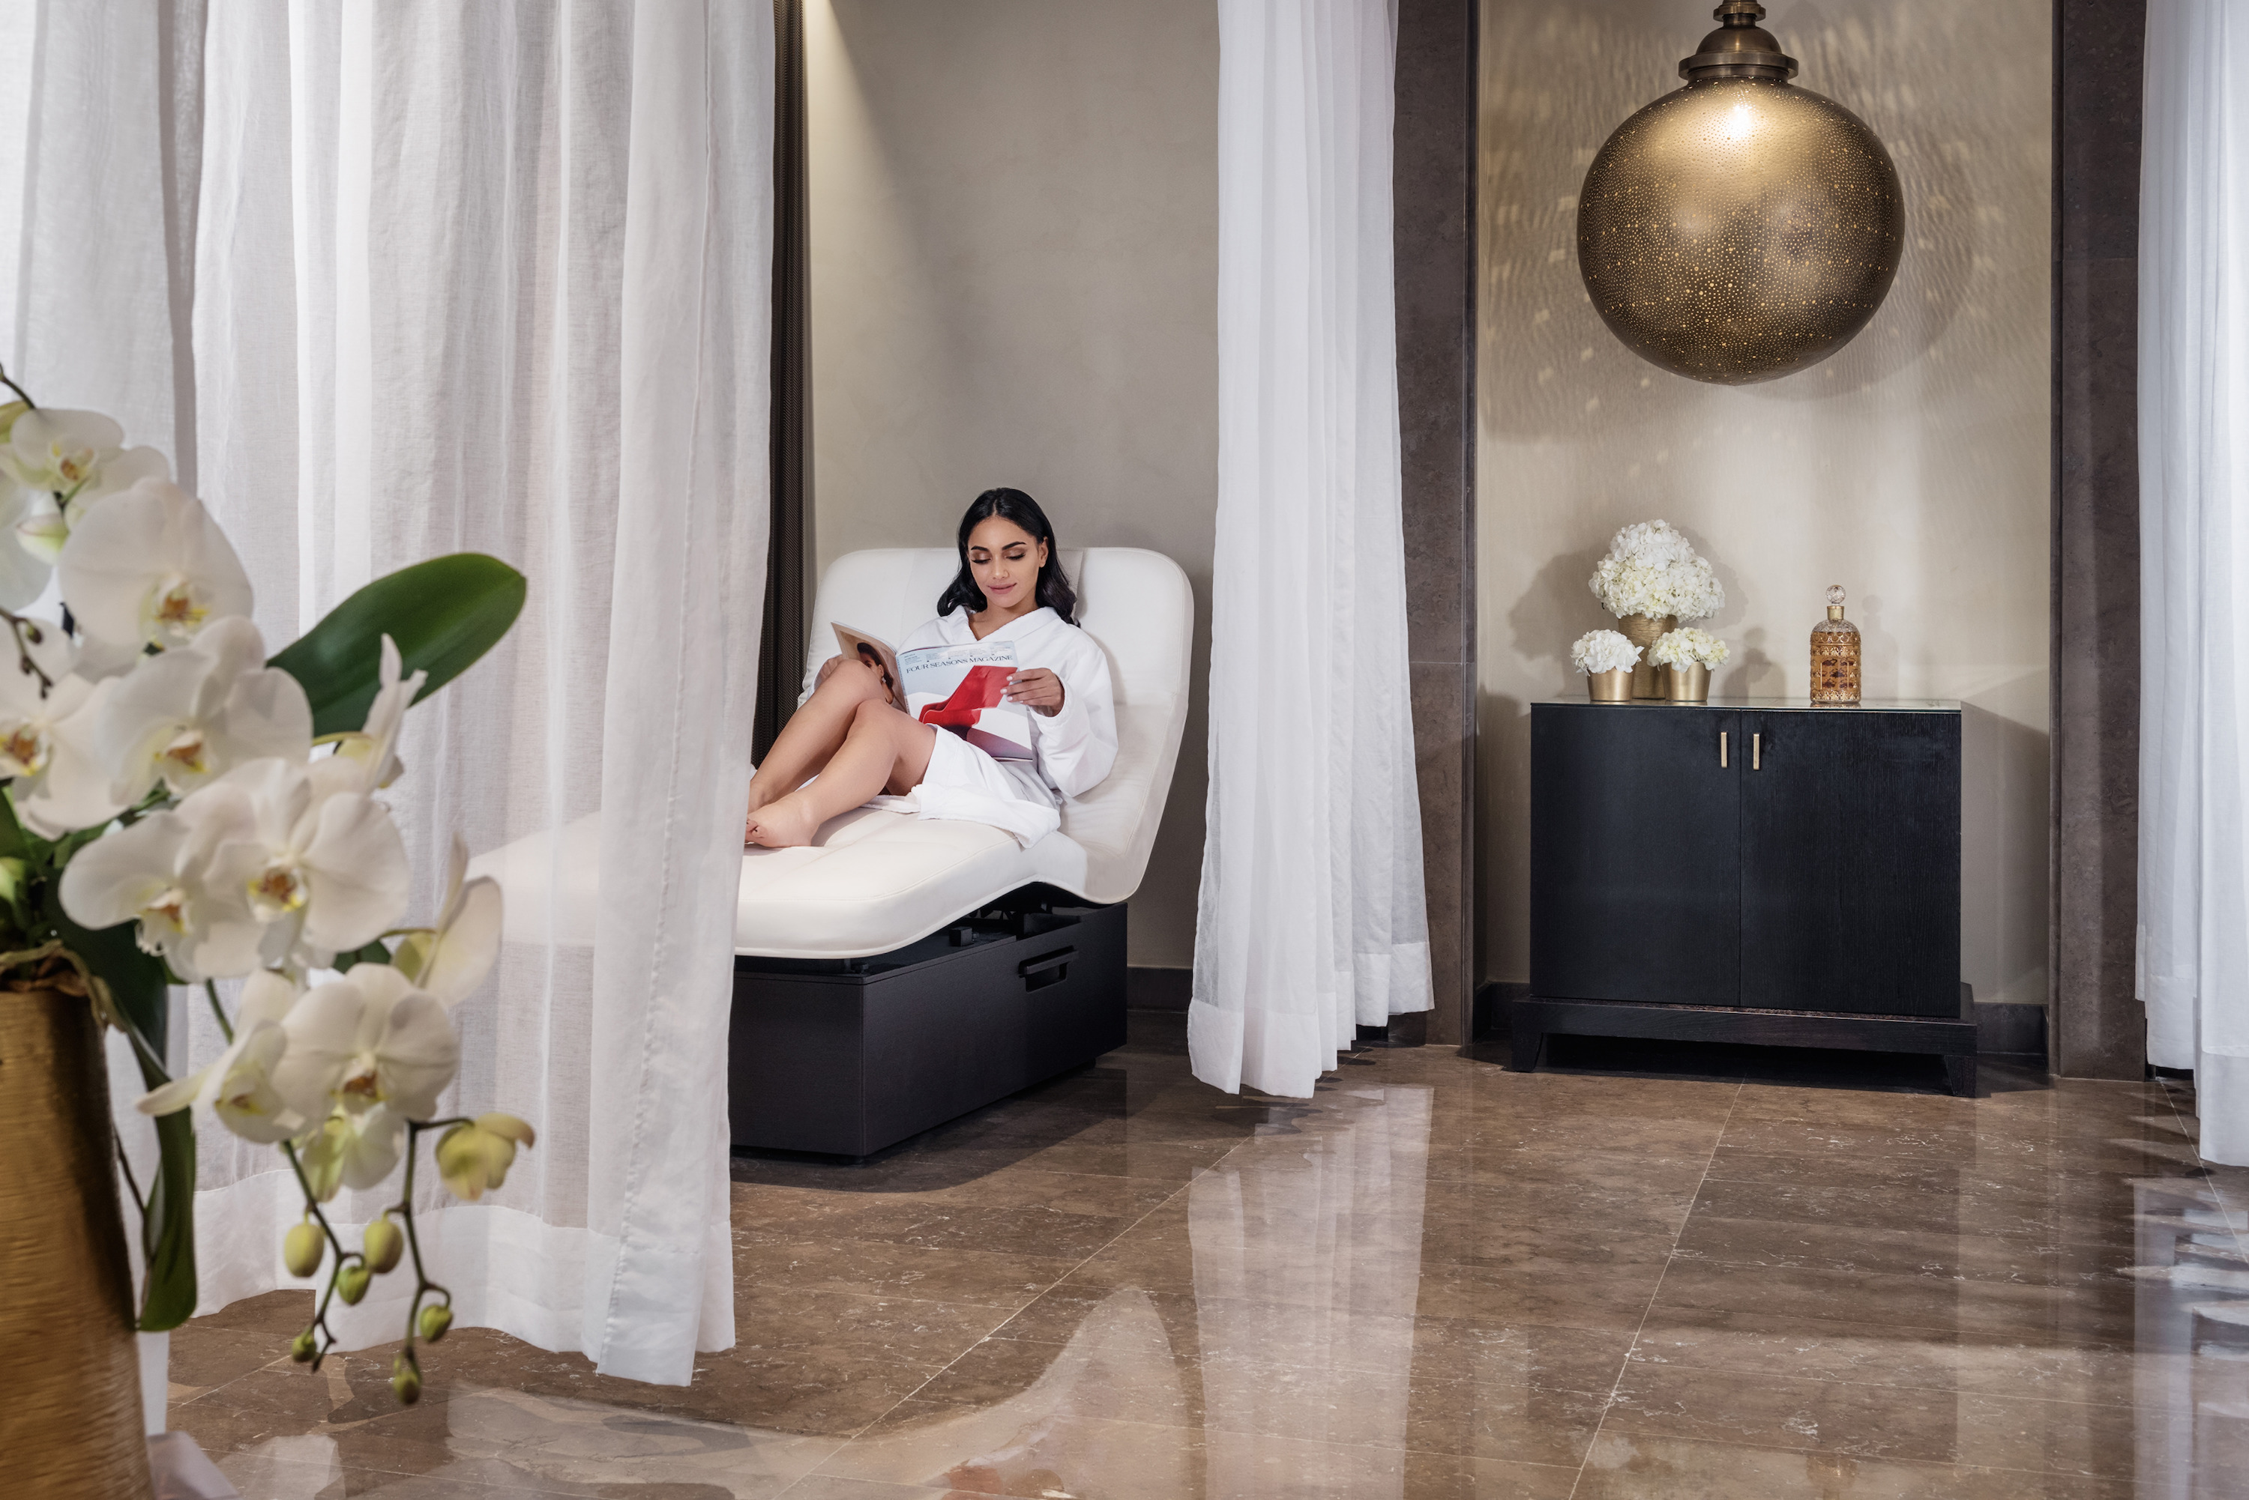
Four Seasons Hotel Casablanca invites guests to celebrate the fall season in the city’s most coveted urban oasis, from a chic afternoon tea experience in the Mint lobby lounge to honey-inspired treatments in the property’s luxurious Spa.
Fall Afternoon Tea at Mint
The signature afternoon tea is back to the delight of local patrons and guests. Pastry Chef Brian Gartner and his team have curated a whimsical menu full of fall-inspired ingredients including the meringue lemon basil mini tart and the sundried tomato muffins made with turkey and beetroot cream cheese. The new feature is the giant éclair trolley, which will be a sure success with sweet-tooth aficionados.
Guests can also enjoy the new selection of savoury and sweet pastries with a glass of champagne tea made with Maison Wright Tea’s emblematic Key West blend.
The afternoon tea experience is now available on week days with a selection of the most popular items presented on a three-tier stand.
- Afternoon Tea Buffet: Saturday from 4:00 until 7:00 pm
- Afternoon Tea Tier-Stand: Sunday to Friday from 4:00 until 7:00 pm
Harvest Flavours at Mint and Bleu
Chef Christophe Laplaza pays homage to the season’s most sought-after ingredients with new dishes at Mint and Bleu.
A new selection of Moroccan dishes featuring seasonal ingredients such as the vegetable couscous and Moroccan salads can be discovered on the new all-day dining menu of Mint.
At Bleu guests can warm up during the cooler fall weather with richly flavoured dishes such as the Dubarry cream of soup made with cauliflower, almond and cauliflower purée; or with main dishes such as rack and shank lamb made with stuffed zucchini, goat cheese tapenade and thyme sauce.
The eggplant signature dish made with pressed eggplant, caviar with cumin and mashed herb purée can also be sampled on both outlet menus.
The Sunday brunch is also back in full swing following a summer break with a locally-infused buffet selection, live grill station, sushi corner and the Hotel’s ever popular selection of French pastries.
- Mint Menu: All day dining
- Bleu Menu: Monday–Saturday, lunch and dinner
- Brunch: Sunday from 12:30 until 3:30 pm
Honey-Inspired Treatments at Le Spa
This fall, Le Spa invites guests to experience anti-ageing facial treatments with the pioneering products of maison Guerlain. Guerlain brings a new angle to its expert treatment designed with the Abeille Royale range to reap all the benefits offered by bee products.
Book a Guerlain Honey Repair treatment today and enjoy a complimentary Afternoon Tea for two.
Autumn Colours in Mint Lobby
Guests can enjoy beautifully curated floral decorations by the in-house floral team with the season’s most eye-catching arrangements in Mint Lobby. Make sure to catch the new weekly floral compositions every Friday.

RELATED

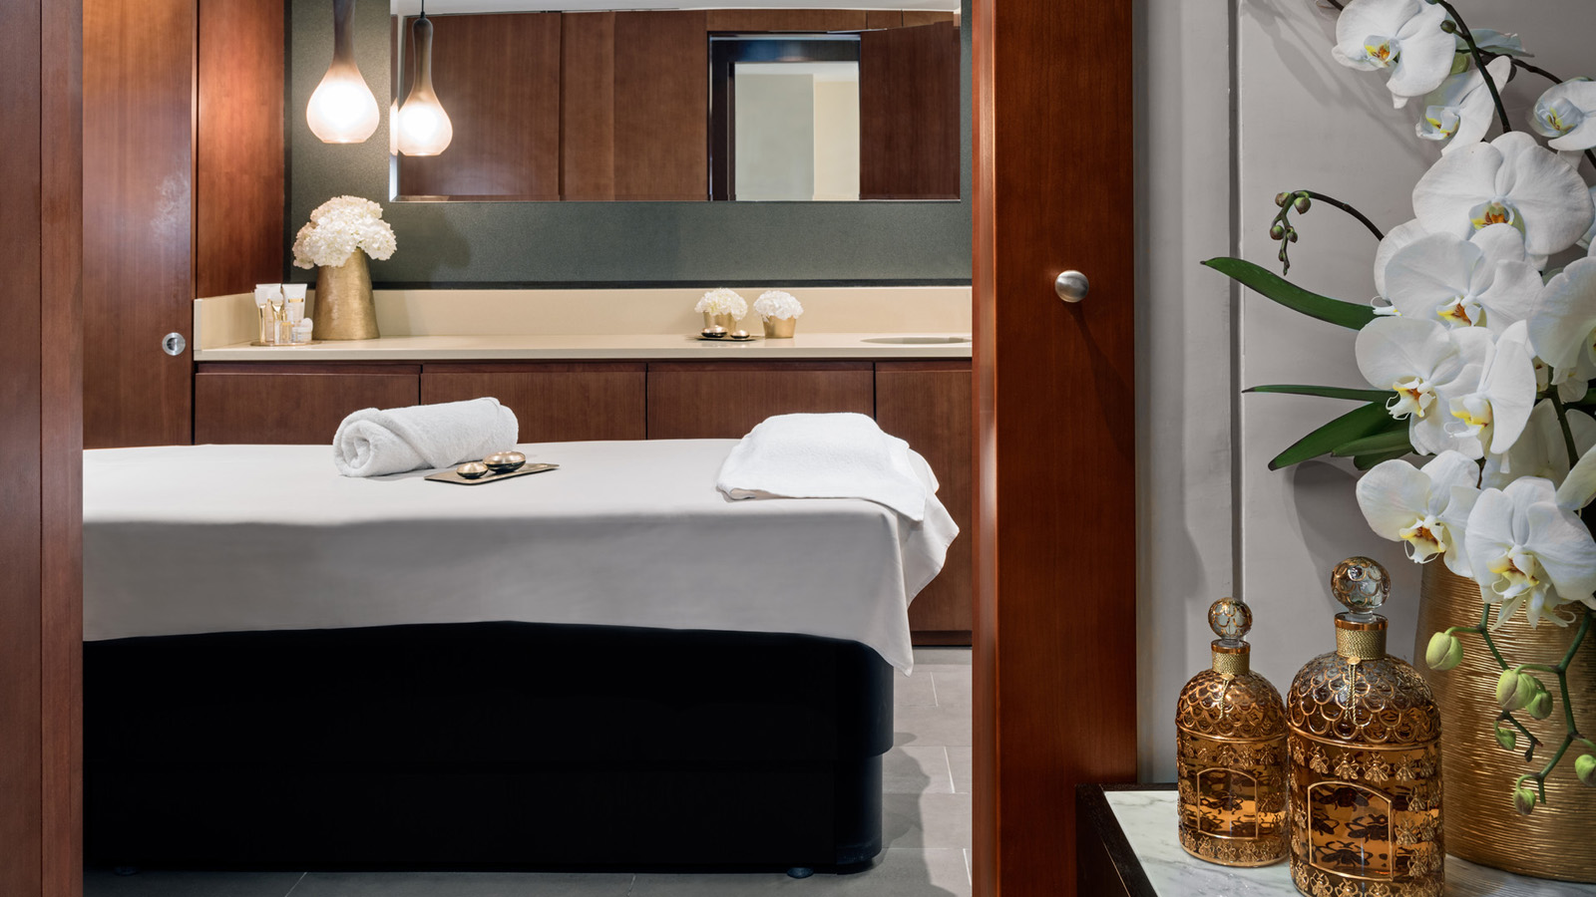 | August 9, 2019, Casablanca, Morocco  Uplift Summer with Guerlain's Slimming Range in a Customised Wellness Experience, Only at Le Spa at Four Seasons Hotel Casablanca  https://publish.url/casablanca/hotel-news/2019/guerlain-summer-spa.html
August 9, 2019, Casablanca, Morocco
Préparez L'Arrivée des Beaux Jours avec les Rituels Minceurs Disponibles au Spa du Four Seasons Hotel Casablanca
https://publish.url/fr/casablanca/hotel-news/2019/guerlain-summer-spa-2.html

PRESS CONTACTS

Jihane Ayed
Public Relations Director
Anfa Place Living Resort, Boulevard de la Corniche, Ain Diab
Casablanca
Morocco
jihane.ayed@fourseasons.com

+212 (0) 529 07 37 00

