Four Seasons Dubai Reveals the Magic of the UAE’s Heritage with The Great Desert Escape

The experience by Four Seasons and Platinum Heritage takes guests on an enthralling expedition into the Arabian Desert
February 17, 2022, Dubai, U.A.E.

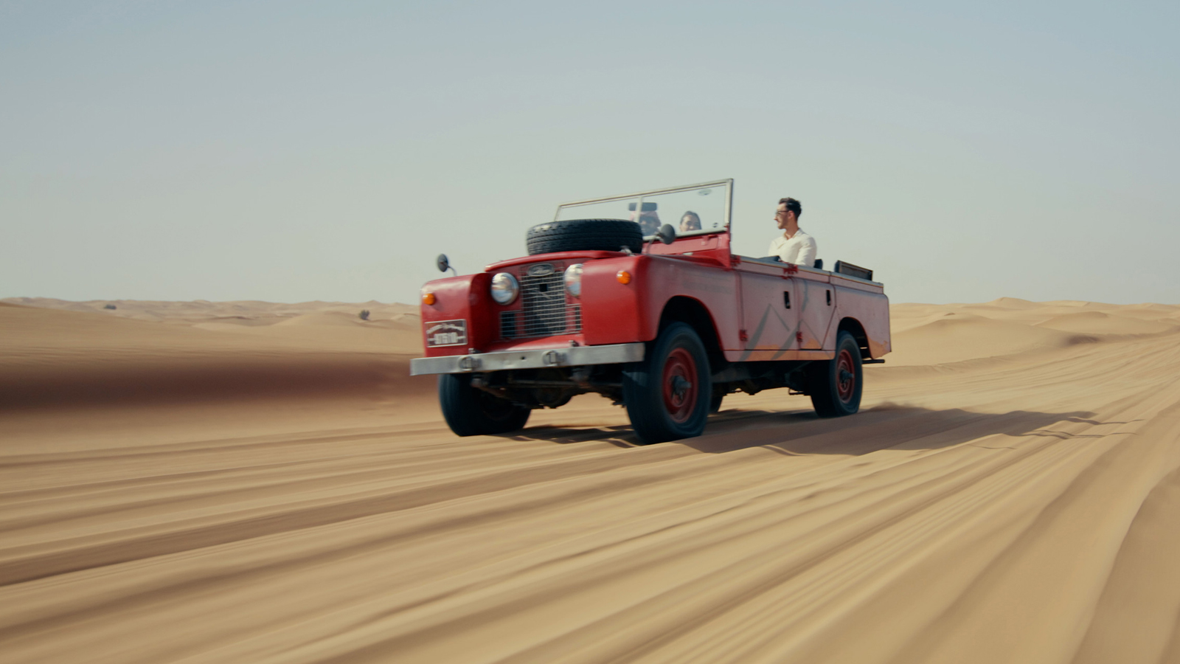 | 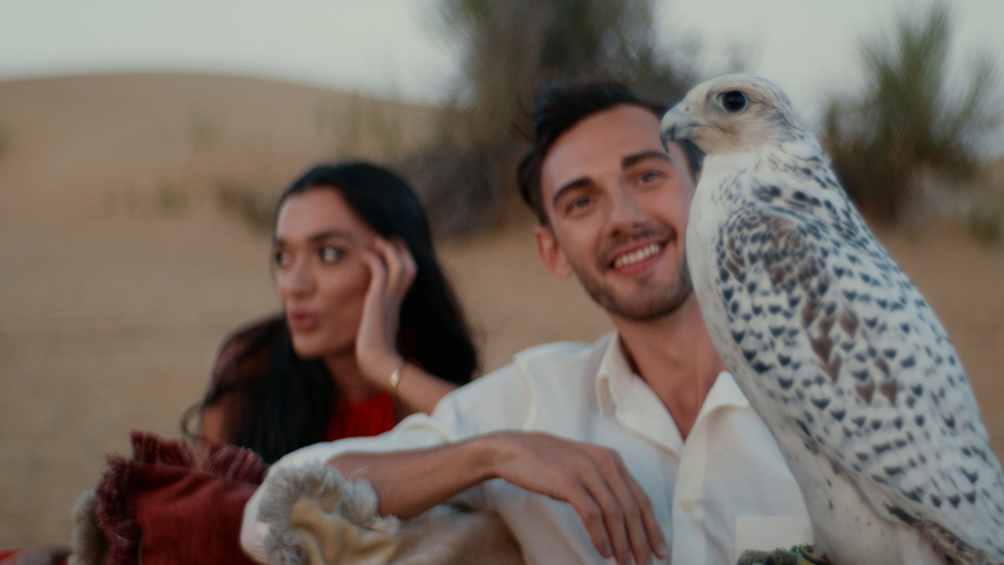 | 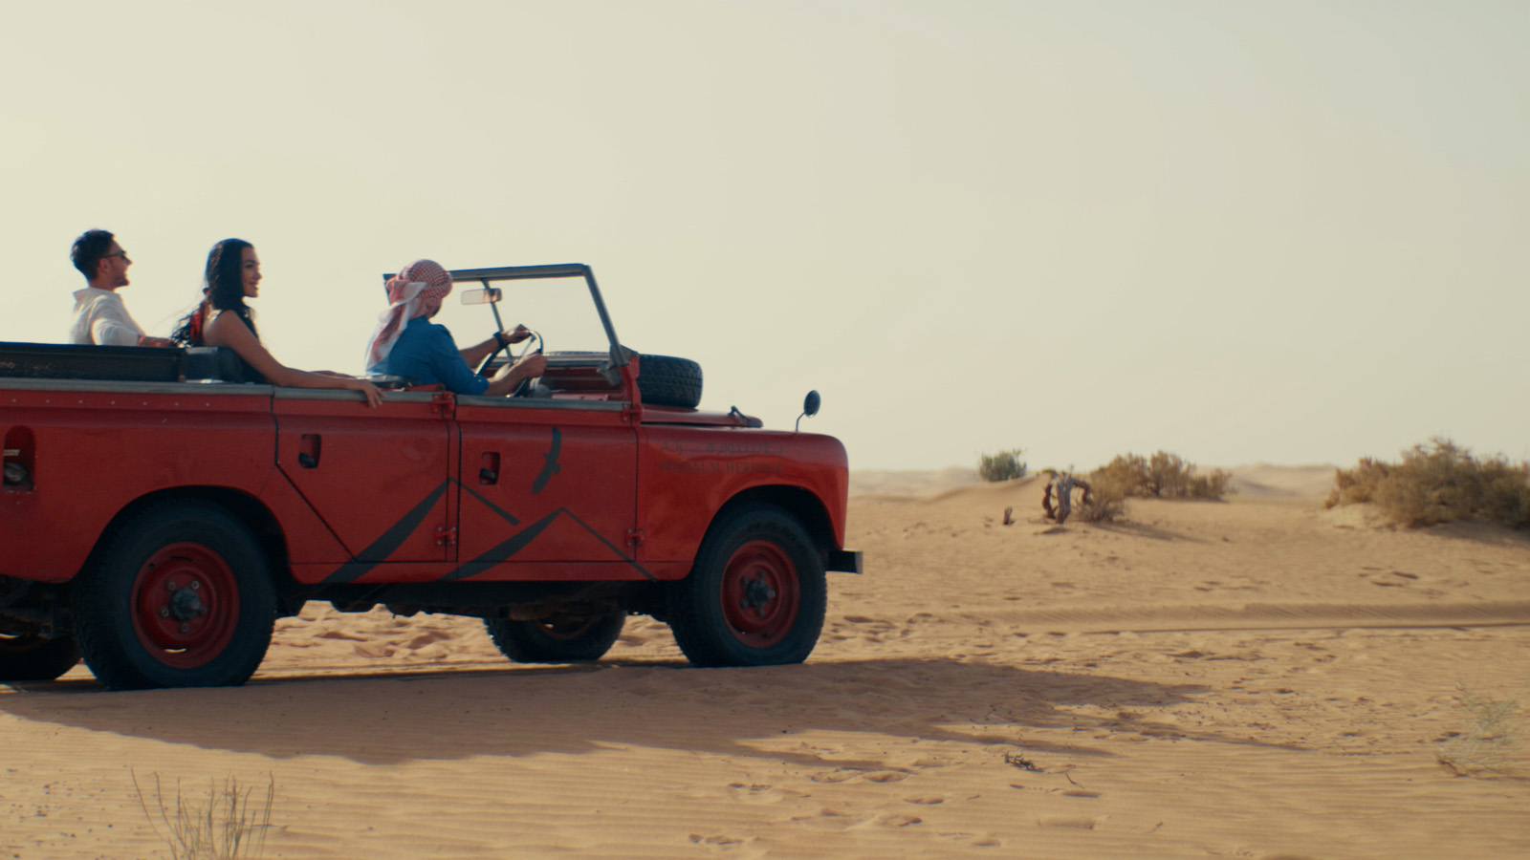
Richly textured, richly coloured and rich with Bedouin history, the desert landscape sits just outside the ultra-modern, vibrant city of Dubai. A place of mystery, heritage and legend, it holds many secrets just waiting to be discovered. Four Seasons Dubai in partnership with Platinum Heritage presents the opportunity for guests to unlock these secrets with The Great Desert Escape, an engaging expedition - which can be seamlessly arranged by the savvy concierge.
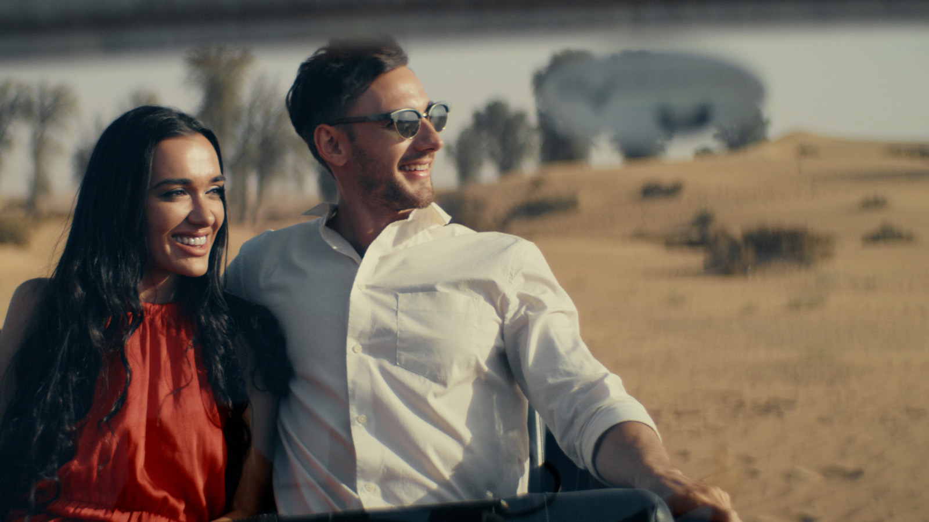 | 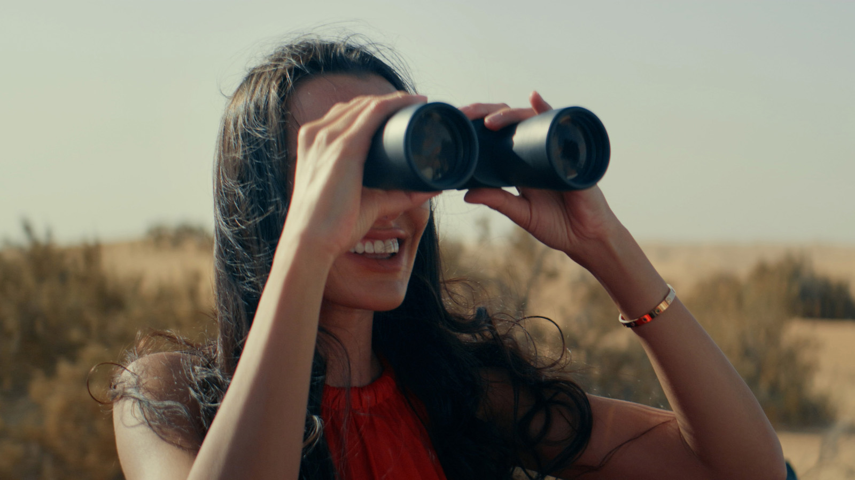 | 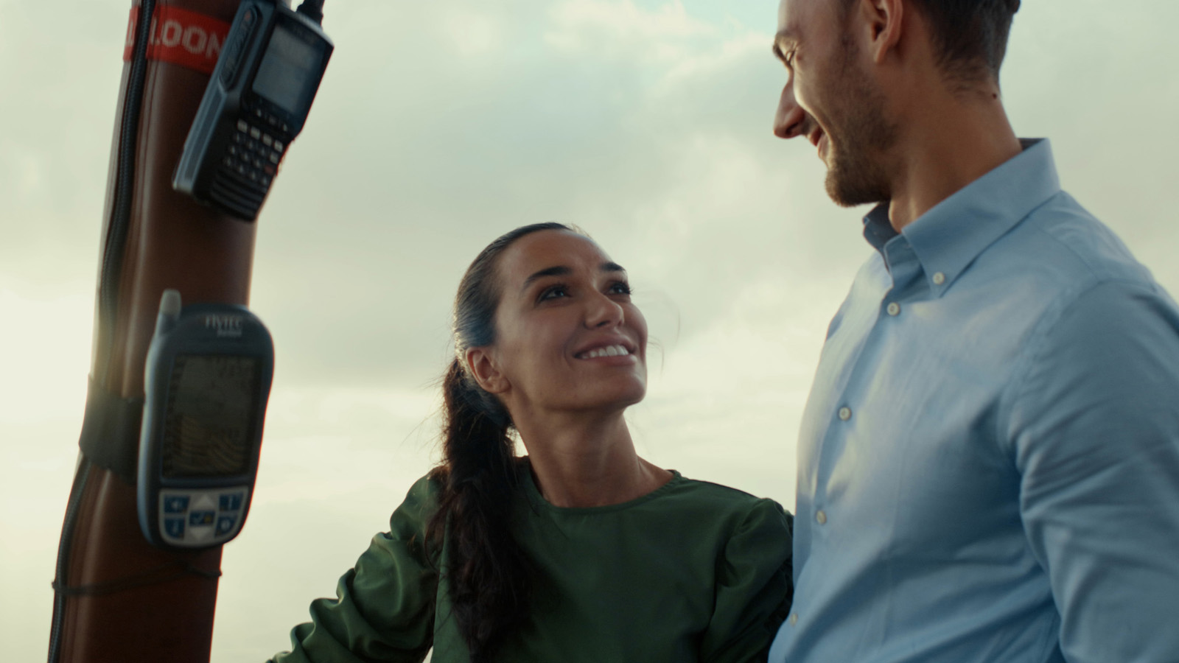
The adventure begins with a royal pick-up in a modern Range Rover at Four Seasons Resort Dubai at Jumeirah Beach or Four Seasons Hotel DIFC. The luxury cruise transports guests to the ancient desert outskirts of the city, waving goodbye to modern architectural wonders, and greeting the charm of winding dunes. It continues like a good movie with a vintage 50’s Land Rover journeying off-road, the sun and breeze playing together, while guests spot Arabian oryx or camels wandering free.
Once guests are safely set down in their own Private Heritage Desert Camp the history starts talking. Guests will experience what a Bedouin village really looks, smells and tastes like. Using local ingredients an authentic Arabian dinner temptingly awaits while the scent of coal-fired gahwa coffee draws one in deeper. There is even Emirati tribal dancing to learn, if one feels like taking a step further into the culture.
For many, sleeping under canvas can be a daunting prospect, not so here. Signature Four Seasons Beds form the centrepiece of the Royal Bedouin tents, where guests sleep in complete luxury while surrounded by wilderness. Although a pre-sunrise wake-up call may not be on everyone’s priority list, soaring up into the sky to see the sunrise from a hot air balloon over the pristine dunes is a brilliantly worthy way to start the day.
As the great escape comes to its close, a traditional Emirati breakfast brings guests together to share their experiences. Adrenaline seekers, history seekers, nature Seekers and those simply seeking change will leave full-up, knowing that little bit more about Dubai’s rich heritage.
To book The Great Desert Escape contact the concierge team at Four Seasons Dubai concierge.dubaijb@fourseasons.com or +971 4 270 7777.

RELATED

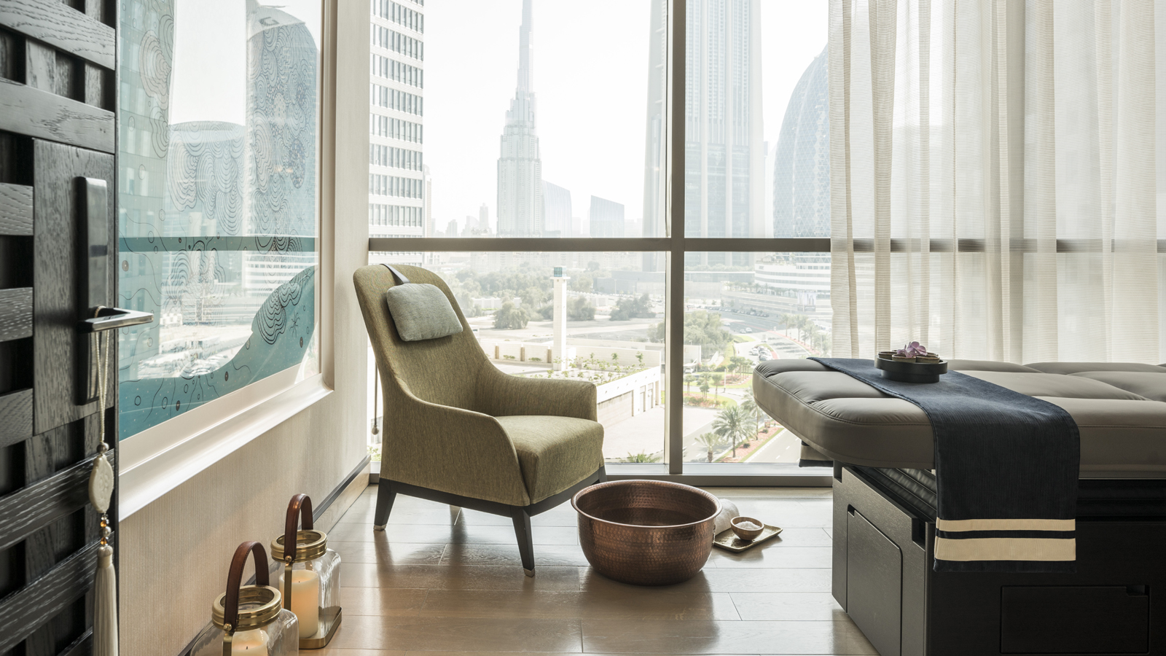 | February 22, 2022, Dubai, U.A.E.  The Pearl Spa and Wellness Launches a Range of Magnesium Based Treatments at Four Seasons Hotel Dubai International Financial Centre with “Of The Islands”  https://publish.url/dubaidifc/hotel-news/2022/new-magnesium-spa-treatments.html
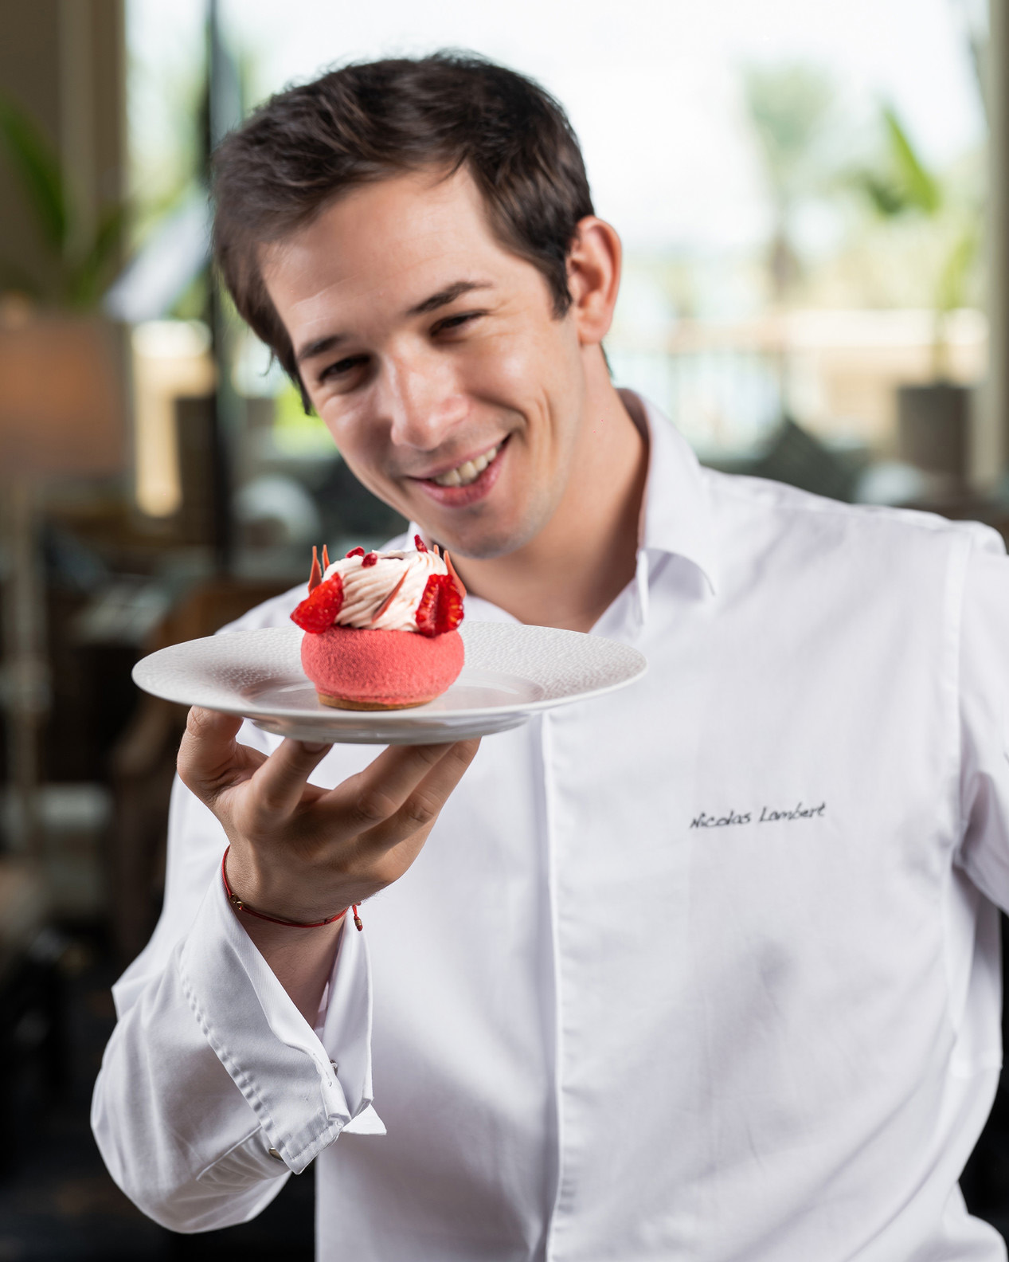 | February 14, 2022, Dubai, U.A.E.  World Pastry Champion Angelo Musa and Pastry Prodigy Nicolas Lambert Collaborate on Unique Creations at Four Seasons Resort Dubai at Jumeirah Beach  https://publish.url/dubai/hotel-news/2022/angelo-musa-and-nicolas-lambert-pastry-collaboration.html

PRESS CONTACTS

Mazhit Ismailov
Senior Director of PR and Communications
Jumeirah Road
Dubai
United Arab Emirates
mazhit.ismailov@fourseasons.com

+ 971 4 270 7723

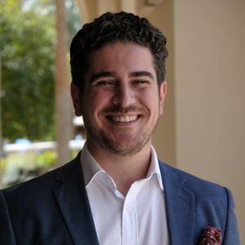 | Ghaith Adnan  Public Relations and Marketing Manager  Jumeirah Road  Dubai  United Arab Emirates  ghaith.adnan@fourseasons.com  + 971 4 270 7884

