Romance is Best Served at Four Seasons Hotel St. Louis

January 14, 2021, St. Louis, U.S.A.

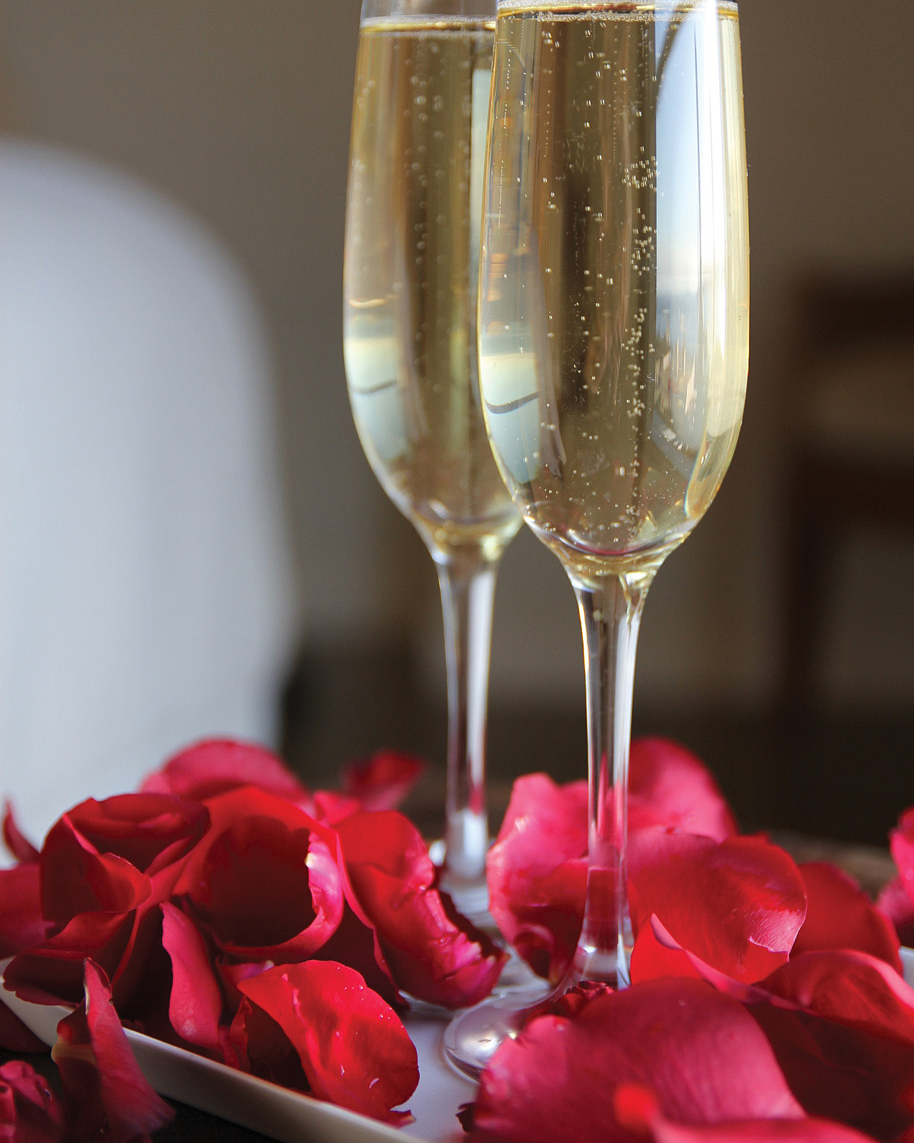
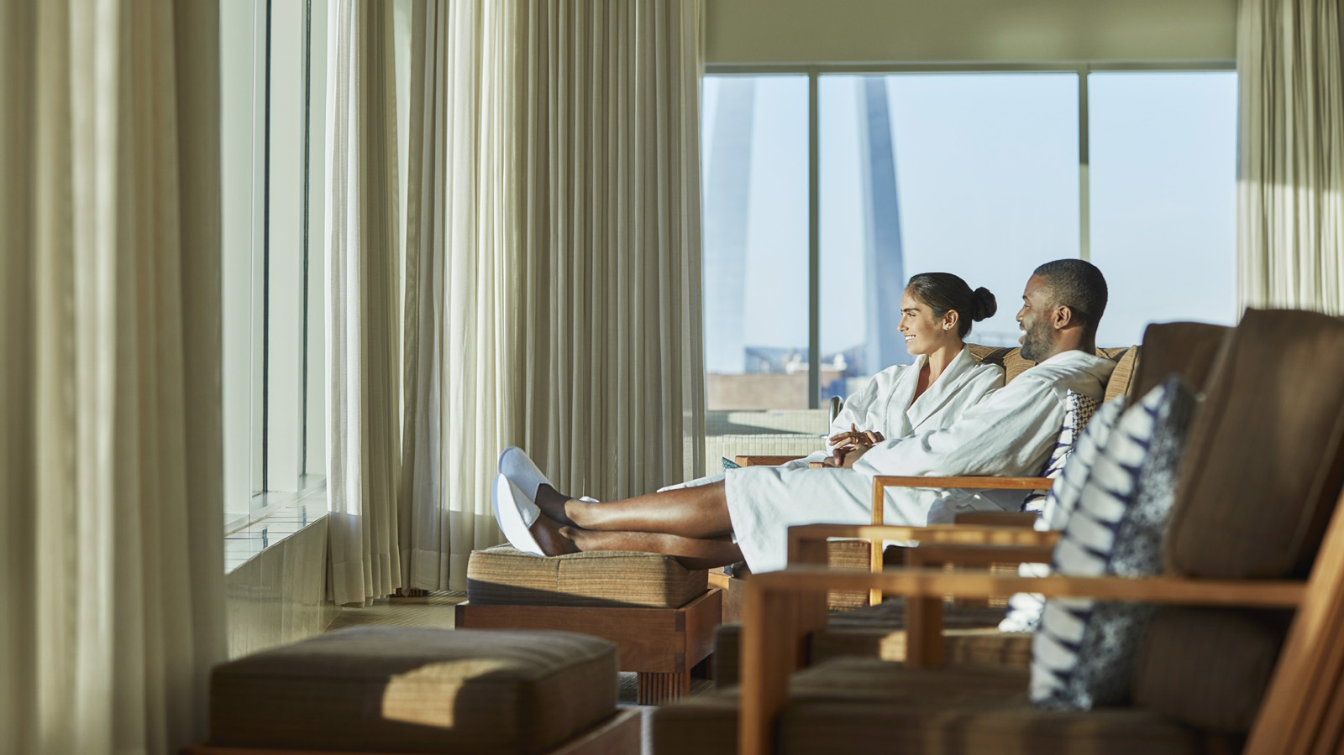 | 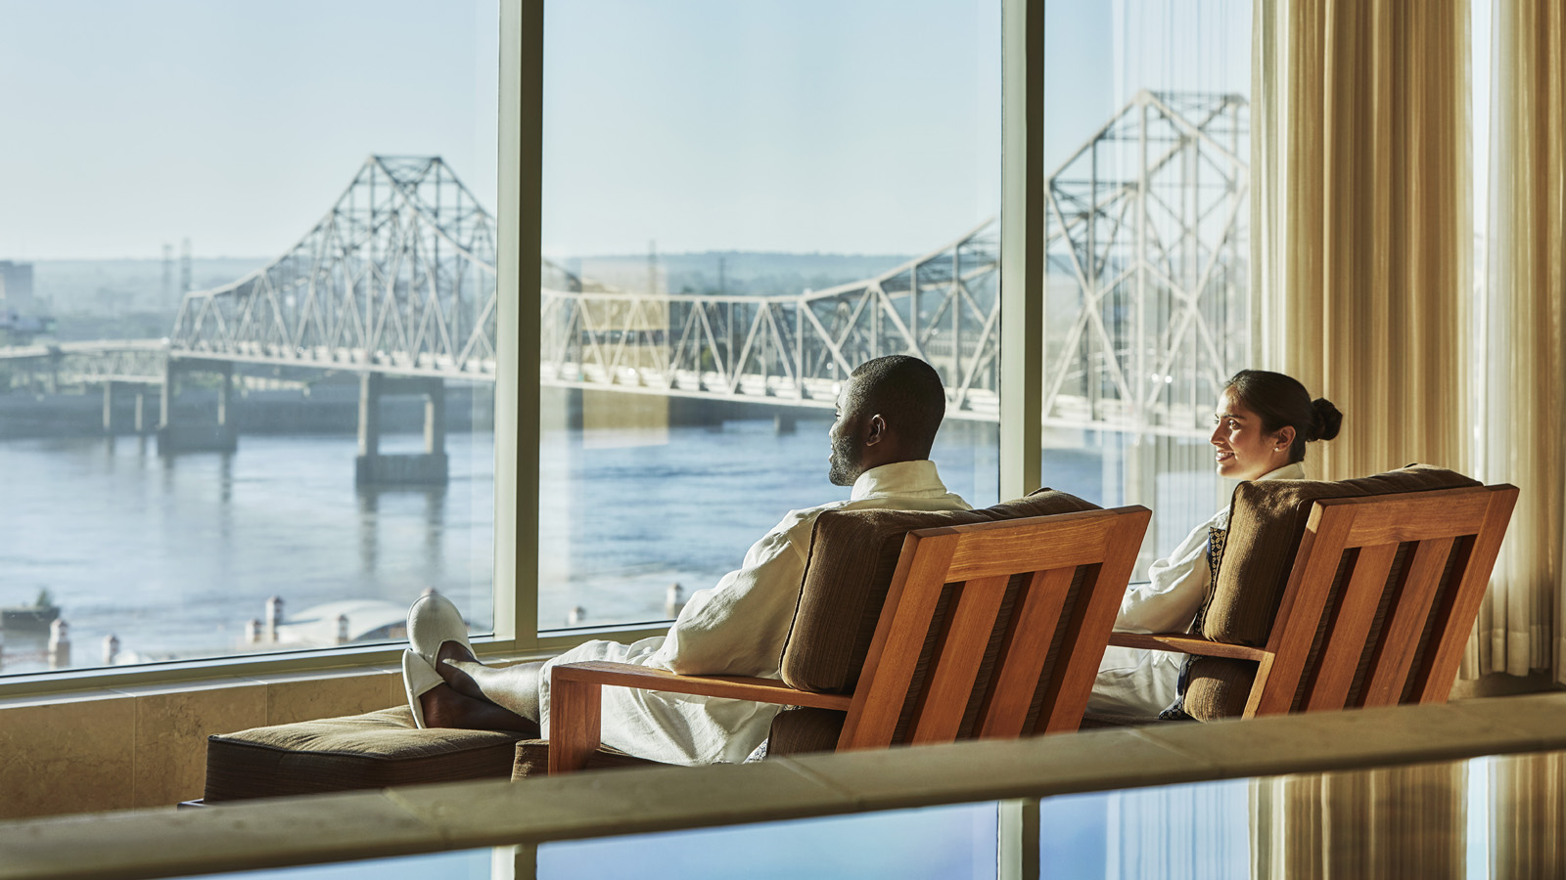 | 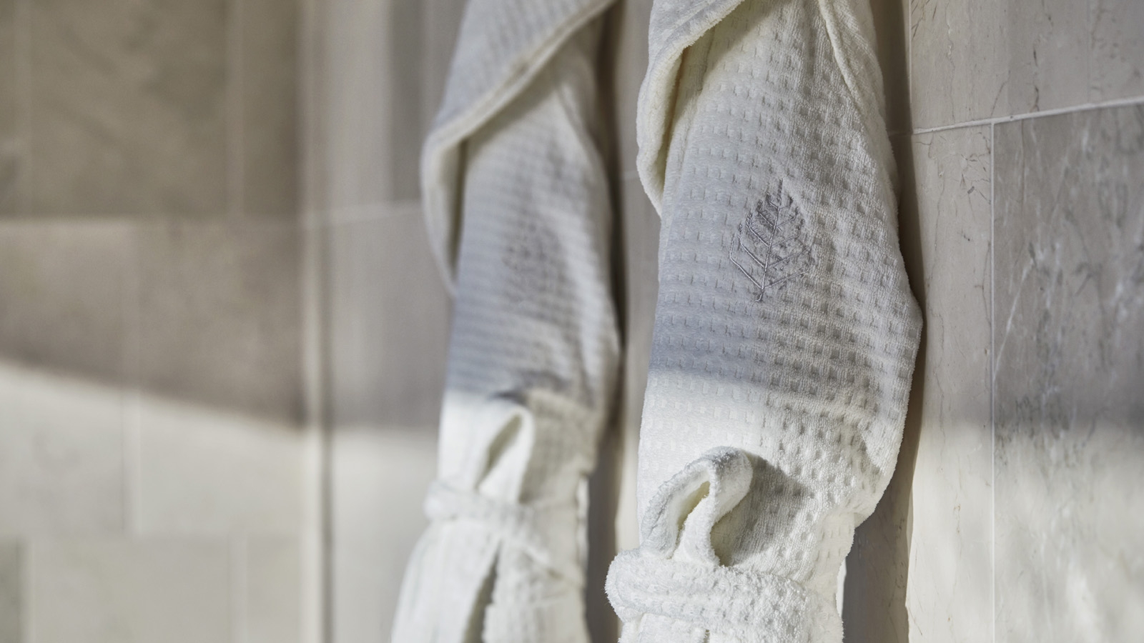
This Valentine’s Day, enjoy new and unforgettable experiences with a loved one in the stunning setting of Four Seasons Hotel St. Louis.
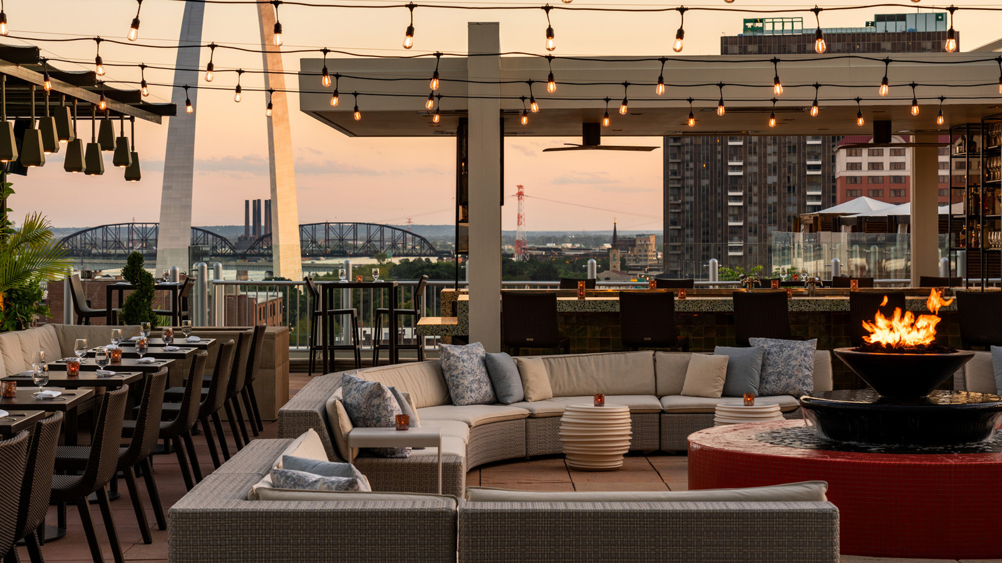 | 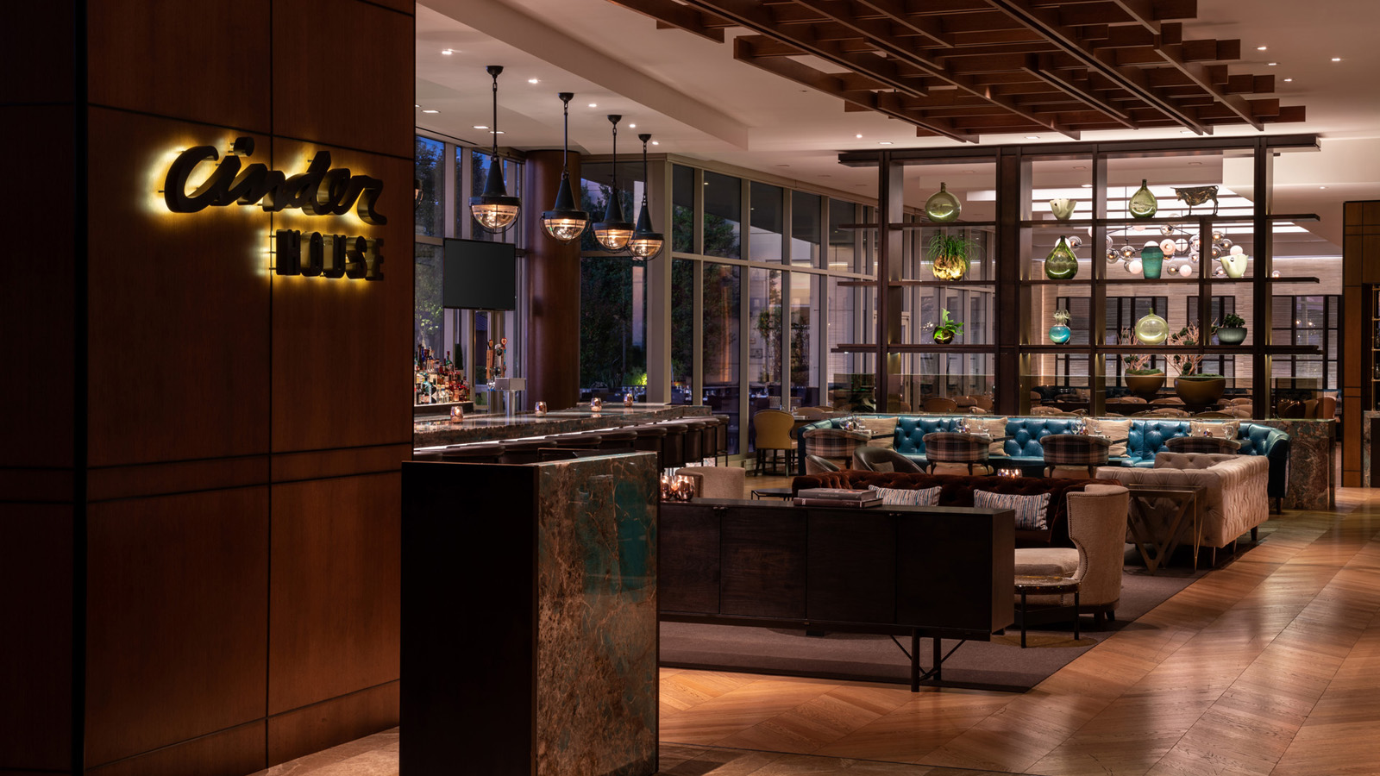
Boasting spectacular views of the Gateway Arch and twinkling lights of the Downtown St. Louis skyline, Cinder House will be showcasing a romantic three-course dinner expertly prepared by Chefs Gerard Craft, Josh Adams and the Cinder House team. The first course features a diver scallop, king trumpet mushrooms, sea cress, leeks and a brown butter-mushroom emulsion. The second-course offers a waygu flatiron steak, prawn and sea urchin vatapa; and the third-course features Valrhona Illanka (creamy Peruvian chocolate made with rare white cocoa beans) for a silky chocolate mousse that includes black currant, raspberry and hazelnut.
The special three-course dinner is available for USD 72 per person, excluding tax and gratuity. The dinner includes two glasses of sparkling wine upon arrival and is available on February 12, 13 and 14, 2021 from 5:00 to 10:00 pm. Black truffle and caviar upgrades will also be offered each evening at market price along with champagne and wine pairings for an additional fee. Reservations are required and can be made online or by calling 314 881 5759.
Valentine’s Day is the perfect time to pamper a loved one with an unforgettable Sweetheart’s Escape in the tranquil setting of an Arch View One Bedroom Suite. Lovebirds will enjoy 60-minute couple’s massages, followed by a relaxing 30-minute, rose-petal drawn bath. Two plush robes, a Four Seasons Hotel St. Louis signature scent blue candle, chocolate dipped strawberries and a bottle of champagne are also included to enjoy in the privacy of the spacious suite; access to the suite is granted for two hours. The Sweetheart’s Escape package is available from February 11 to 14, 2021 for USD 1,130, inclusive of tax and gratuity, between the hours of 8:30 am and 5:30 pm. Reservations can be made by contacting the Spa directly at 314 881 5758.
For those interested in both a Spa and culinary experience, roll out the red carpet with the ultimate gift and celebrate love with the exclusive Spa After Dark experience. This thoughtfully curated experience provides private access to the Spa for two after hours and includes a candle-lit and rose petal three-course dinner overlooking the majestic Mississippi River in the relaxation lounge, 80-minute massages in the Couple’s Suite, access to the infrared sauna, whirlpools, steam rooms and more. Pricing for the Spa After Dark Package starts at USD 1,800. Call 314 881 5758 to make a reservation; the Spa After Dark experience must be booked at least seven days in advance.
Playing Cupid has never been easier with the help of the concierge team. These romantic ambassadors can assist with staging a guest room with long-stem roses, champagne on ice, a path of rose petals, chocolate truffles and more. For special requests or assistance with an overnight reservation contact the Hotel directly at 314 881 5800.

RELATED

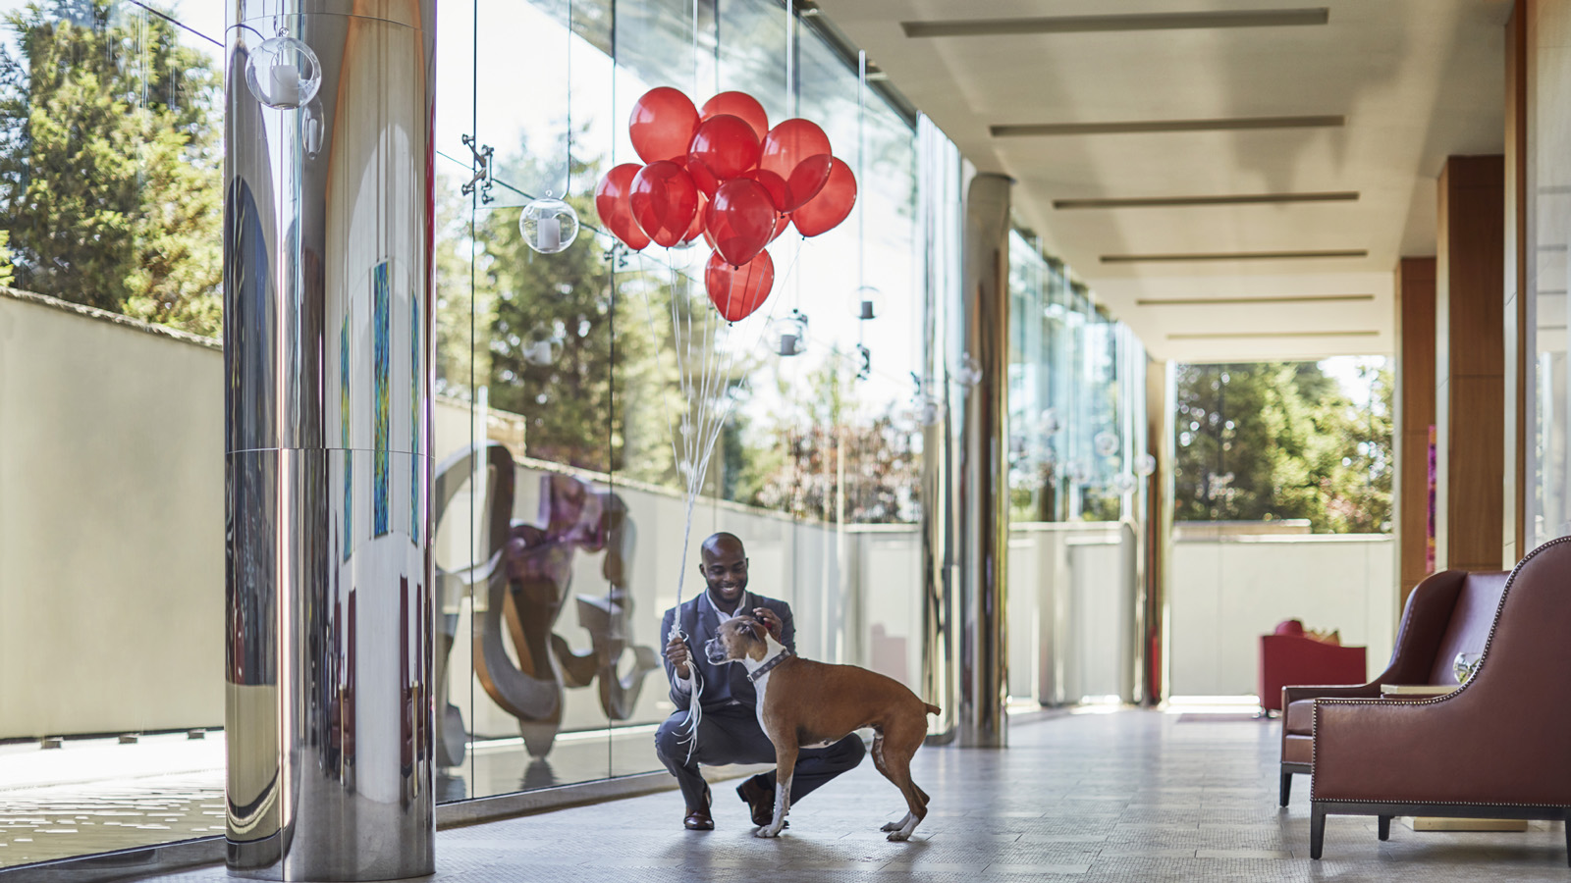 | December 7, 2020, St. Louis, U.S.A.  Four Seasons Hotel St. Louis: The Ultimate Haven for Holiday Magic  https://publish.url/stlouis/hotel-news/2020/festive-season.html
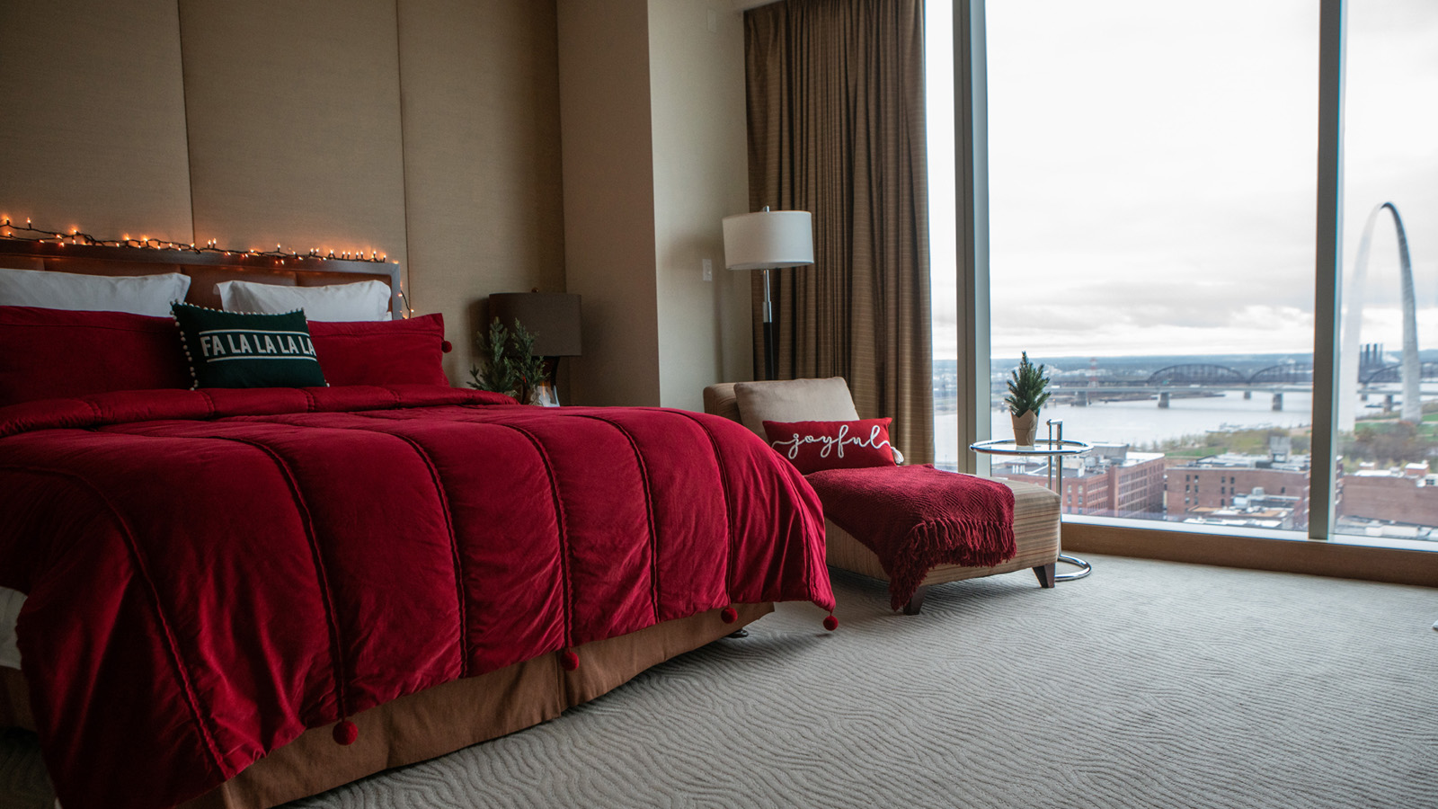 | December 2, 2020, St. Louis, U.S.A.  Stay the Night in a Festively Decorated Holiday Suite at Four Seasons Hotel St. Louis This December  https://publish.url/stlouis/hotel-news/2020/holiday-suite.html

PRESS CONTACTS

Chloe Caylor
Director of Public Relations and Communications
999 North 2nd Street
St Louis
USA
Chloe.Caylor@fourseasons.com

+1 (314) 881-2021

