An Intimate Island Escape at Four Seasons Resort Langkawi

Just steps from the waves, the Studio Beach Villa is wrapped in tropical greenery and magical sea views
October 22, 2020, Langkawi, Malaysia

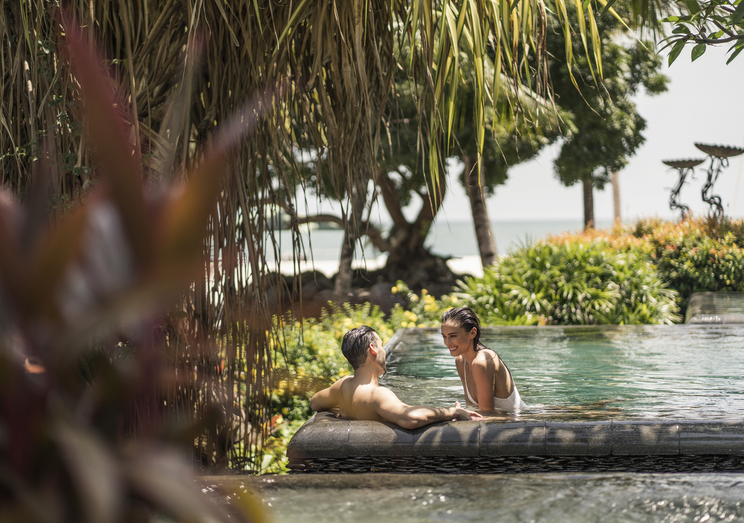
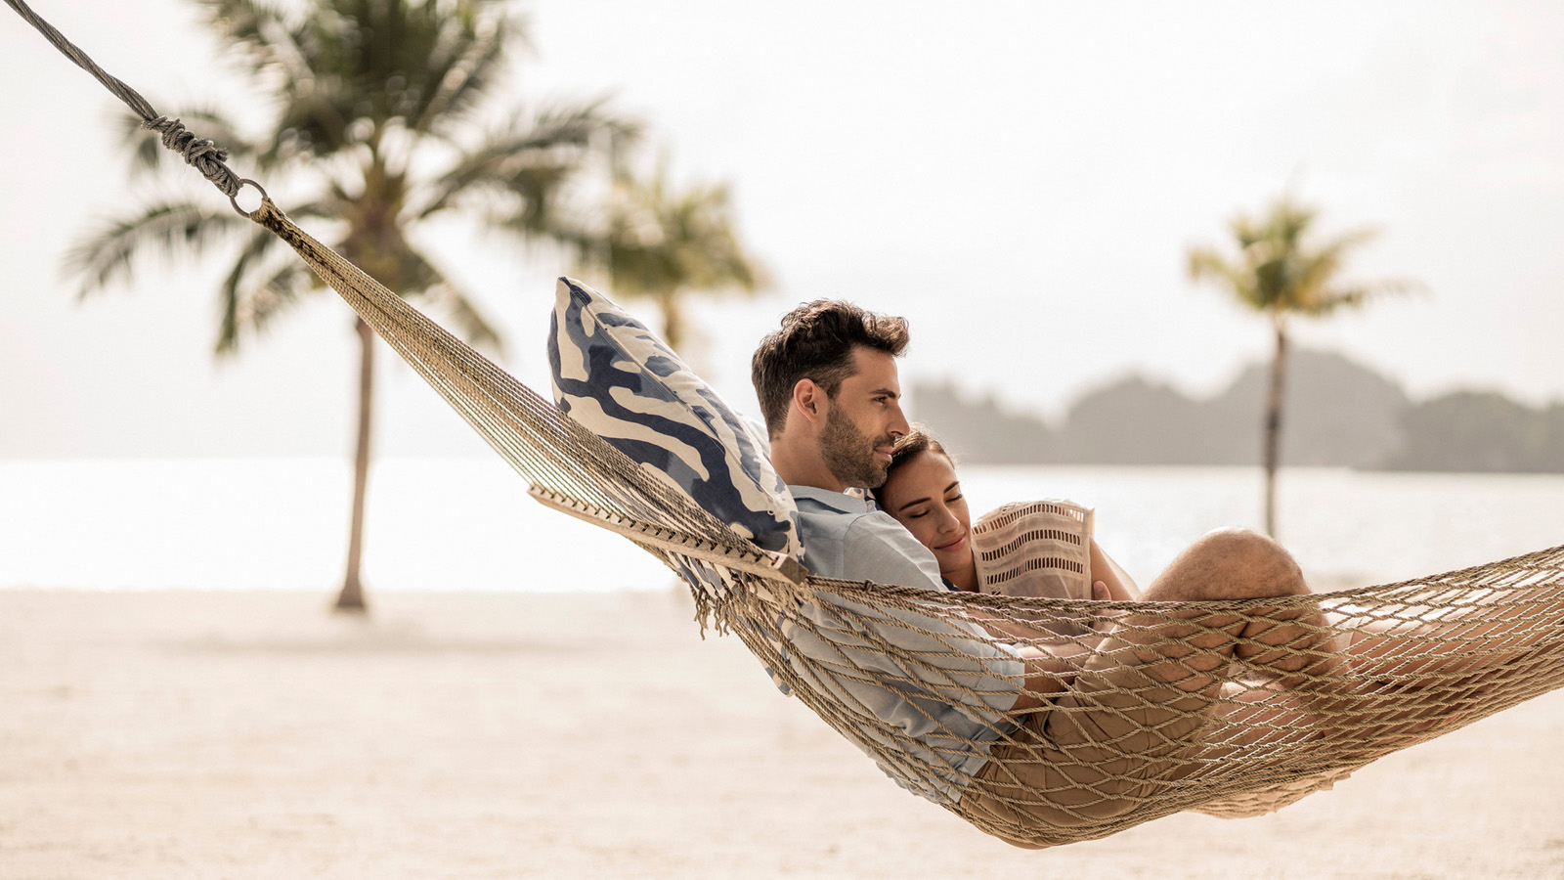 | 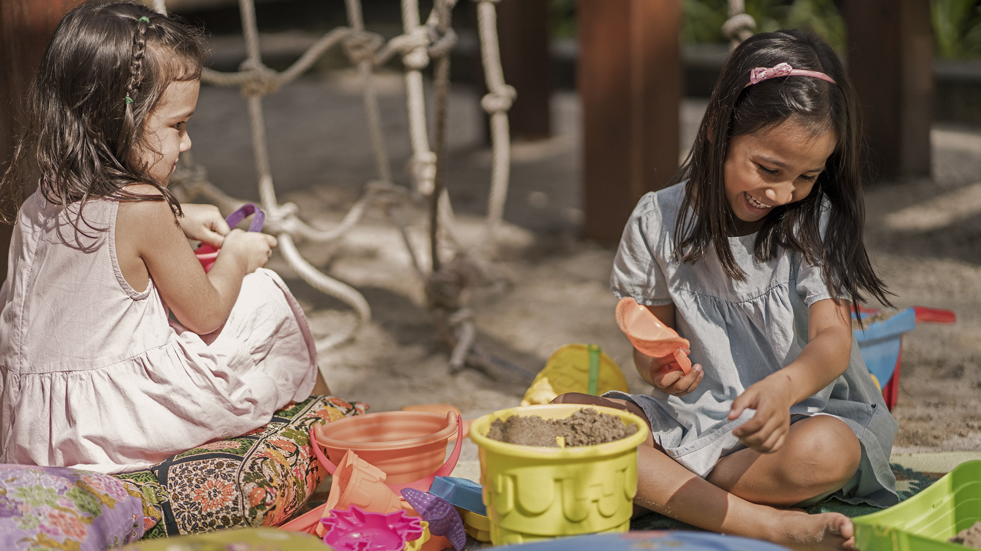
Discover the best of island life at the new Studio Beach Villa with a private pool at Four Seasons Resort Langkawi. Surrounded by lush jungle, stunning rock formations and the sparkling Andaman Sea, this ultra-private sanctuary is tailor-made for couples and small families.
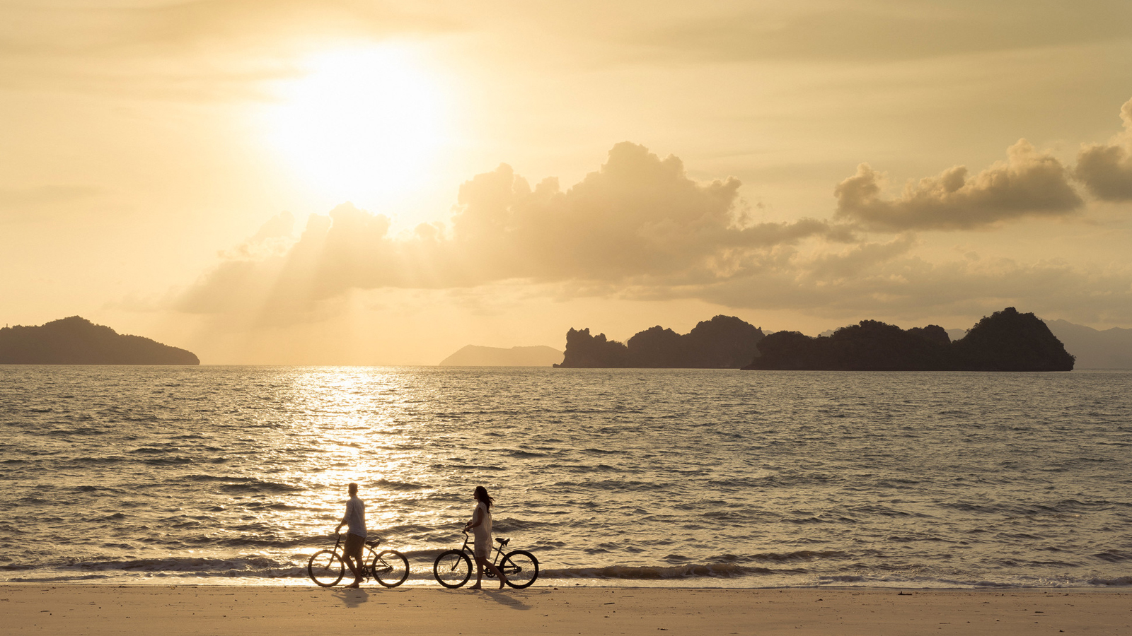
“This is a place designed for you to leave behind daily distractions and reconnect with your nearest and dearest. It really feels like the island is all yours,” says General Manager David Macklin, noting that there is only one such unit in the entire Resort.
A Bespoke Hideaway
With the villa’s contemporary design and thoughtful amenities, guests can enjoy the marvels of nature in comfort and style. Discover sweeping seascapes from the private pool, situated just steps from the white sandy beach, and indulge in a luxurious bathing ritual at the spa-style bathroom, featuring an outdoor rainforest shower and locally-sourced organic toiletries. The airy interiors, done up in tropical wood and Spanish marble, are brightened with floor-to-ceiling views and an abundance of natural light.
Undisturbed Tranquility
Nestled on a secluded stretch of the mile-long private beach at Four Seasons, the Studio Beach Villa is ideal for those seeking the ultimate privacy, be it an intimate family vacation or a romantic getaway.
All-Day Island Inspiration
Wake up to the magic of the sea and forest. Enjoy leisurely strolls and bicycle rides, with majestic hornbills and shy dusky leaf monkeys for company. Sunset brings enchanting views of the Rumah Ikan Fish House – the perfect prelude to popping a bottle of bubbly, toasting marshmallows over a bonfire or sharing a family-style barbecue on the beach.
The Studio Beach Villa is ready for check-in. It can accommodate up to two adults and two children. Book your island getaway here, or chat with us via the Four Seasons App.

RELATED

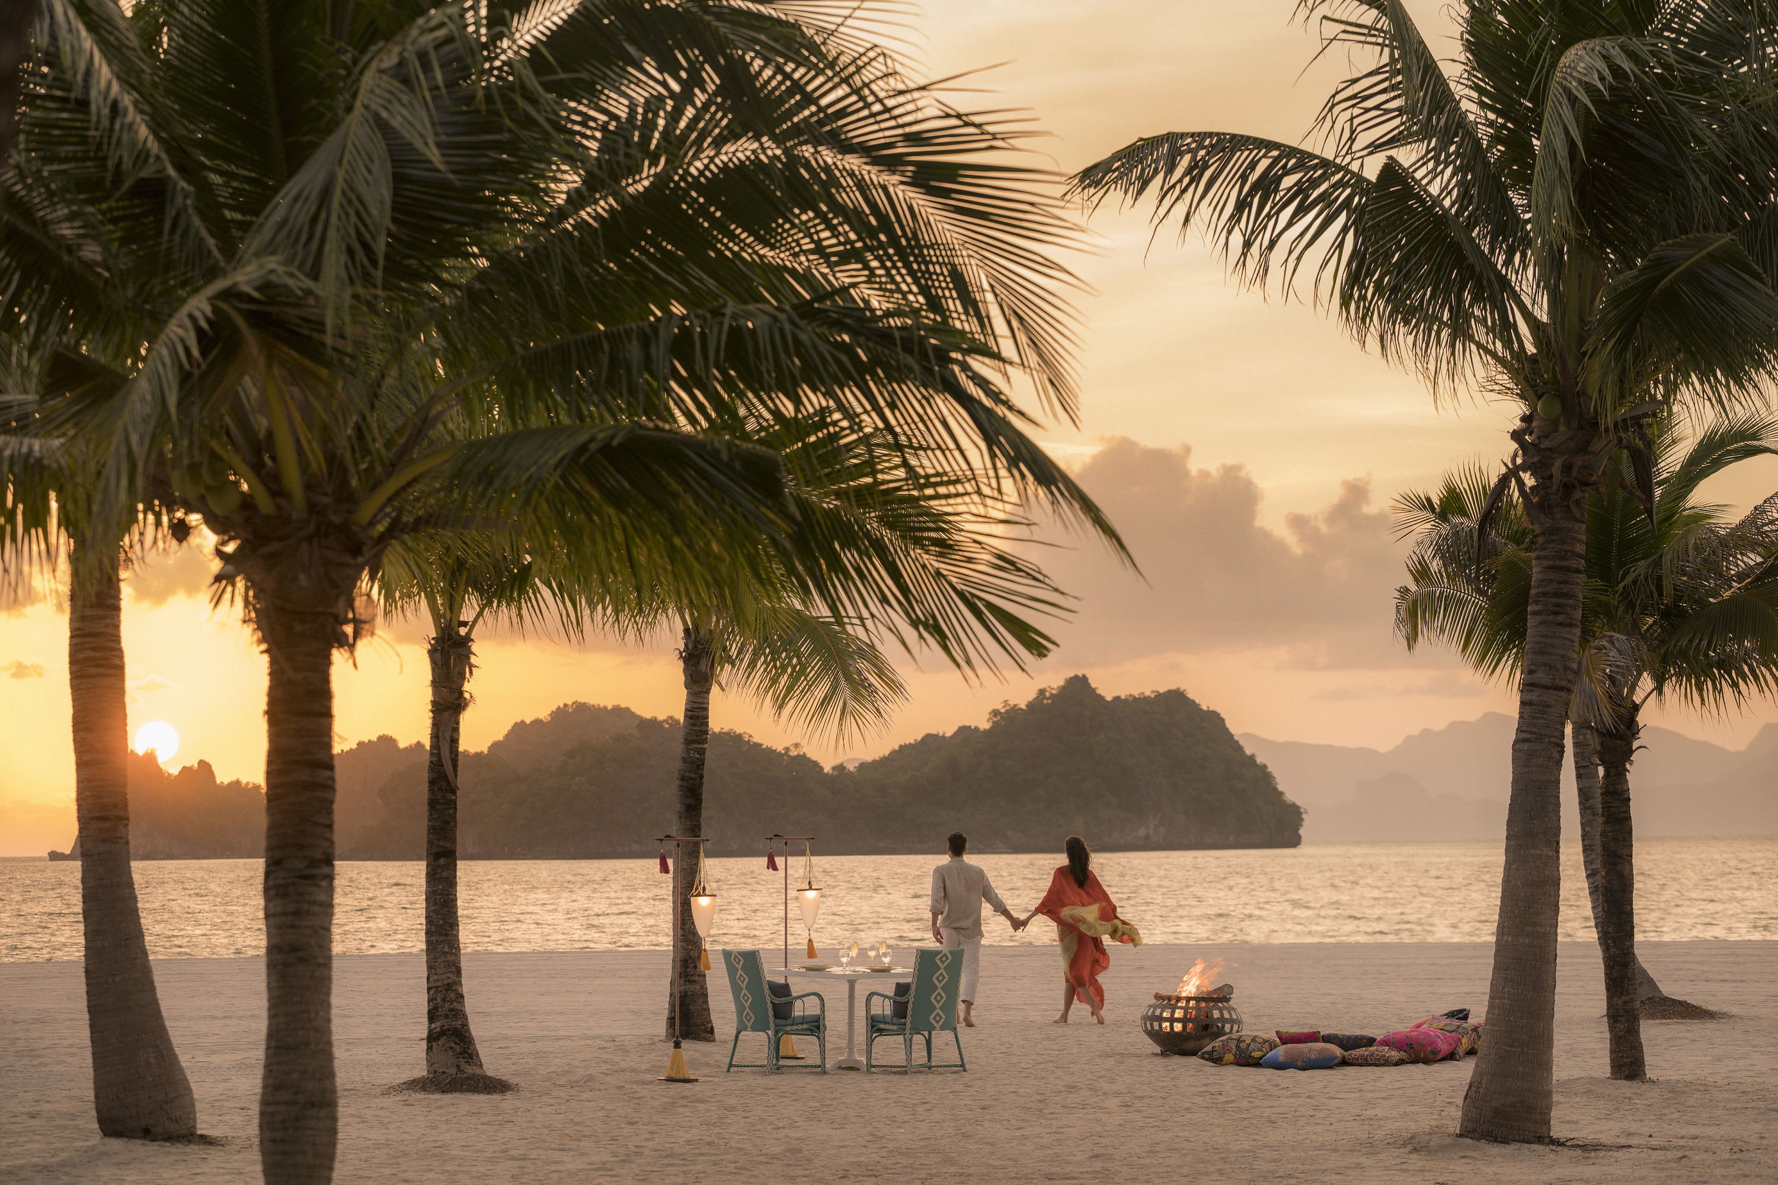 | October 6, 2020, Langkawi, Malaysia  Malaysia’s #1 Resort: Four Seasons Resort Langkawi Takes Top Spot in 2020 Readers’ Choice Awards by Condé Nast Traveler  https://publish.url/langkawi/hotel-news/2020/top-resort-in-malaysia.html
September 9, 2020, Langkawi, Malaysia
Four Seasons Resort Langkawi Unveils the Island's Most Spectacular New Holiday Villa
https://publish.url/langkawi/hotel-news/2020/new-five-bedroom-beach-villa.html

PRESS CONTACTS

Kanchana Ganglani
Director of Public Relations
145 Jalan Ampang
Kuala Lumpur
Malaysia
kanchana.ganglani@fourseasons.com

+6(03) 2382 8740

