Four Seasons Hotel Seattle Introduces Creative Culinary Experiences for Social Events

September 10, 2020, Seattle, U.S.A.

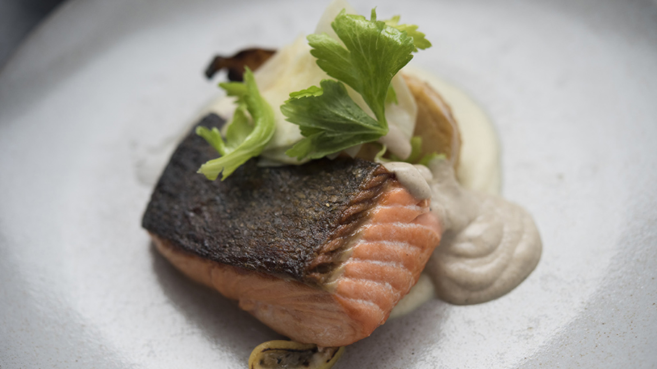
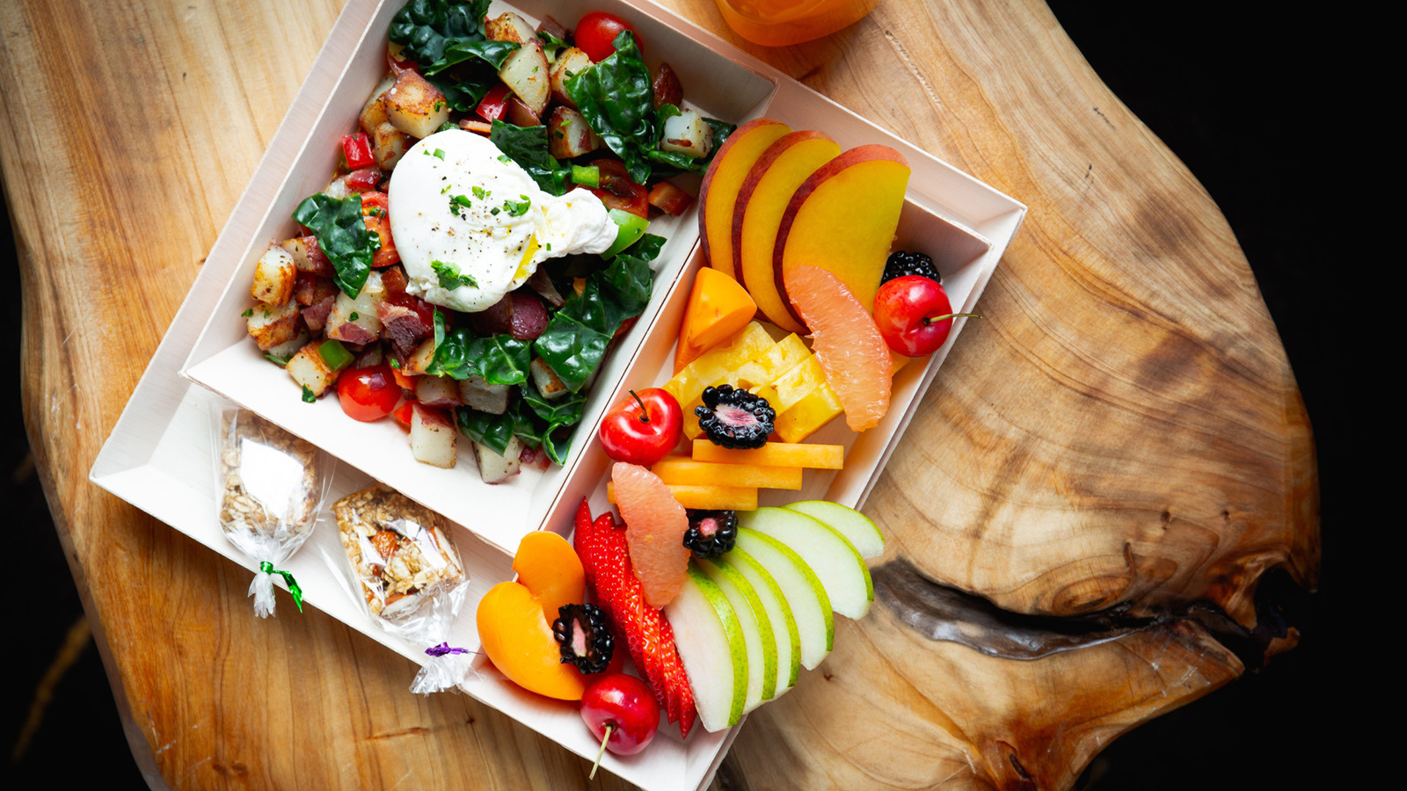 | 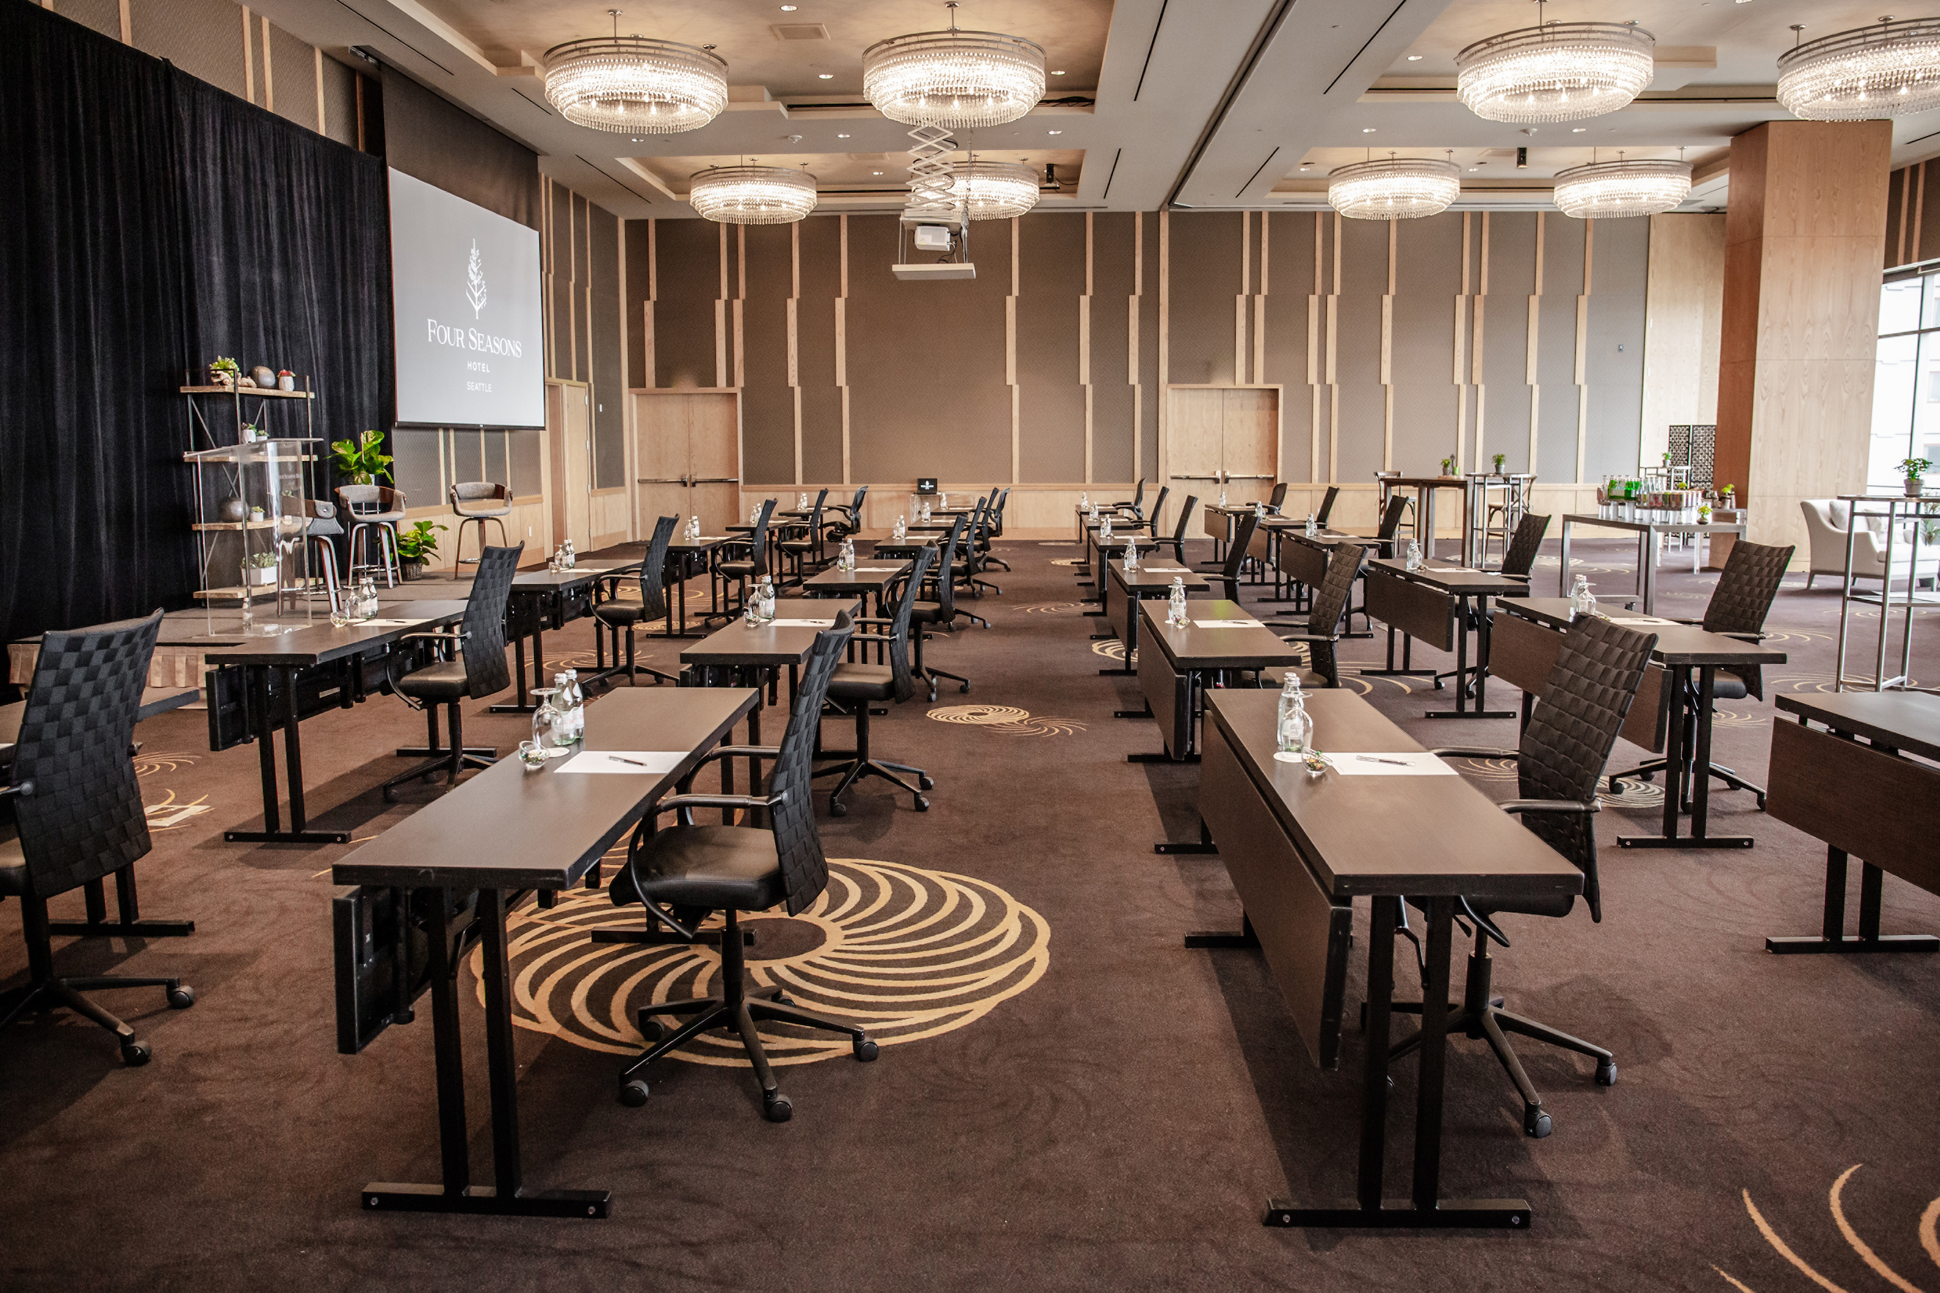
The events and culinary teams at Four Seasons Hotel Seattle have curated new experiences to elevate events, whether in the comfort of one's home, guest room, or from one of the unique spaces at the waterfront property.
Gala-to-Go
As events and gatherings move online, planners can enhance their virtual celebrations with a full culinary menu from Four Seasons chefs. Select from reception-style hors d'oeuvres, an artisan cheese and dessert spread, or a full three-course dinner with wine pairings.
Imagine a crema di mozzarella to start, followed by a cedar plank king salmon or wagyu short ribs, before ending with a lemon poppyseed cake, and paired with wines from L’Ecole and Mark Ryan Winery.
“Food has always been a driving force to connect people and places, and the Gala-to-Go experience bridges that gap for attendees of an event who can’t meet in person,” says Jaclyn Jerstad, Director of Catering & Conference Services at Four Seasons Hotel Seattle.
“Each culinary box is practically prepared for guests to enjoy during the online event. The boxes can also be customised to include event materials to provide a comprehensive virtual gala experience,” continued Jerstad.
New Event Menus: Onsite and To-Go
For micro-meetings and intimate events held at the Hotel, Chef Emmanuel Calderon and his team have created individually-served bento boxes and plated meals for breakfast and lunch. Menus continue to reflect the quintessential spirit of the Pacific Northwest, and can be personalised further for guests’ needs.
A breakfast bento box may include a Northwest hash cup with roasted potatoes, caramelised onions, bell peppers, kale, broccolini, bacon and poached egg. All boxes also include fresh juice, seasonal fruit cup and an energy bar.
For lunch, guests can delight in a Pike heirloom caprese and a Washington turkey club with bacon, cheddar, apple, tomato, and mixed greens. Lunch bento boxes include seasonal fruit salad, pastry chef's seasonal dessert and bottled water.
For those partaking in meetings from home, the Hotel’s to-go meals elevates any virtual meeting. Meals will be individually packaged in compostable, eco-friendly materials.
Four Seasons Chat and text messaging with a Four Seasons team member on property is encouraged to foster connection with attendees and planners, and reduce physical contact.
Chic and intimate, with sweeping panoramas of Elliott Bay and Puget Sound, Four Seasons Hotel Seattle offers one of the city’s most exclusive vantage points for events. Offering unsurpassed service to every member of an event, Four Seasons ensures each experience is one to treasure, whether at the Hotel or at home.
At Four Seasons, the health and safety of employees and guests are a top priority and are strengthened in the new health and safety program, Lead With Care. Genuine care and the highest levels of service are enhanced with a commitment to cleanliness and health safety. Full details can be found here.
For more information, visit the Hotel online or contact an event manager at 206 749 3900.

RELATED

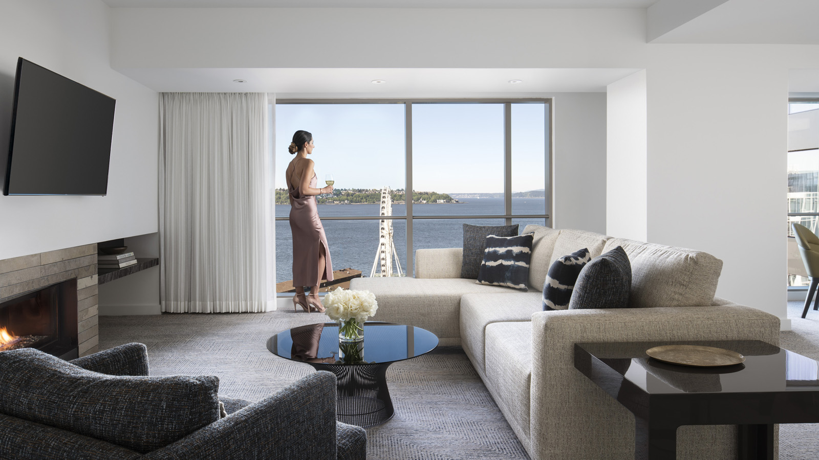 | September 3, 2020, Seattle, U.S.A.  Four Seasons Hotel Seattle Recognised as the Best Hotel in Washington State  https://publish.url/seattle/hotel-news/2020/forbes-five-star-hotel.html
August 27, 2020, Seattle, U.S.A.
The Spa at Four Seasons Hotel Seattle Reopens with Luxury Massages and Body Treatments
https://publish.url/seattle/hotel-news/2020/spa-reopening.html

PRESS CONTACTS

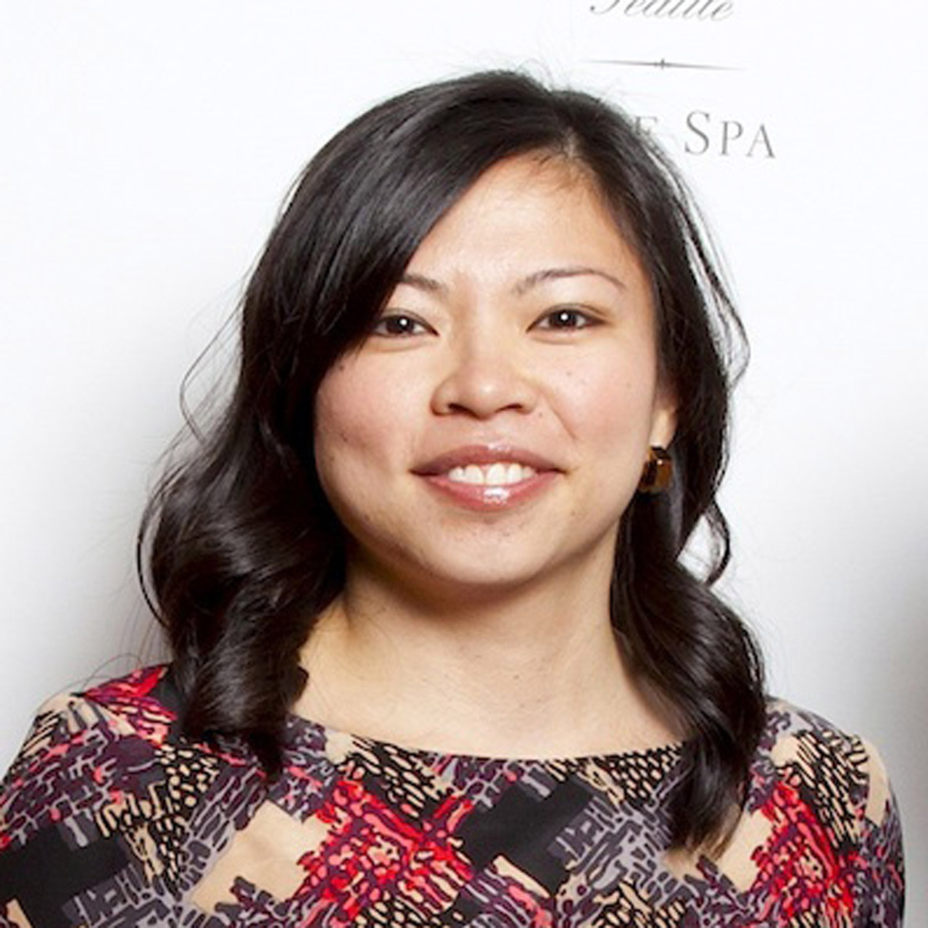 | Meg Paynor  PR Consultant  99 Union Street  Seattle  U.S.A.  meg@paynorpr.com  1 (206) 913-3848
Crystal Southcote
Digital Media Manager
99 Union Street
Seattle
U.S.A.
crystal.southcote@fourseasons.com

+1 (206) 749-3909

