Experience North America’s Premier Ski Destinations with Four Seasons Mountain Collection

Jackson Hole, Santa Fe, Vail and Whistler gear up for a memorable 2021-2022 winter season
November 16, 2021, Toronto, Canada

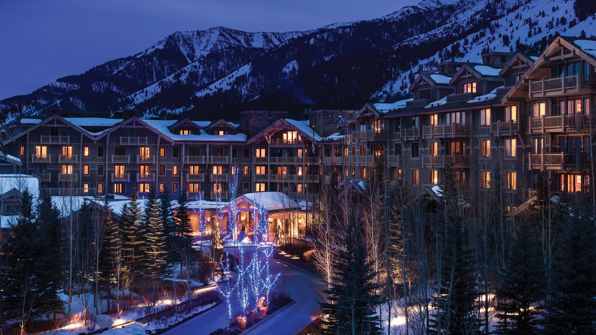 | 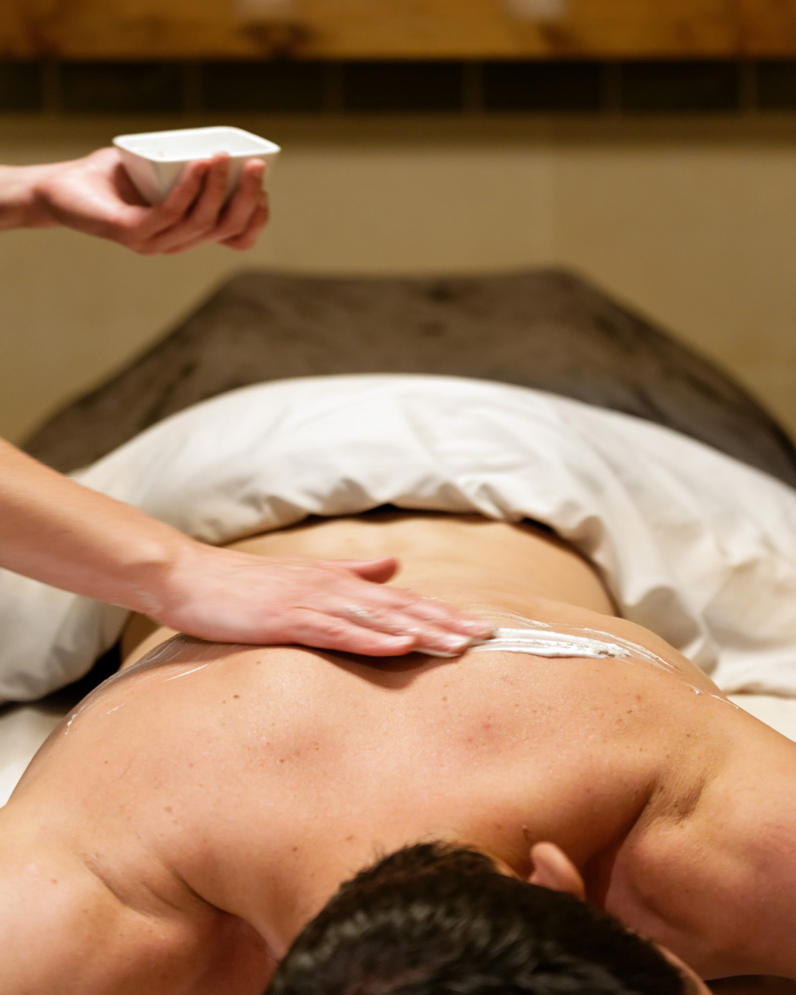 | 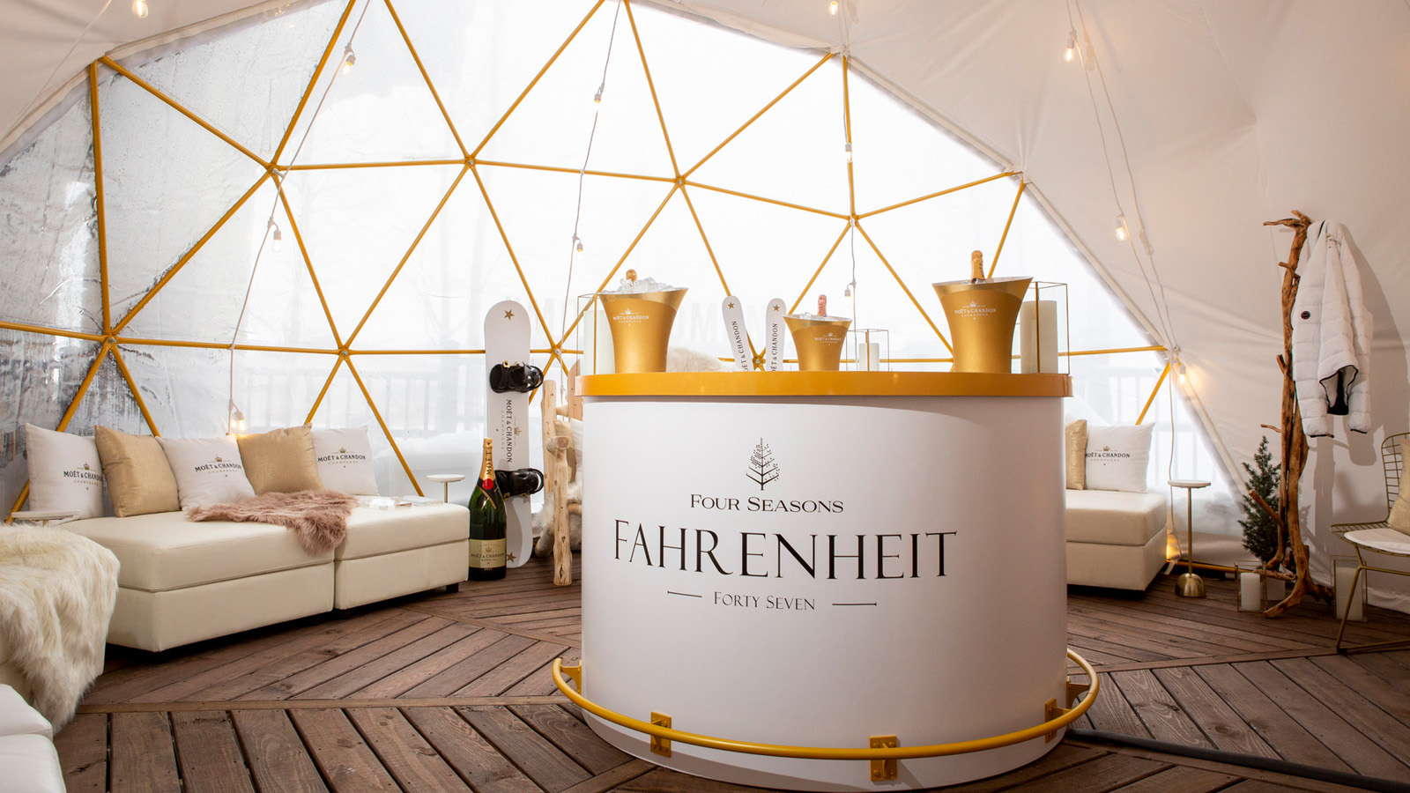
This winter, visit one, or all, of Four Seasons Hotels and Resorts Mountain Collection properties. From elevated après-ski experiences to relaxing fireside and regionally-inspired wellness treatments, Four Seasons Resort and Residences Jackson Hole, Four Seasons Resort Rancho Encantado Santa Fe, Four Seasons Resort and Residences Vail and Four Seasons Resort and Residences Whistler have a plethora of ways to enjoy special moments in the world’s most breath-taking mountain resorts.
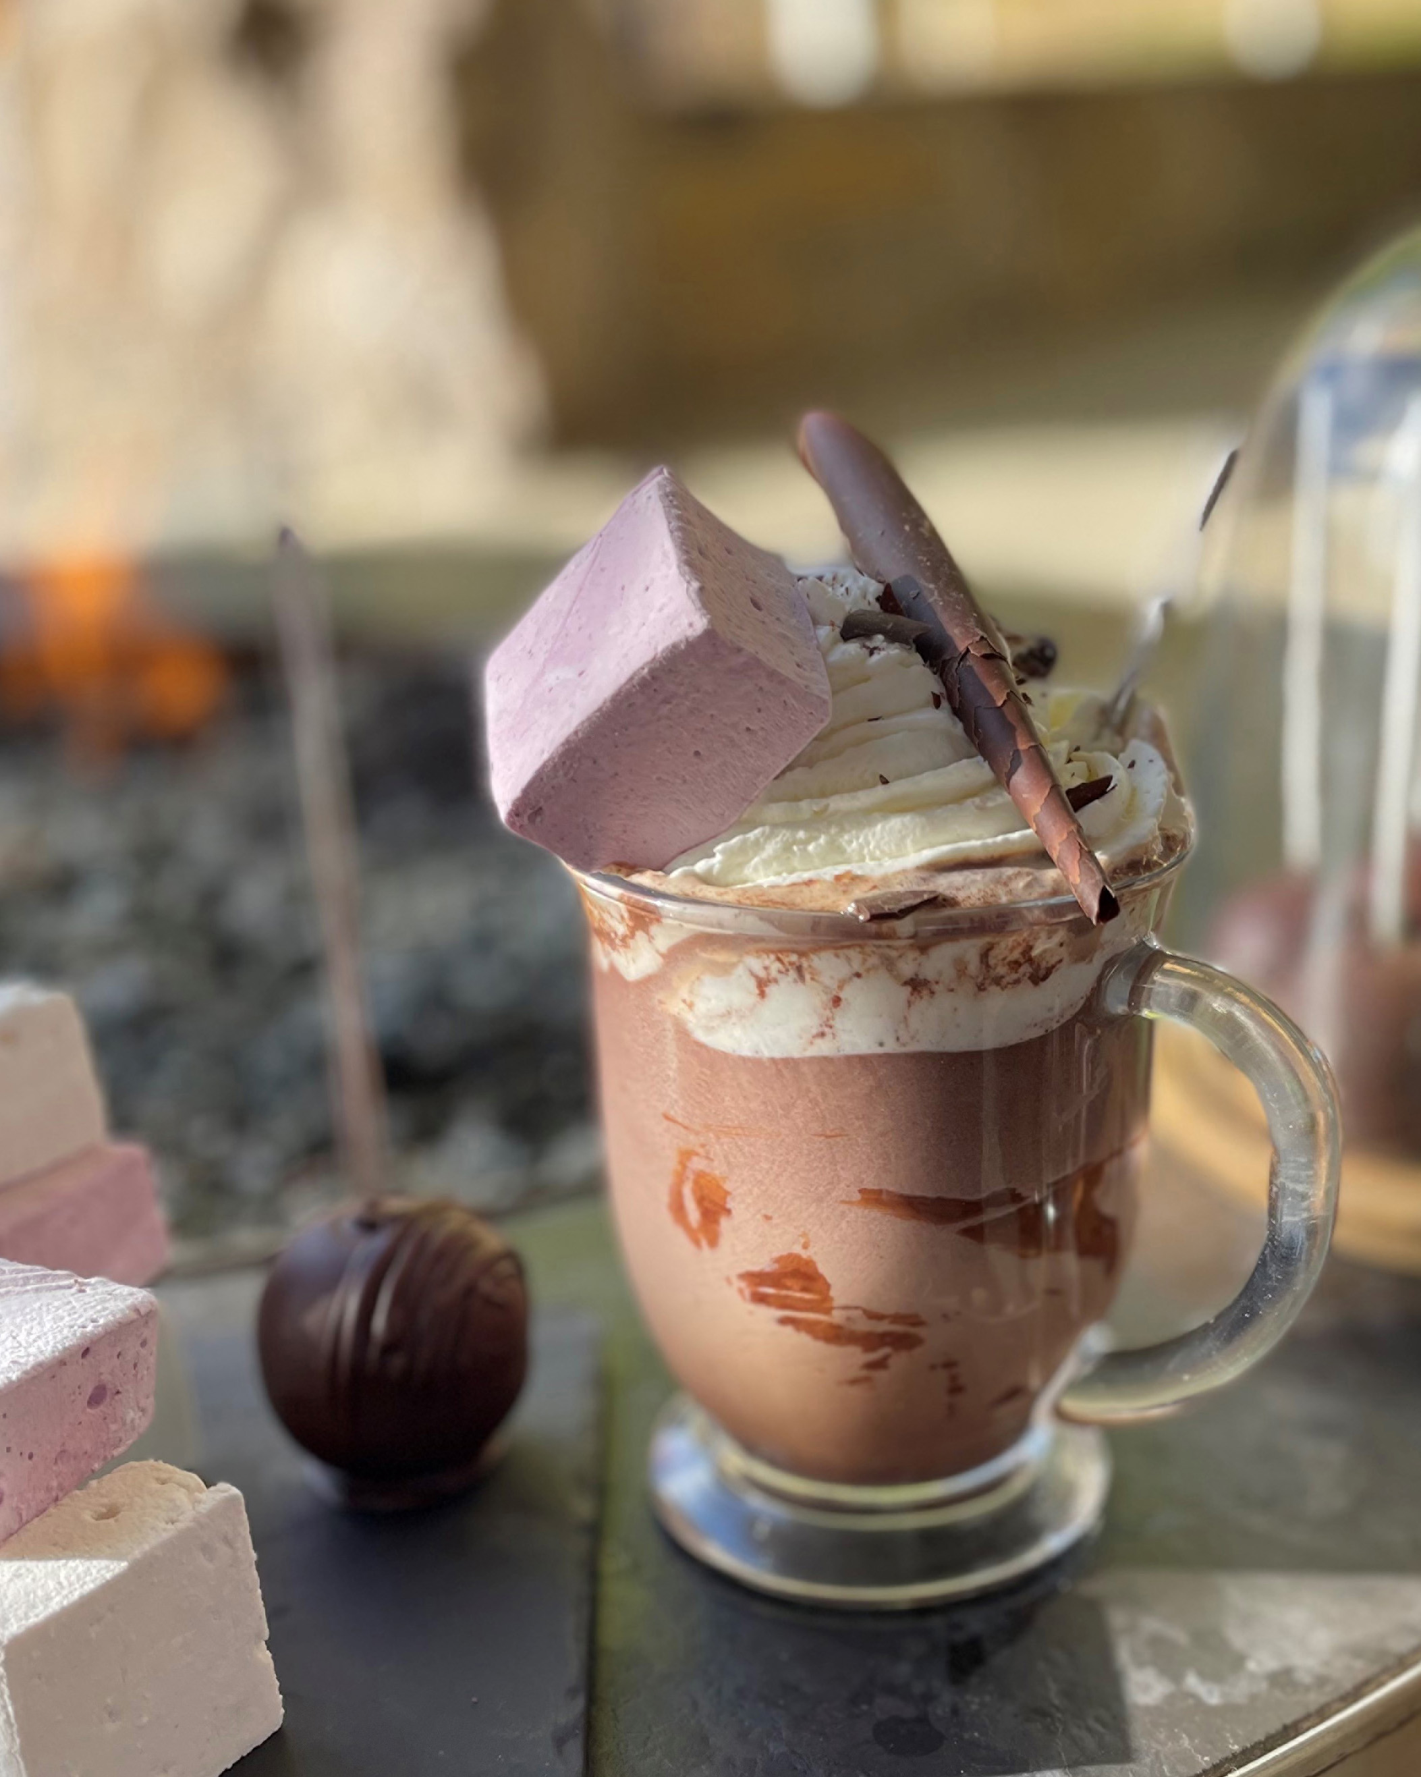 | 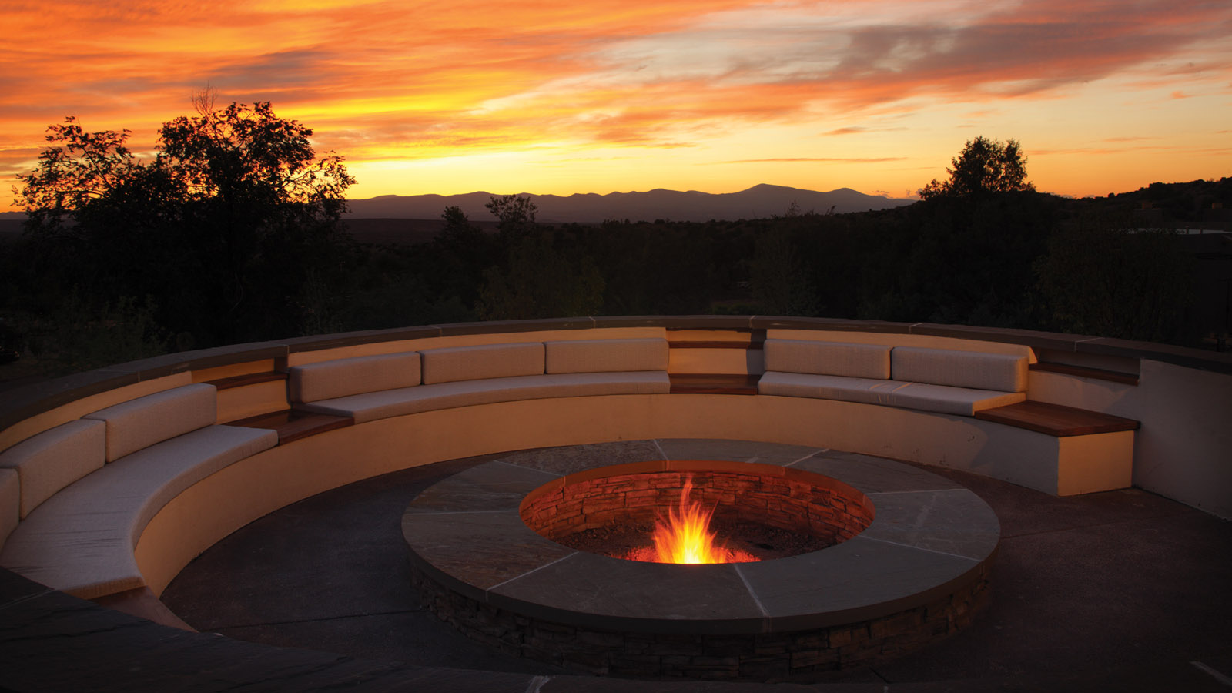 | 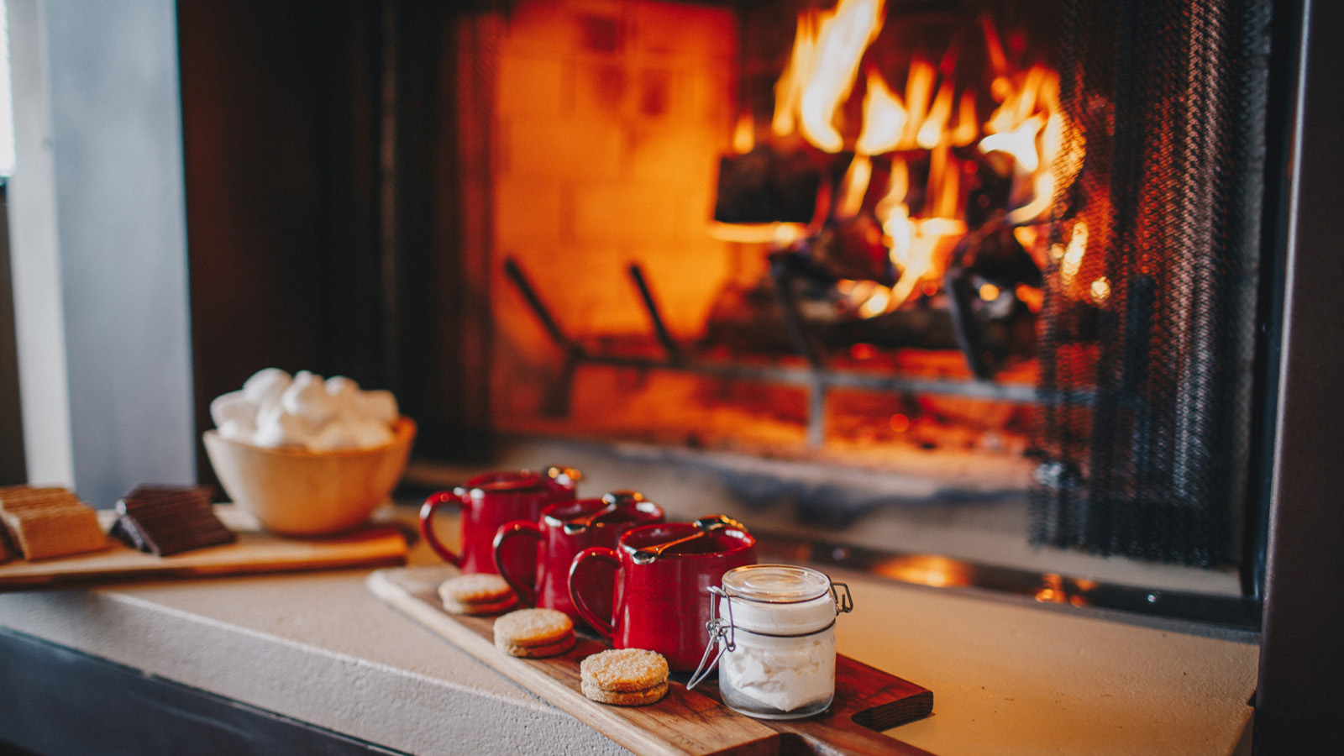
Après-Ski for Everyone
In celebration of the beloved alpine tradition of après-ski, all four Mountain Collection resorts have created bespoke experiences celebrating this time-honoured tradition.
- Elevated Après - Four Seasons Resort and Residences Jackson Hole announces the return this season of Fahrenheit Forty-Seven. Named for the ideal temperature at which to serve Champagne, this dome-shaped bar will once again transform the pool deck into a winter wonderland experience of chic luxury and the ultimate après chill. Fahrenheit Forty-Seven will offer Moët & Chandon Impérial and Moët & Chandon Rosé Impérial by the glass and by the bottle, plus bespoke cocktails featuring Moët & Chandon Ice Impérial. Curated culinary après offerings also will be available for purchase, including osetra caviar with toast points, Maine lobster salad canapes and kumamoto oyster shooters. Fahrenheit Forty-Seven is open daily this winter season from 3:30 to 6:30 pm.
- Après and The Art of Mixology - After a day on the slopes, head back to Terra Bar at Four Seasons Resort Rancho Encantado for a series of curated après-ski experiences, including learning the art of mixology from Terra’s beverage experts and how to create inventive craft cocktails using a variety of unique techniques and regional ingredient, and then guests can choose their own personalised signature libation; or enjoy a custom tequila and mezcal tasting and pairing experience with Terra Bar’s own Certified Tequila Expert.
- Vail’s Favourite Après Experience - Four Seasons Resort and Residences Vail boasts Vail's premier après locale, served up at one’s table, bar-side or at one of the select, sought-after fire-pits with seating on The Remedy's beautiful terrace, offering unmatched views of Vail Mountain. Talented mixologists specialise in curated cocktails ranging from elixirs to potions, each offering the perfect prescription to post-slope revelry - while the culinarians craft protein-rich bites to refuel and recharge after a day on the mountain.
- Hot Chocolate Around the World – For those looking for a cosy and warm après experience, Four Seasons Resort and Residences Whistler presents the ultimate hot chocolate program, available at the newly renovated Braidwood Tavern. Inspired by their home and travel memories, the creative bar team has launched a collaborative spiked hot chocolate menu, designed to transport tastes from all over world to the mountains. Surrounded by the stunning alpine scenery, guests may choose from a menu of craveable favourites, while recapping the laughs and adventures of the day.
Fireside
There’s nothing like cosying up next to a fire following a long day on the mountain. Four Seasons Mountain Collection has created the following elevated experiences for guests to enjoy and savour this winter season.
- Sophisticated Fireside Sips – Hot chocolate reaches new levels of sophistication this season with a specialty hot chocolate cart available daily from 3:00 to 6:00 pm at Four Seasons Resort and Residences Jackson Hole. Guests can choose from five different types of specialty chocolate, ranging from the sophisticated Valrhona 70 percent Guanaja and Valrhona 64 percent Manjari to classic milk chocolate. The Chocolate Connoisseur will help guide guests to the perfect selection to complement their palate. Gourmet toppings include homemade marshmallows in an array of flavours – vanilla, peppermint, huckleberry and cinnamon fireball. For those looking for an added kick, spirited additions also are available. So cosy in to one of the nearby oversized sofas, enjoy the roaring fire and sip to a heart's delight.
- Fireside Delights - With its elevated terrace and large outdoor firepit, Terra Bar at Four Seasons Rancho Encantado offers the ideal gathering spot, for locals and guests a like, to imbibe and unwind while taking in the region’s most stunning sunset views. Enjoy fireside chats and live music, and nightly s’mores along with a progressive selection of seasonal cocktails, local brews and extensive wine options, paired with an evolving menu of eclectic bites. For a more intimate fireside experience, guests can cosy up in their spacious casita, complete with indoor and outdoor wood-burning fireplaces and private patios, and have the Fire Butler light their fire and deliver a customised s’mores kit or a make-your-own cocktail kit, with a spread of accoutrements.
- Experience the Haut Chocolat Fireside – At Four Seasons Resort and Residences Vail, guests can choose to enjoy a fire pit on The Remedy terrace, roast s’mores at the S’more Haus on the pool terrace, or cuddle up next to the fireplace in their guest room, suite, or residence. Pastry Sous Chef Braeden Gilbert and her talented team have created the perfect addition to make the experience even cosier – the world-famous Haut Chocolat – elevated with guest’s choice of liquor upon request.
- The Vintage Camper is Back – Four Seasons Resort and Residences Whistler charming vintage patio camper is back for winter, serving up luxurious decadent hot chocolate and cook-your-own s’mores. Guests can gather around the fire pit to warm up after a long day out adventuring, and enjoy the playful signature hot chocolate, The Tipsy Snowman, or wind down with the sommelier’s selection of British Columbia wine, with complimentary tastings offered each evening.
Locally-Inspired Winter Wellness
Rejuvenating therapies capture the essence of each of the unique alpine regions of the Mountain Collection award-winning spas.
- Snow Melt Ritual - Four Seasons Resort and Residences Jackson Hole introduces the Snow Melt Ritual in The Spa, launching January 1, 2022. The treatment begins with a soothing milk bath in a private Spa Suite. Sip while soaking on an aromatic mocktail, blending allspice and cardamom for a drink that warms from the inside out. Continue the bliss with a Swedish full-body massage, followed by a rich mask of shea butter with extracts of goat milk and sweet vanilla. Enjoy an immersive full-body wrap, while simultaneously experiencing a luxurious foot massage with chai spice and vanilla warming balm.
- Warm Bourbon Brown Sugar Body Scrub Experience - This season, guests can escape to The Spa at Four Seasons Resort Rancho Encantado and indulge their senses with a warm, skin-smoothing brown sugar and bourbon-infused body scrub treatment, followed by a tension-melting shea butter application that will leave skin feeling renewed, nourished and hydrated. To complete the experience, enjoy a cosy glass of bourbon and decadent almond bourbon truffles while lounging fireside in the warming room, or relaxing in the hot tub in a private spa courtyard.
- Après at The Spa - Enjoy a high-altitude, post adventure treatment from head to toe at the award-winning Spa at Four Seasons Resort and Residences Vail. This winter season, The Spa brings back signature rituals and à la carte treatments focusing on recovery, hydration, exfoliation and detoxifying while re-mineralising the body. Newly developed and classic treatments have incorporated holistic, results-driven offerings from celebrated brands including Natura Bisse, Phytomer, Sanara and Tara Spa.
- Peak to Feet Experience – After an adventurous day exploring Whistler and Blackcomb mountains, The Spa at Four Seasons Resort and Residences Whistler introduces its signature Peak to Feet package, ensuring head to toe relaxation. The experience starts with a rejuvenating Sports Recovery Massage, including a combination of stretching techniques and soothing essential aromas, followed by a relaxing scalp massage, using spa-made warmed oil to massage the scalp and hydrate hair. To complete the treatment, the expert team prepares a luxurious alpine mint foot massage, where peppermint crème is used to ease soreness and tired muscles. Wrapped in cosy soft robes and in full bliss, guests can enjoy a comforting cheese or fruit platter with this experience.
About Four Seasons Mountain Resorts
In addition to world-class skiing, each Four Seasons Mountain Resort offers the ultimate winter getaway in an enviable location, as well as fine dining, luxurious spa retreats, après ski offerings, and new, one-of-a-kind experiences. With the Resorts’ signature amenities and renowned personalised service, Four Seasons Resort and Residences Vail, Four Seasons Resort Rancho Encantado Santa Fe, Four Seasons Resort and Residences Whistler and Four Seasons Resort and Residences Jackson Hole are in a class of their own among winter destinations.

RELATED

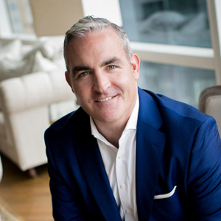 | November 17, 2021, Jackson Hole, U.S.A.  Sean Casserly Appointed Resort Manager at Four Seasons Resort and Residences Jackson Hole  https://publish.url/jacksonhole/hotel-news/2021/new-resort-manager-sean-casserly.html
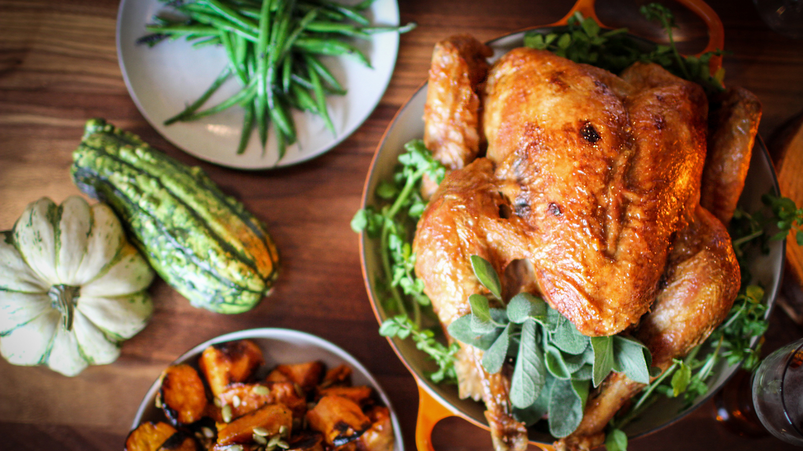 | November 9, 2021, Santa Fe, U.S.A.  Four Seasons Resort Rancho Encantado Santa Fe Kicks Off the Season with a Line-up of Holiday Offerings, Festive Favourites, and New Experiences  https://publish.url/santafe/hotel-news/2021/festive-season.html

PRESS CONTACTS

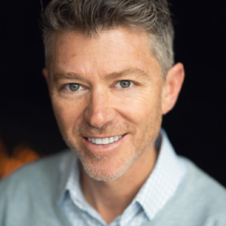 | Jonathan Reap  Senior Director of Public Relations  One Vail Road  Vail  USA  jonathan.reap@fourseasons.com  +1 970 477 8687
Kim Cole APR
Director of Public Relations
7680 Granite Loop Road, PO Box 544
Teton Village
USA
kim.cole@fourseasons.com

+1 480 980 8773

Michelle Duncan
Director of Public Relations
198 State Road 592
Santa Fe
USA
michelle.duncan@fourseasons.com

+1 646 229 2797

Carolina Pires
Public Relations Manager
4591 Blackcomb Way
Whistler
Canada
carolina.pires@fourseasons.com

+1 604 967 1869

