Four Seasons Resort Orlando Named in the 2018 U.S. News & World Report Best Hotels Rankings

For the fourth year in a row, Four Seasons Resort Orlando receives the top honour for Central Florida
February 6, 2018, Orlando at Walt Disney World Resort, U.S.A.

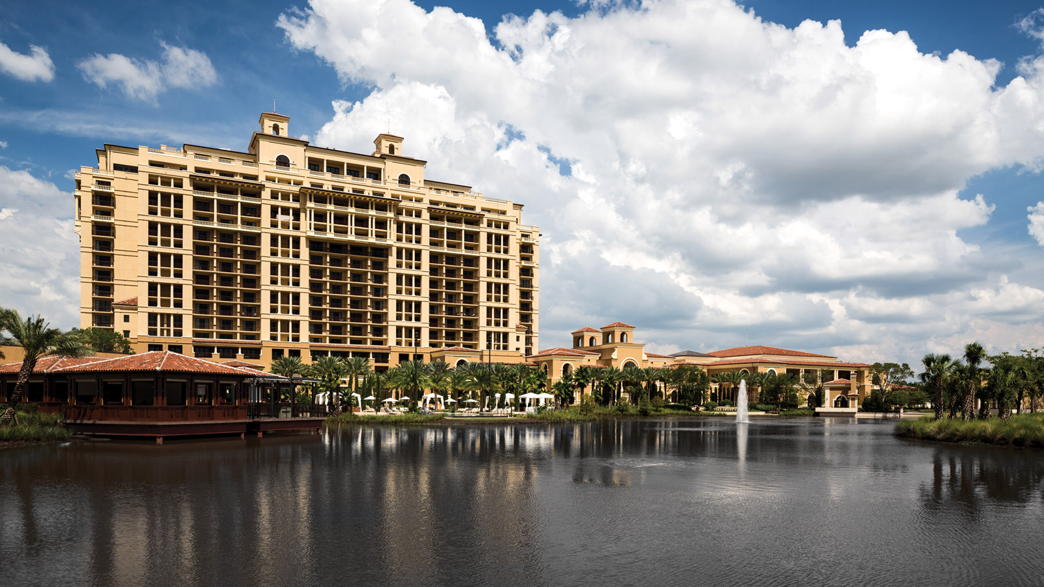
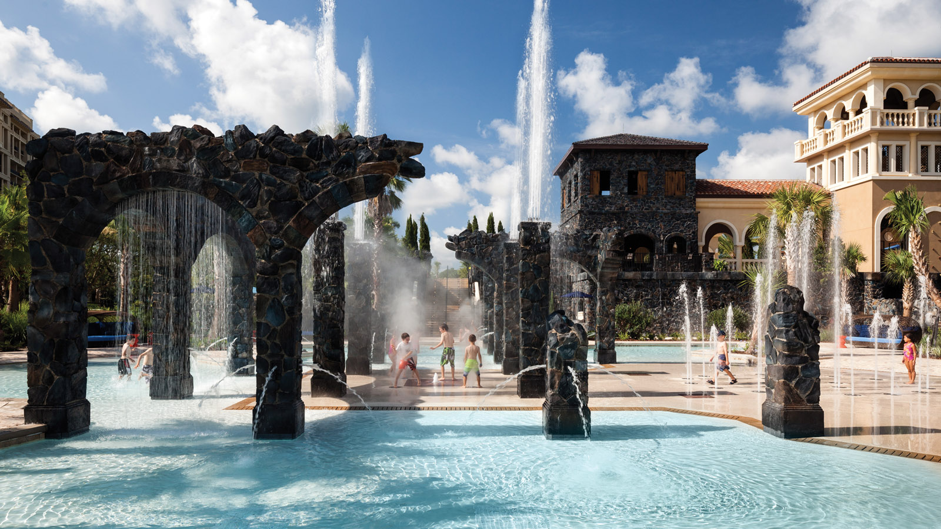 | 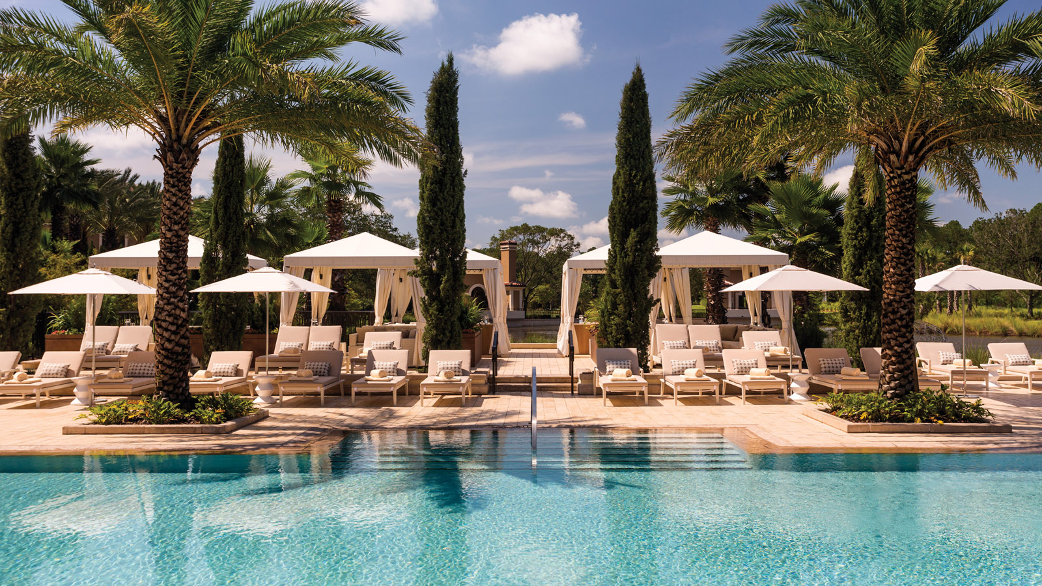 | 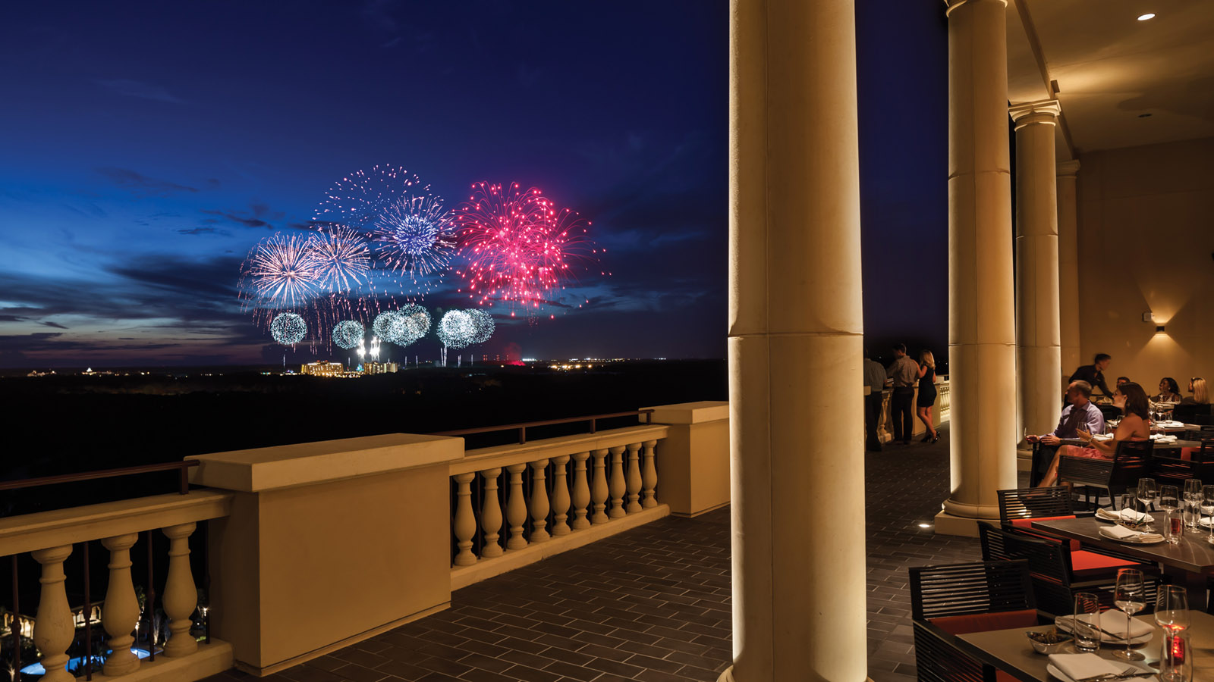
U.S. News & World Report, a nationally recognised publisher of consumer advice and information, recognised Four Seasons Resort Orlando at Walt Disney World Resort as the #1 hotel in the category of Best Hotels in Orlando - Walt Disney World in its annual evaluation of hotels that offer high-quality amenities and exceptional experiences. This is the fourth year Four Seasons Resort Orlando has received the top ranking.
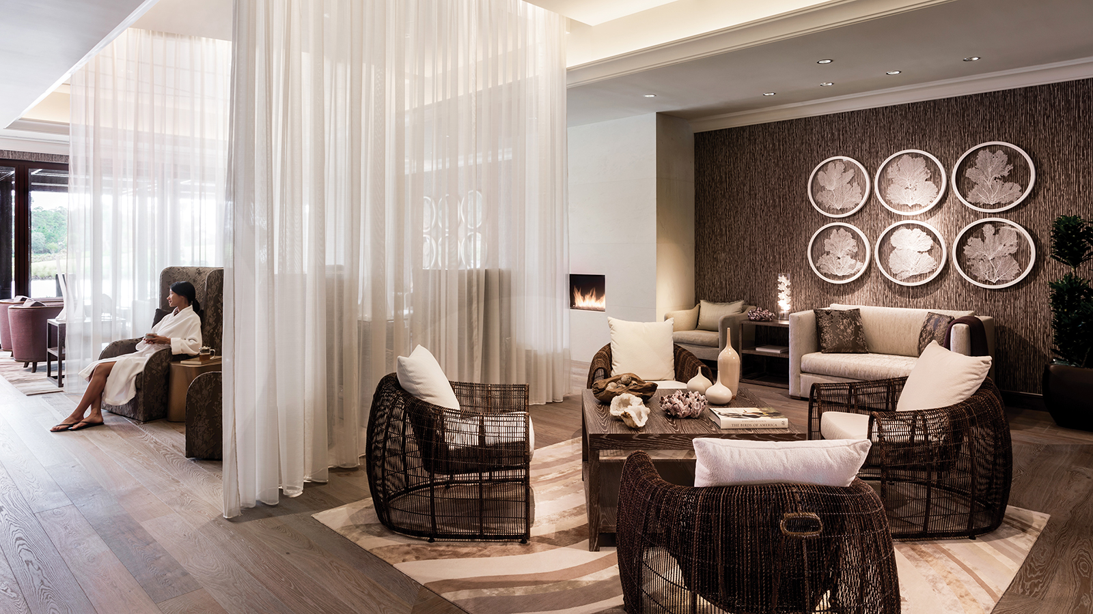
“We are extremely honoured to be named the #1 hotel within the category of Best Hotels in Orlando for four consecutive years,” says Thomas Steinhauer, Regional Vice President and General Manager of Four Seasons Resort Orlando. “The award is a testament to our incredible team of dedicated hospitality professionals that truly make all the difference.”
In addition to being ranked Best Hotel in Orlando by U.S. News & World Report, Four Seasons Resort Orlando was also named as the #2 Best Hotel in Florida. Four Seasons Resort Orlando also remains the first and only property within Central Florida to hold the coveted AAA Five Diamond Award.
New for 2018: Four Seasons Resort Orlando recently unveiled an extensive USD 2.5 million renovation to its golf practice facility at Tranquilo Golf Course, complete with a Par 3 course and 18-hole putting course. In addition, Tranquilo Golf Course has transitioned to an exclusive course, accessible for play only by Resort guests and members. Two new memberships are available, enabling the community to join as either a Golf Club member or Resort and Golf Club member. This is the first opportunity for local residents to join the only Club affiliated with a Five Diamond Award ranked resort. These enhancements further elevate Four Seasons Resort Orlando as a sought after destination for golf enthusiasts.
Guests of Four Seasons Resort Orlando enjoy complimentary transportation in a Four Seasons motor coach to Magic Kingdom Park, Epcot, Disney’s Animal Kingdom and Disney’s Hollywood Studios. In addition to enjoying all the nearby Disney attractions, a highlight of Four Seasons Resort Orlando is the five-acre (two hectare) Explorer Island water park, including a winding lazy river complete with a rapids section, two water slides, an interactive splash zone with water cannons, and much more. The Kids For All Seasons program offers organised activities for children ages 4-12, and is complimentary. Adults will enjoy the adult-only pool, 18-hole Tom Fazio-designed Tranquilo Golf Course, and The Spa at Four Seasons. Recreational pursuits for guests of all ages are sure to provide ample entertainment.
The eighth annual U.S. News & World Report Best Hotels rankings evaluate more than 24,000 luxury properties across the United States, Europe, Canada, Bermuda and Mexico. The methodology accounts for both expert and guest sentiment, the combination of which helps determine each hotel's rank.

RELATED

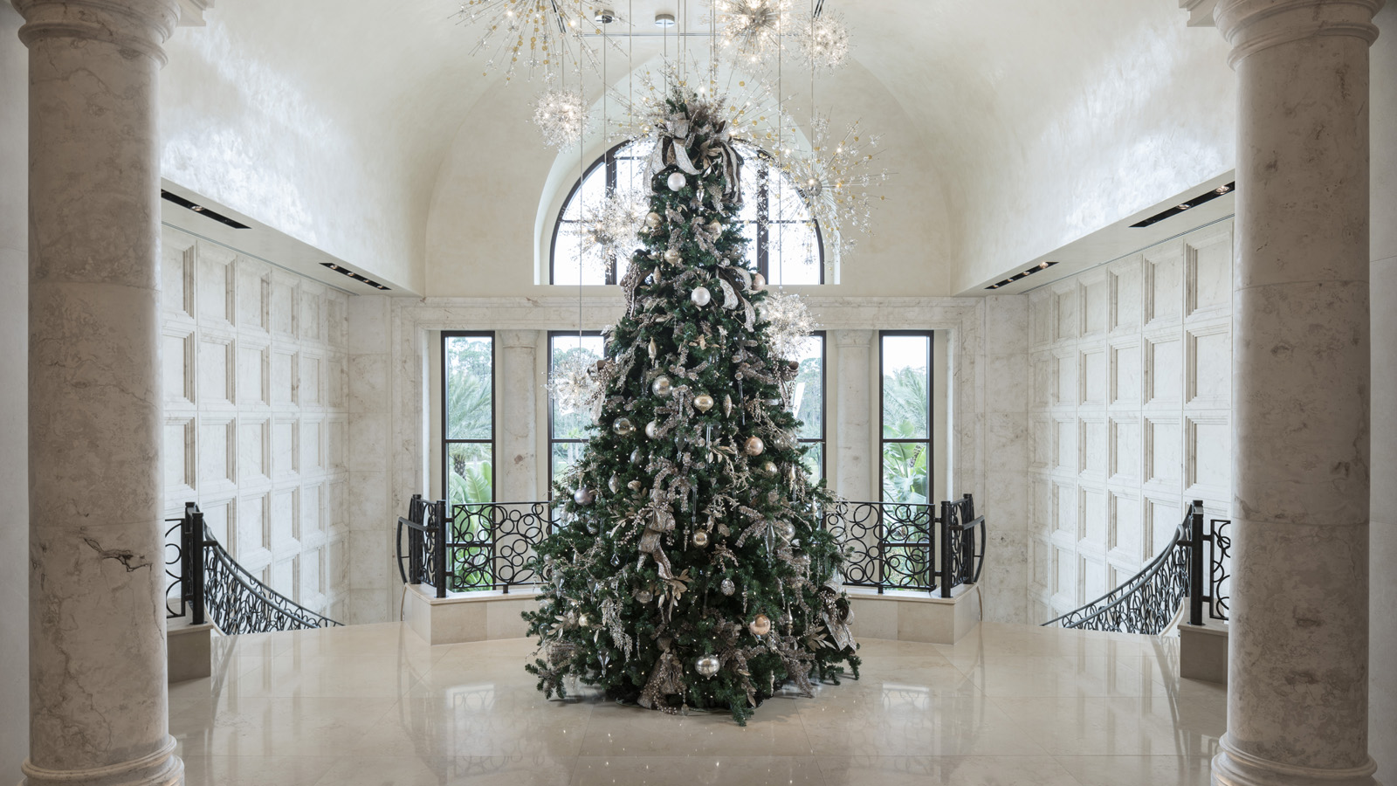 | October 3, 2019, Orlando at Walt Disney World Resort, U.S.A.  Rejoice with a Festive Season Vacation Under the Sun at Four Seasons Resort Orlando at Walt Disney World Resort  https://publish.url/orlando/hotel-news/2019/festive-season.html
September 23, 2019, Los Angeles at Beverly Hills, U.S.A.
Experience the Flavours of Italy with “A Night in Tuscany and Piedmont” at Culina Restaurant at Four Seasons Hotel Los Angeles at Beverly Hills
https://publish.url/losangeles/hotel-news/2019/guest-chef-dinner-at-culina.html

PRESS CONTACTS

Dana Berry
Director of Public Relations
10100 Dream Tree Boulevard
Orlando
U.S.A.
dana.berry@fourseasons.com

1 (407) 313-7777

