Four Seasons Hotels and Resorts Showcases Continued Support for Cage-Free Egg Sourcing Initiative

Four Seasons commits to sourcing cage-free eggs across global operations by 2025
August 15, 2019, Toronto, Canada

Four Seasons Hotels and Resorts, the world’s leading luxury hospitality company, has committed to sourcing 100 percent cage-free eggs (both shell and liquid) throughout hotel and resort operations in the United States, Canada and Europe by December 31, 2019.
At this time, hotels and resorts in the United States, Canada and Europe are on track to meet this goal, with nearly all properties in the United States, more than 80 percent of properties in Europe, and all four Canadian properties sourcing only cage-free shell and liquid eggs. Remaining hotels and resorts in these regions are actively working towards this commitment to source only cage-free eggs by the end of 2019.
Working with The Humane League, a leading farm animal protection non-profit organisation, the initiative is part of an overall goal to source only cage-free eggs across Four Seasons global portfolio by 2025.
With a growing portfolio of more than 100 hotels and resorts worldwide, Four Seasons commitment to the cage-free initiative will have a positive impact on animal welfare and sustainable food sourcing at both the local and global level.
For more information on The Humane League’s efforts to reduce animal suffering click here.

RELATED

July 8, 2019, Singapore
Raising a Glass to Four Seasons in the Asia Pacific Region
https://publish.url/news-releases/2019/asia-pacific-bar-program.html

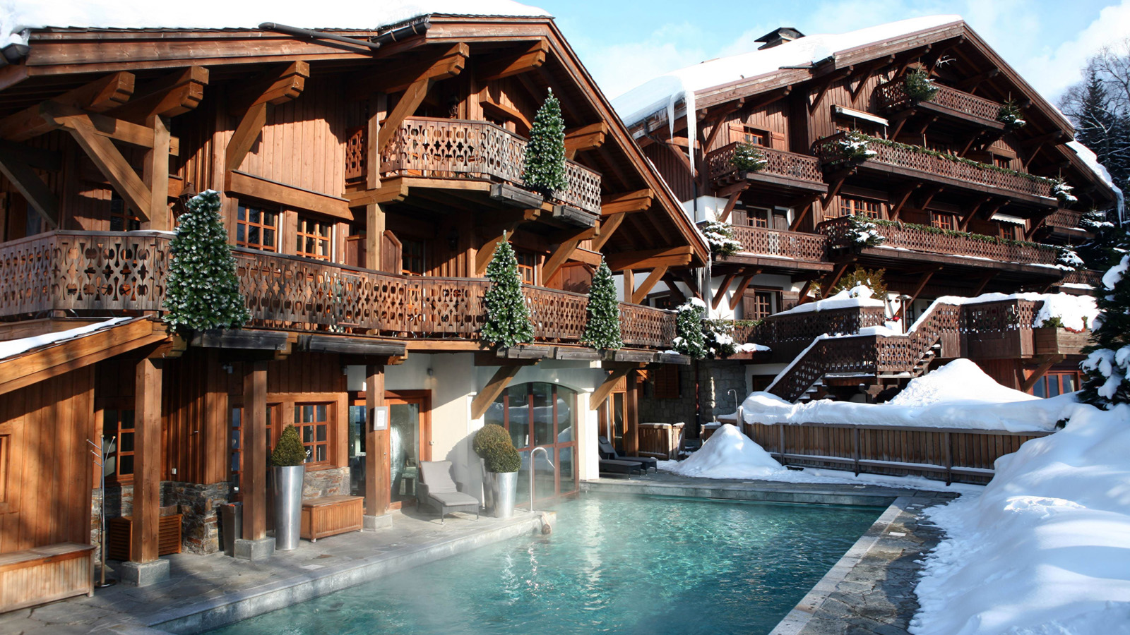 | April 10, 2019, Toronto, Canada  Four Seasons leva mais uma experiência de luxo para os Alpes Franceses com o Les Chalets du Mont d’Arbois, Megève, A Four Seasons Hotel  https://publish.url/news-releases/2019/les-chalets-du-mont-darbois-now-a-four-seasons-hotel-3.html

PRESS CONTACTS

Sarah Tuite
Senior Director, Corporate Public Relations
1165 Leslie Street
Toronto
Canada
prsm@fourseasons.com

+1 (416) 441-4350

