The Tailored Man

March 31, 2016, Palo Alto, Silicon Valley, U.S.A.

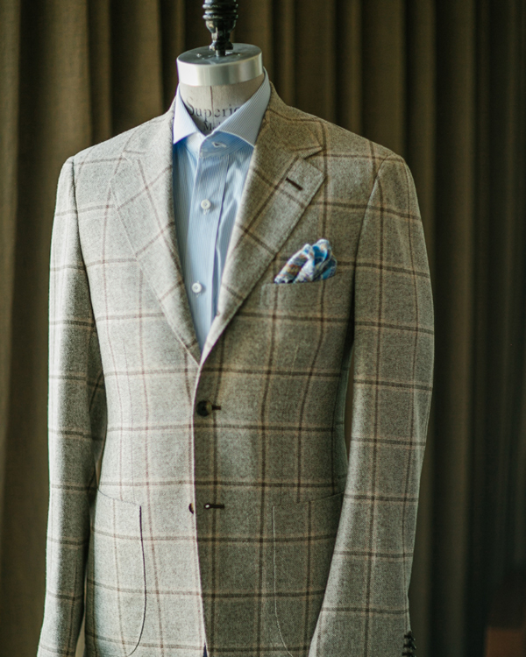
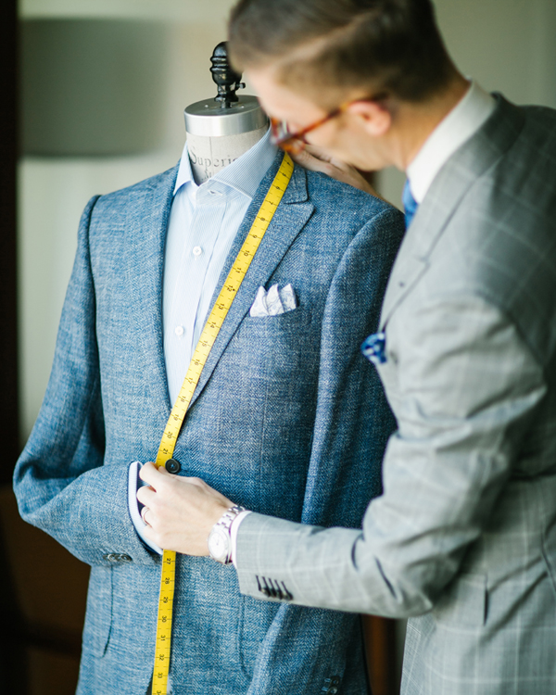
Beyond the hoodies and hiking boots, there’s still a breed of gentleman who will live and die by the power suit, and this is a very good thing for Devan Rosdahl. The bespoke, made-to-order custom clothing line, Devan Vincent (Vincent is Devan’s middle name) was launched right here in Silicon Valley in 2014.
With a belief that luxury tailored clothing is equal parts quality and service, Devan will visit clients in New York, San Francisco, his new showroom in downtown Burlingame, or better yet, right in your room at
Four Seasons
Hotel Silicon Valley at East Palo Alto.
Featured pieces are showcased in the Hotel lobby and sold at the Spa. Appointments can be made through the Hotel’s concierge team.

RELATED

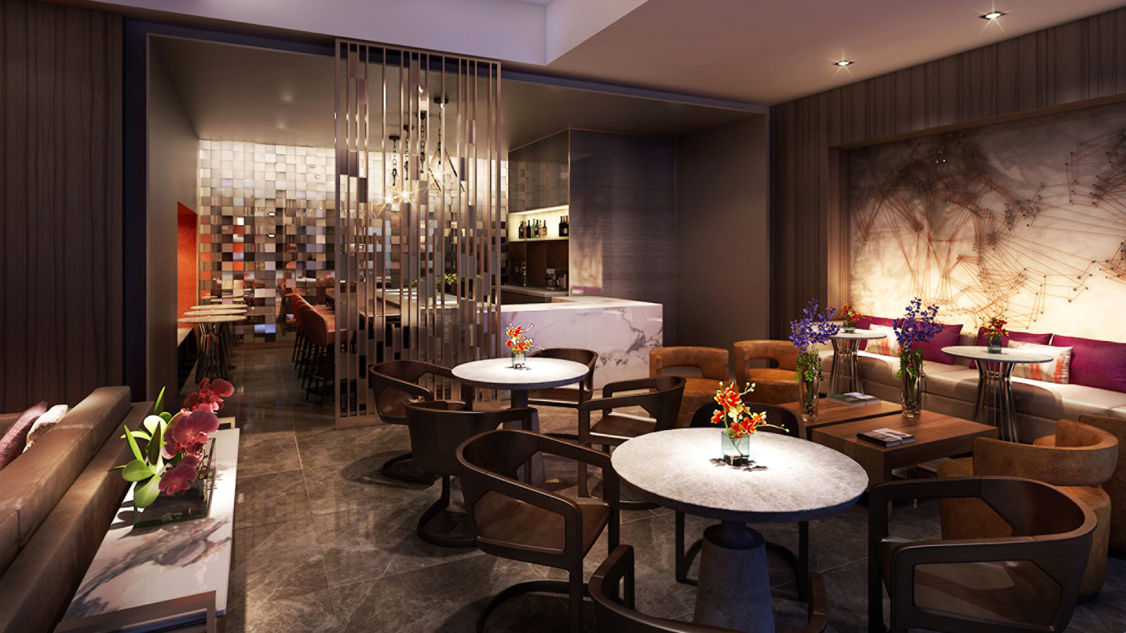 | March 31, 2017, Palo Alto, Silicon Valley, U.S.A.  Four Seasons Hotel Silicon Valley Launches [esc] - A Sleek Lounge-Style Lobby and Dining Destination in Palo Alto  http://publish.url/siliconvalley/hotel-news/2017/new-esc-lobby-and-dining.html
March 22, 2017, Palo Alto, Silicon Valley, U.S.A.
Four Seasons Hotel Silicon Valley at East Palo Alto Partners with Silicon Valley Innovation Center to Offer Exclusive Silicon Valley Tech Experiences for Groups
http://publish.url/siliconvalley/hotel-news/2017/silicon-valley-tech-experiences-for-groups.html

PRESS CONTACTS

Malia O'Connor
Public Relations and Communications Manager
2050 University Avenue
East Palo Alto
U.S.A.
malia.oconnor@fourseasons.com

+1 (650) 470-2810

