Five Exceptional Gifts to Experience a Magical Christmas with Four Seasons Hotel George V, Paris

October 8, 2021, Paris, France

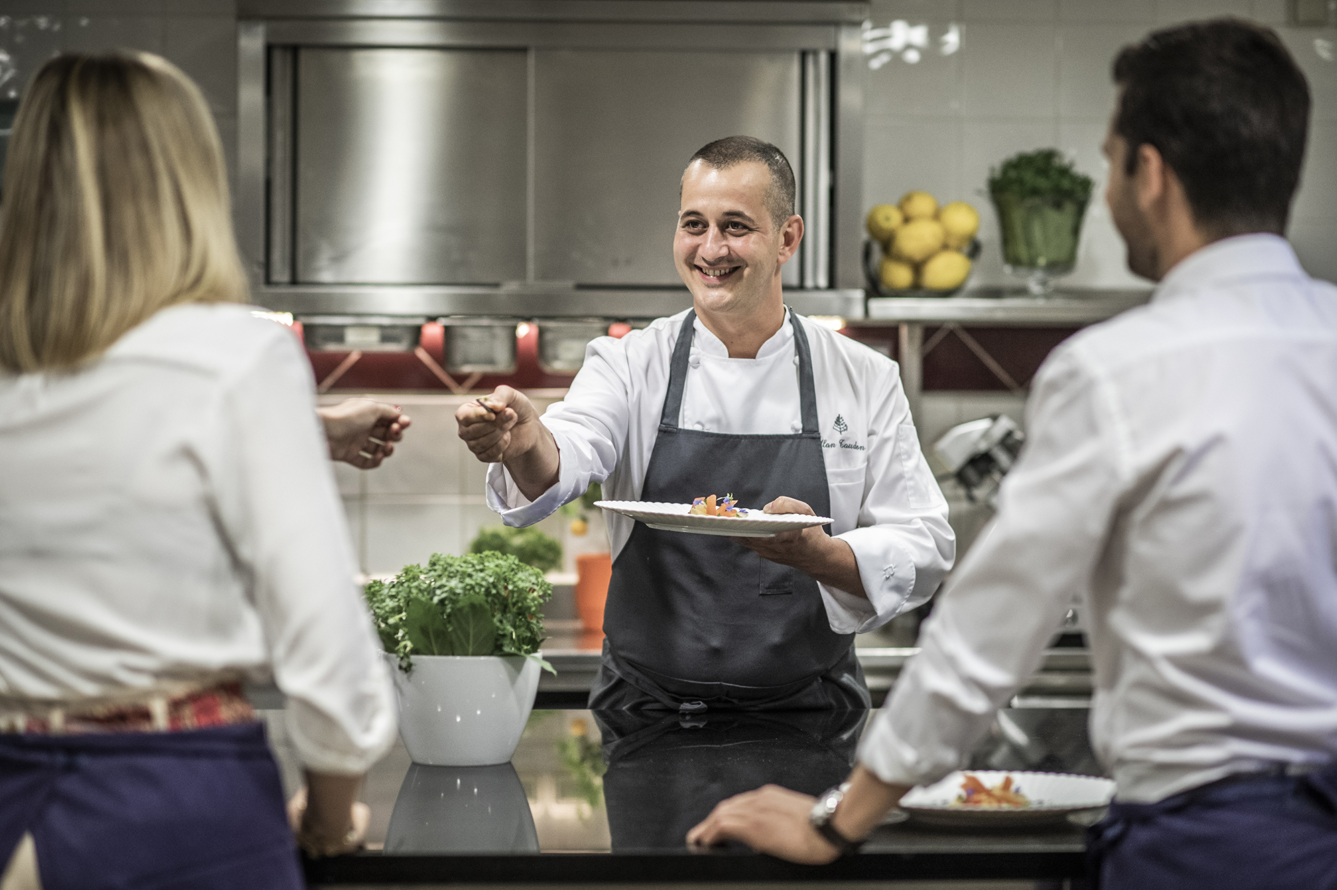
 | 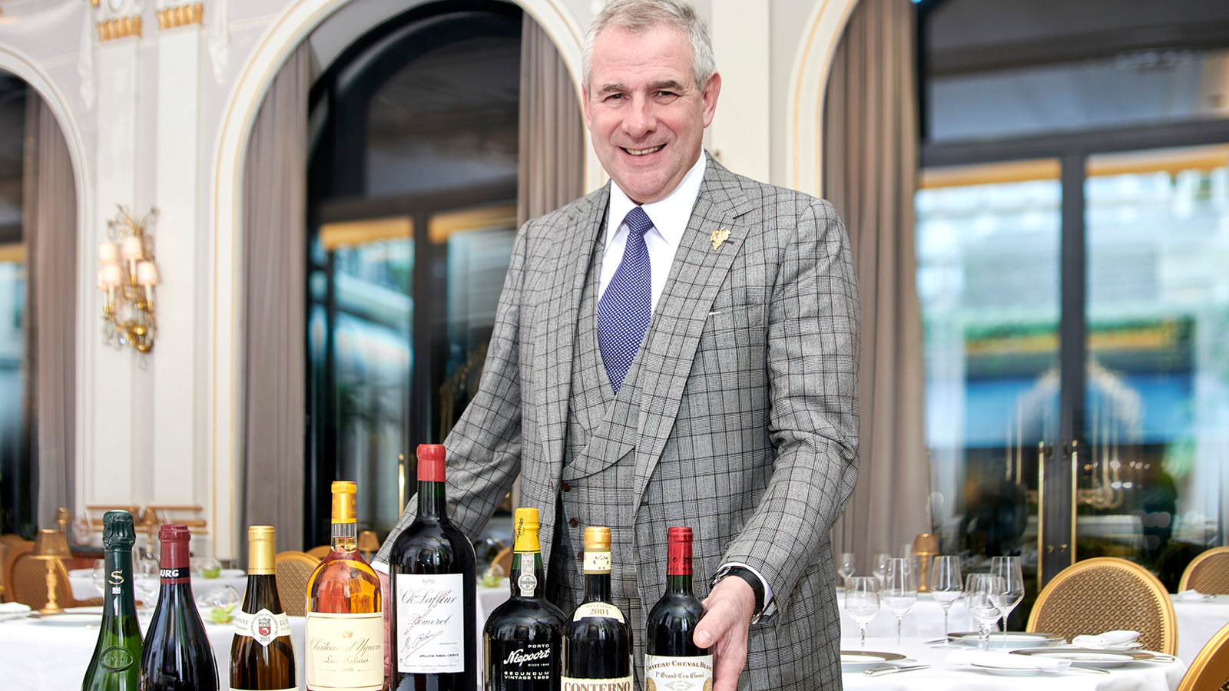 | 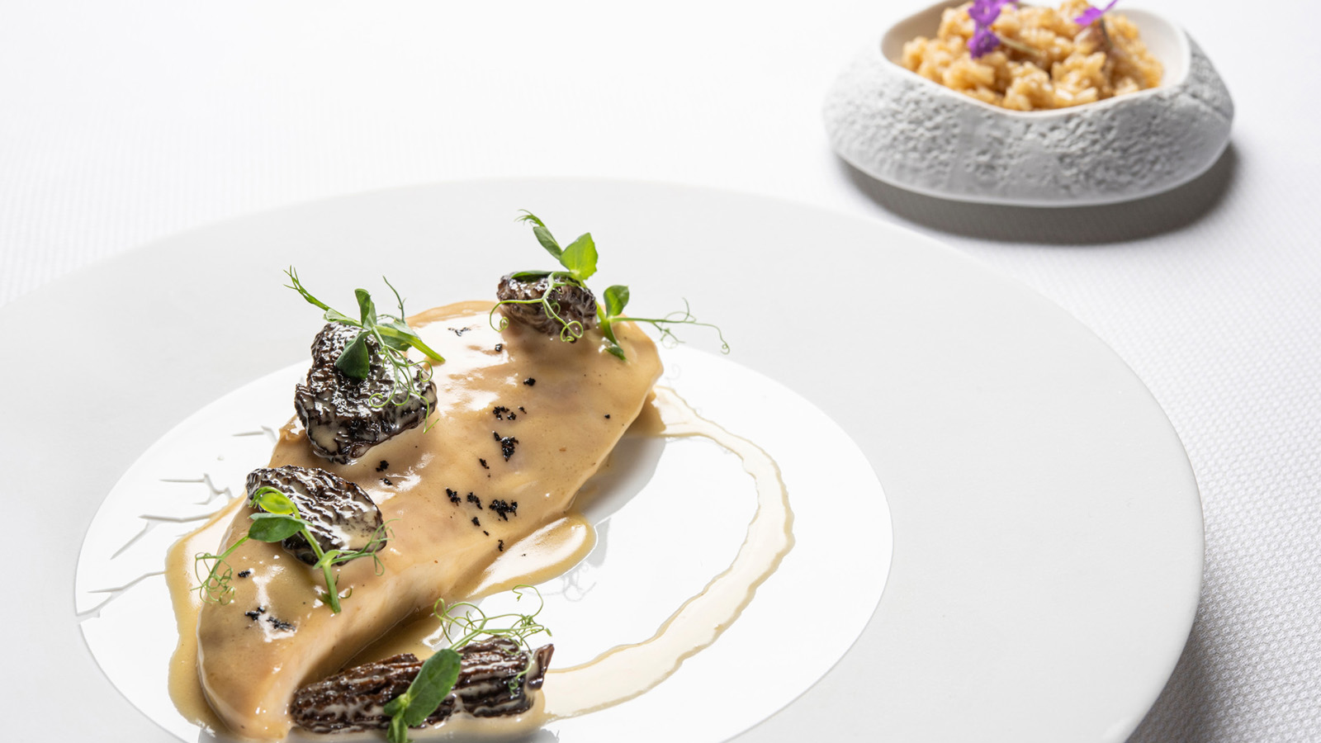
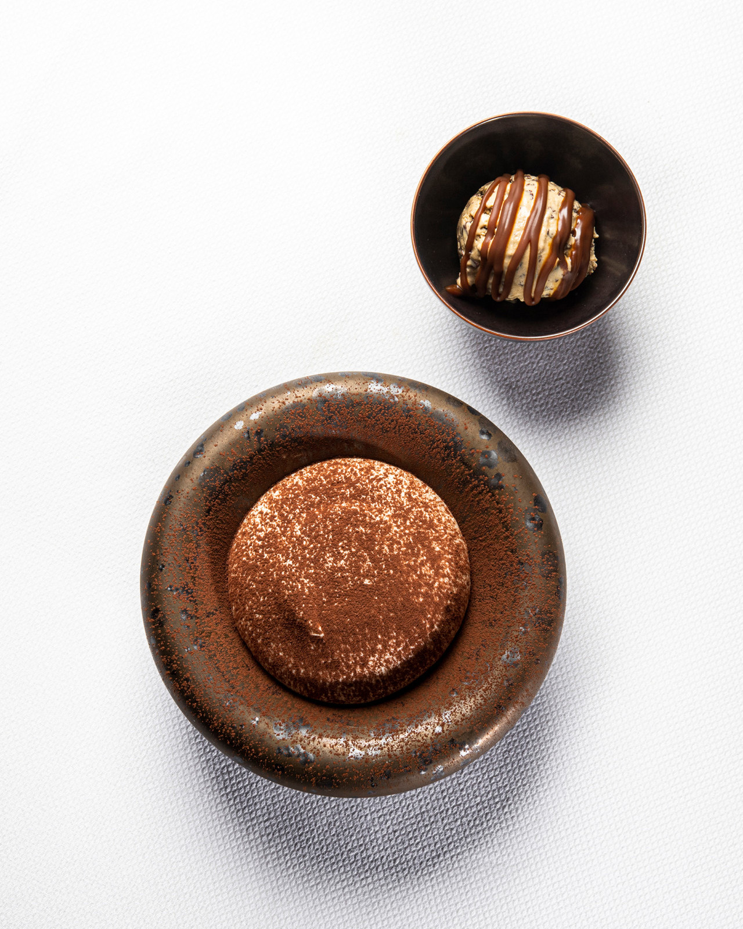 | 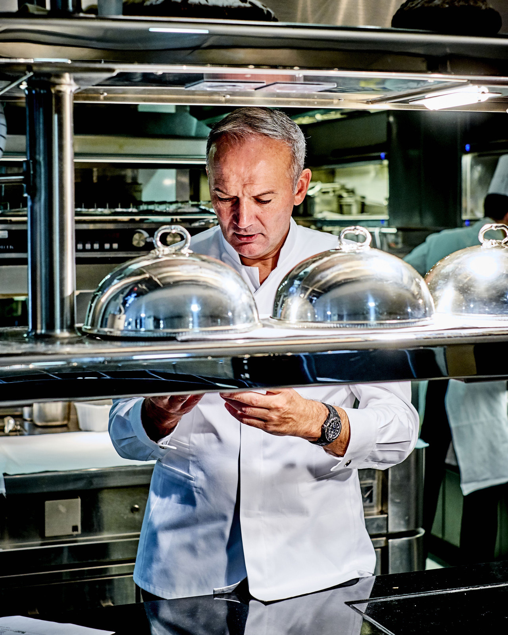 | 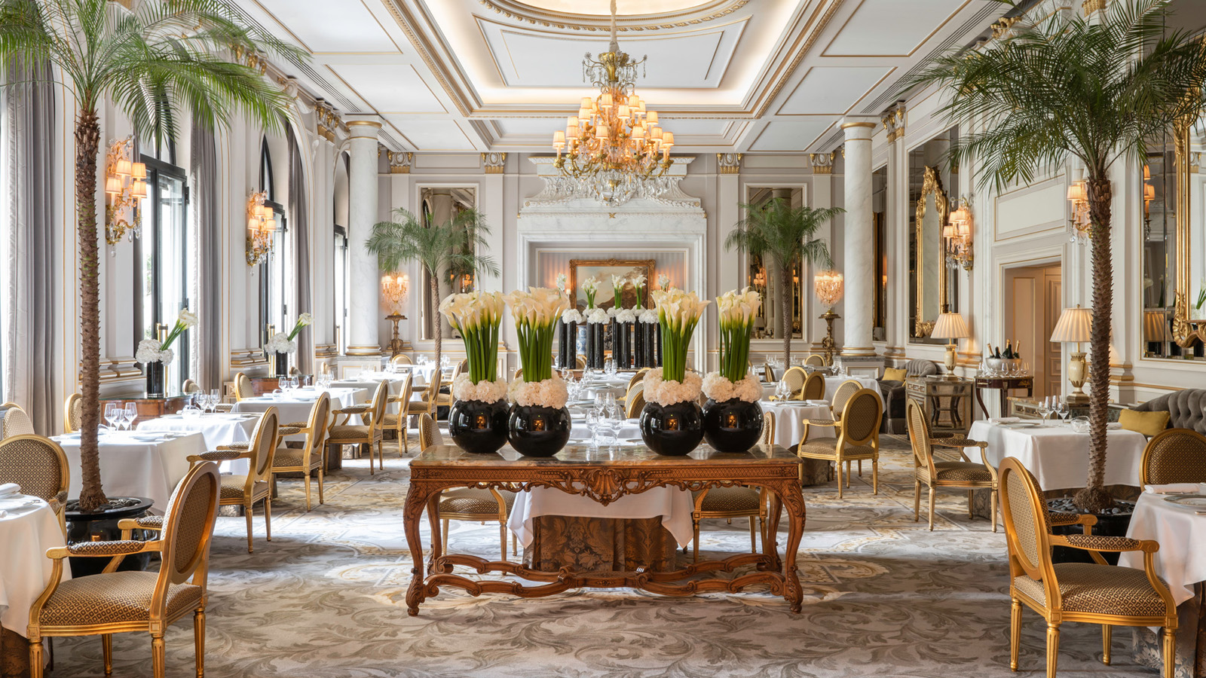
To celebrate the magic of Christmas with the perfect gift, Four Seasons Hotel George V, Paris offers a range of unique experiences that are sure to impress friends and loved ones.
Bespoke Classes Created by the Hotel’s Michelin-Starred Chefs
In the magnificent setting of Le Cinq, guests will take part in cooking classes led by the Hotel’s Michelin-starred chefs. Each class ends beautifully, with lunch or afternoon tea savoured in the restaurant’s elegant dining room.
Lovers of Italian cuisine will learn how to craft exquisite Mediterranean dishes with Chef Simone Zanoni, while those wishing to learn the art of crafting light and creative dishes will discover the plant-based cuisine of Alan Taudon. Food lovers will also have the opportunity to enjoy a very special experience with three Michelin-starred Chef Christian Le Squer. With Pastry Chef Michael Bartocetti, sweet tooths will discover how to make festive and airy gourmet desserts. Finally, Chef Christian Le Squer, Pastry Chef Michael Bartocetti and Sommelier Eric Beaumard have come together for a full day dedicated to guests wishing to learn how best to craft a gourmet and exceptional festive menu. The trio will share three Michelin-starred recipes, the art of making exquisite gourmet desserts and suggestions on the best wine pairings.
- Sunday, October 31, 2021, 10:00 am – 1:30 pm - A taste of La Dolce Vita in Paris by Simone Zanoni, priced at EUR 750 per person
- Sunday, November 14, 2021, 10:00 am – 1:30 pm – Light, gourmet and creative plant-based cuisine by Alan Taudon, EUR 750 per person
- Sunday, November 28, 2021, 2:00-5:30 pm - The George V’s festive desserts by Michael Bartocetti, EUR 650 per person
- Sunday, December 12, 2021, 9:00 am – 12:30 pm, and 2:00-4:00 pm – Festive Meals: a magical gourmet New Year’s Eve dinner by Christian Le Squer, Eric Beaumard and Michael Bartocetti, EUR 2,150 per person
- Sunday, January 30, 2022, 10:00 am – 1:30 pm – In the footsteps of a three Michelin-starred chef: Le Cinq’s signature creations by Christian Le Squer, EUR 1,150 per person
An Exclusive “Ritual of Life” Signature Treatment at the Spa
The Spa at Four Seasons Hotel George V, Paris is a veritable haven of peace in the heart of the Golden Triangle, renowned for its innovative and effective anti-ageing treatments.
The festive season is the perfect time for guests to discover the numerous benefits of the signature Ritual of Life treatment, created exclusively for the Spa by Olivier Claire. The French natural skincare brand offers beauty products formulated with bio-active ingredients that support the natural function of the skin, combining wellbeing with optimal effectiveness.
This exclusive face and body treatment combines the power of native cells and seabass with massage techniques to re-oxygenate the skin and stimulate cell renewal. The perfect ritual to immerse guests in a unique universe of beauty and wellbeing.
- 80-minute treatment EUR 320, 120-minute treatment EUR 540
An Immersion into the World of Wine, with Hotel Sommeliers Sharing Their Passion for Vineyards
With Italian Sommelier of Le George Francesco Cosci, guests will embark on a journey to discover the finest Italian wines to try at least once in a lifetime. They will also delve into the heart of Burgundy with Eric Beaumard. The legendary sommelier will shed light on grape varieties and wine production in the region, giving tips on how to help develop the palate. A blind tasting session will conclude this bespoke class, ensuring a truly memorable and multi-sensory experience.
- Sunday, January 9, 2022, 4:45-7:45 pm – Fine Italian wines to try once in a lifetime by Francesco Cosci, priced at EUR 550 per person
- Sunday, January 23, 2022, 4:45-7:45 pm – Discovering the extraordinary wines of Burgundy by Eric Beaumard, priced at EUR 1,050 per person
Little George
Little guests will enjoy the loving and loyal presence of Little George, the George V mascot by Tartine et Chocolat that was created specially by the French high-end brand. The younger brother of Lucien the Dog, this cute and cuddly soft toy is adorned with a soft and timeless Garda stripe – Tartine et Chocolat’s gentle and timeless signature stripe much loved by the George V - in soft tones of pearl grey, echoing the colours that symbolise the spirit of the luxury Hotel.
- Little George, priced at EUR 75 and EUR 45 for the baby version
The Perfect Gift Voucher for Every Occasion
Another a one-of-a-kind culinary experience in one of the Hotel’s Michelin-starred restaurants, a savoury festive tea time or a relaxing beauty treatment at the Spa; Christmas is the ideal occasion to spoil loved ones with a personalised gift.

- This selection of vouchers is available throughout December 2021, starting at EUR 46 per person

RELATED

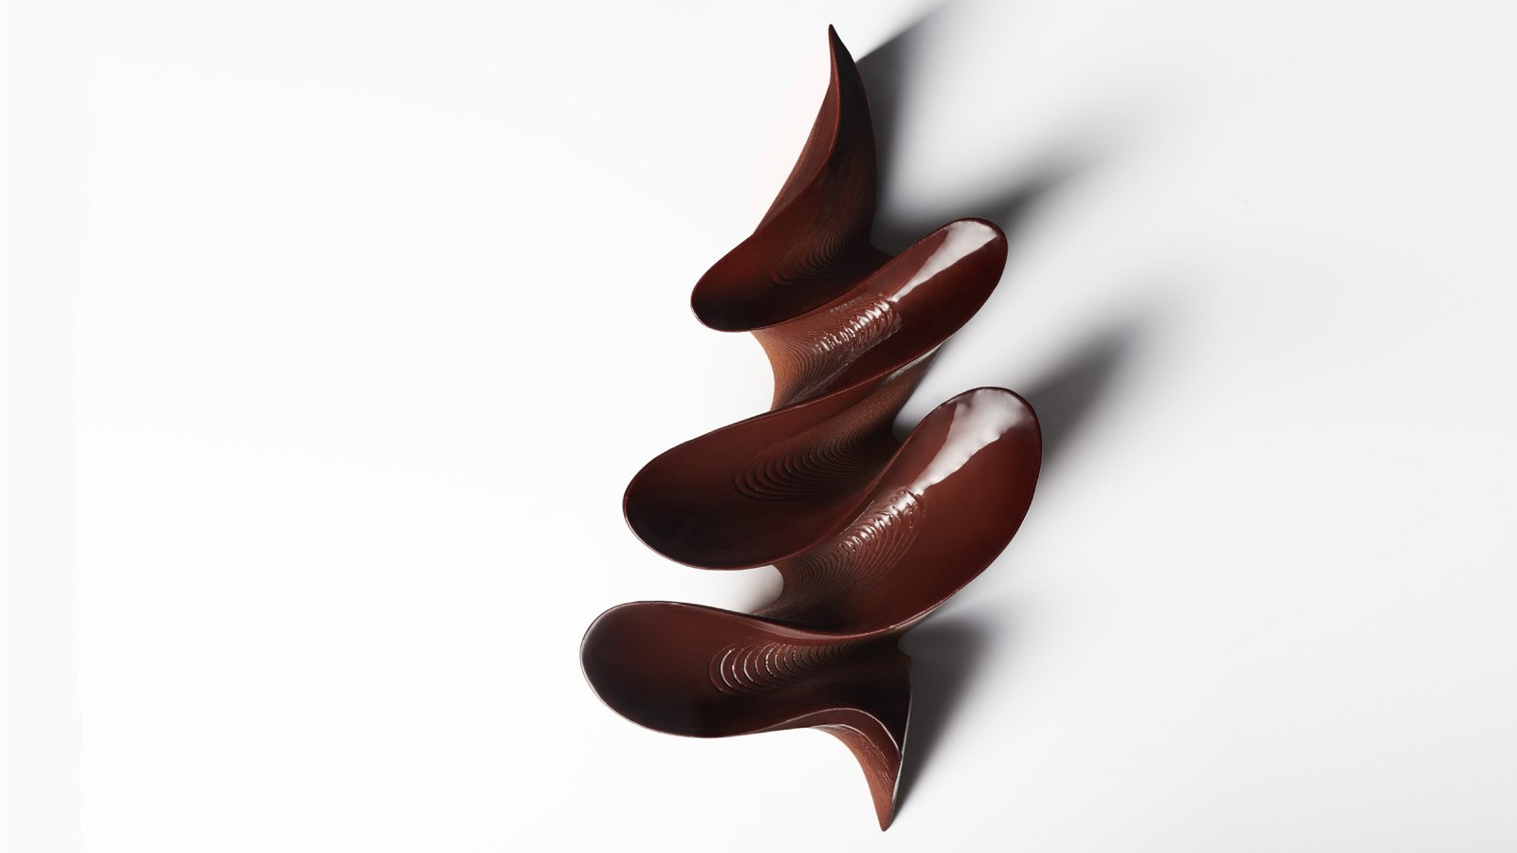 | October 6, 2021, Paris, France  Pour les fêtes de fin d’année, le Four Seasons Hotel George V, Paris dévoile sa bûche de Noël imaginée par le chef pâtissier  https://publish.url/fr/paris/hotel-news/2021/yule-log-2.html
October 6, 2021, Paris, France
To Celebrate This Year’s Festive Season, Four Seasons Hotel George V, Paris Unveils a Yule Log Imagined by Pastry Chef Michael Bartocetti
https://publish.url/paris/hotel-news/2021/yule-log.html

PRESS CONTACTS

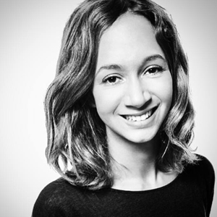 | Samuelle Dorol  Public Relations and Communications Manager  31, avenue George V  Paris  France  samuelle.dorol@fourseasons.com  +33 1 49 52 71 69
Nathalie Vimar
Director of Public Relations and Communication
31 avenue George V
Paris
France
nathalie.vimar@fourseasons.com

+33 1 49 52 71 69

