Reconnect with Loved Ones by Planning the Ultimate Summer Family Reunion at Four Seasons Resort Orlando

Make up for lost family time and celebrate with an incredible destination reunion, where the whole family will have a blast creating magical memories
April 19, 2021, Orlando at Walt Disney World Resort, U.S.A.

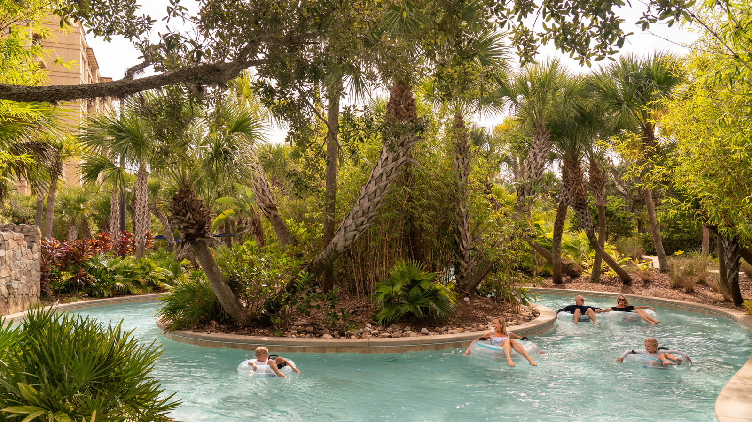
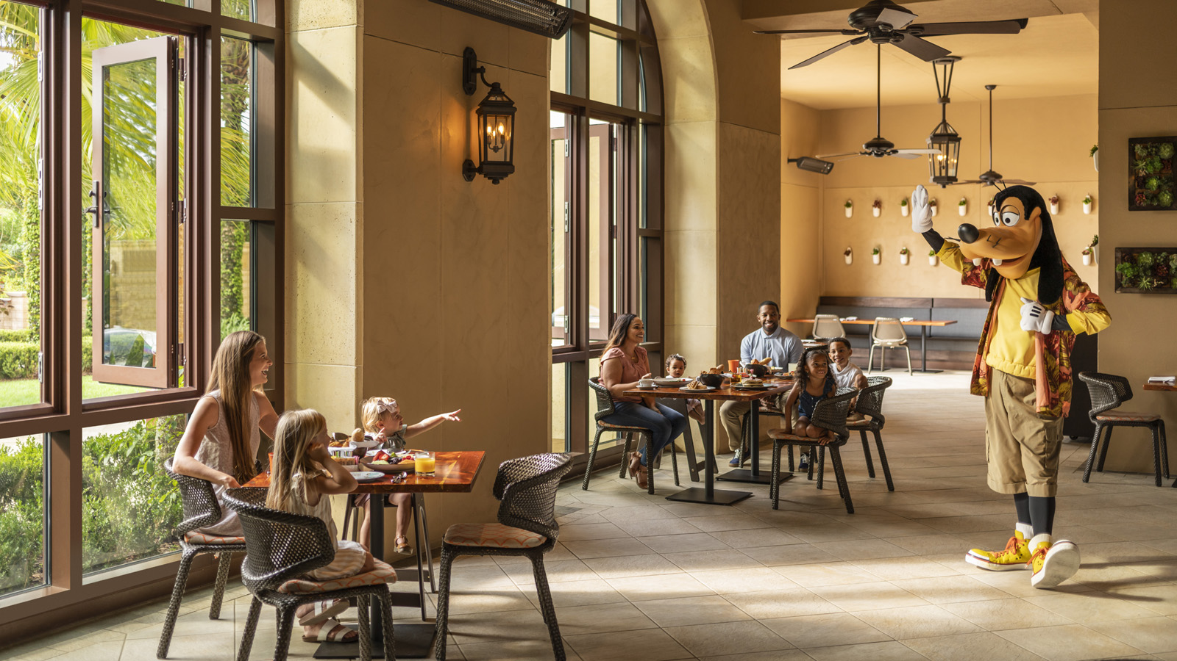

RELATED

April 12, 2021, Orlando at Walt Disney World Resort, U.S.A.
Four Seasons Resort Orlando Expands Luxury Meetings and Events Capabilities
https://publish.url/orlando/hotel-news/2021/new-meetings-and-events-offerings.html

March 1, 2021, Orlando at Walt Disney World Resort, U.S.A.
Celebrate World Sleep Day with a Sleep Ritual Massage and Special Offerings at The Spa at Four Seasons Resort Orlando
https://publish.url/orlando/hotel-news/2021/sleep-treatments-and-packages.html

PRESS CONTACTS

Dana Berry
Director of Public Relations
10100 Dream Tree Boulevard
Orlando
U.S.A.
dana.berry@fourseasons.com

1 (407) 313-7777

