Will You Be My Valentine? Love is in the Air at Four Seasons Hotel Kuala Lumpur

Explore a collection of gastronomic journeys, tailored for two
January 25, 2023, Kuala Lumpur, Malaysia

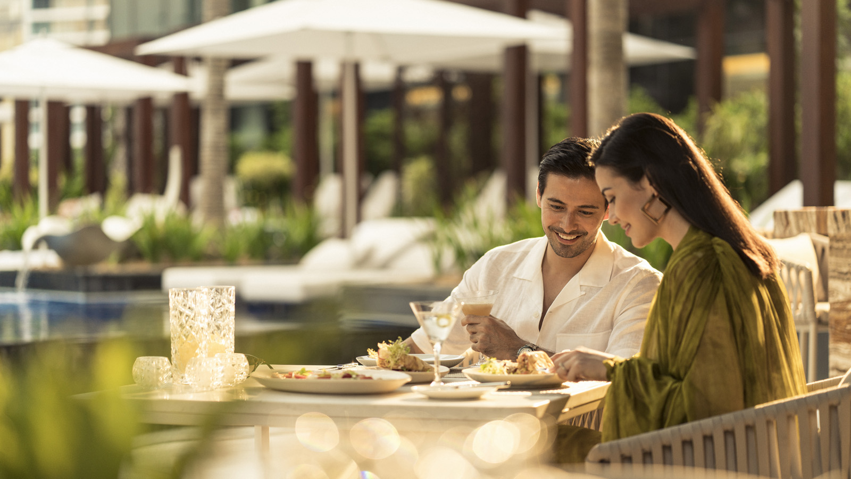
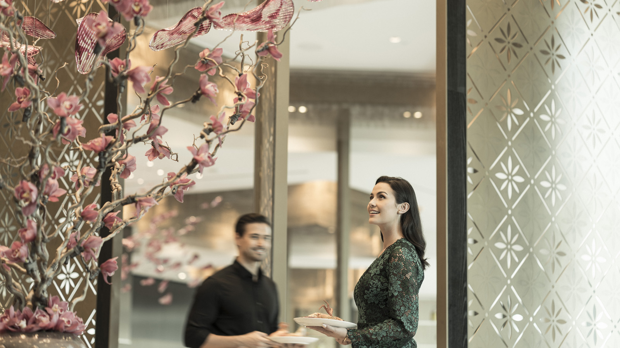 | 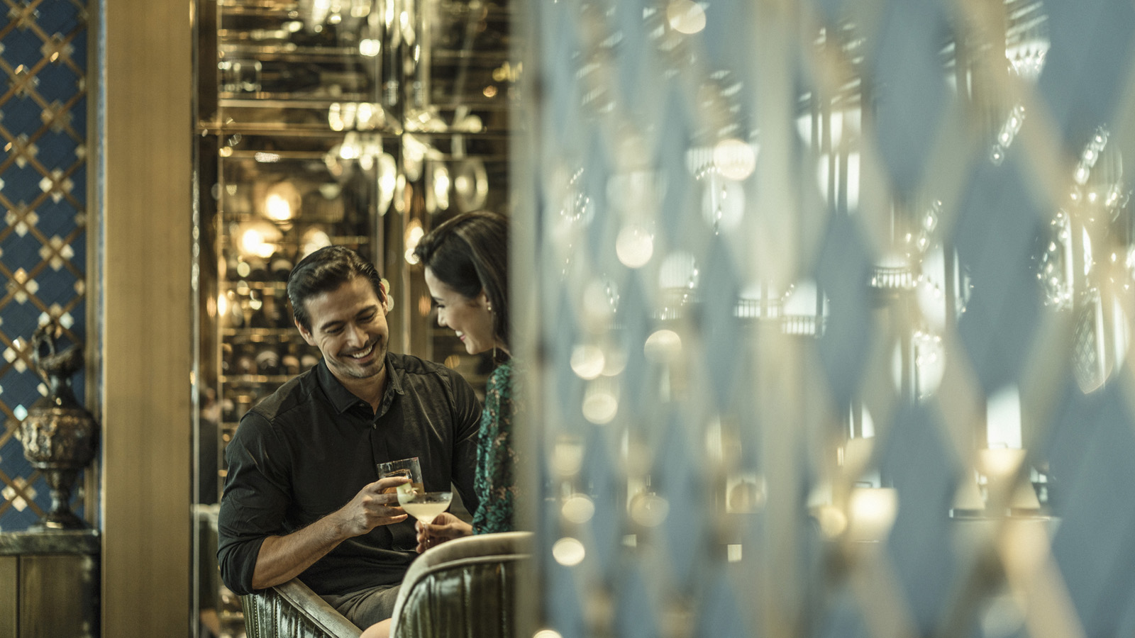 | 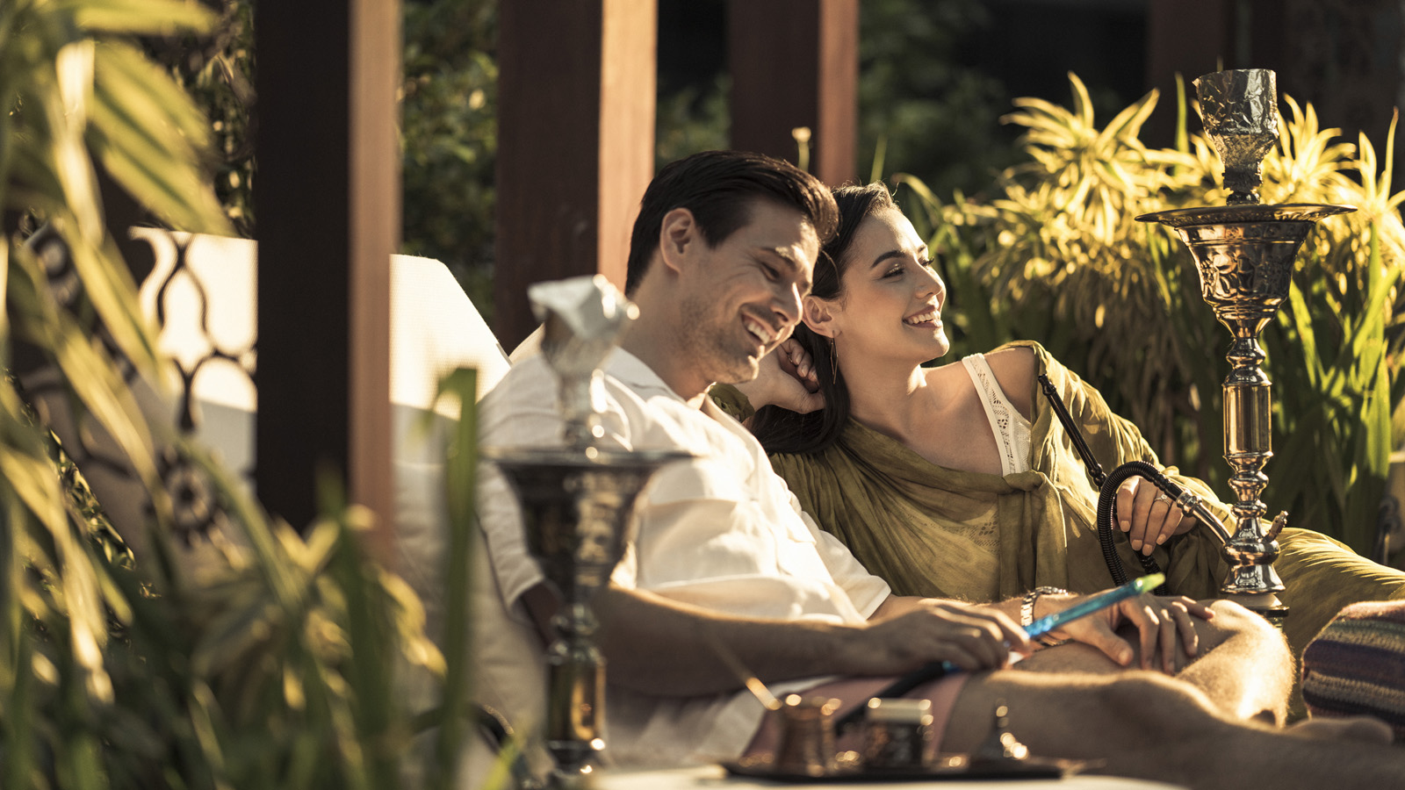
This Valentine’s Day, spice up the celebrations with tantalizing flavours and breath-taking views at Four Seasons Hotel Kuala Lumpur. Brimming with warmth and vibrancy, the glamorous urban retreat presents exquisite dining journeys for lovebirds to share and cherish.
Heart’s Desire: Valentine’s Dinner at The Lounge
Starting February 10, 2023, couples can embark on a romantic culinary adventure at The Lounge. Crafted with aphrodisiacs such as caviar, oysters, black truffle, foie gras and sea urchin, the sensational menu brings a delicious sizzle to date night.
Rediscover the pleasure of spending time together over five superb courses, with playful names inspired by the seasons of love: think Seduction, Affection and Deep Affair. The dreamy Love Potion mocktail is served with compliments. Also on the menu: a live solo performance and other surprises for the couple.
- The Lounge at Four Seasons
- February 10-14, 2023, 6:00-10:00 pm
- Five-course set menu with mocktail
- MYR 588 per couple
Love @ First Bite: Valentine’s Buffet at Curate
Let romance bloom in the hibiscus-bright setting of Curate. Savour the many facets of love with a sumptuous buffet featuring Valentine’s-themed selections – from Seduction, Fondness and Warmth to Adoration, Reverence and Sweet Nothings. This extravagant spread features specialties such as Steamed Whole Fish in Baba Nyonya Curry Broth, Sarawak Crusted Beef Ribeye, and Trigona Honey Rotisserie Chicken with Osmanthus Pollen.
Share prized delicacies such as slipper lobster, tiger prawns and freshly shucked oysters, and exhilarate the taste-buds with signature creations such as Raspberry Kombucha Liquid Nitrogen Ice Cream – a refreshing explosion of flavour that leaves one wanting more. A live violinist sets the stage for moments of magic, while servers stop by the table with delightful treats all night long, from Flambé Scallops to Ice Cream Pralines.
- Curate
- February 14, 2023
- MYR 500 per couple
- Add-on beverage package with red wine, white wine, Tiger beer: MYR 188 (add sparkling wine: MYR 328)
Amore: Valentine’s Dinner by the Pool
Reignite the spark with an exquisite dinner under starry skies. Aphrodite casts her spell of desire with a signature four-course menu, crafted with the finest aphrodisiac ingredients from around the world – caviar, oysters, black truffle, foie gras and sea urchin.
Served in the intimate embrace of a private cabana, this love-feast is framed by spectacular views of the shimmering poolside and Kuala Lumpur’s skyline. Serenaded by a violinist, couples can sip a complimentary glass of sparkling wine as they whisper sweet nothings and create glittering new memories.
- Pool Bar & Grill
- February 14, 2023
- Four-course dinner in private cabana
- MYR 700+ per couple
- Advance reservations highly recommended
For reservations, contact the Hotel via Four Seasons Chat.

RELATED

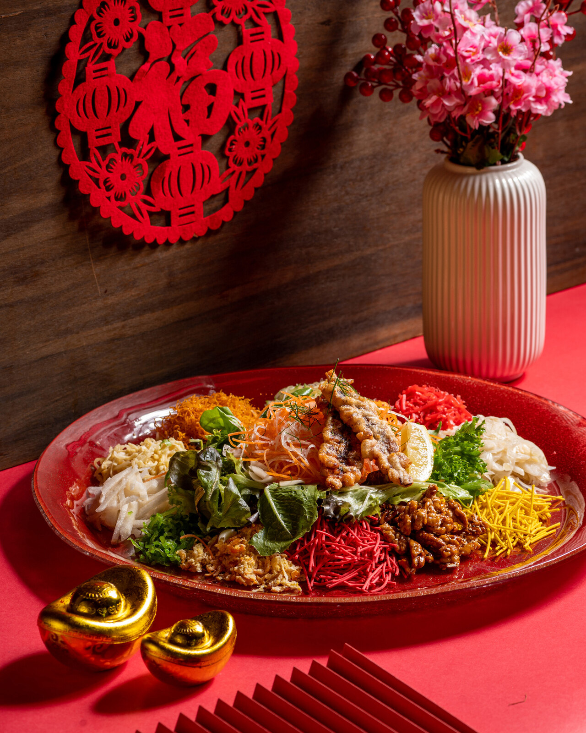 | January 11, 2023, Kuala Lumpur, Malaysia  Hop into the Year of the Rabbit with Delectable Celebrations at Four Seasons Hotel Kuala Lumpur  https://publish.url/kualalumpur/hotel-news/2023/lunar-new-year.html
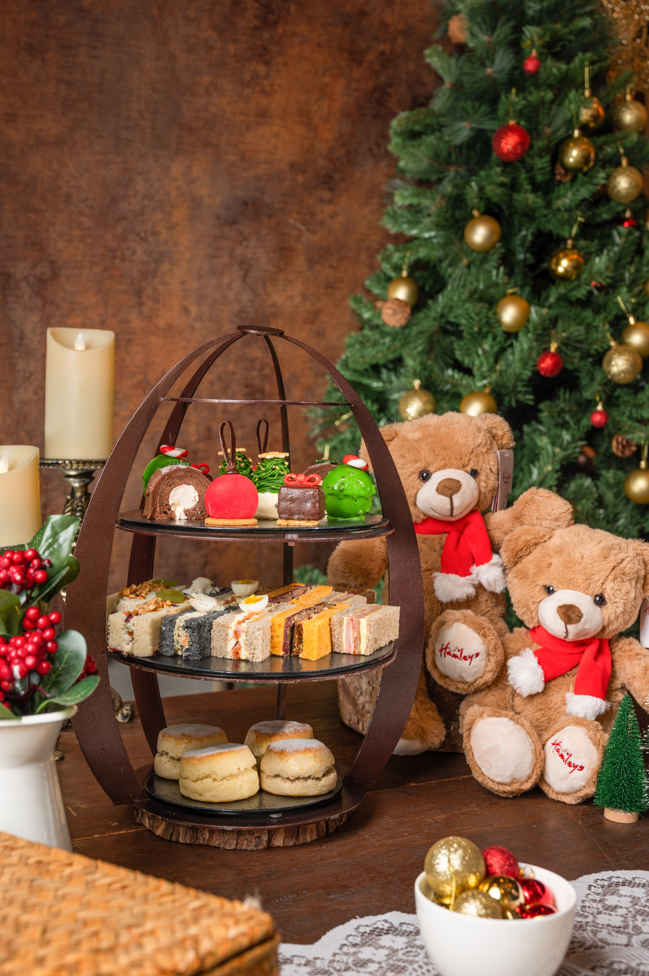 | November 7, 2022, Kuala Lumpur, Malaysia  Mistletoe & Magic: Celebrate the Holidays in Traditional Style with Four Seasons Hotel Kuala Lumpur  https://publish.url/kualalumpur/hotel-news/2022/festive-season.html

PRESS CONTACTS

Kanchana Ganglani
Director of Public Relations
145 Jalan Ampang
Kuala Lumpur
Malaysia
kanchana.ganglani@fourseasons.com

+6(03) 2382 8740

