Love is in the Air at Four Seasons Hotel Guangzhou

Hotel launches Wedding Pop Up showcases with a themes afternoon tea and a series of wedding workshops
May 1, 2019, Guangzhou, China

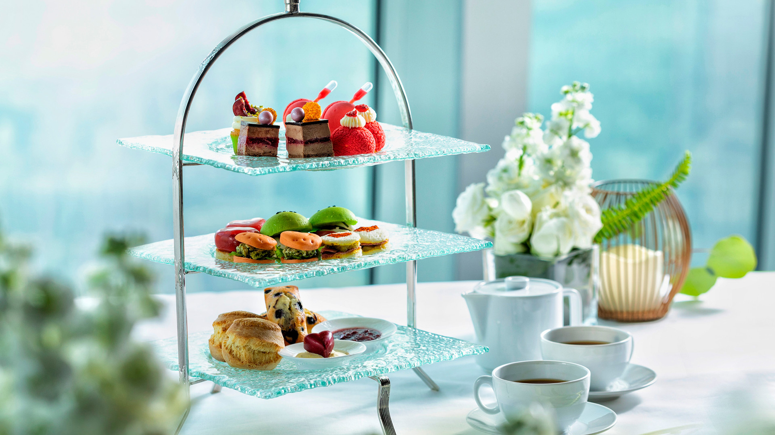
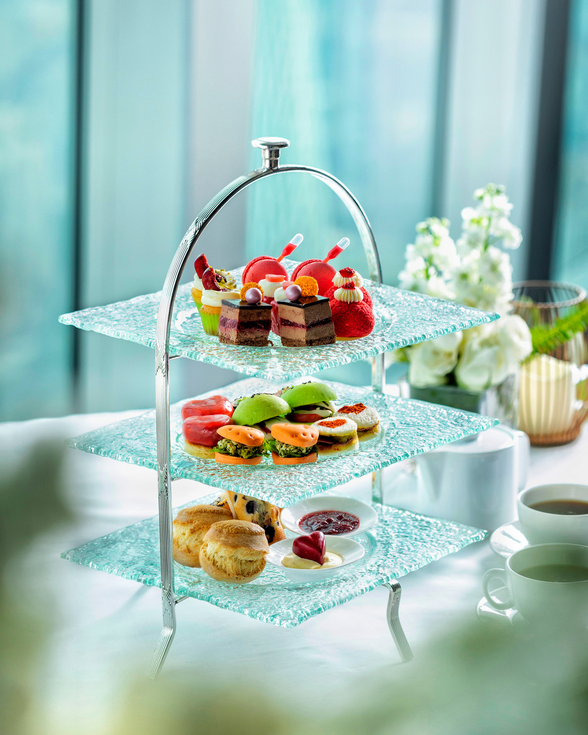 | 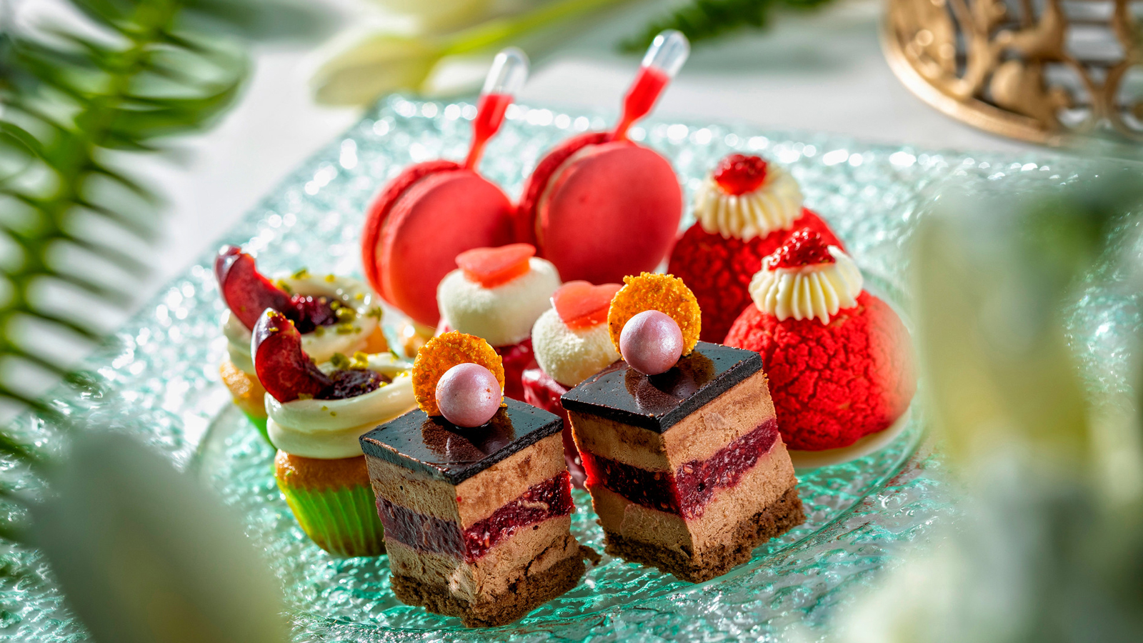
From May 1 to 31, 2019, Four Seasons Hotel Guangzhou launches the “Love is in the Air” wedding pop up in Atrium, partnered with renowned wedding planners, wedding photographers as well as famous wedding dress brands in Guangzhou. The Pop Up is to showcase Four Seasons weddings and the craftsmanship of the talented chefs who have created a Love is in the Air wedding themed Afternoon Tea with colourful presentations and innovative flavour combinations. In May, let love float up in the cloud.
Themed Afternoon Tea
Surrounded by the romantic wedding set up, guests can enjoy a delicate afternoon tea, handcrafted by Executive Pastry Chef Franck Istel. Immerse in the sweetness of flavour with his new and exuberant creations. The Atrium will be transformed into a summer garden inspired by the fairy tale of the Afternoon of The Faun. Price is from CNY 488 for two persons, subject to 15 percent service charge (applicable government tax included). For reservations, call the Atrium at 86 (20) 8883-3370.
Wedding Pop Up Workshops
May 1, the opening day for the showcases, a wedding gown fashion show will be presented by a well known designer brand – WeCouture, with its latest 2019 wedding collection. Three different wedding workshops will be organised on the following Saturdays: May 11, corsage DIY by Bloemen-Huis, the top floral design company from Singapore; May 18, capture the Moment up in the Cloud by VeraHo Production, an award-winning wedding photography company; May 25, Chinese traditional fan DIY by Yu Xiu, the leading Chinese style wedding gown brand.
“It’s a perfect time to plan wedding in May. Many couples make reservations for wedding dinners during this period,” says Crystal, Director of Catering. “By hosting a series of wedding pop up showcases, guests can access the latest wedding information and begin planning a dream wedding at Four Seasons.”
Four Seasons Hotel Guangzhou is located at the centre of Pearl River New City, the new axis of culture, shopping and business in Guangzhou. Three splendid ballrooms with dramatic high ceilings and built-in projection screens effortlessly blend form and function, which is the ideal venue for wedding celebrations. Well experienced wedding planners, elegant design, the-state-of-art equipment, thoughtful service and delicate delicacies bring every couple an unforgettable wedding experience.
A summer wedding package is now available, priced from CNY 6,888 net per table. This offer is eligible for weddings in May, July or August. For wedding inquiries and reservations, call 86 (20) 8883-3738.

RELATED

May 24, 2019, Beijing, China
Girls Just Want to Have Fun: Parties, Pampering and More at Four Seasons Hotel Beijing
https://publish.url/beijing/hotel-news/2019/girls-trip.html

May 24, 2019, Beijing, China
乐享北京·嗨翻姐妹行
https://publish.url/zh/beijing/hotel-news/2019/girls-trip-2.html

PRESS CONTACTS

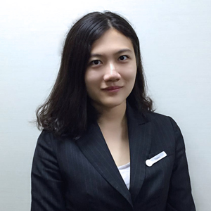 | Trerry Chen  Assistant Public Relations Manager  5 Zhujiang West Road, Pearl River New City, Tianhe District  Guangzhou  China  trerry.chen@fourseasons.com  +86 20 8883 3903
Vivian Koh
Director, Public Relations and Content, Asia-Pacific
Tourism Court, 1 Orchard Spring Lane #04-01
Singapore
Singapore
vivian.koh@fourseasons.com

+65 6739 5806

