Four Seasons Offers New Family Escape Packages in Three Timeless Northeastern American Cities

June 1, 2018, Toronto, Canada

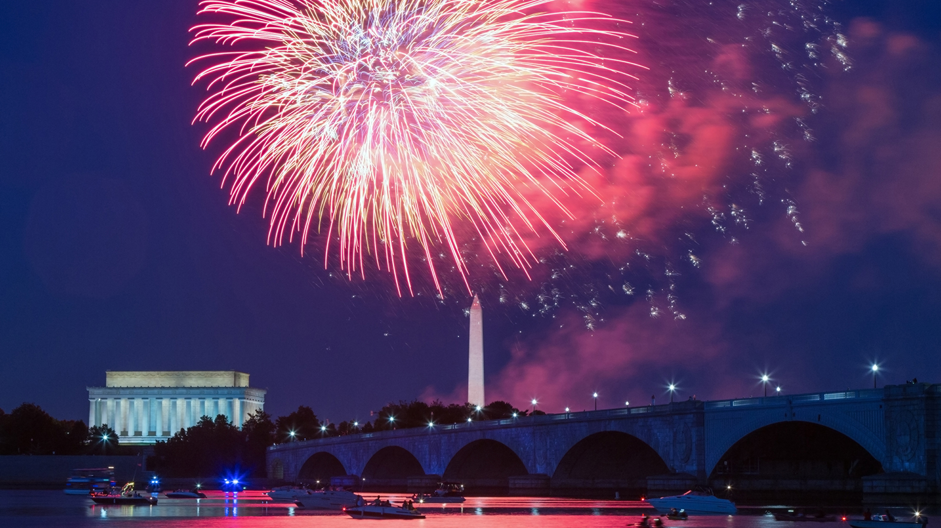
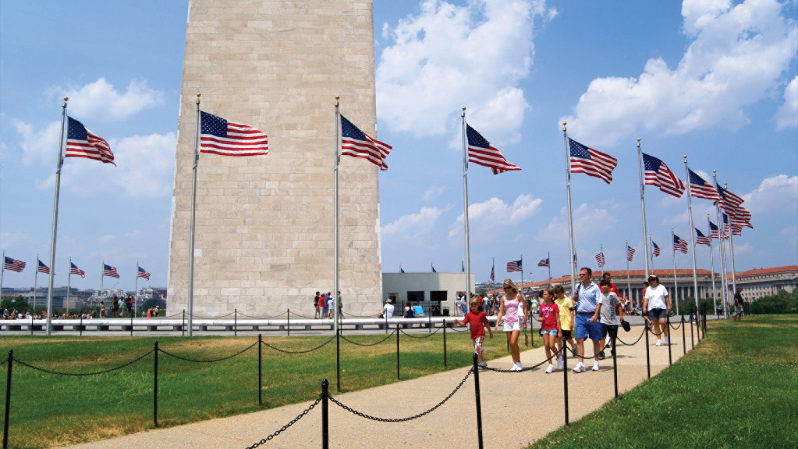 |  | 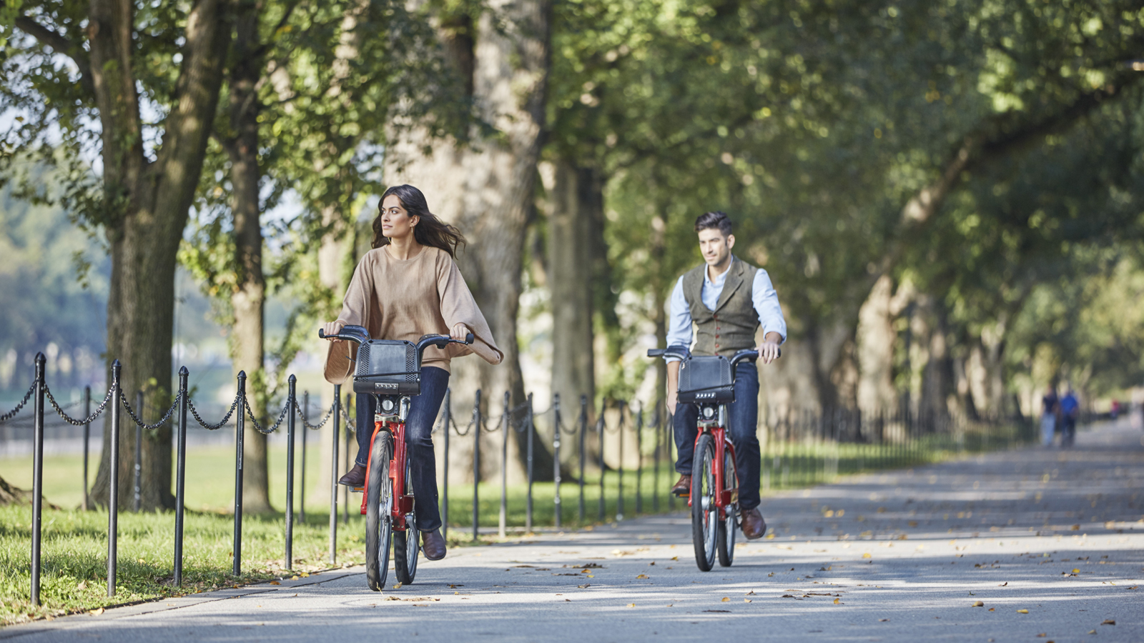
Four Seasons
has made it easier than ever to enjoy quintessential American experiences with the entire family. For a limited time this year, three iconic northeastern cities are offering the Family Escape package, curated to offer a luxurious experience for the entire family to enjoy. With inclusive offerings such as late check-out, complimentary airport transfers or overnight parking, and a USD 100 hotel credit to use on property, a memorable family vacation is effortless. Customised itineraries from
Four Seasons
Concierge teams ensure families won’t miss a thing as they explore these first-class American cities, rich in history and renowned for their timeless appeal.
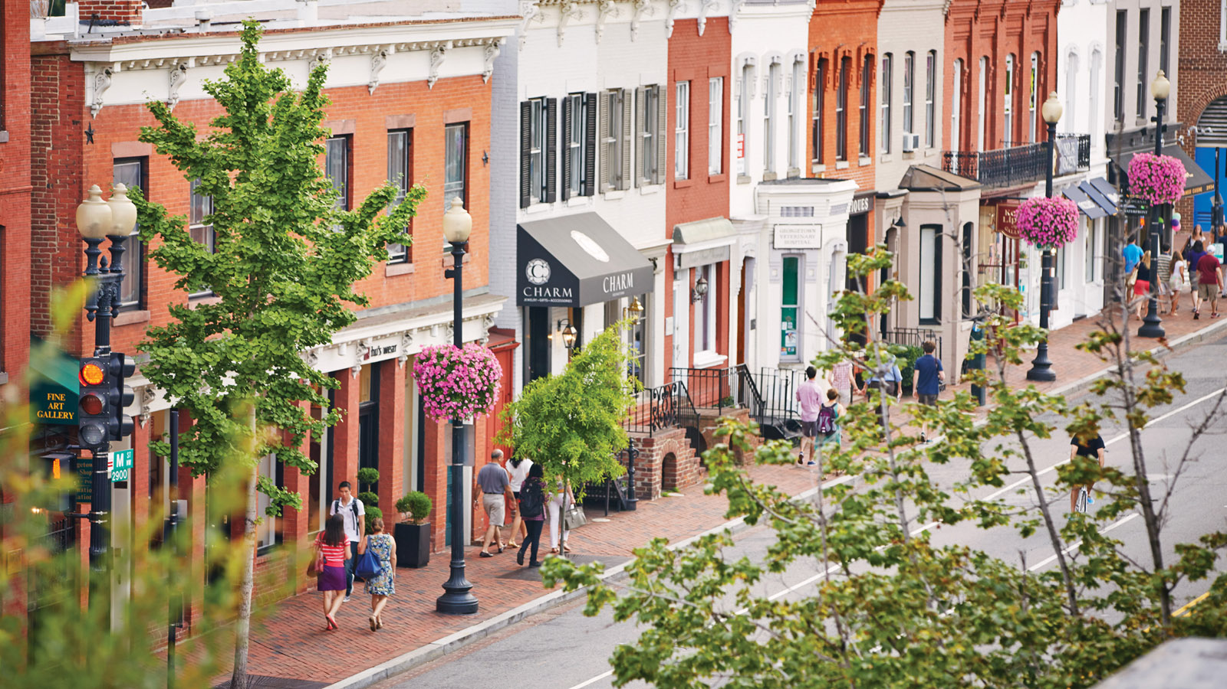 | 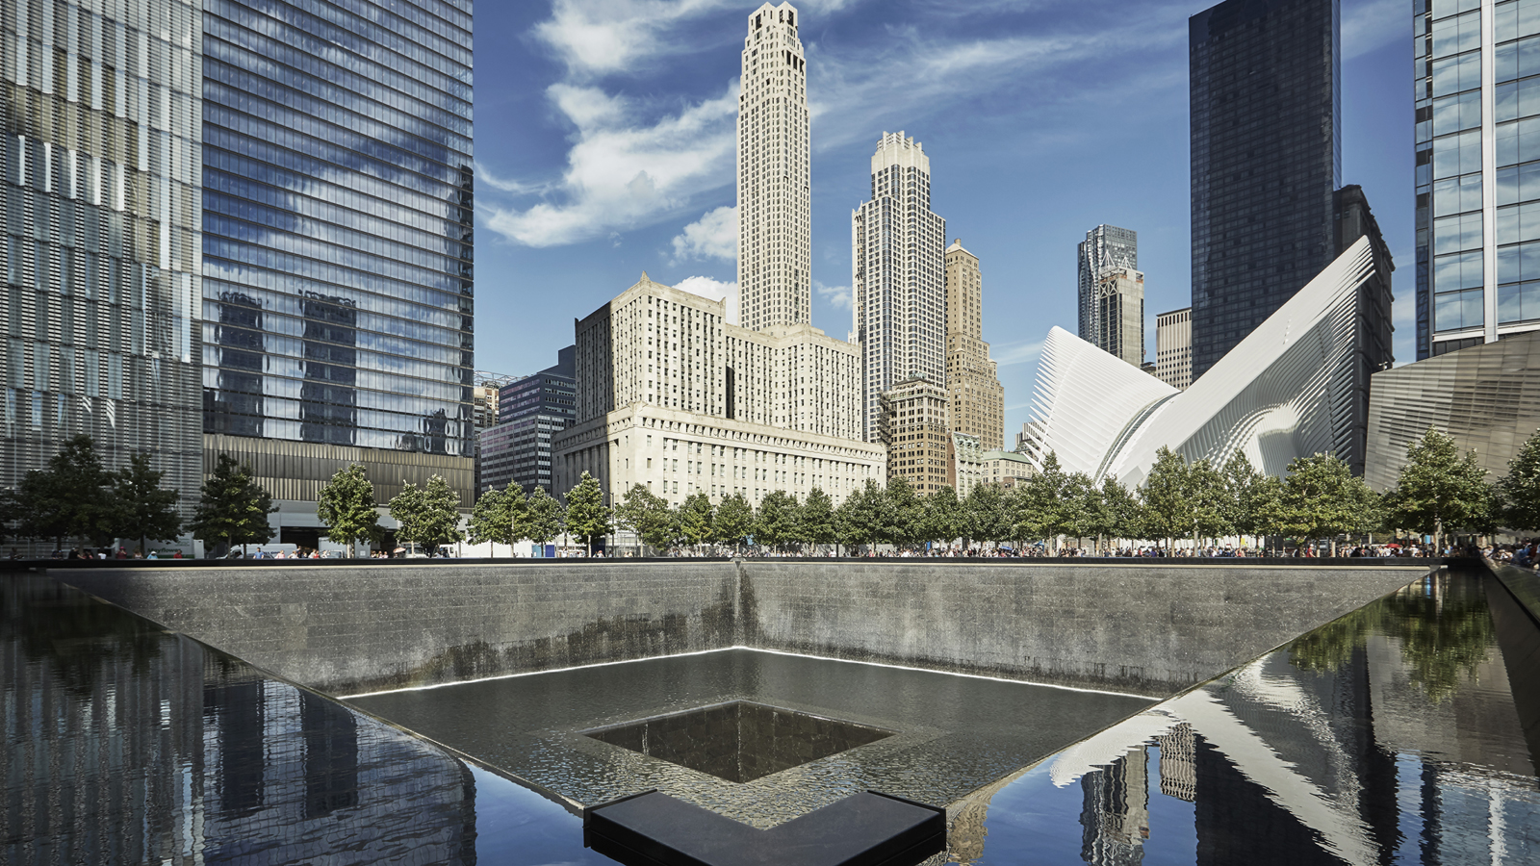 | 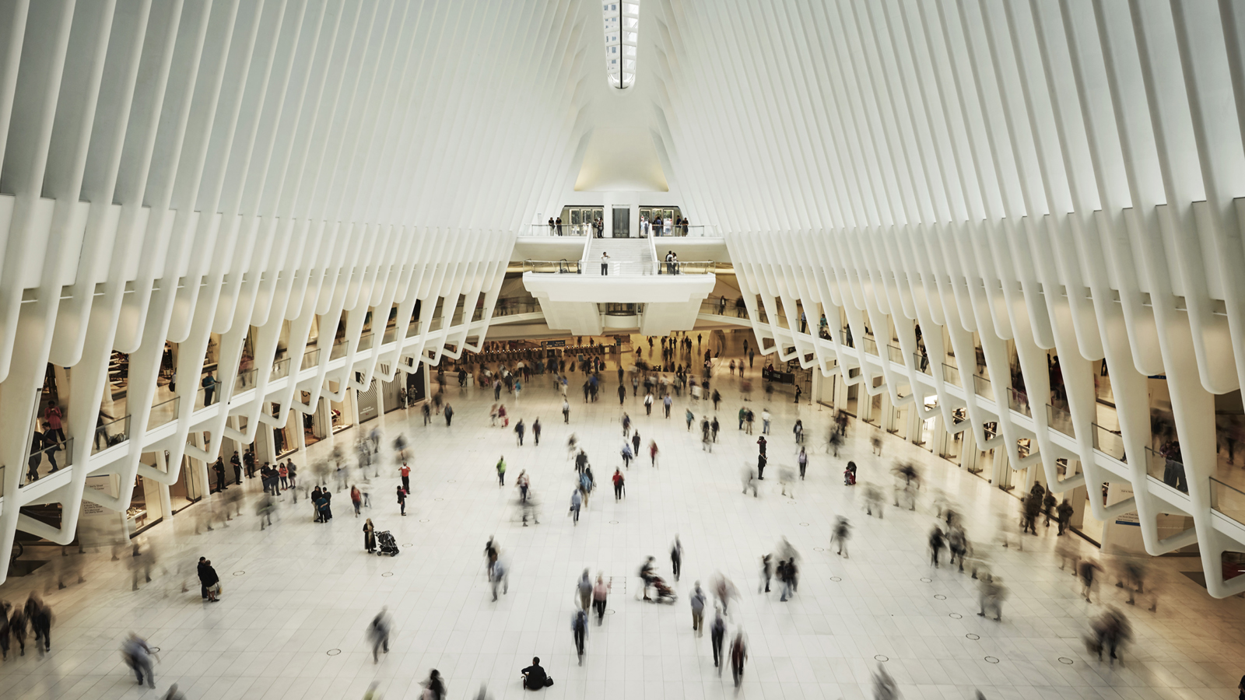
Boston, Massachusetts
Boston, a global metropolis that is cleverly disguised as a charming New England town, has endless offerings for travellers of all ages. As the city that gave rise to the American Revolution, there is no shortage of historic experiences to enlighten visitors of all ages. From the Freedom Trail to Paul Revere’s House and the site of the Boston Tea Party, Boston offers an opportunity to pair a luxurious getaway with a one-of-a-kind historic experience for the entire family.
Beyond the cobblestoned streets and the charming brownstones, the ocean is a moment away with local beaches and water-view restaurants welcoming guests to enjoy a true coastal metropolis. The Concierge team at
Four Seasons
Hotel Boston is ready to secure tickets on a harbour cruise or arrange for a private sailboat tour around the city.
Sports fans can also indulge in the many experiences “Title Town” boasts, including Fenway Park, the oldest Major League Baseball stadium currently in use in the country, or TD Garden, home to the famed hockey and basketball teams of Boston. After a full day in America’s Walking City, guests are invited to get off their feet and enjoy the Hotel’s glass-enclosed pool and whirlpool overlooking the Boston Public Garden, or relax in their room with a complimentary movie. Families can also enjoy their USD 100 credit to unwind with spa services or a family dinner at the Bristol Restaurant and Bar. Late check-out at 2:00 pm and a complimentary upgrade is also available based on availability.
The Family Escape package offers rates starting at USD 695 for a Deluxe King Room, and also includes a Boston-themed welcome amenity for the whole family as well as age appropriate surprises for children.
New York, New York
This summer, make the most of family time and explore everything that Lower Manhattan has to offer at
Four Seasons
Hotel New York Downtown. Spend the day exploring the historic cobblestone Seaport District with unique boutiques and dining options, or enjoy a performance at Pier 17, the latest outdoor concert venue with stunning views over the East River and the twinkling lights of the Brooklyn and Williambsurg Bridges.
Travelling with some thrill-seekers? Take the elevator to the top of One World Observatory, the tallest building in the Western Hemisphere at 1,776 feet (541 metres) and enjoy the most breathtaking views that Manhattan has to offer. Alternatively, keep those feet planted firmly on the ground and take advantage of world-class shopping at Westfield World Trade Center, set inside the Oculus, the world's most expensive transportation hub, designed by Spanish architect Santiago Calatrava. Just a short walk away is Brookfield Place, another premier shopping destination offering luxury retailers including Diane Von Furstenberg, Louis Vuitton and the world's first dedicated Herm&egrave;s Parfumerie.
Bask in the summer sun and take in the sights of New York Harbor including the Statue of Liberty and Ellis Island from a historic sailboat. Private sailboat excursions just for the family (maximum of 6 people) can also be arranged by the Concierge team. History buffs will enjoy a tour of Trinity Church, the final resting place of American Founding Father Alexander Hamilton and Elizabeth Schuyler Hamilton, just a short walk from the Hotel.
After a full day of adventure, return to
Four Seasons
Hotel New York Downtown to relax with an in-room movie that will please the entire family. The following morning, enjoy a late start and take advantage of a complimentary 2:00 pm late check-out. The USD 100 Hotel credit can be used towards in room dining, CUT, The Spa or for any other incidentals. Complimentary overnight parking is also included. Rates for the Family Escape package start at USD 695 for a Superior King Room.
Washington, DC
Washington, DC is more than the capital of the country; it’s the capital of cool with cool experiences, cool restaurants and cool places to visit this summer. A stay at
Four Seasons
Hotel Washington, DC not only opens the door to one of the most family friendly rooms in the city, it also opens doors to some fascinating places for guests of all ages.
Guests have unparalleled access to the most interesting cultural institutions in the world. From any of the nineteen complimentary Smithsonian museums and galleries (including the world famous Air and Space Museum), to the city’s twenty-five iconic memorials, DC charms and delights all who visit.
For espionage and justice aficionados, the International Spy Museum, FBI’s Crime Museum and the Newseum are educational and thrilling. Sports enthusiasts can support any of DC’s teams from the Washington Capitals to the Nationals and the Wizards, or even take part in two national sporting events this summer: Major League Baseball’s All-Star Week and The CitiOpen tennis tournament. The Hotel’s Concierge team will customise each itinerary and assist with access to premier seats, coveted restaurant tables and a road map to creating family friendly memories in the nation’s capital.
After a full day of sightseeing and discovery, guests are invited to relax and enjoy the Hotel’s pool and whirlpool. Families can also use their USD 100 credit to unwind with either a massage at The Spa, a family dinner at BOURBON STEAK or enjoy dinner and a complimentary movie in the comfort of their upgraded room.
The next day, families can take advantage of the 2:00 pm late check-out to tour the cobblestone streets of the Hotel’s Georgetown neighbourhood, filled with shops and restaurants. They can depart with ease with pre-arranged complimentary transportation, or in the family car that is packed and ready for the trip home.
The Family Escape package offers rates starting at USD 690 for a Premier Suite, and also includes a DC-themed welcome amenity for the whole family plus age-appropriate children's surprises and treats.

RELATED

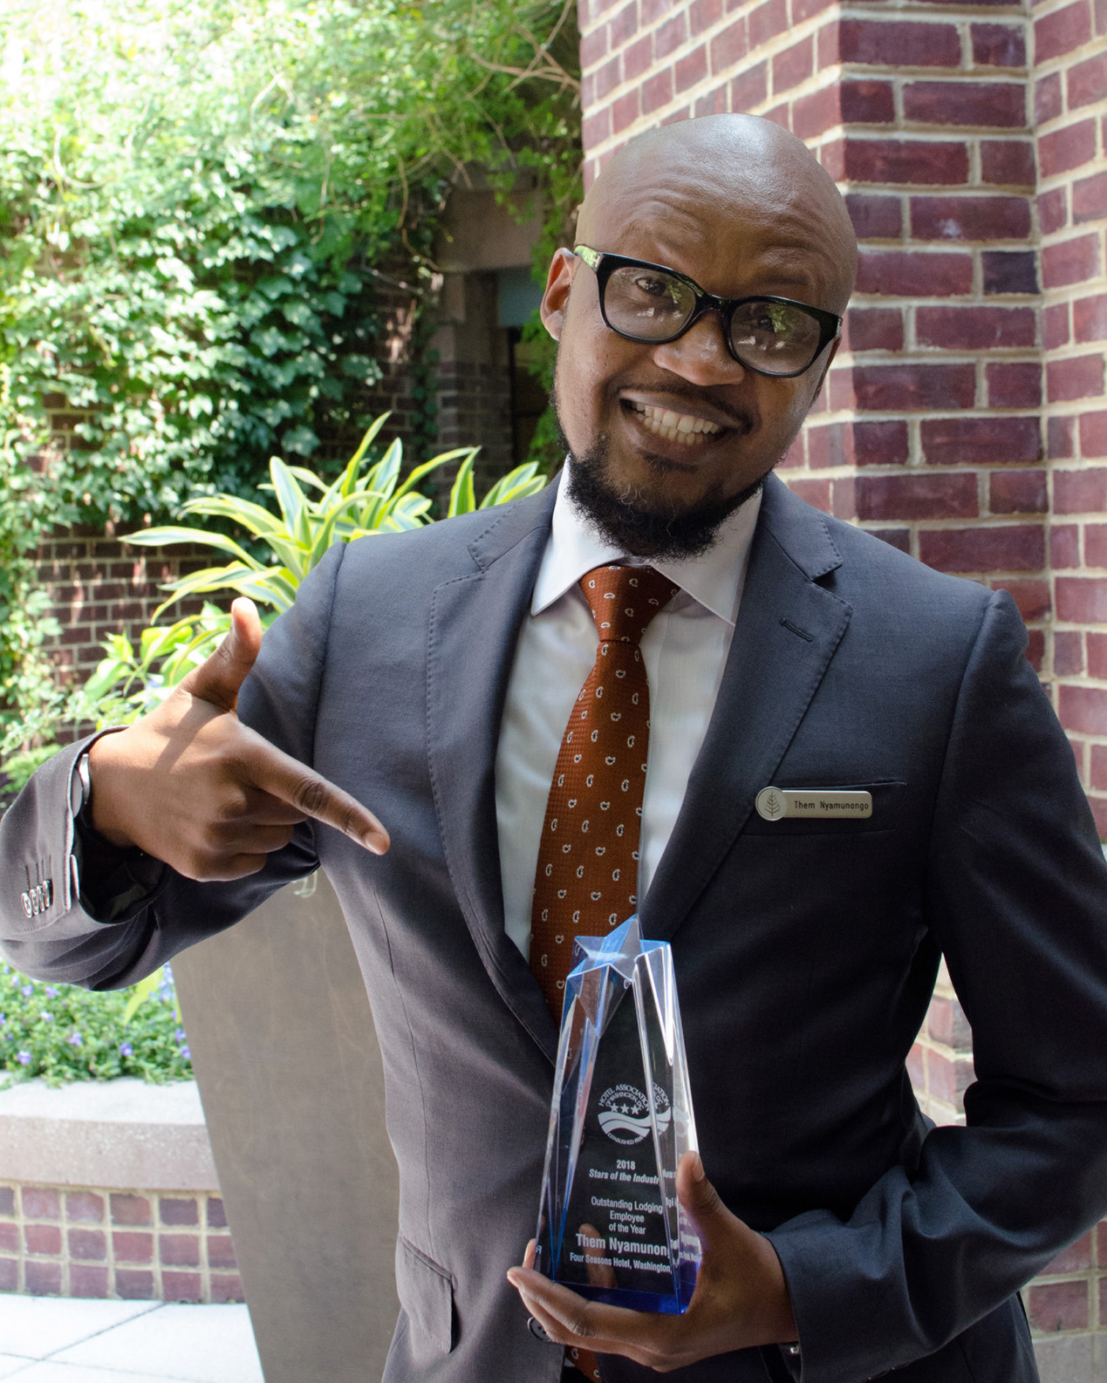 | June 22, 2018, Washington, DC, U.S.A.  The Hotel Association of Washington, DC awards Them Nyamunongo of Four Seasons Hotel Washington, DC Outstanding Lodging Employee of the Year  https://publish.url/washington/hotel-news/2018/outstanding-lodging-employee-of-the-year.html
June 20, 2018, Washington, DC, U.S.A.
Dinka Cammett Named Spa Director at Four Seasons Hotel Washington, DC
https://publish.url/washington/hotel-news/2018/new-spa-director-dinka-cammett.html

PRESS CONTACTS

Bridget Kearney
Sales and Public Relations Coordinator
200 Boylston Street
Boston
U.S.A.
bridget.kearney@fourseasons.com

+1 (617) 351-2205

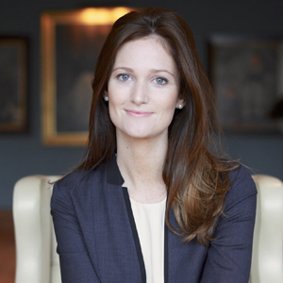 | Maggie Lawler  Public Relations and Communications Manager  200 Boylston Street  Boston  U.S.A.  maggie.lawler@fourseasons.com  +1 (617) 351-2161
Kristi Blake
Director of Public Relations and Communications
27 Barclay Street
New York
U.S.A.
kristi.blake@fourseasons.com

+1 (646) 880-1917

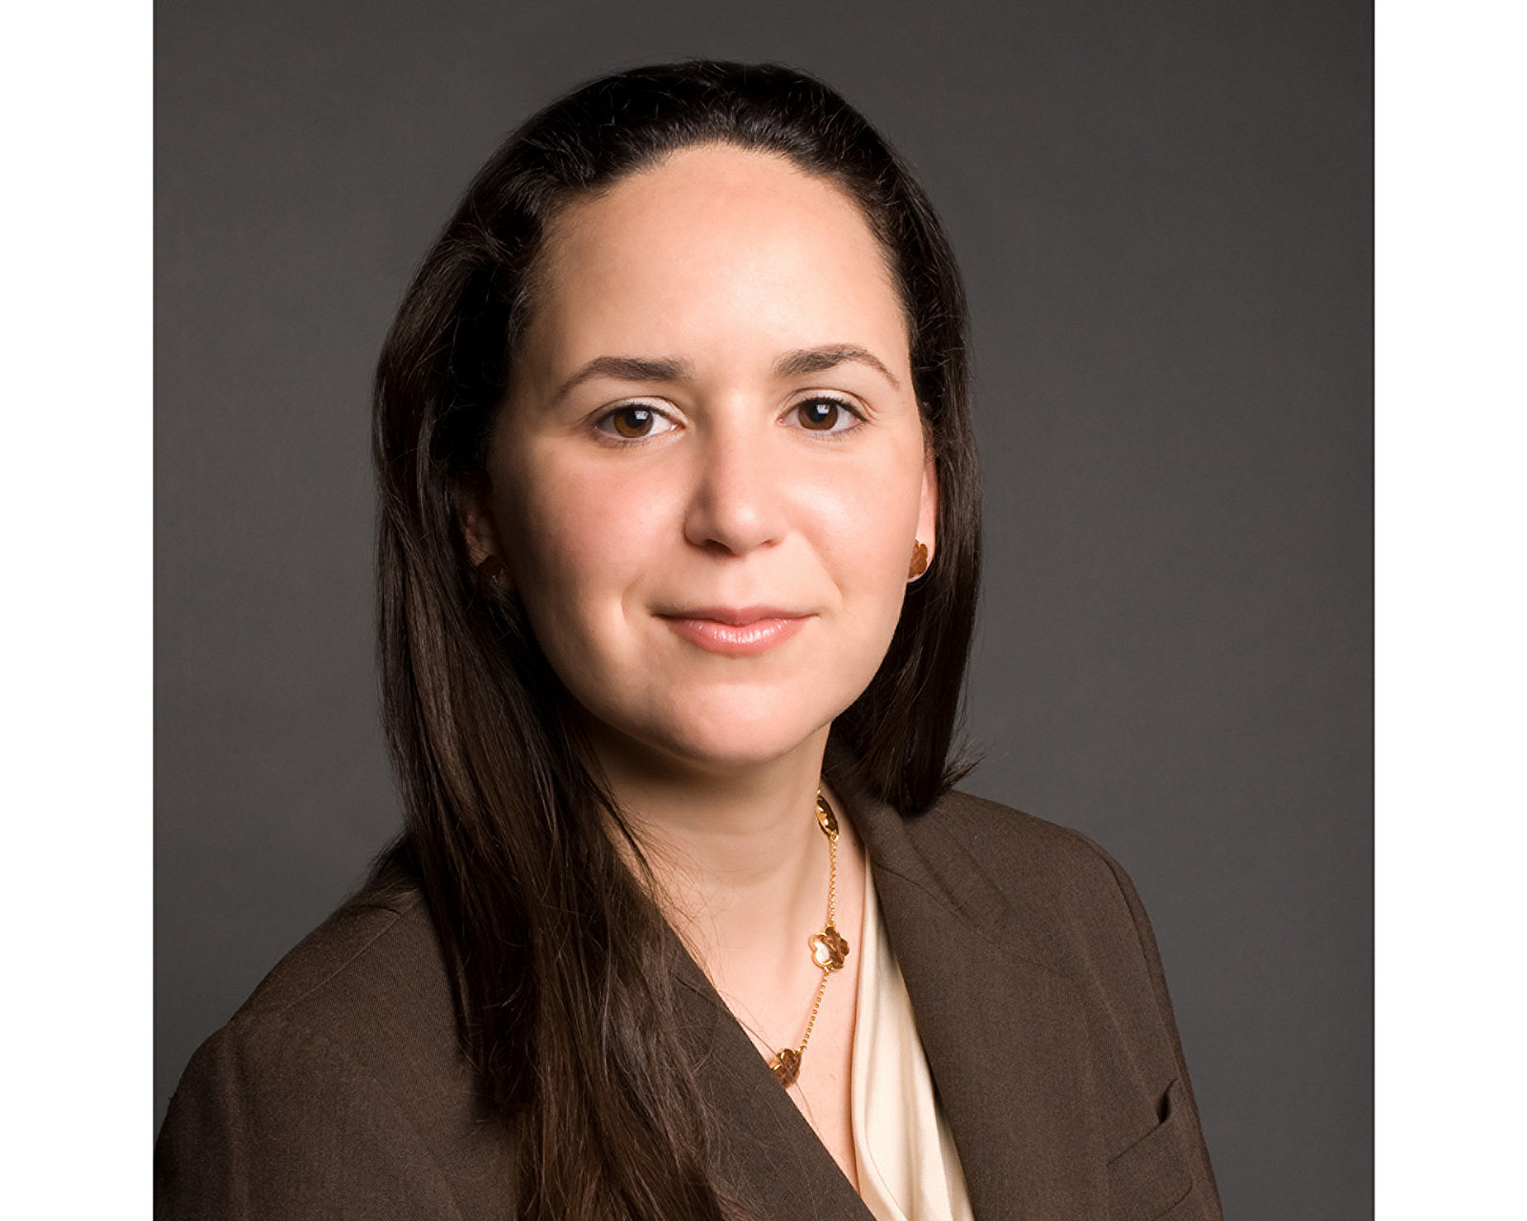 | Liliana Baldassari  Director of Public Relations  2800 Pennsylvania Avenue N.W.  Washington  U.S.A.  liliana.baldassari@fourseasons.com  1 (202) 944-2074
Nicole Otero
Public Relations Coordinator
2800 Pennsylvania Avenue N.W.
Washington
U.S.A.
nicole.otero@fourseasons.com

+1 (202) 944-2059

