Four Seasons Dubai Charms Guests to Believe in Valentine’s Day

January 27, 2022, Dubai, U.A.E.

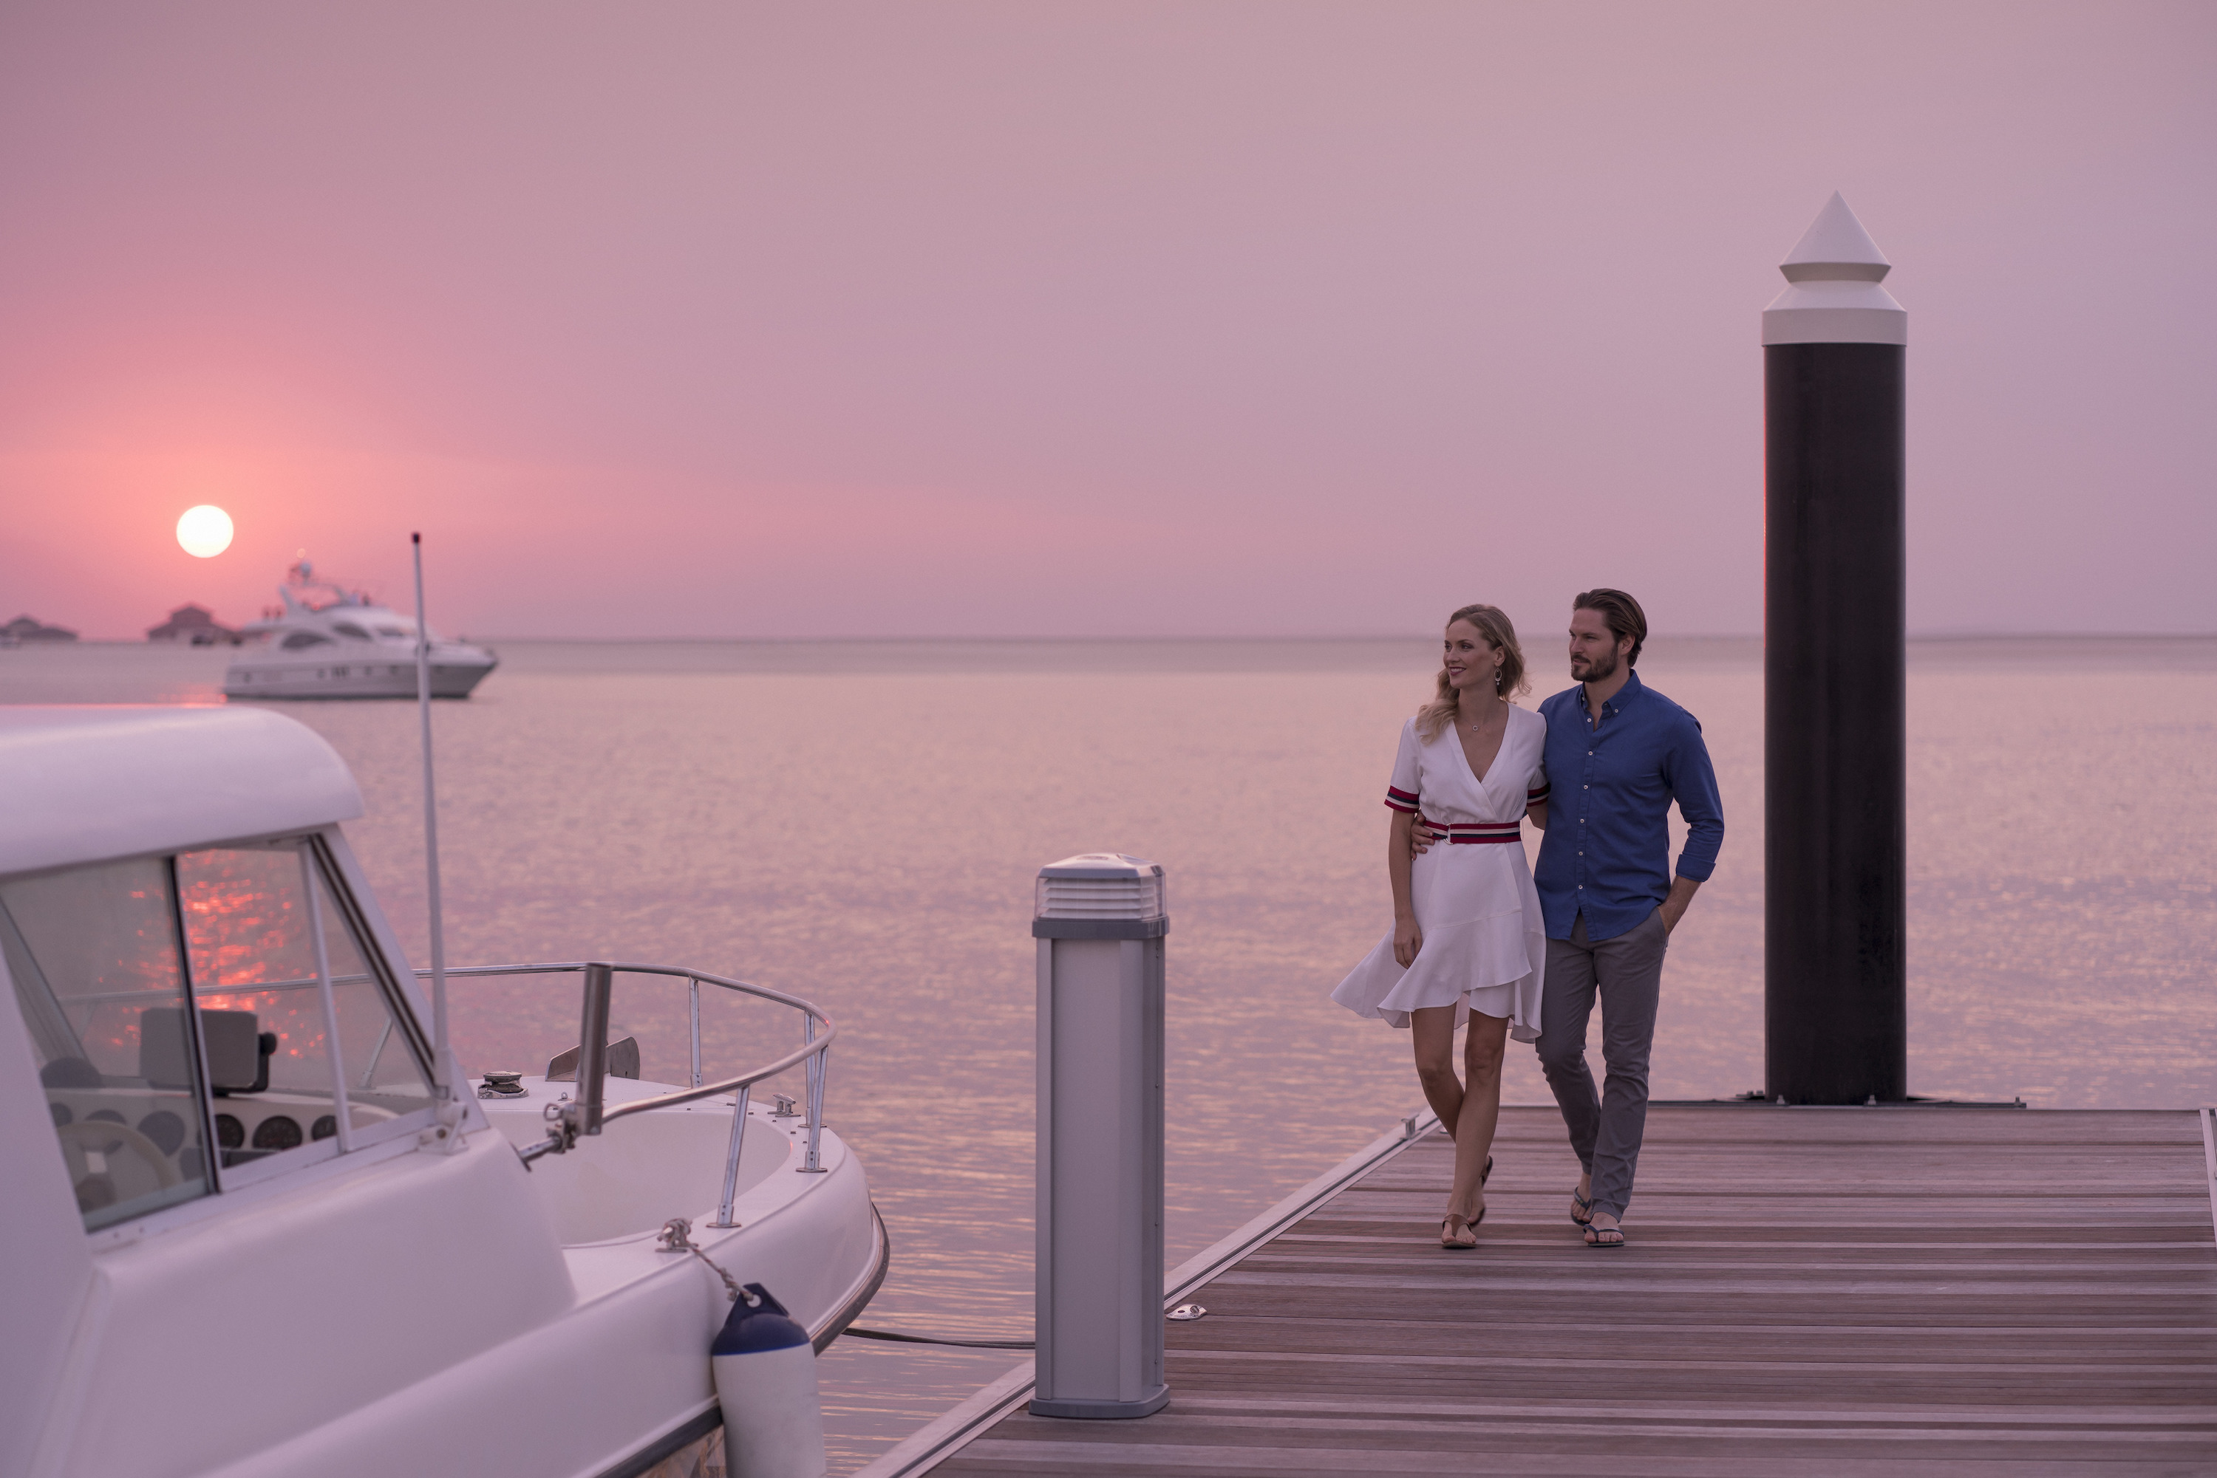
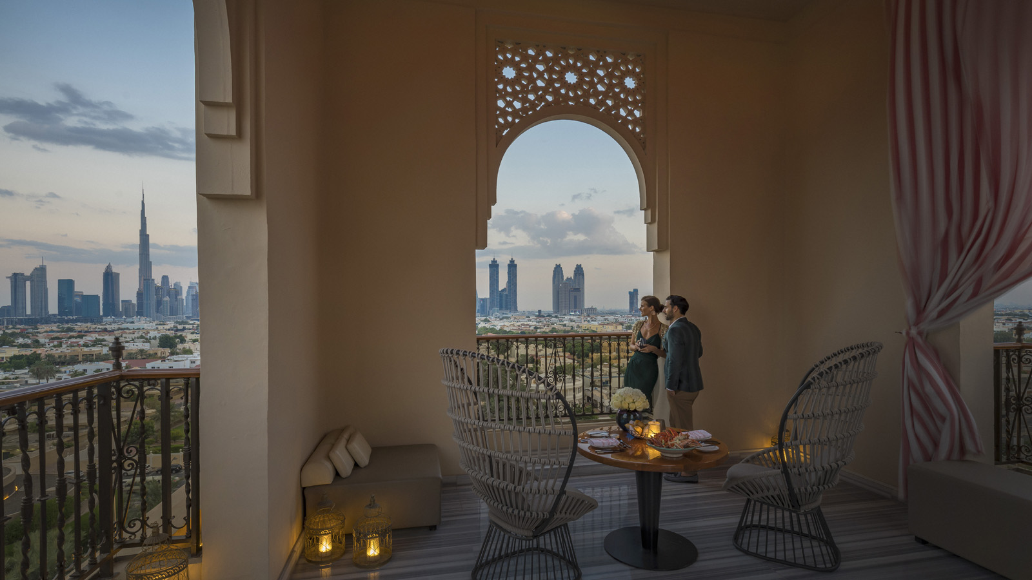 |  | 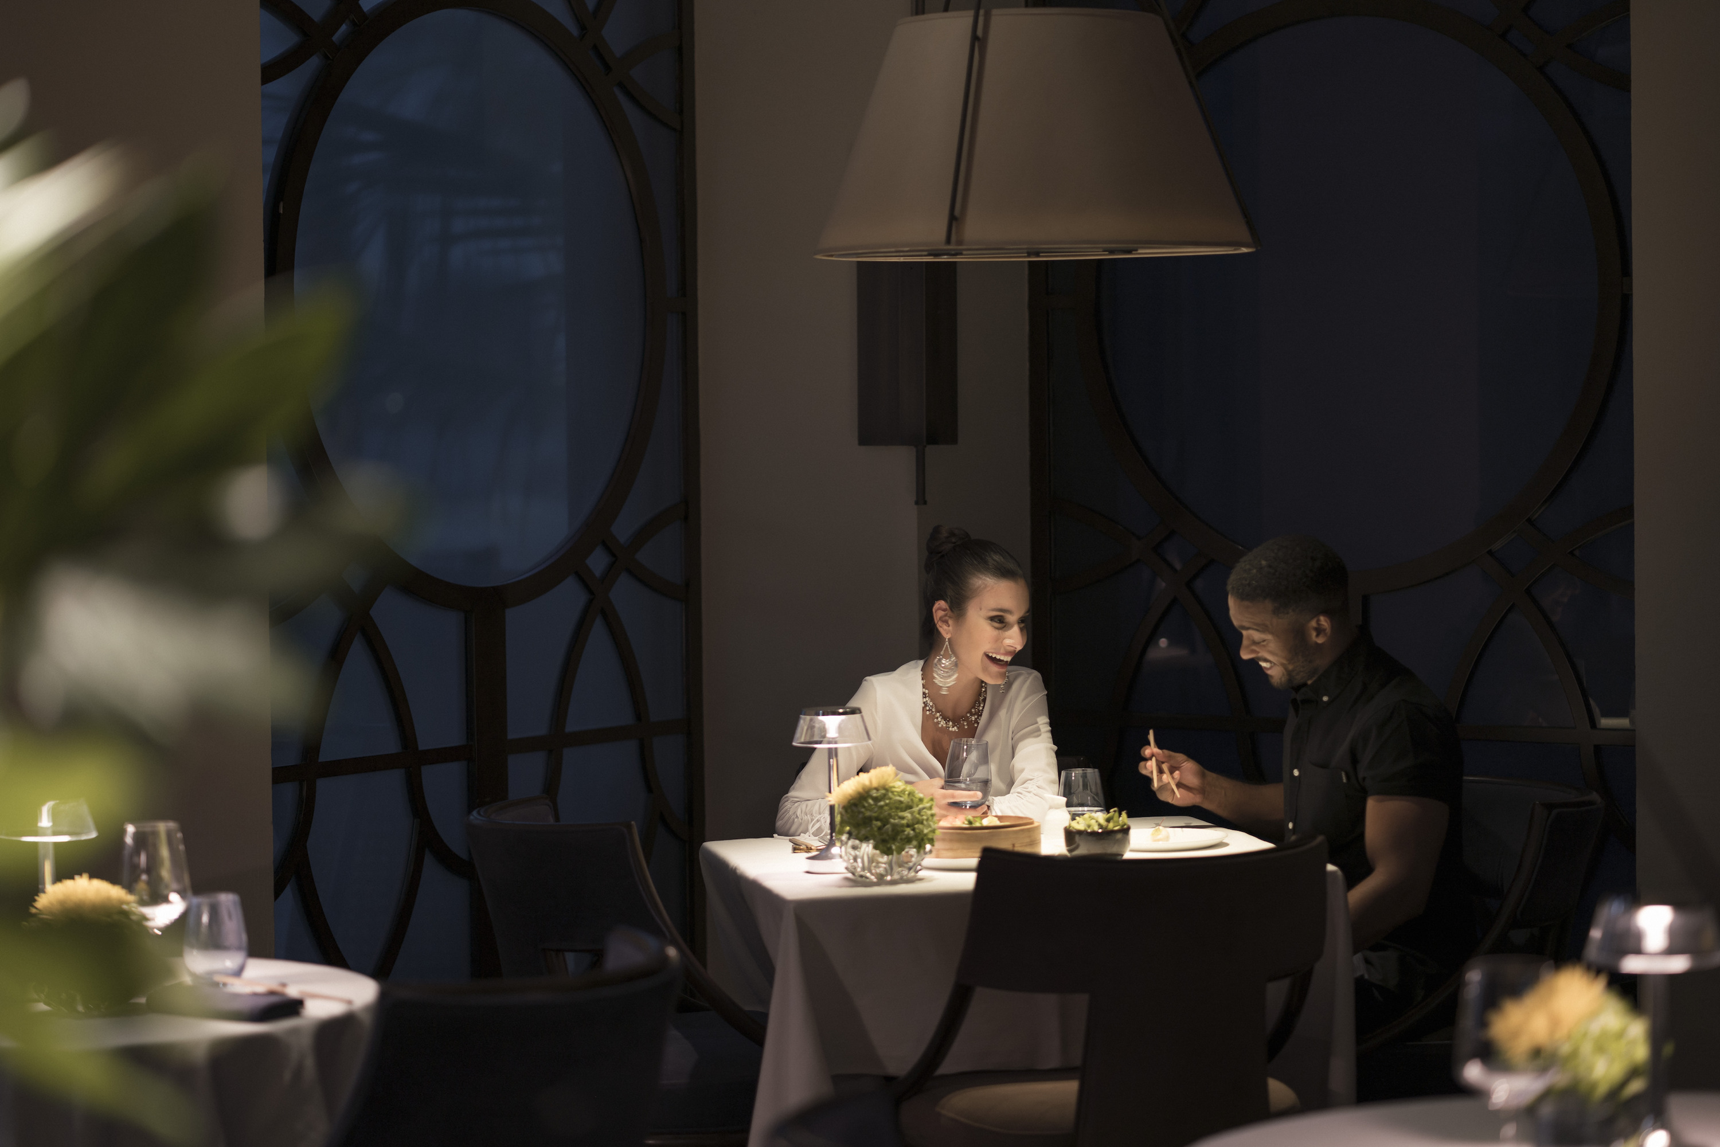
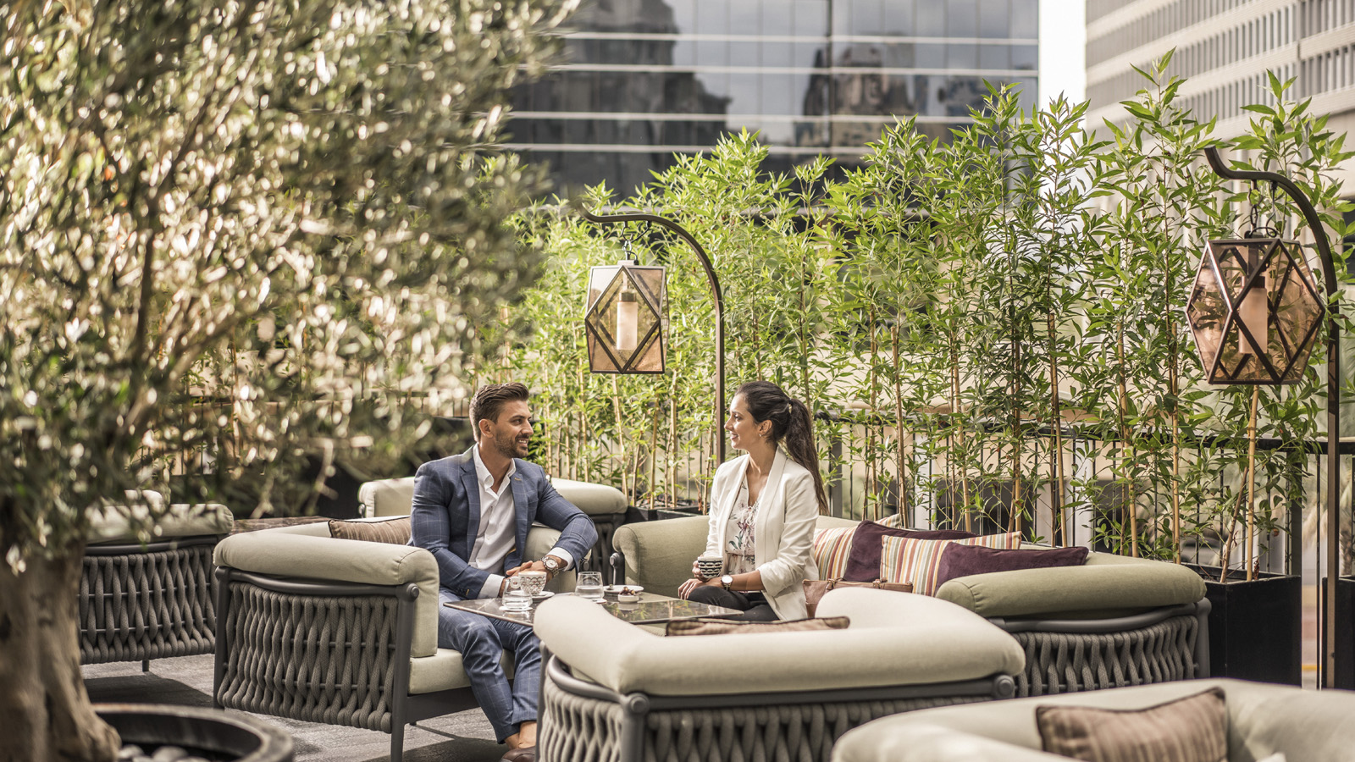
Hearts be not weary. This year Four Seasons Dubai have announced a fresh collection of experiences dedicated to Valentine’s Day spanning across their widely acclaimed portfolio of venues. From the sweeping beachscapes of Four Seasons Resort Dubai at Jumeirah Beach to the hip city vibes of Four Seasons Hotel Dubai International Financial Centre, there promises to be the perfect backdrop to win over every heart.
Believe in Waves of Emotion
Royal Cabana at the Beach, Four Seasons Resort Dubai
An experience for real romantics, celebrating the greatest emotion of all, love. The Royal Cabana by the secluded shore is a magical setting for a dinner. Transformed into a bohemian emblem of amour, the ambience perfectly complements a five-course menu designed to mimic the stages of falling in love, from first sight to a kiss under the moon. The dinner is paired with a premium bottle of Ruinart rosé, the perfect accompaniment to enchant and captivate. A souvenir of the romantic evening, the couple is gifted a forever rose and a box of chocolates to savour together.
- February 12-14, 2022
- Time: 7:00 pm onwards

RELATED

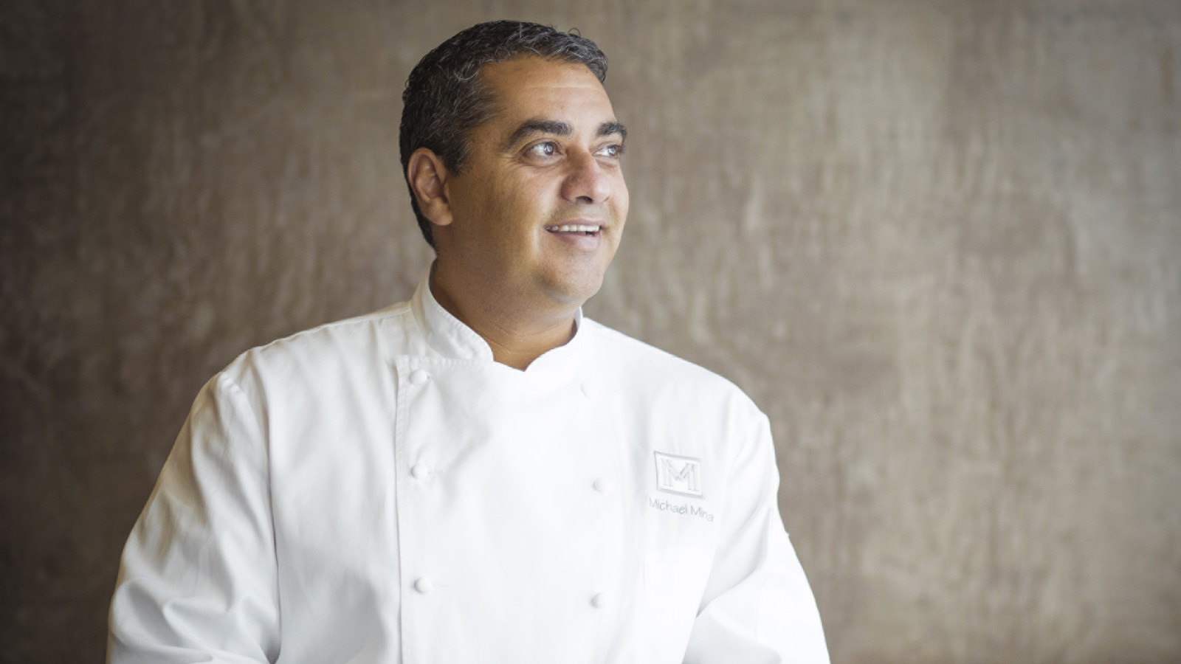 | February 8, 2022, Dubai, U.A.E.  Award Winning Chef Michael Mina is Back to Treat Diners to His Masterful Cuisine at Four Seasons Hotel Dubai International Financial Centre  https://publish.url/dubaidifc/hotel-news/2022/chef-michael-mina-at-mina-brasserie.html
February 3, 2022, Dubai, U.A.E.
Mercury Lounge Unmasks an Exhilarating Venetian Masquerade at Four Seasons Resort Dubai at Jumeirah Beach
https://publish.url/dubai/hotel-news/2022/venetian-masquerade-event-at-mercury-lounge.html

PRESS CONTACTS

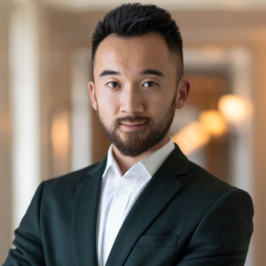 | Mazhit Ismailov  Senior Director of PR and Communications  Jumeirah Road  Dubai  United Arab Emirates  mazhit.ismailov@fourseasons.com  + 971 4 270 7723
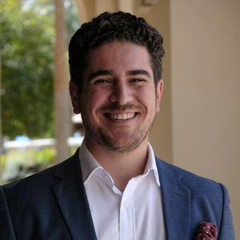 | Ghaith Adnan  Public Relations and Marketing Manager  Jumeirah Road  Dubai  United Arab Emirates  ghaith.adnan@fourseasons.com  + 971 4 270 7884

