Join Together This Holiday at Four Seasons Resorts Lanai

Celebrate the season with two resorts on one secluded Hawaiian island
November 9, 2022, Hawaii, Lanai, U.S.A.

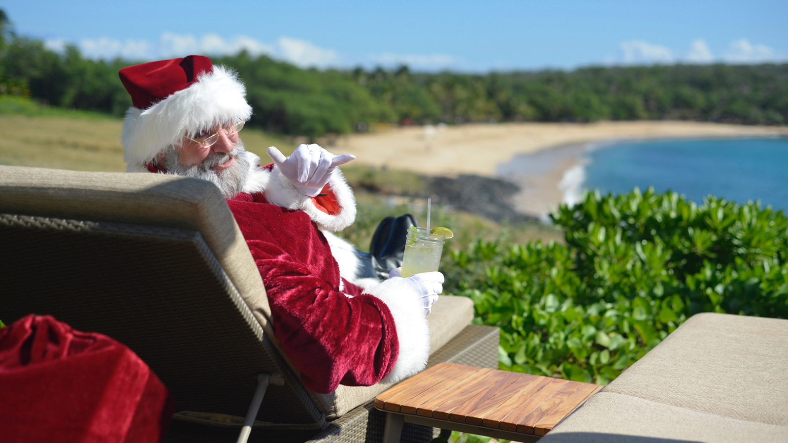
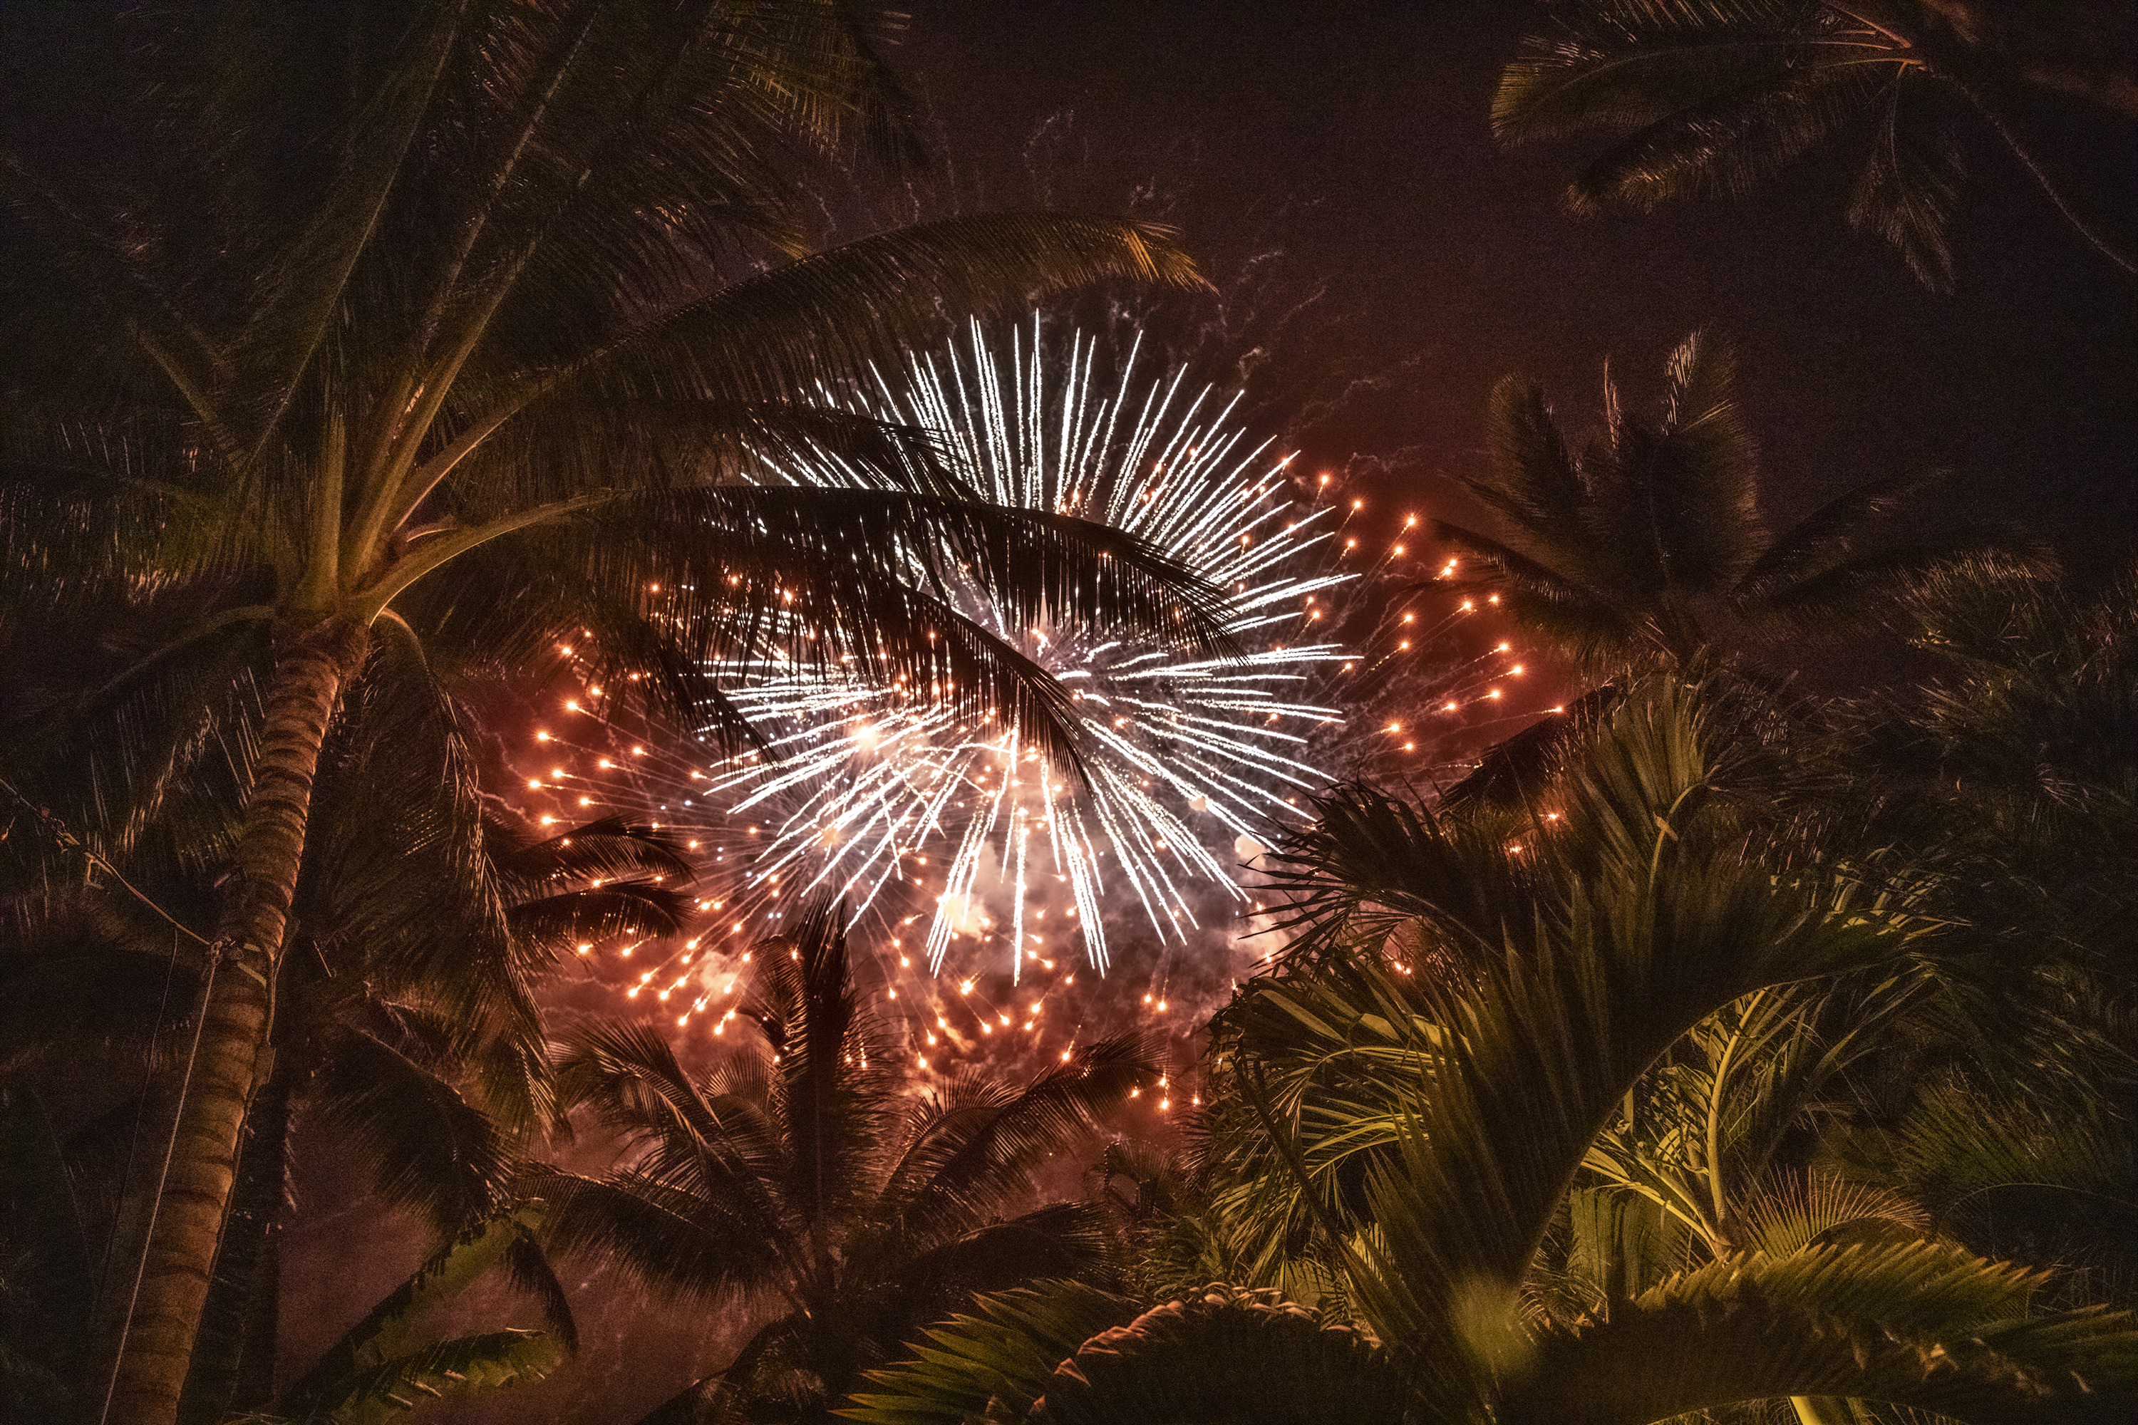 | 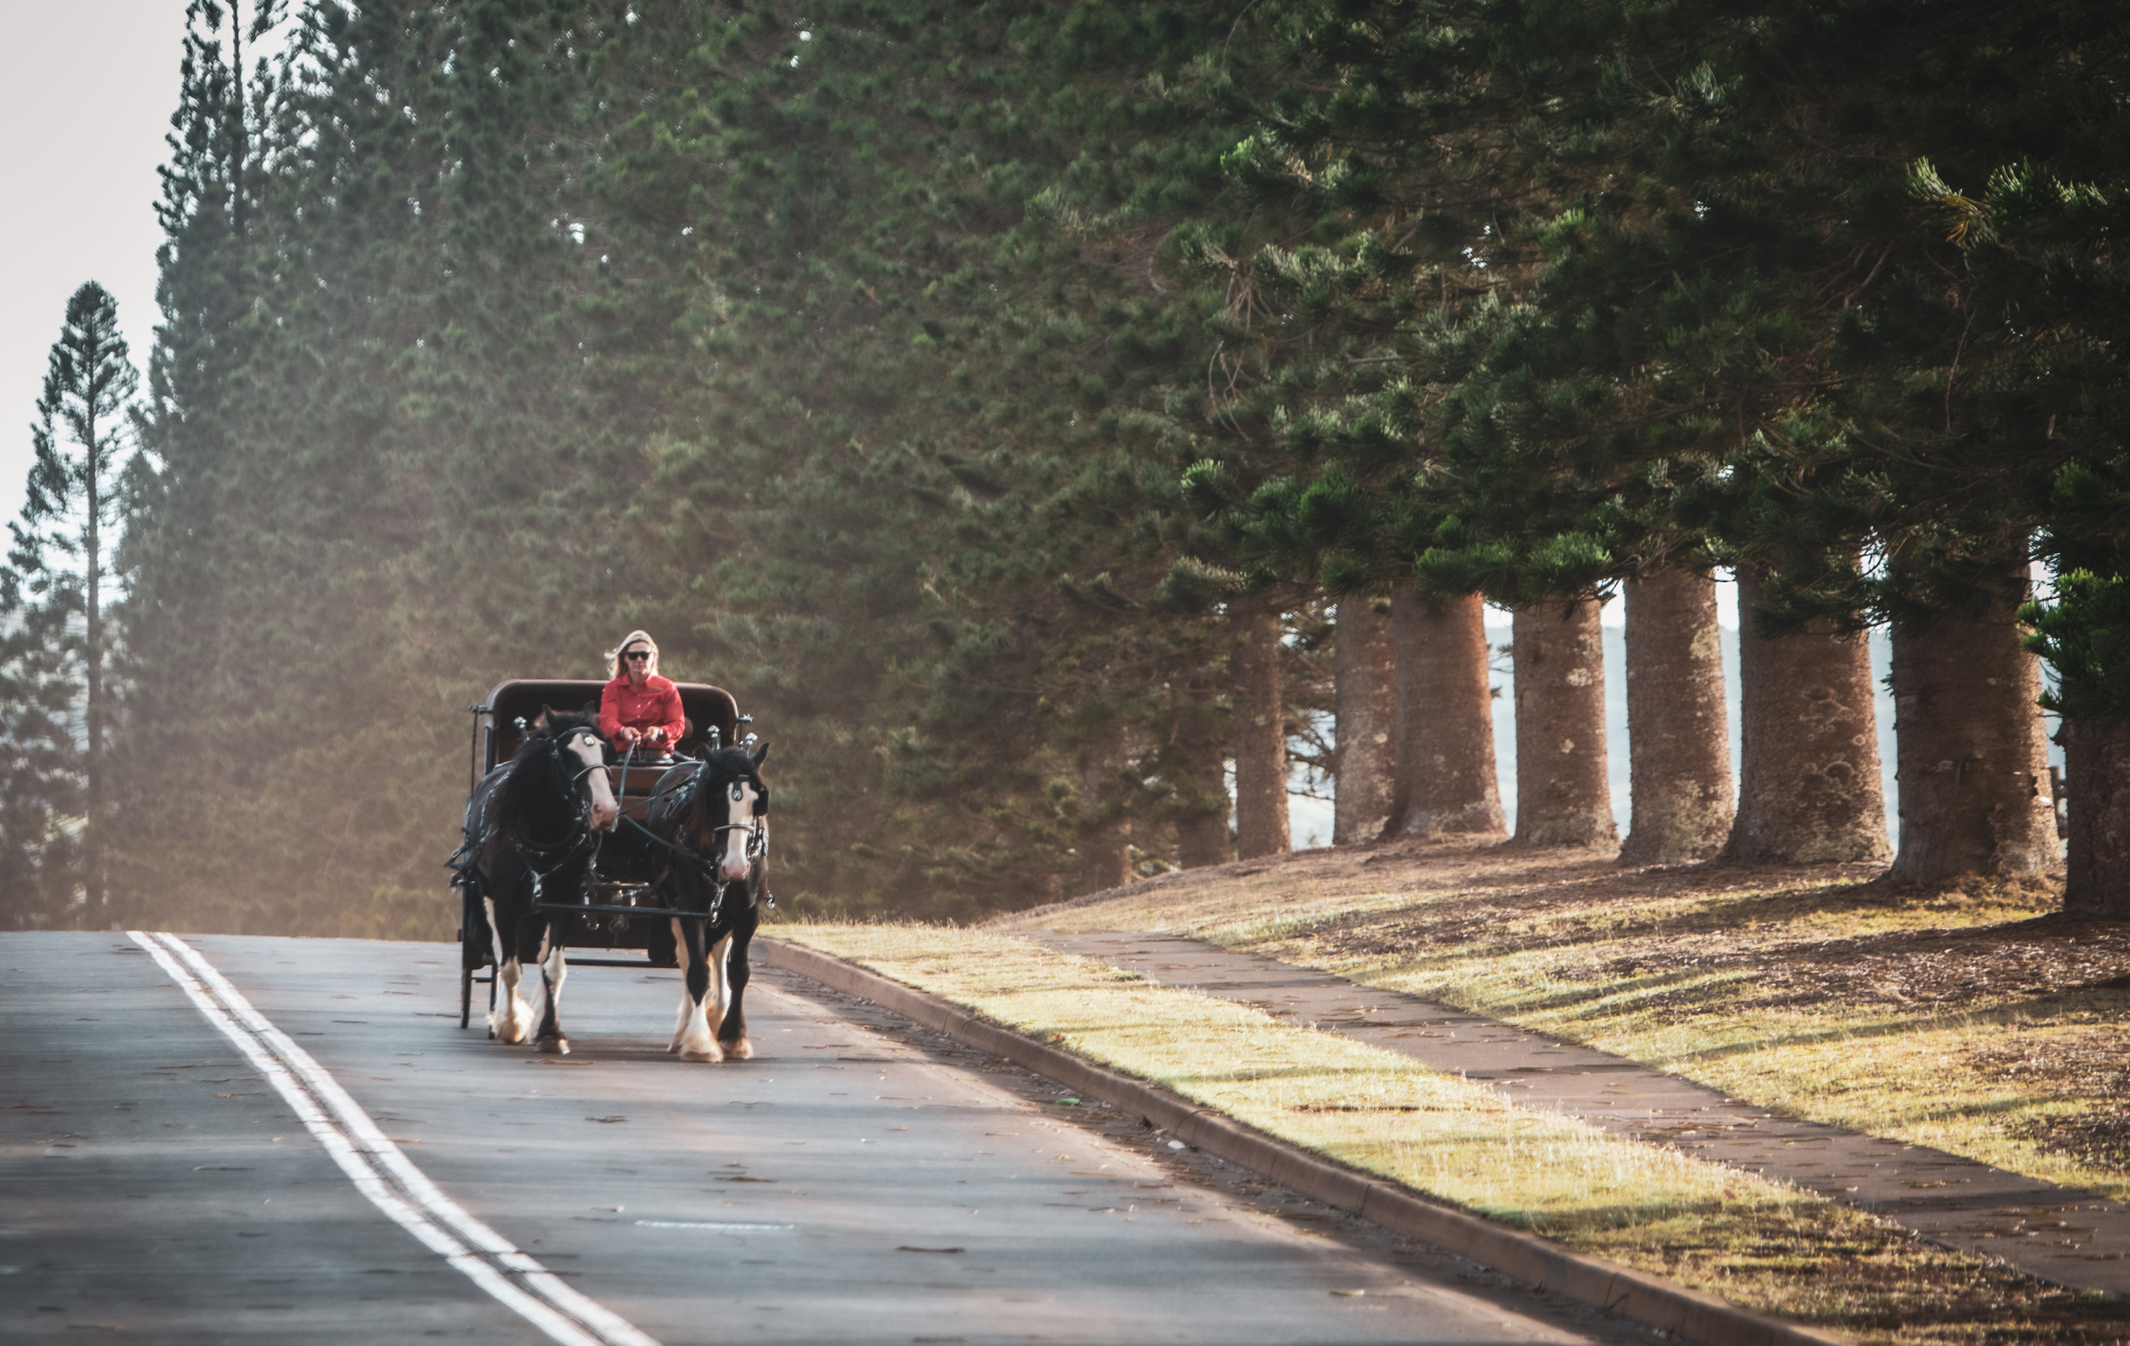 | 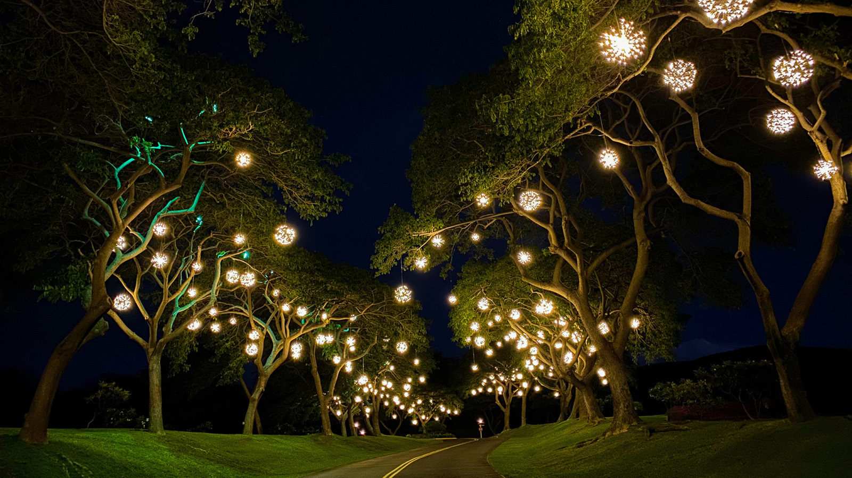
Enjoy this festive season with cherished loved ones on the authentic, unspoiled island of Lanai. Featuring seasonal spa and golf events, special holiday menus and music, festive décor, kids programming and more, travellers can choose from two resorts as their home away from home this special time of year.
The 90,000 acre (36,000 hectare) Hawaiian paradise is an ideal destination for a holiday escape, offering land, ocean and air activities for small groups and private parties as well as award-winning luxurious accommodations to call home during the season. The beachfront Four Seasons Resort Lanai features 213 guest rooms in a series of low-rise buildings spread along the Pacific coastline, providing a private residential experience. The Resort offers outdoor restaurants, including NOBU LANAI, spa, golf and tennis, a kid club, beach and pool with spacious seating areas nestled among tropical gardens, a variety of complimentary classes and events and luxury retail boutiques to ensure a special island adventure for guests.
The adults-only Sensei Lanai, A Four Seasons Resort offers a serene oasis set on 24 acres (10 hectares) of rolling hills, tropical greenery and natural beauty. Dine at Sensei by Nobu, enjoy golf and tennis along with island activities or luxuriate in private spa hales with a range of therapeutic treatments. Enhance personal well-being through a wide variety of experiences and programs, from complimentary fitness and wellness classes to lectures and one-on-one private sessions with a trained team of Sensei Guides and practitioners who hold degrees in their respective fields.
Guests have signing privileges at all restaurants and access to most programming.* Check the online activity calendar for up-to-date listings for special events, many complimentary, during the holidays including:
Golf
Test skills in a “Hit the Green” competition at Manele Golf Course, relax with family and friends après golf at Jingle Bell Rock ‘N Range or finish holiday gift buying at the Manele Golf Shop Social. Non-golfers can get in the game with a tour of the Resort’s most scenic holes along with a cocktail as the day comes to an end, or take a fling with Holiday Disc Golf.
Spa and Wellness
Relax and rejuvenate at Hawanwana Spa. Exclusive to the spa, the 115-minute Island Serenity Ritual renews and enables guests to turn off the outside world, re-centre, and refresh their spirit, as the island of Lanai invites guests to do. Couples can enjoy Suite Serenity, a 120-minute Body & Massage Ritual for each, paired with 60-minute luxury facials of choice and light-fare dining two in the private couples suite. Stay active with a selection of complimentary and fee-based classes such as aerial yoga, beach yoga and meditation or enjoy private sessions upon request.
Love Lanai Cultural Programs
Join the Resort’s Lanai Cultural Advisors for complimentary Hoolauna workshops and learn Hawaiian history, how to play the ukulele, lauhala leaf weaving, hula, lei making, Hawaiian herbal healing workshops and more. Or take a Resort Tour and learn about the vivid history of the areas of Manele and Koele, including native traditions, antiquity, and historical facts. Go holoholo on a guided island off-roading excursion. A nightly Pu blowing ceremony will mark the end of the day and welcome a new evening.
Keiki (Kids)

RELATED

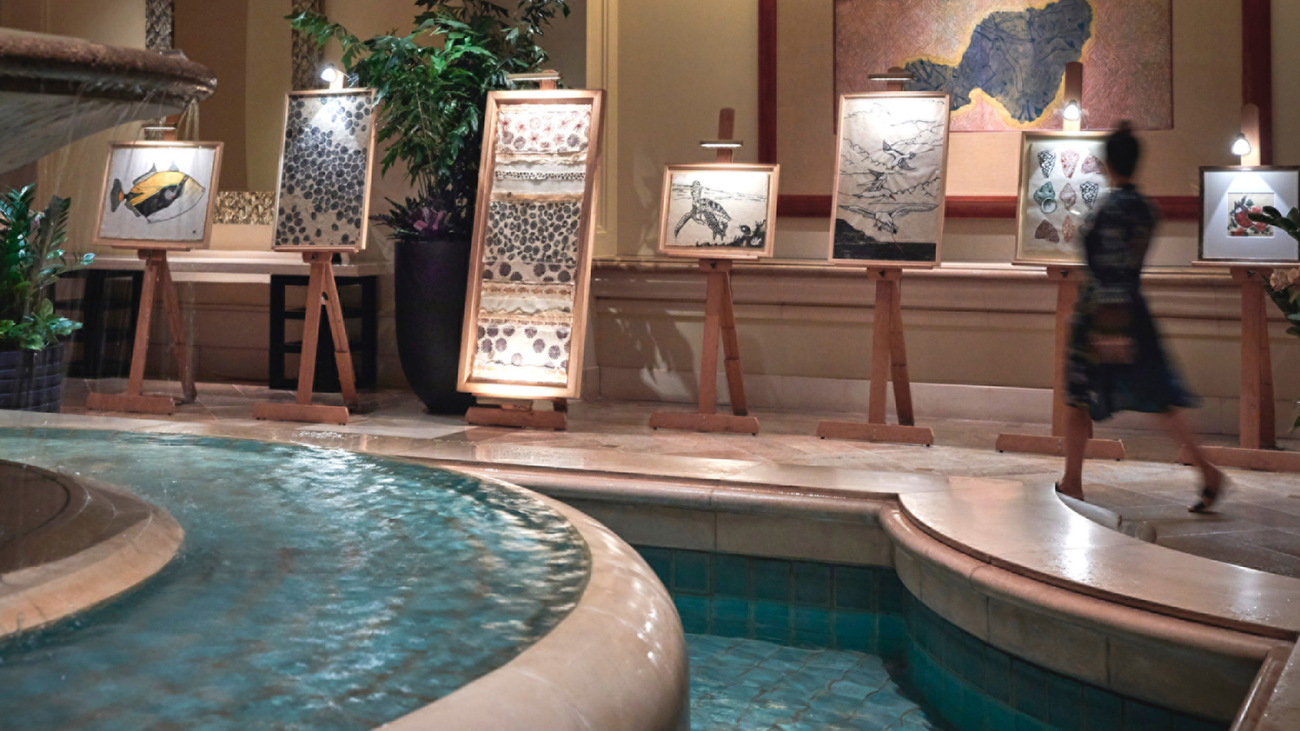 | November 10, 2022, Hawaii, Maui, U.S.A.  Four Seasons Resort Maui Announces “Showcase Under the Stars” Fine Art Auction  https://publish.url/maui/hotel-news/2022/showcase-under-the-stars-art-auction.html
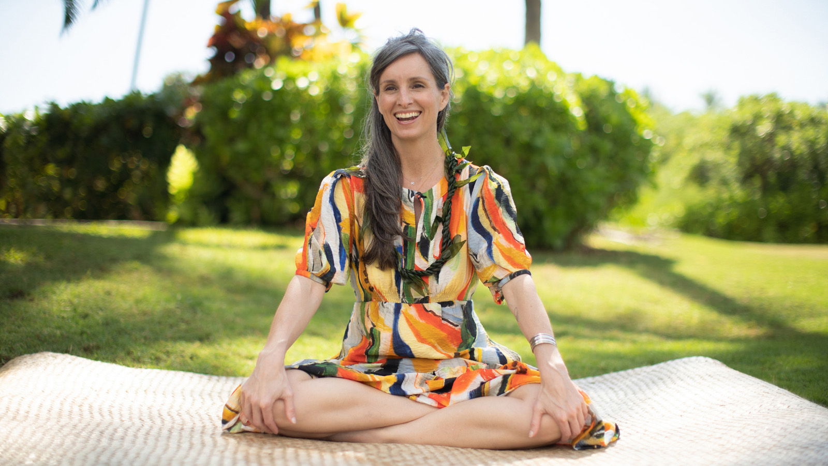 | November 4, 2022, Hawaii, Oahu, U.S.A.  Four Seasons Resort Oahu at Ko Olina Announces Healer-in-Residence Program with Dana Childs – Intuitive Energy Healer, Author and Educator  https://publish.url/oahu/hotel-news/2022/dana-childs-wellness-residency.html

PRESS CONTACTS

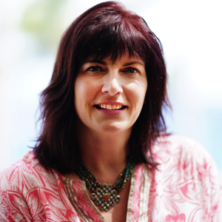 | Lori Holland  Senior Director of Public Relations  6100 Center Drive, Suite 1250  Los Angeles  USA  lori.holland@fourseasons.com  +1 201 294 7810
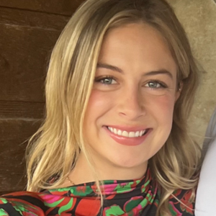 | Anna Peirano  Digital Marketing Manager  Lanai  USA  anna.peirano@fourseasons.com  +1 808 649 8970

