Four Seasons Hotel Milano Presents a New Edition of its Festive Urban Chalet Pop-Up, Inspired by the Glamour and Wintry Ambience of the Alps

The arrival of winter marks the return of the Hotel’s stylish wooden-clad retreat, which immerses guests in a magical mountain setting in the heart of Milan
November 18, 2019, Milan, Italy

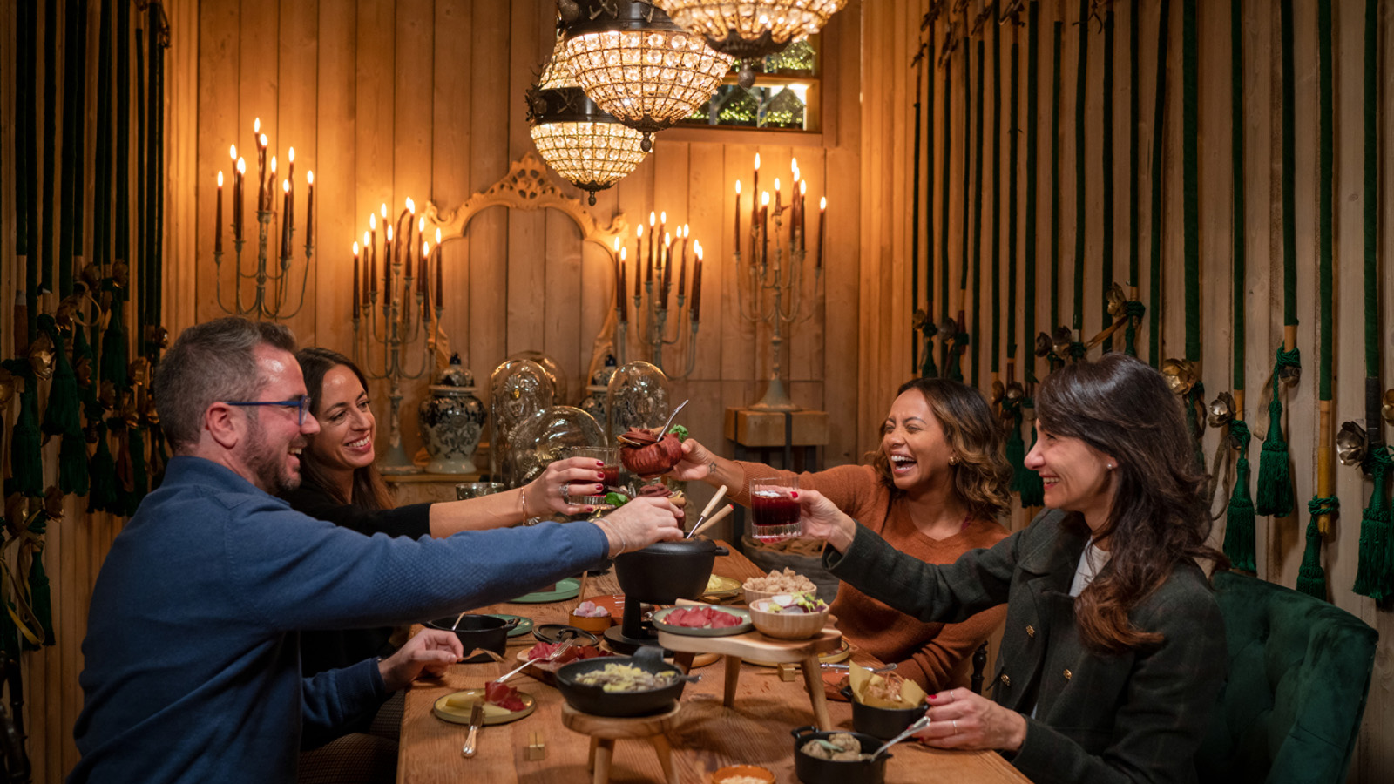
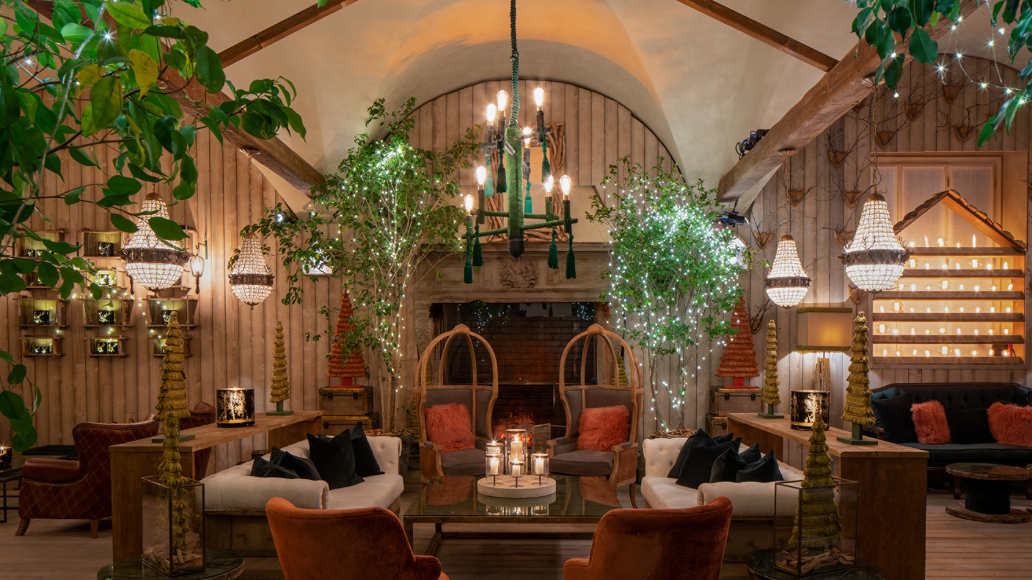 | 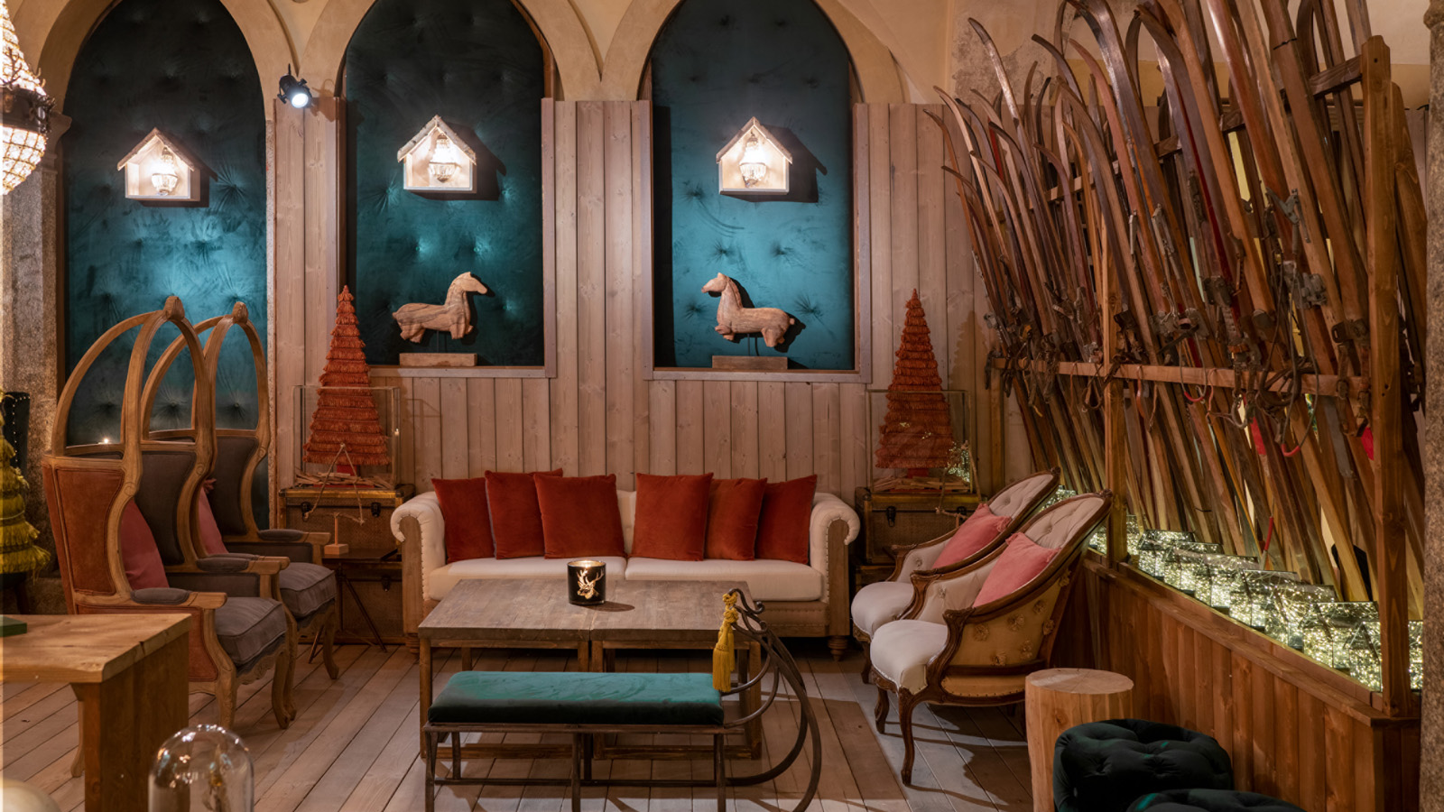
Four Seasons Hotel Milano has unveiled this year’s Urban Chalet pop-up, a cosy Alpine hideaway in the Hotel’s Sala Camino, inspired by the style and glamour of the Alps. Designed by acclaimed Artistic Director Vincenzo Dascanio, this year’s Urban Chalet is sure to wow both Hotel guests and locals alike, transporting them into the warm atmosphere of a mountain chalet right in the heart of Milan's exclusive Fashion District. Available until the end of January 2020, the Urban Chalet exudes a snug and cosy festive feeling, providing the ultimate setting to escape the hustle and bustle of central Milan.
Renowned for creating striking floral arrangements, Vincenzo Dascanio has dressed the space with a cosy Alpine look, transforming it into a magical white wonderland, with wood panelled interiors, furry rugs and faux-fur cushions and throws. Vintage skis, festive wreaths and twinkling lights create an authentic mountain feel, while cosy alcoves provide plenty of warmth, perfect for an intimate tête-à-tête with friends, colleagues or loved ones.
Chef Fabrizio Borraccino has crafted a warming Alpine-inspired menu, with comforting sweet and savoury treats. Sharing boards, cheese fondue and traditional Christmas panettone – a Milanese Christmas cake that symbolises the festive season – are just some of the delights available. Winter warmer cocktails complete the offer, bringing an authentic après-ski atmosphere to the heart of the city. The drinks list features the likes of Glow Wine, a spiced and warming mulled wine, and Skypass, a rum-based drink made with black tea, lemon juice and orange liqueur – both the perfect antidote to cold weather.
Four Seasons Hotel Milano is set in a restored 15th century convent in the heart of the city’s glamorous Fashion District, providing the perfect location from which to enjoy some festive shopping. Home to haute couture boutiques, emerging designers and prominent Italian tailors, Milan’s famous Fashion District is one of the city’s most exclusive destinations, characterised by glittering window displays that truly come to life during the festive season. Combining comfort and style, Four Seasons Hotel Milano offers outstanding cuisine and a cosy Spa with vaulted ceilings that is perfect to relax and unwind after a day of shopping and sightseeing.
The Urban Chalet can be booked for private events and dinners to celebrate the festive season in style, with personalised alpine-themed dishes and drinks that capture all the charm of winter in the nearby Alps.
Mountain Bites to Share Menu
- Carpaccio served with citrus and fennel - EUR 15
- Pizzoccheri - EUR 15
- Sciatt from Valtellina - EUR 15
- Italian knödel with speck, butter and sage - EUR 15
- Goulash served with polenta - EUR 15

RELATED

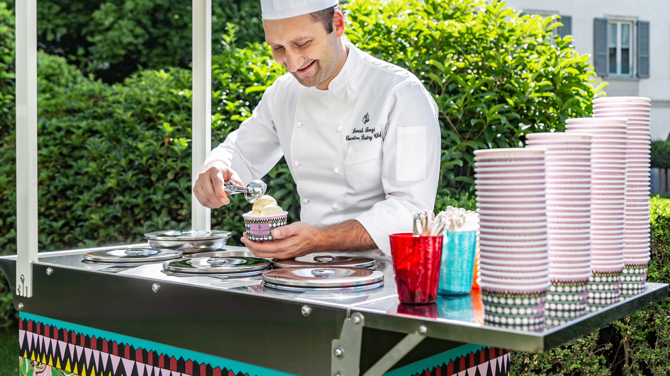 | July 24, 2019, Milan, Italy  Four Seasons Hotel Milano Launches Dreamy Ice Cream Flavours, with Stylish Cups and Playful Cart Designed by JJ Martin  https://publish.url/milan/hotel-news/2019/summer-ice-cream-cart.html
July 24, 2019, Milan, Italy
Il Nuovo Ice Cream Trolley Disegnato da JJ Martin e il Gelato Artigianale by Four Seasons Hotel Milano
https://publish.url/it/milan/hotel-news/2019/summer-ice-cream-cart-2.html

PRESS CONTACTS

Caroline Mennetrier
Director of PR and Marketing Communication
Via Gesù 6/8
Milano
Italy
caroline.mennetrier@fourseasons.com

+33 6 26 39 96 76

Anita Ruozzi
Public Relations and Marketing Communication Coordinator
Via Gesu, 6/8
Milano
Italy
anita.ruozzi@fourseasons.com

+39 02 7708 1123

