An Argentinean Tango, Lying Down

June 1, 2011, Buenos Aires, Argentina

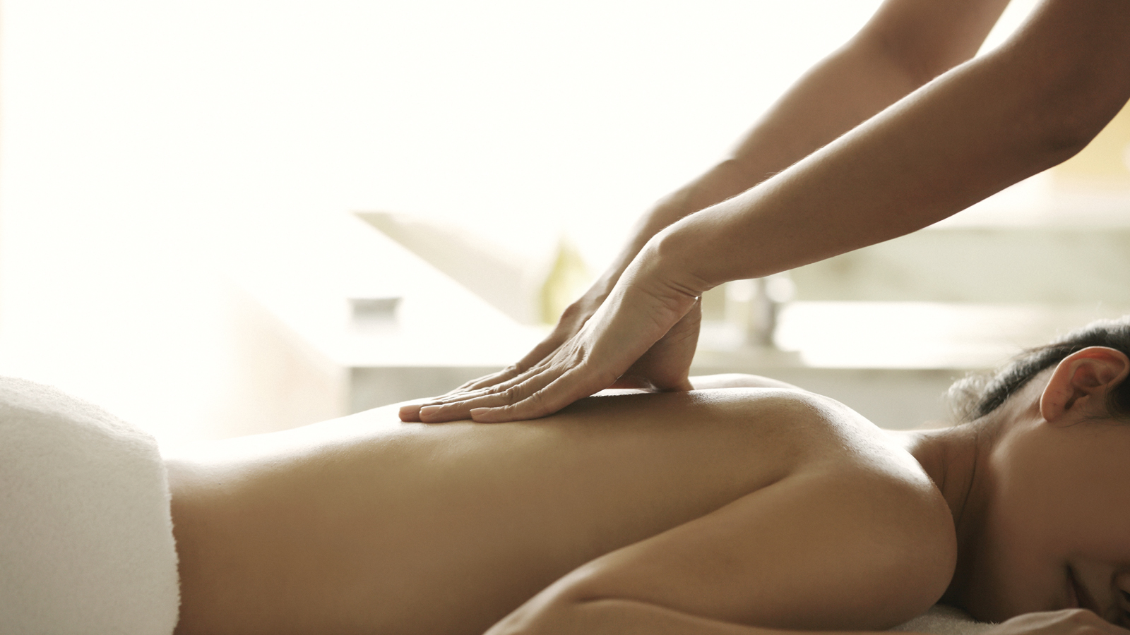
At the Spa at Four Seasons Hotel Buenos Aires, a signature spa treatment celebrates the passionate culture of Porteños, as the people who live in the port city are known. The Porteño Tango massage uses natural ingredients such as grape oil and red wine, known for its powerful antioxidants and rich concentration of vitamin E.
The treatment is complemented by the music of the tango, a dance with African roots that was made popular by working class Porteños in the 1890s and now enjoys worldwide fame.

RELATED

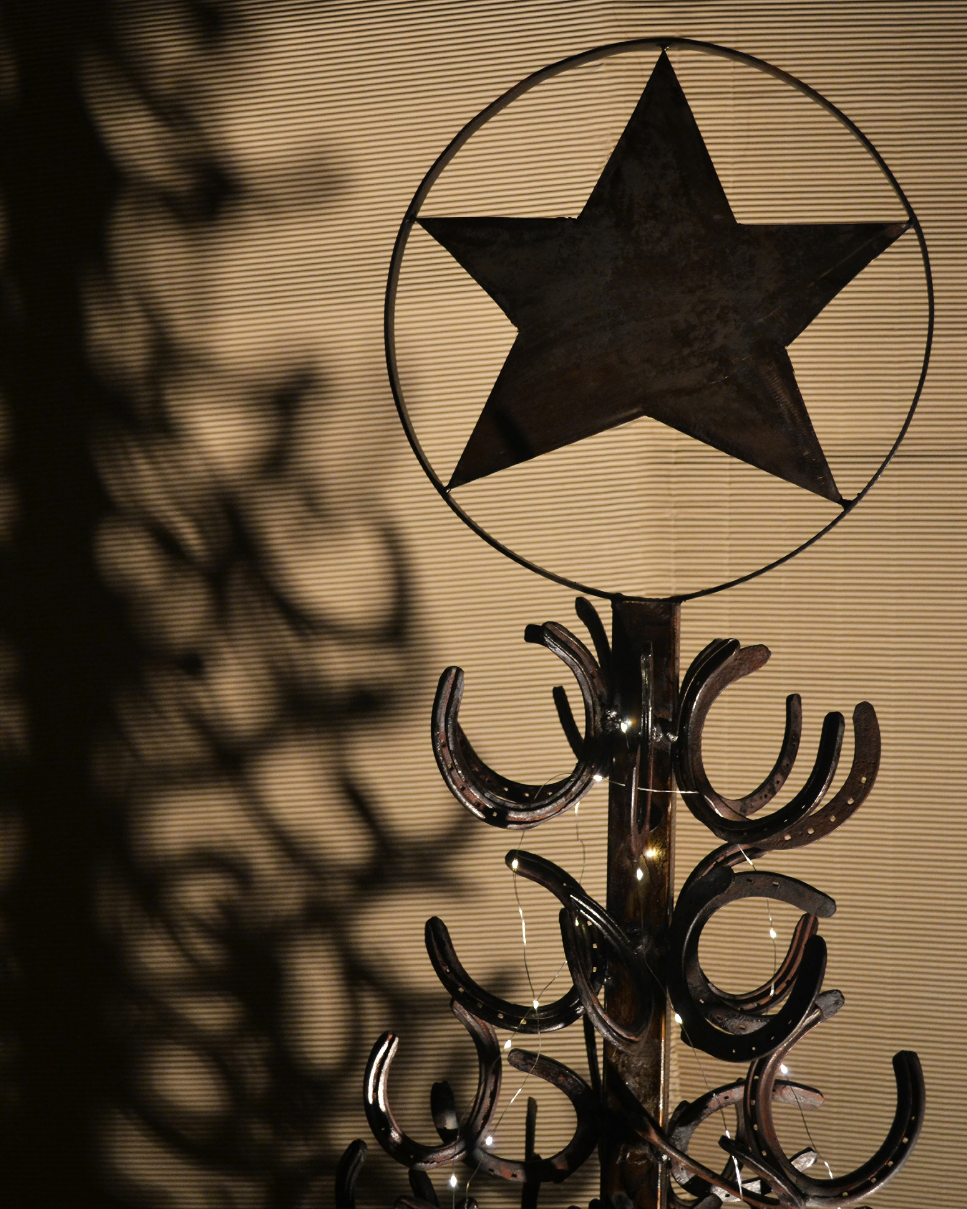 | December 4, 2018, Buenos Aires, Argentina  El Árbol Navideño de la Suerte  https://publish.url/es/buenosaires/hotel-news/2018/festive-season-2.html
December 4, 2018, Buenos Aires, Argentina
The Christmas Lucky Tree at Four Seasons Hotel Buenos Aires
https://publish.url/buenosaires/hotel-news/2018/festive-season.html

PRESS CONTACTS

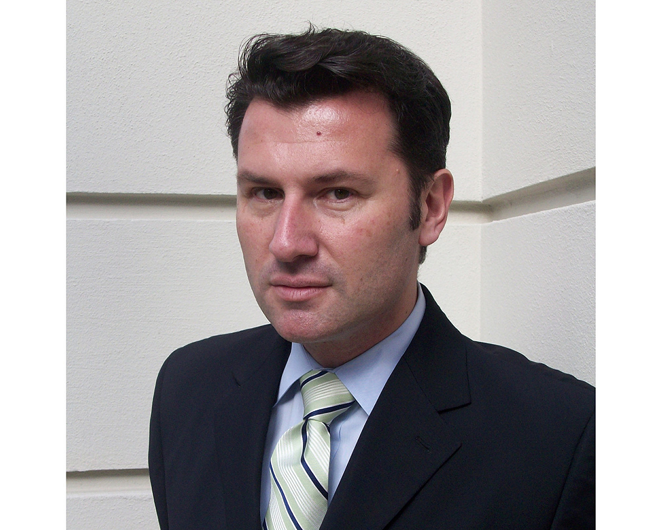 | Gabriel Oliveri  Director of Marketing  Posadas 1086/88  Buenos Aires  Argentina  gabriel.oliveri@fourseasons.com  54 (11) 4321-1634

