Discover Inspirational Luxury at Four Seasons Private Retreats in Kuala Lumpur

Just like home – but better
September 10, 2020, Kuala Lumpur, Malaysia

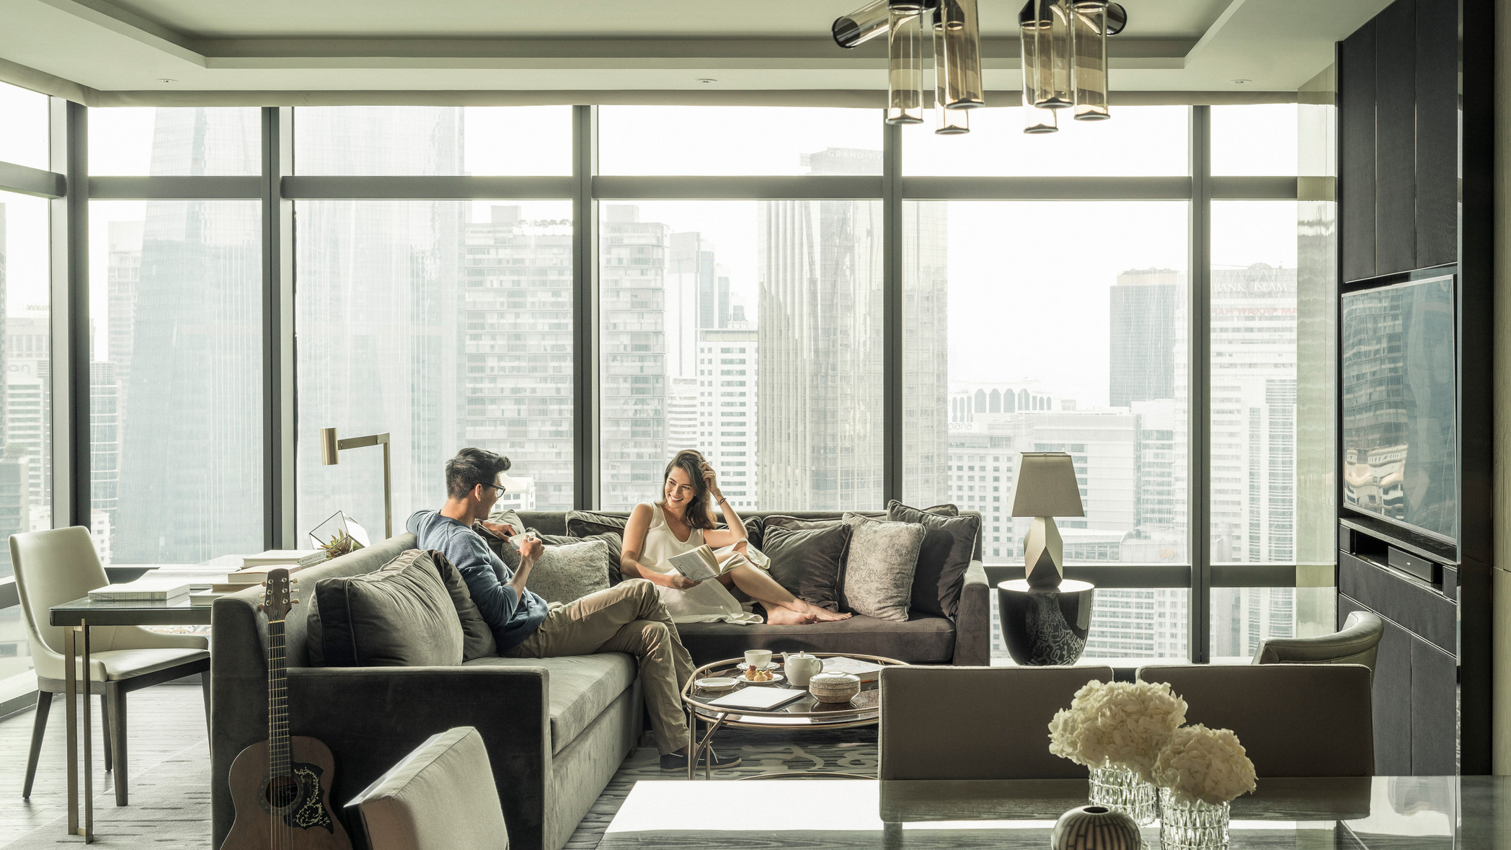
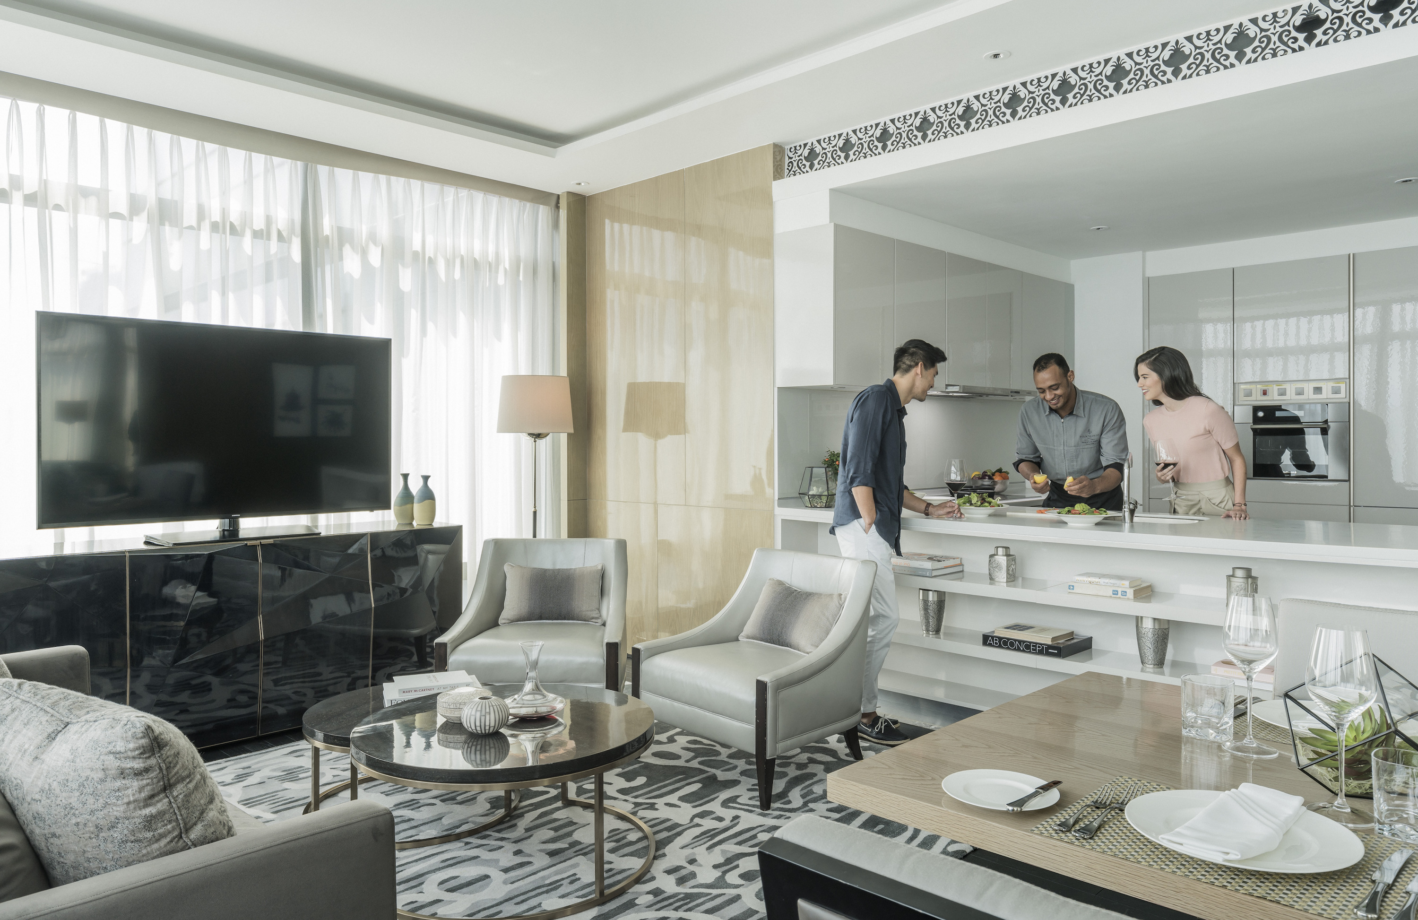 |  | 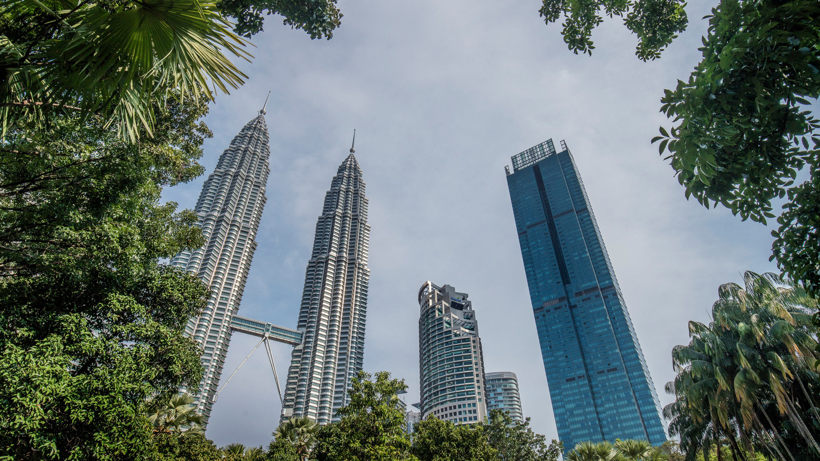
The events of 2020 have been transformational, changing everything from the way we work and live, to how we travel. Space and privacy are now the foremost luxuries sought by discerning travellers, be it a family holiday, a business trip or a romantic staycation.
Enter Four Seasons Private Retreats, the most spectacular private homes situated in remarkable locations around the world. At Four Seasons Hotel Kuala Lumpur, rising high above the verdant KLCC park in the city’s Golden Triangle area, Four Seasons apartments deliver an unrivalled vacation experience. Enjoy all the warmth and comfort of home, along with flawless service, panoramic views and tailor-made activities. It’s just like home – but better.
With serene bedrooms, an open-concept kitchen and inviting living areas, each apartment provides an expansive urban retreat for couples or families to spread out in style. Sweeping city vistas form a stunning backdrop to at-home adventures, from a sunlit breakfast in bed to post-dinner drinks overlooking the glittering skyline.
Find new inspiration within the privacy and safety of the apartment. Rejuvenate with a bespoke spa experience, or savour a live cooking session as an expert Four Seasons chef prepares a personalised menu in the kitchen. Just steps away, the Hotel’s award-winning restaurants and destination bar await discovery. Or explore carefully-curated experiences, including culinary masterclasses, art workshops and yoga sessions. A private concierge is on hand to attend to every need, from arrival to departure.
These city apartments are equally suitable for business travellers, with a work desk for tending to emails and a stylish living room for hosting discreet negotiations. Throughout their stay, guests enjoy complimentary access to the Executive Lounge, the perfect venue for informal meetings with business partners.
Spend more time experiencing the very best of Kuala Lumpur with the Stay Longer offer. Book two nights at a Four Seasons apartment and receive a complimentary third night.
Book your Private Retreat in Kuala Lumpur directly on the website, or chat with us via Four Seasons app for more information.

RELATED

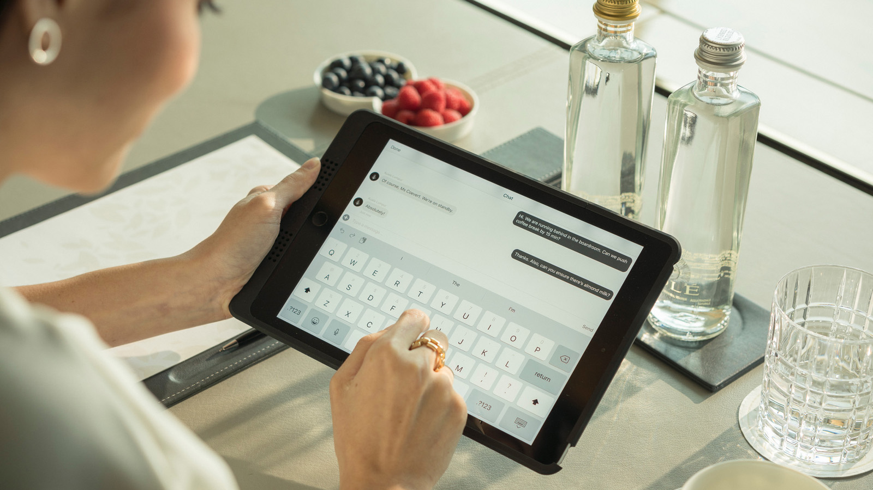 | September 2, 2020, Kuala Lumpur, Malaysia  Get Back to Business with Virtual Meetings at Four Seasons Hotel Kuala Lumpur  https://publish.url/kualalumpur/hotel-news/2020/virtual-meeting-package.html
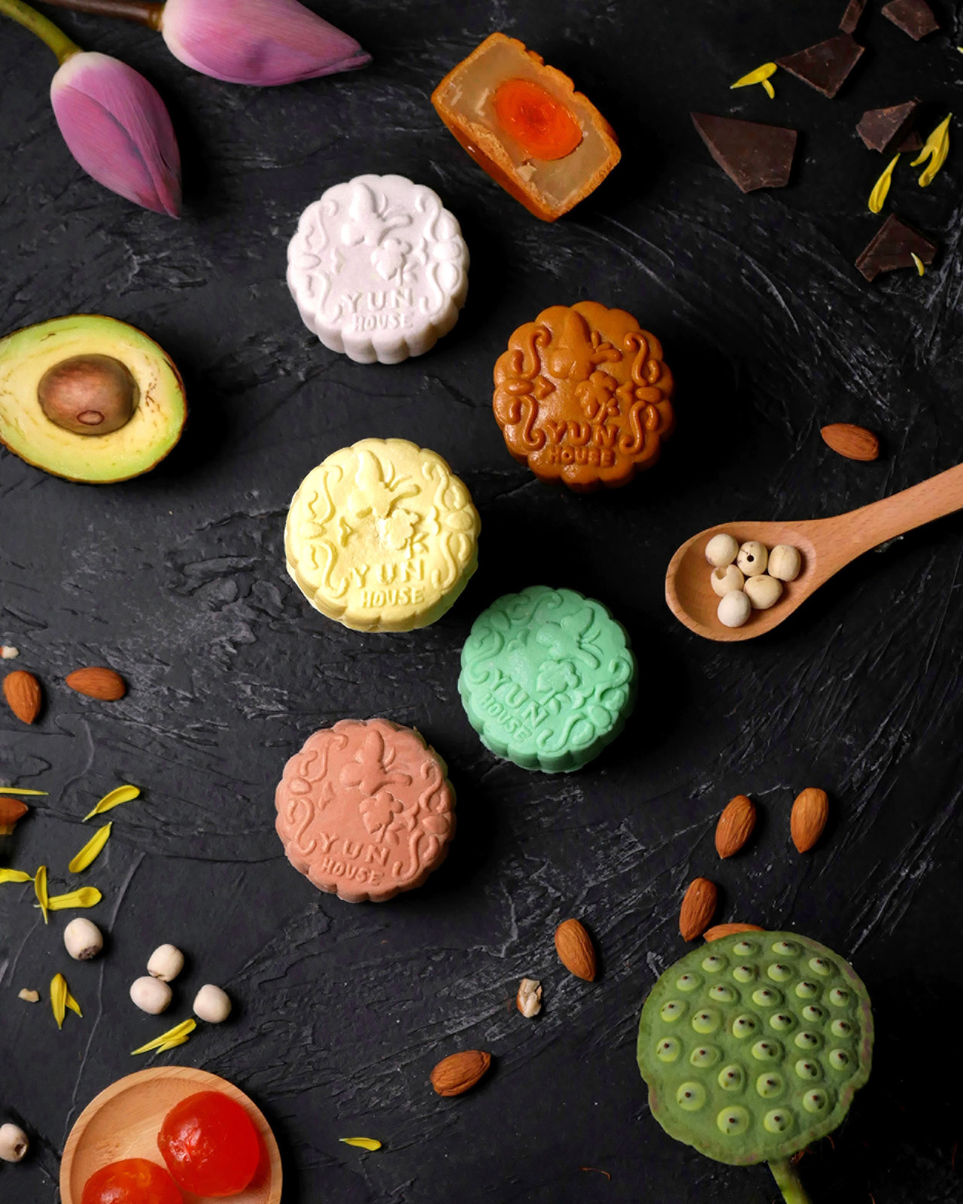 | July 20, 2020, Kuala Lumpur, Malaysia  Make Mid-Autumn Festival Extra Special with Mooncakes from Four Seasons Hotel Kuala Lumpur  https://publish.url/kualalumpur/hotel-news/2020/mooncakes.html

PRESS CONTACTS

Kanchana Ganglani
Director of Public Relations
145 Jalan Ampang
Kuala Lumpur
Malaysia
kanchana.ganglani@fourseasons.com

+6(03) 2382 8740

