Sustainability Initiatives

December 18, 2019, New York, U.S.A.

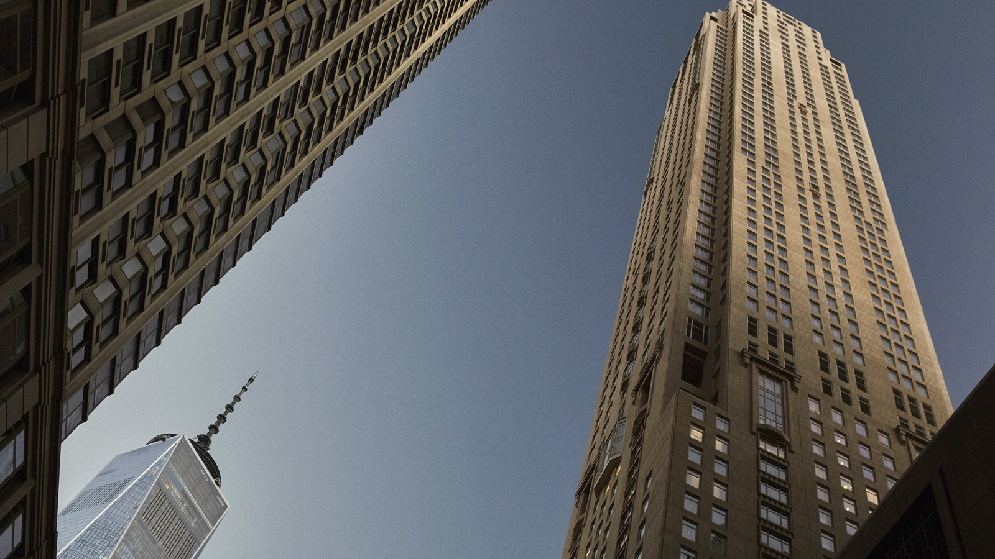
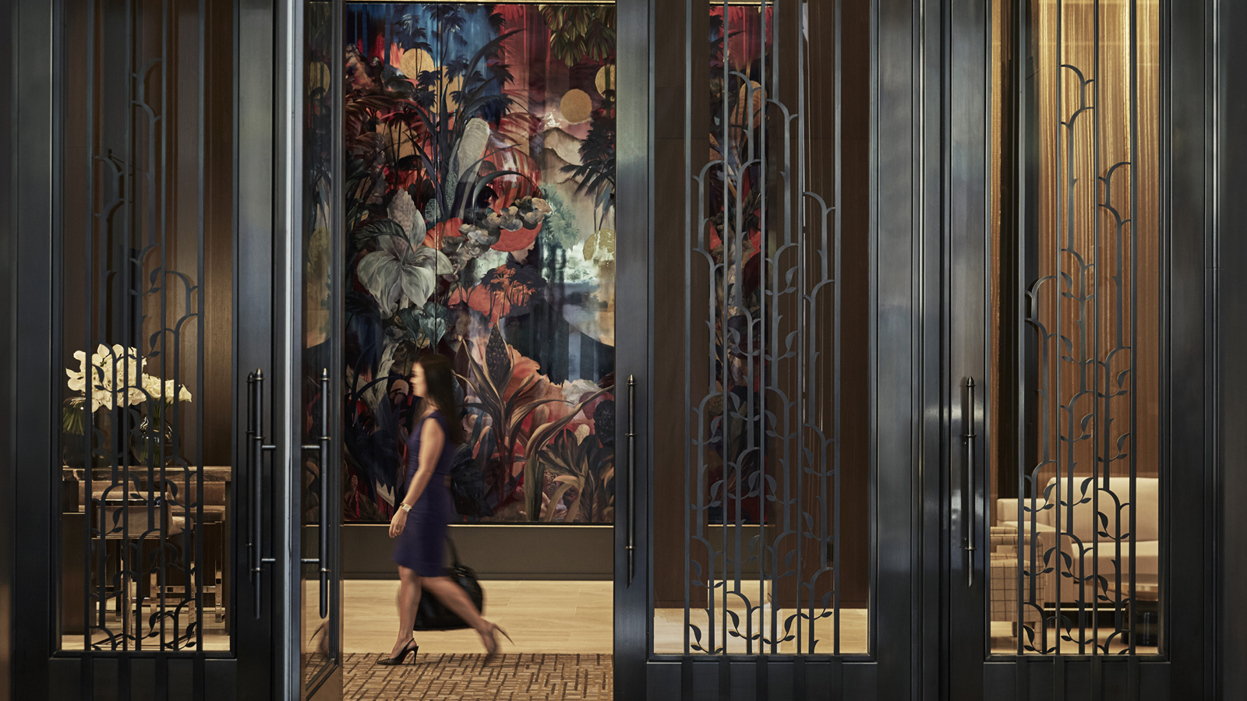 | 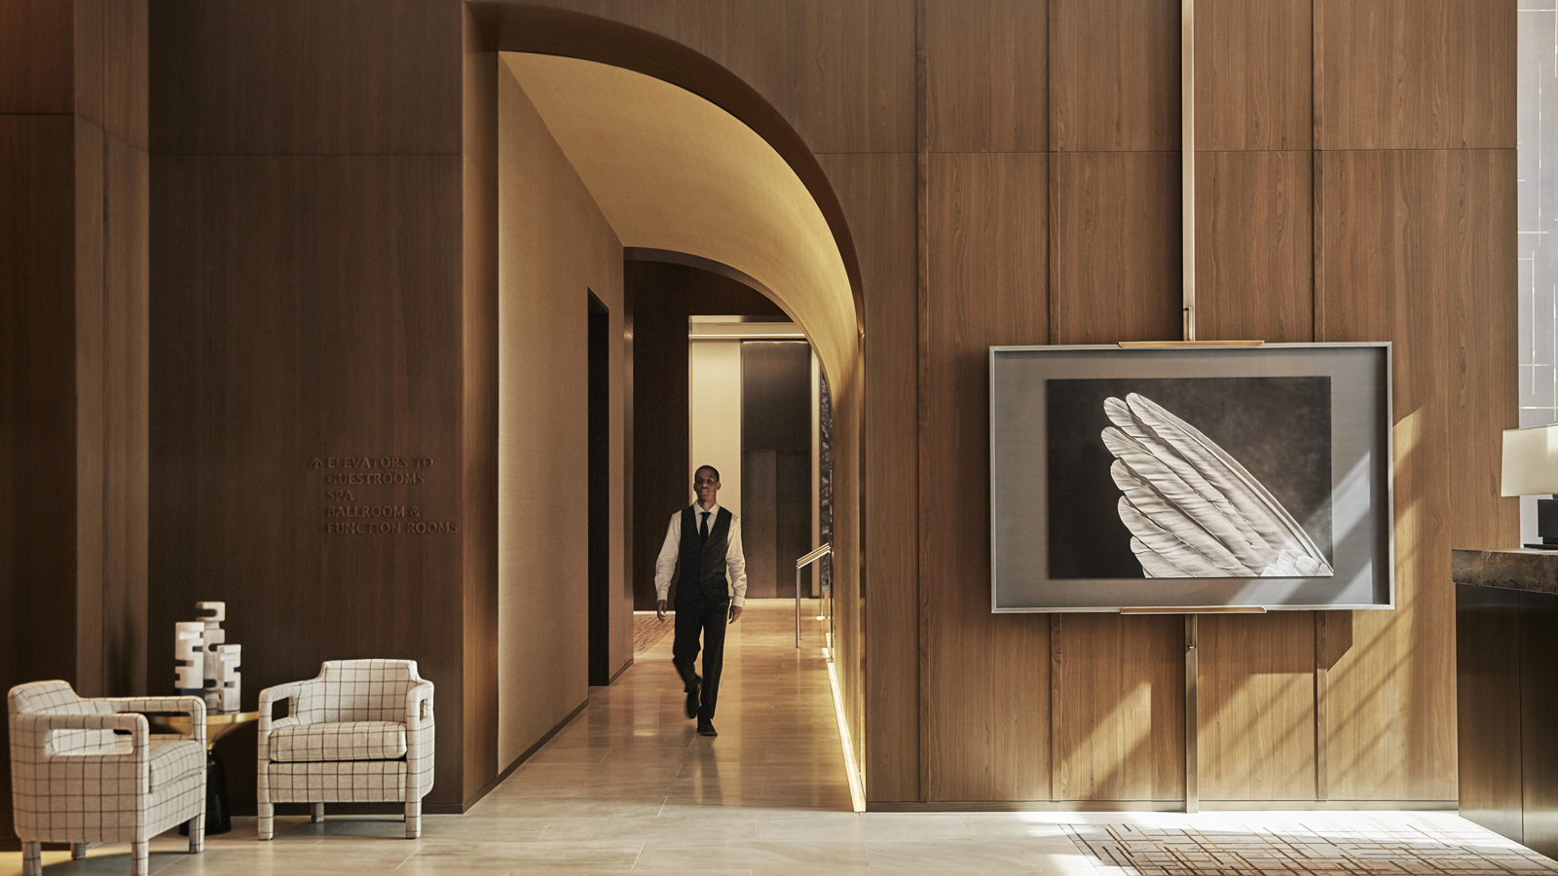
Four Seasons Hotel New York Downtown is committed to sustainability and green initiatives. We believe it is imperative to continually look for ways to reduce our carbon footprint, and reduce our impact on the planet for future generations.
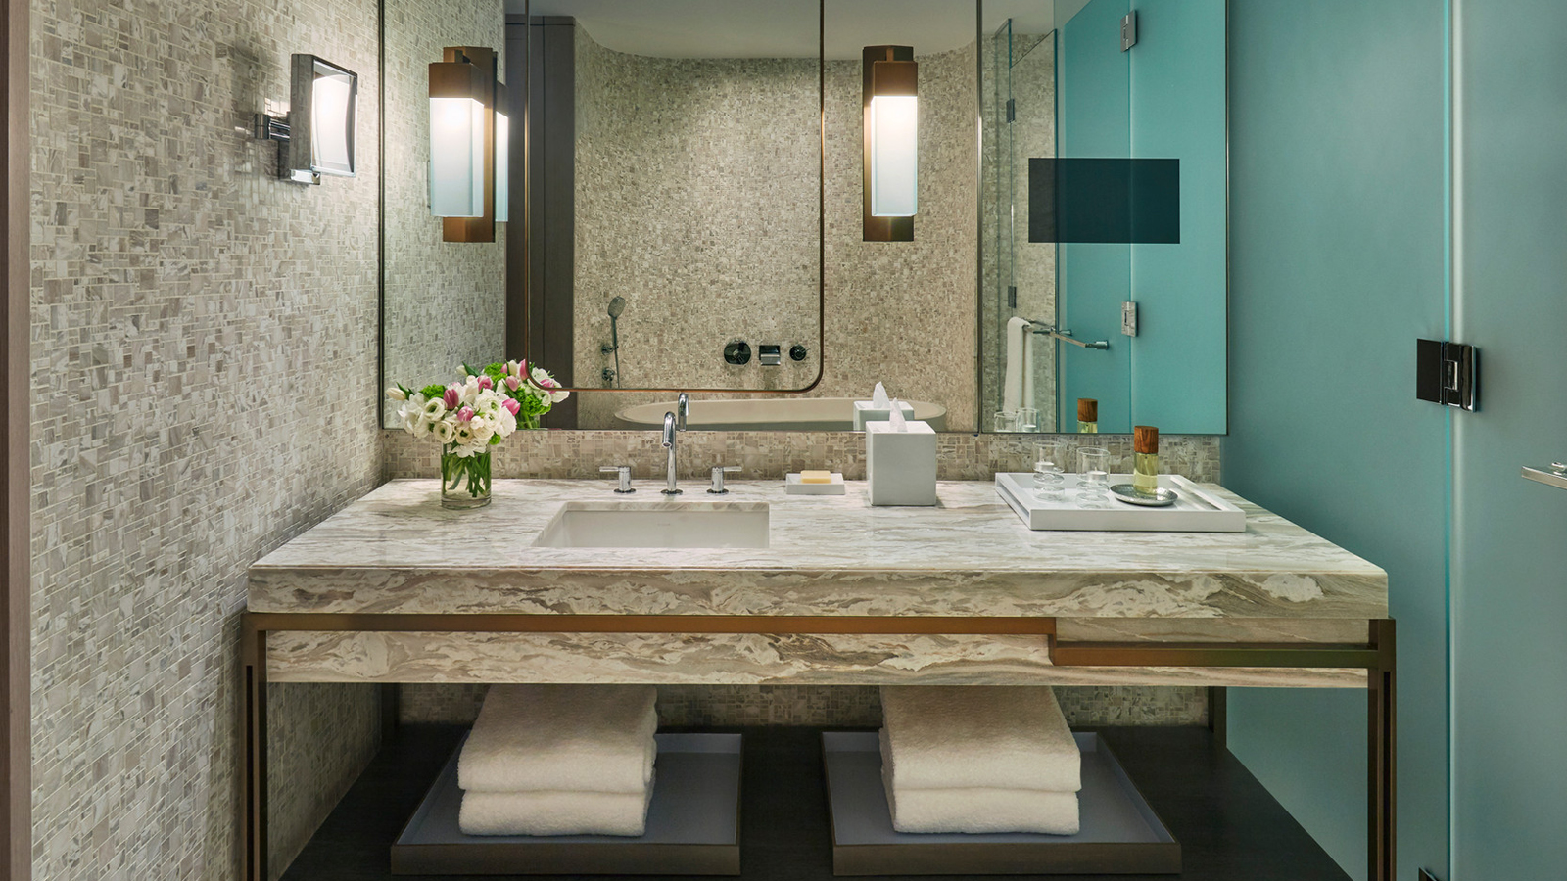
To this end, we have implemented the following sustainability initiatives within the Hotel:
Energy Curtailment Program
Participation in this program in partnership with Con-Edison allows us to reduce usage to alleviate the strain on the city’s electric grid during peak usage.
Lighting Project
We are currently in the midst of a lighting project as we transition to LED lighting in all common and back-of-house spaces. This will reduce our utility cost and carbon footprint significantly.
Water Conservation
We are also in the midst of a water conservation audit that will bring a balance to all rooms and suites within the Hotel and reduce consumption.
Elimination of Plastic
We are currently in the process of going completely plastic-free within the Hotel.
Our recent initiatives include:
- Replacement of all plastic water bottles by early 2020
- Converted to non-plastic straws in late 2018
- Converted to biodegradable keycards in 2019
- Utilisation of paper (recyclable) retail and to-go bags
- Guest-request items including toothbrushes, razors and Q-tips are now packaged in paper only
- In the process of transitioning to biodegradable options for take-away containers, coffee lids and other one-time use containers
Recycled Products
Two of our most popular guest products used for turndown include our coasters and turndown mats, both of which are made from recycled tire rubber.
We will continue to adapt, change and innovate in an effort to make this planet a better one for future generations.

RELATED

March 2, 2023, New York, U.S.A.
Four Seasons Hotel New York Downtown Celebrates Female Designers at The Edit: A Curated Pop Up Shop
https://publish.url/newyorkdowntown/hotel-news/2023/female-designers-at-the-edit.html

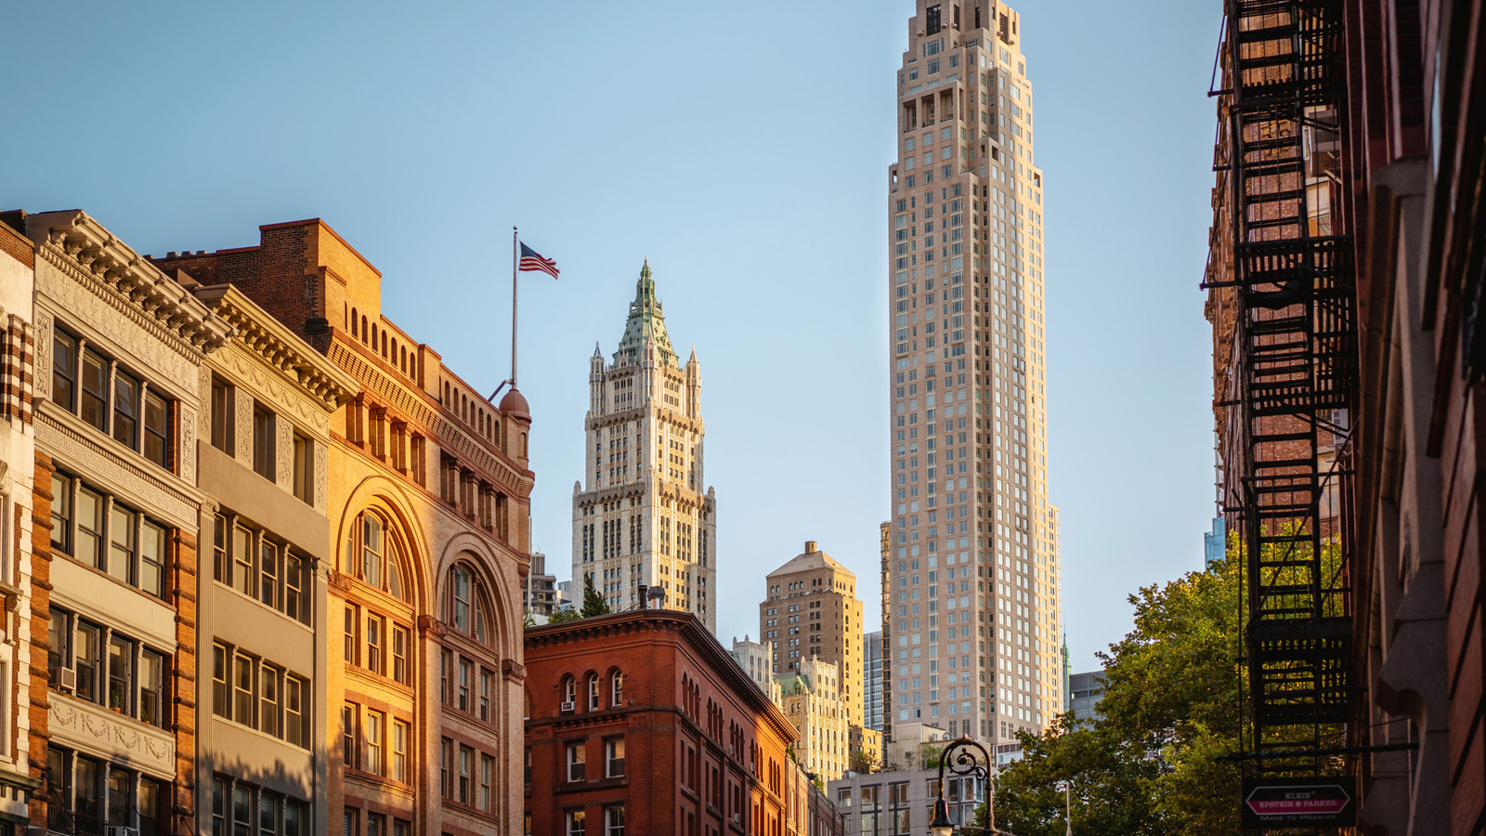 | February 15, 2023, New York, U.S.A.  Four Seasons Hotel New York Downtown Earns Highest Travel Industry Honours for Fifth Year in a Row  https://publish.url/newyorkdowntown/hotel-news/2023/forbes-five-star-hotel-and-spa.html

