Five Ways Locals Can Celebrate the Holidays at Four Seasons Resort Orlando

A beautiful holiday party for as few as six guests, holiday Spa treatments, unique gifts, and more: discover reasons to make a trip to Four Seasons Resort Orlando
December 1, 2020, Orlando at Walt Disney World Resort, U.S.A.

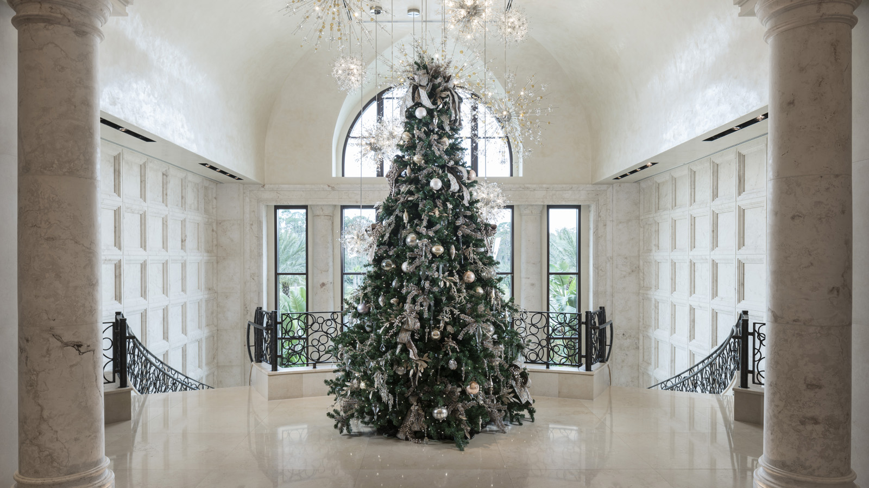
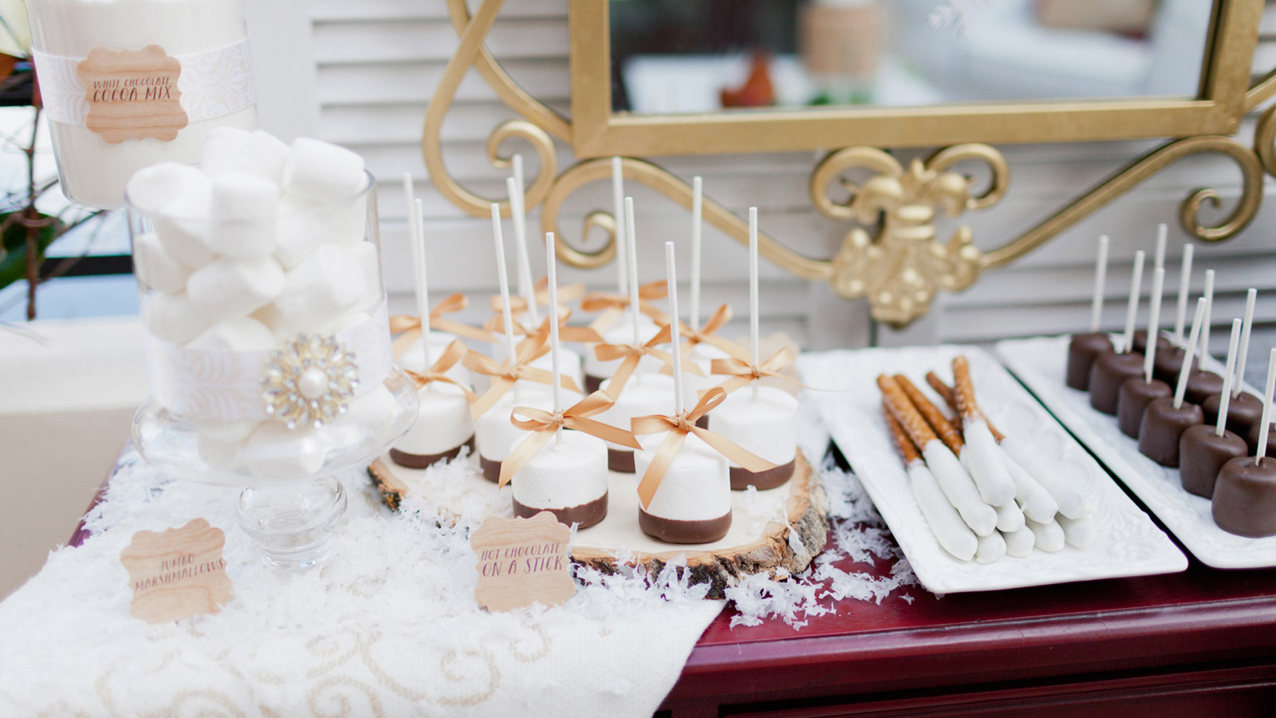 | 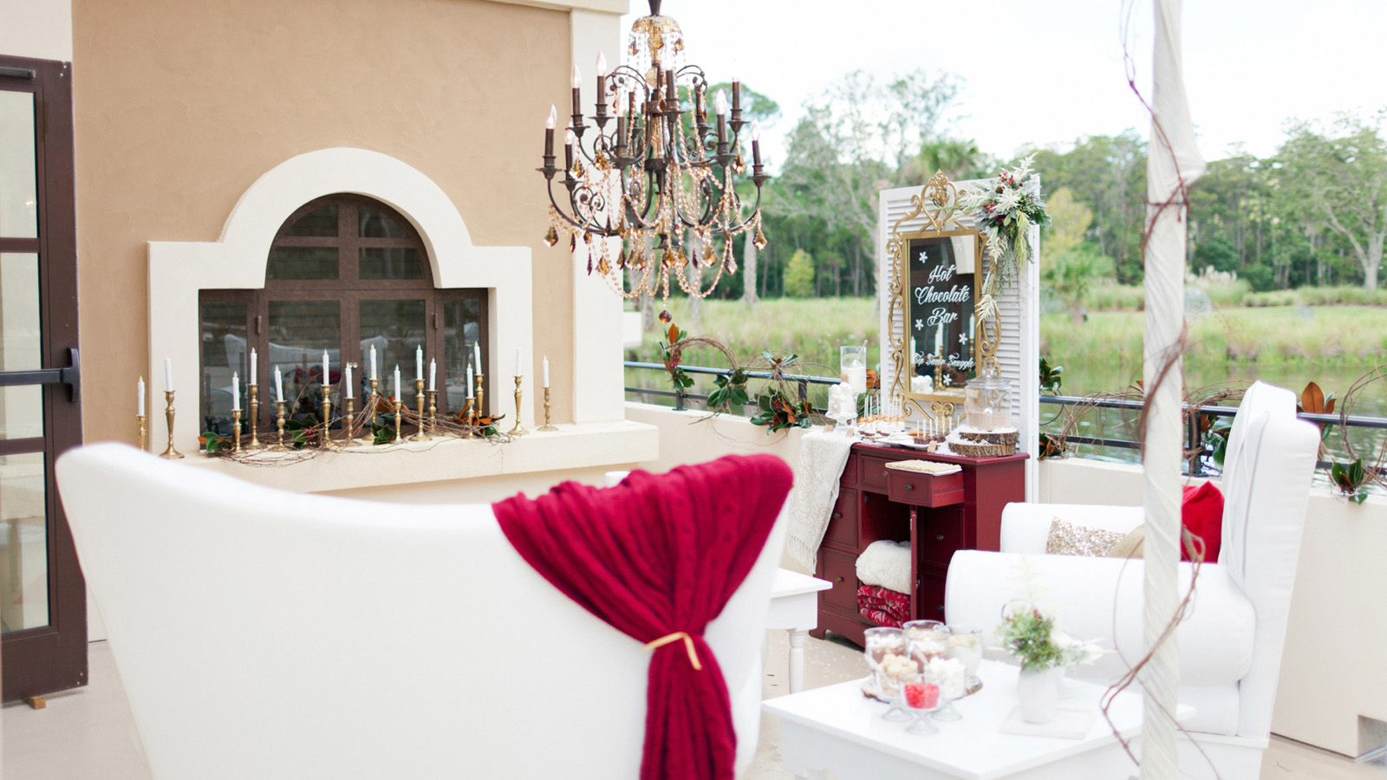 | 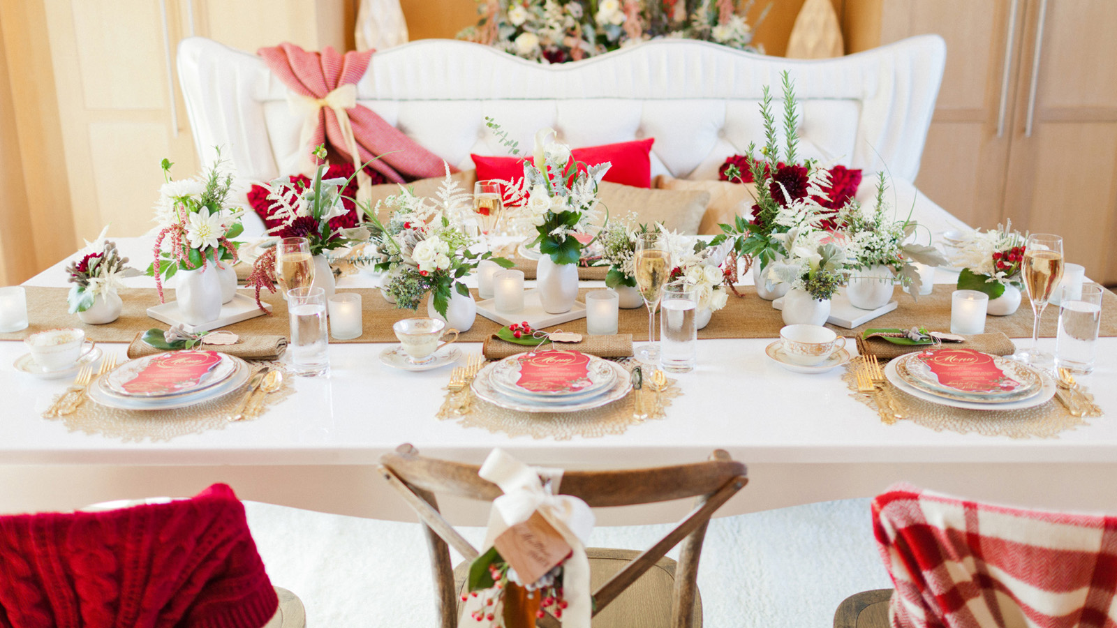
The holiday magic has transformed Four Seasons Resort Orlando at Walt Disney World Resort into a dazzling sight to behold, with beautiful palm trees wrapped in glittering white lights, festive floral arrangements, and the Resort’s signature Christmas tree in the main lobby evoking awe and wonder as soon as one sets foot into the lobby. This holiday season, the Resort offers numerous reasons for locals to come visit, in addition to providing a perfect backdrop to capture a family photo while everyone’s dressed in their holiday best.
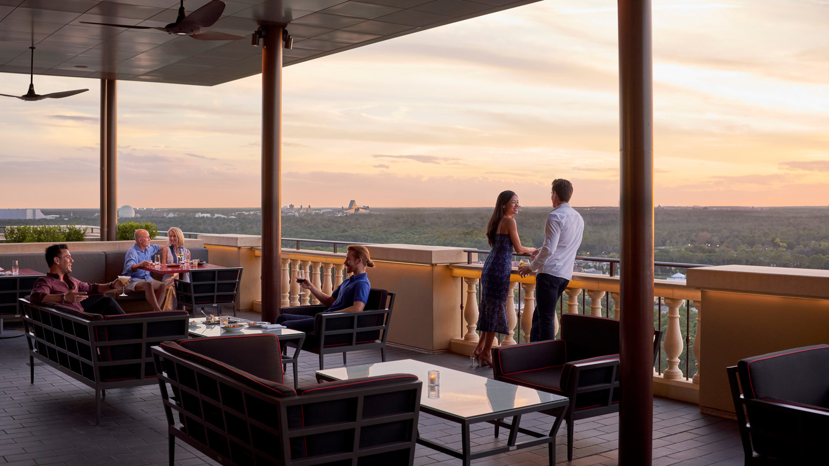
Intimate Private Dining Holiday Event
This year, now more than ever, people are celebrating the holidays with their closest family and friends only. For as few as six people, Four Seasons Resort Orlando has introduced two new decadent menu options for private celebrations, in the Resort’s beautiful Lakeside Event Pavilions. The two Lakeside event rooms are located on the north side of the Resort’s main lake, freestanding buildings that also offer a private terrace on the lake and an outdoor fireplace, perfect for creating wintertime ambiance. The Resort’s catering team can assist with special event décor, such as holiday-inspired floral centrepieces, custom chargers and place cards, themed table linens, faux fur pillows, accent throws and more. The new holiday event offerings available in the Lakeside pavilions include an afternoon tea service, or a hot chocolate bar and dessert station. The tea service is available for USD 55 per person and includes an assortment of teas, plus the following menu:
Desserts:
- Peppermint macaron
- Pumpkin macaron
- Apple crumble mini tart
- House-made cranberry scones with cinnamon whipped cream
Tea Sandwiches:
- Chicken salad, cranberries, pecans, curry aioli
- Prosciutto, herb goat cheese, asparagus
- Pimento cheese, sweet drop pepper, pumpernickel
The hot chocolate bar and dessert station is available for USD 60 per person, and would be ideal for a late afternoon or evening setup, when guests can use the fireplace and enjoy views of the illuminated palm tree-lined pathway. This offering includes chocolate bombes (house made chocolate spheres filed with hot chocolate mix) and assorted hot milks (whole, skim, two percent, oatmeal) for a rich, make-your-own hot chocolate station, complete with all the toppings including mini marshmallows, chocolate shavings, cinnamon, whipped cream, chocolate marshmallows.
Desserts include PB&G holiday s'mores with peppermint chocolate, and Italian nut cookies, plus Spanish churros with chocolate dipping sauce.
“The Lakeside rooms are absolutely perfect for a magical afternoon holiday celebration with close family or friends,” says Laure Hitzig Clavtte, Director of Catering. “Guests will feel special when hosted in this unique setting that feels secluded and charming, with its own private outdoor space and fireplace.”
In addition to these special offerings in the Lakeside rooms, the Resort offers private dining menus for the two main restaurants, Ravello and Capa, for parties of up to 30 guests. A private dining room rental fee applies. For more details or to reserve a special holiday private dining offering, contact the Resort’s Catering team at 407 313 6745.
Holi-Dazzle at The Spa & Salon
The Spa at Four Seasons offers a variety of treatments for locals to look and feel their very best, including facials, massage, body treatments, cryotherapy, hair and nail care, plus new Vitality Drip therapies. To treat oneself to holiday relaxation, or to give the gift of relaxation to a spa-lover, The Spa can be a one-stop shop for beauty and wellness.
The new Signature Silk Hair Treatment, USD 140, offers a luxurious deep sea salt scalp and hair exfoliation with essential oils followed by a caviar hair mask and warm towel treatment. The Signature Silk Hair Treatment is an effective, natural and decadent solution for the ultimate in hair shine, softness and hydration. The Merry Mani & Mistle Toes, 90 minutes for USD 160, offers the comforting, festive and spiced scent of warm apple cider or the peaceful and traditional benefits of precious frankincense and myrrh. Including a warming soak, exfoliation, massage and much needed hydration, this service includes nail shaping, cuticle care, buffing and the perfect seasonal polish. To reserve a Spa appointment, contact 407 313 6160.
Shop the Season’s Best Gifts at Wardrobe and Fable
A best-kept-secret among locals in-the-know are the Resort’s lobby level boutiques, Wardrobe and Fable, which boast unique apparel and accessories for all ages. Wardrobe offers a wide selection of stylish apparel, swimwear, footwear and accessories for both men and women, from renowned designers such as Golden Goose, Veronica Beard, Tory Burch, and more. Wardrobe is open every day from 10:00 am to 6:00 pm. Fable, the whimsical shop across the hall from Wardrobe, offers a variety of necessities for the on-the-go traveller, including new Corkcicle cups and many fun accessories. Fable also features sought-after Four Seasons logo apparel as well as exclusive gifts and memorable treasures. Stoney Clover Lane bags and accessories that can be customised with patches exclusive to Four Seasons Resort Orlando are a hot item at Fable. Satisfy those with a sweet tooth with Sugarfina candy gifts, stock up on organic Coola Suncare or find a delightful gift for little ones, such as Jellycat plush toys. Fable has something for the entire family, and is open from 10:00 am to 6:00 pm daily.
Dinner at Ravello or Capa
The Resort’s signature restaurants are always a treat for locals to enjoy, whether it’s authentic Italian by Executive Chef Fabrizio Schenardi, or expertly grilled steaks and Spanish tapas by Capa Chef Gabriel Massip. At Ravello, diners can enjoy a spacious restaurant with a covered terrace, and a menu with new seasonal offerings such as braised lamb shank and wild mushroom risotto. At Capa, the new Espana Clasica prix-fixe paella menu available on Wednesday nights only for USD 85 per person is a must-try. Capa has a beautiful rooftop terrace, perfect for taking in the sunset while enjoying a signature Capa GinTonic cocktail or glass of Iconoclast cabernet. The restaurants have modified seating capacities to ensure physical distancing, and private dining rooms are available to reserve for those who would like a private space. For dining reservations, call 407 313 6161.
Chef Rabii Saber’s Holiday Chocolate Display
Stop by simply to be wowed by the amazing chocolate creation designed by Executive Pastry Chef Rabii Saber and his team of pastry professionals. This year’s creation is designed to be a Christmas Village, reflective of the old-world style, featuring a small town and tiny village of homes and shops. A beautiful lake and a train surround the darling village, complete with sculpted chocolate and fondant animals such as reindeer. While viewing the creation is sure to inspire one’s cravings for sweets, Lickety Split, just around the corner, awaits. Lickety Split is a sweet treat for locals to enjoy decadent coffee drinks, milkshakes, and holiday gelato flavours such as eggnog and white peppermint. Don’t miss Chef Saber’s special holiday offerings available for purchase, such as hazelnut cookies, peanut butterscotch dark chocolate bark, and pecan brownie cheesecake. Locals can also order a custom cake, in an assortment of design and flavour options, and even a bûche de Noël, for pick-up.
Holiday décor will be in place through January 5, 2021. For reservations, call 407 313 7777.

RELATED

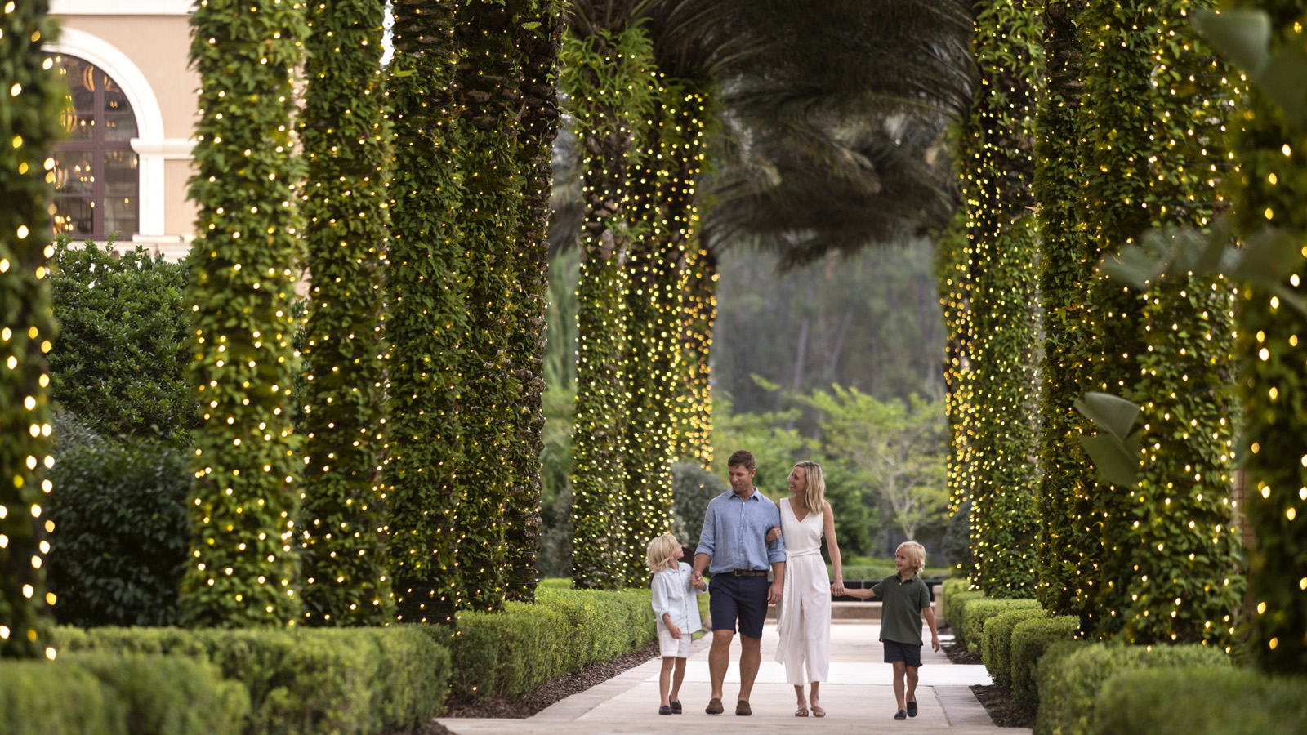 | November 19, 2020, Orlando at Walt Disney World Resort, U.S.A.  “Unwrap” New Enhancements at Four Seasons Resort Orlando, in Time for a Fun-Filled Holiday Vacation at the Most Magical Place on Earth  https://publish.url/orlando/hotel-news/2020/festive-season.html
October 5, 2020, Orlando at Walt Disney World Resort, U.S.A.
Experience Fall Delights at Four Seasons Resort Orlando
https://publish.url/orlando/hotel-news/2020/fall-promotions.html

PRESS CONTACTS

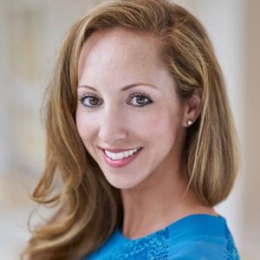 | Dana Berry  Director of Public Relations  10100 Dream Tree Boulevard  Orlando  U.S.A.  dana.berry@fourseasons.com  1 (407) 313-7777

